A PROJECT REPORT ON

QUERY SOLUTIONS

SUBMITTED IN PARTIAL FULLFILLMENT OF THE REQUIREMENT FOR THE DEGREE OF

BACHELOR IN COMPUTER APPLICATION

BY

SHUBHAM RAY

ROLL NO. 66224UT17091

UNDER THE GUIDANCE OF

Mr SURAJIT DAS

PROJECT GUIDE, TACT, BHUBANESWER



DEPARTMENT OF BACHELOR IN COMPUTER APPLICATION

TRIDENT ACADEMY OF CREATIVE TECHNOLOGY

BHUBANESWER



**DECLARATION**

I, Shubham Ray, do hereby declare that project report entitled “**Query Solution**” submitted to Trident Academy of Creative Technology, Utkal University, Bhubaneswer for the award of the Degree of Bachelor of Computer Application (BCA), is an authentic and original work carried out by me from 03- 05-2020 to 25-06-2020.

Under the guidance of **Mr Surajit Das**.

Date - 10-07-2020 **Shubham Ray**

Reg no. **66224UT17091**

**ACKNWOLEDGE**

We express our thanks and gratitude to Almighty God, our parents and other family members and friends under whose unconstrained support, we could not have made this career in Bachelor of Computer Application. We are grateful to our internal project guide, Mr Surajit Das, Dept. of BCA, Trident Academy of Creative Technology for his constant motivation and valuable help throughout the project work. We express our gratitude to Mr Surajit Das, of Dept. of BCA, for his valuable suggestions and advices throughout the BCA course. Finally, we would like to thank all our well-wishers for their cooperation to complete this project.

**Shubham Ray**

Reg no. **66224UT17091**



**CERTIFICATE**

This is to verify that the project report entitled “**QUERY SOLUTIONS**” submitted by **SHUBHAM RAY** (**66224UT17091**) to **TRIDENT ACADEMY OF CREATIVE TECHNOLOGY**, Bhubaneswer in partial fulfilment of the requirement for the award of the degree of **BCA** is a record of bonafide work carried out by him under the guidance of **MR. SURAJIT DAS.** The project fulfils the requirement as per the regulations of this university. The contents of this report have not been submitted and will not be submitted either in part or in full, for the award of any other degree or deploma and the same is certified.

HEAD OF DEPARTMENT EXTERNAL EXAMINER

PRINCIPAL TACT BBSR INTERNAL EXAMINER

|  |  |  |
| --- | --- | --- |
| **Content** | **PAGE NO.** | |
| 1. Abstract | 7 – 8 |  |
| 2. Introduction | 9 – 10 |  |
| 3. System Analysis  3.1 Objective  3.2 Scope  3.3 Functionalities of the system  3.4 Tools & Environment  3.5 Software Design Paradigm Applied | 11 - 23 |  |
| 4. Technical Specification | 24 – 68 |  |
| 4.1 Backend | 24 - 43 |  |
| 4.1.1 Java  4.1.2 Spring Framework  4.1.3 Hibernate  4.1.4 H2  4.1.5 MySql |  |  |
| 4.2 Frontend | 44 - 68 |  |
| 4.2.1 Thymeleaf  4.2.2 JavaScript  4.2.3 CSS  4.2.4 Bootstrap  4.2.5 AJAX  4.2.6 Jquery |  |  |
| 5. System Design  5.1 DED  5.2 Use Case Diagram  5.3 ERD | 69 - 79 |  |
| 6. Sample Coding | 80 - 388 |  |
| 7. Implementation Screenshot | 389 - 405 |  |
| 8. Testing | 406 – 409 |  |
| 9. Conclusion and Future Work | 410 |  |
| 10. Bibliography | 411 |  |

**1. Abstract**

Learning comprises all forms of electronically supported learning and teaching. The information and communication systems, whether networked learning or not, serve as specific media to implement the learning process. The term will still most likely be utilized to reference out-of-classroom experiences via technology.

E-learning is essentially the computer and network-enabled transfer of skills and knowledge. E-learning applications and processes include Web-based learning, computer-based learning, virtual education opportunities, and digital collaboration. Content is delivered via the Internet or intranet. Abbreviations like CBT (Computer-Based Training), IBT (Internet-Based Training) or WBT (Web-Based Training) have been used as synonyms to e-learning. E-Learning, or electronic learning, is the delivery of learning and training through digital resources.

There are many terms used to describe learning that is delivered online, via the internet, ranging from Distance Education, to computerized electronic learning, online learning, internet learning and many others. We define e-Learning as courses that are specifically delivered via the internet to somewhere other than the classroom where the professor is teaching.

It is not a course delivered via a DVD or CD-ROM, video tape or over a television channel. It is interactive in that you can also communicate with your teachers, professors or other students in your class. Sometimes it is delivered live, where you can “electronically” raise your hand and interact in real time and sometimes it is a lecture that has been prerecorded.

Although e-Learning is based on formalized learning, it is provided through electronic devices such as computers, tablets and even cellular phones that are connected to the internet. This makes it easy for users to learn anytime, anywhere, with few, if any, restrictions.

Basically, e-Learning is training, learning, or education delivered online through a computer or any other digital device. Nowadays educational institutions as-well-as individuals are mostly dependent on online platforms of learning like scholastic websites, mobile applications, and video streaming platforms. Like we all know there is huge competition in the market of E-Learning platforms to provide the best apparatus to make E-Learning easier and accessible.

Many of these applications and websites tend to make huge money off it by asking people to avail their products. So we want to offer a platform of learning which will help you in computer programming solutions. Now that

we’ve outlined the definition and history of e-Learning, you’ll have a better idea of exactly what it is. Implementing e learning into your organization is beneficial and easy to do. Query Solutions” as the name suggest, there can be some questions to which users will be actually dealing with, what kind of solutions we are talking about, what sort of features would be including for the users and many more.

“Query Solutions” is basically a simple platform that focuses primarily on imparting education and knowledge and not on making money or profit. We believe this forum will help in the betterment of the society and the mankind as a whole. So now talking about our project, “Query Solutions”, it is a platform providing programming solutions but is not limited to it. It combines the work of searching for solutions, theories and online tutorials to present a full package of technical assistance and support.

**2. Introduction**

Recently e-learning systems are experiencing rapid development. The advantages of learning through a global network are manifold and obvious: the independence of time and space, learners can learn at their own pace, learning materials can be organized in one place and used-processed all around the world. One of the most important segments in today’s development and use of the e-learning system is the personalization of content and building of user profiles based on the learning behaviour of each individual user. The personalization options increase efficiency of e-learning, thus justifying the higher initial cost of their construction. In order to personalize the learning process and adapt content to each learner, e-learning systems can use strategies that have the ability to meet the needs of learners. Also, these systems have to use different technologies to change the environment and perform the adaptation of teaching materials based on the needs of learners. The process of adaptation can be in the form of adaptation of content, learning process, feedback or navigation.

However, current theories and practices in e-learning are neither simple nor coherent, meaning that the implementation of this solution is happening sporadically, randomly, and with varying degrees of success. In spite of the enthusiasm and commitment being shown by the UK government, there is still considerably apathy, confusion and scepticism about e-learning amongst teachers, students and academics alike. Although most recognise that e-learning has the potential to enhance greatly learning and the learning experience at all levels, many feel that its drawbacks are currently still too great to commit so heavily to it.

Although much has been said and written on the subject of e-learning, there are few definite conclusions to be drawn from it. Books are written, Internet groups are formed and conferences are held, but we still seem unable to really define how, when or where e-learning should best be used. While the arguments rage on, an increasing number of institutions are attempting to pioneer their own style of e-learning, all with their own successes and failures.

In spite of the fact that there is only 'emerging evidence that e-learning can help to improve attainment and raise standards'2, the Government is convinced that e-learning is the way to take education and therefore the country at large forward. In line with the Prime Minister's plan to give all schools broadband connectivity by the same year. The Government does however understand that not everyone shares its belief in the commitment to e-learning. It sees a primary purpose of the consultation and strategy process as being to bring e-learning to the attention of education and industry leaders, and to convince them of its ongoing worth.

There were however, several consistent areas of concern amongst respondents. Key among these was the issue of funding, with the majority holding the view that the Government should underwrite the cost. Many believed that funding should be available for the long term and that a unified funding strategy should be developed along side the 'unified e-learning strategy'. Interestingly, there was a consistent belief that education and industry leaders must be convinced of the benefits of e-learning, suggesting that they are not currently. This is a potential barrier to funding being allocated for e-learning. In view of the fact that e-learning is intended to benefit every citizen, many were concerned about the effect of the 'digital divide', which is still considerable in this country. Some respondents pointed out that at present, less that half of UK households have Internet access, with many considering the cost of computer hardware and connection prohibitive, while seeing no benefit in having Internet access. Many respondents believe that broadband connectivity is vital to e-learning, which cuts out those who cannot afford it and those in rural communities who cannot get access to it.

Some respondents also included in the digital divide those with disabilities that prevent them from using conventional computer equipment and those with Special Education Needs. The DfES did try to counter this in the consultation document by explaining how e-learning (if programmed to) can in fact include those who struggle in traditional education, such as the visually impaired, those with communication difficulties and those with specific learning difficulties such as Dyslexia.

Learning comprises all forms of electronically supported learning and teaching. The information and communication systems, whether networked learning or not, serve as specific media to implement the learning process. The term will still most likely be utilized to reference out-of-classroom experiences via technology. E-learning is essentially the computer and network-enabled transfer of skills and knowledge. E-learning applications and processes include Web-based learning, computer-based learning, virtual education opportunities, and digital collaboration. Content is delivered via the Internet or intranet. Abbreviations like CBT (Computer-Based Training), IBT (Internet-Based Training) or WBT (Web-Based Training) have been used as synonyms to e-learning. E-Learning, or electronic learning, is the delivery of learning and training through digital resource.

**3. System Analysis**

**3.1 Objective**

This application builds a learning process with the combination of content that is both delivered digitally. E learning contributes to the shifts from traditional face-to-face learning to the use of web technological tools which enhances collaborative learning and presents an entirely new learning platform for students. ELearning has also been the principal form of distance education but now, it is also changing the instructions on higher education as it is now becoming a global agent in higher education. Advancements in technology learning have contributed to the enhancements of generations of face-to-face learning and generations of distance education. As to it, when e learning develops, it has begun to use different approaches to address diverse goals.

### The Major Goals of Query Solution is to:

* Enhance the quality of learning
* Meet the learning style or needs of students
* Improve the efficiency and effectiveness
* Improve user-accessibility and time flexibility to engage learners in the learning process
* Build a friendly environment
* Provide a brief, clear and specific statement to the user according his requirement
* Set everything in a categorized order to easily distinguish
* Providing better retention techniques
* Making users to choose, demonstrate, implement, perform
* Make everything free and much more attractive

This type of Learning process is a vast and an expanding platform with huge prospective in higher education. Since there are many challenges in making e learning effective, it is important to know how to manage it and access to the resources.

**3.2 Scope**

“Query Solutions” is a platform that provides technical assistance for budding developers and programmers. It takes on the job of finding theories, codes and tutorials to provide the user with a full package of support all at the same place.

**A Comparison with Other Websites:**

Comparing with the “W3 Schools” website (www.w3schools.com) these provides certain courses such as HTML, CSS, Python, Javascript, Angular, etc. Comes with a con that it uses its search operation with the help of Google’s API. Where Query Solution has its ability to search its Contents by itself.

Comparing with the “GeeksForGeeks” website (www.geeksforgeeks.org) these allows other publishers to post articles into its website. But does not provides any voting options to neither of its guests nor the other publishers also. But this website, gives the opportunity to the publishers to vote other publisher’s contents.

Comparing with the “Quora” website (www.quora.com) though its allow other users to vote some publisher contents but it still now uses its Topics to get match when anyone searches for anything. Query Solutions provides its publishers to write articles, it also comes with the new #hashtags feature for a ease in search operation.

Comparing with the “StackOverflow” website (stackoverflow.com) it doesn’t provide any tutorial sessions to users. Whereas Query Solutions provides the question answer sessions as similarly provided by StackOverflow as well as it also provides the tutorials for its guests to use.

Comparing with the “JavaTPoint” website (www.javatpoint.com) it does provide tutorials but does not provides any compiler to run the codes. Whereas Query Solutions comes with a online compiler to write the code and test it on the spot.

This makes the website as a whole, very accommodating and useful. For this cases Query Solutions stand outside of the line comparing to other websites.

**The Data Requirements-**

* Publishers Email
* Appropriate Question Heading
* Suitable Title for Article
* Necessary hash-tags
* Brief description on contents

This website accepts question based on any computer programming terminology and provides its answers using our models. Even if we dearth in providing any answer, the question would be open for all and anyone who knows and is willing to give its answer can do so. We take the data or the answers from the users and store it in the model for future reference. This makes finding answers by new comers and beginners very easily and effortlessly.

Our website lays out a forum for the questioners and the responds to interact within a community of like-minded people. We provide aid in finding answers to computer jargons and theories and also in hunting for solutions to computer programming problems.

**Website goals-**

It excludes all the irrelevant data and advertisements that make its experience smooth and well ordered. It also eliminates the inconvenience caused to programmers in finding backings on the internet. It also provides the features of online tutorials computer programming languages. The most eminent feature of the website is that it charges no extra money to access its contents.

**User information-**

This is also a platform that is inclusive of all, starting from programming beginners to professionals, and helps them in every possible way.

**Updation Process-**

We also have an alluring feature for our community. When a user signs up or logs in, his profile is created or logged in on the website. When the user visits his/her profile section, a number of articles and questions are shown based on their browsing activities. The user has the option to view or react the articles and respond to questions.

**3.3 Functionalities of the system**

**1. Derogatory words scrutinizing -**

a) When a user performs any of the tasks like posting a question, writing an article etc. the server, at all times, keeps an eye on the input of dialect.

b) It checks if any expletive words are entered by the user, may it be intentionally or unintentionally.

c) On finding one, the server pops out a message displaying an enjoin to change the entered word and informs the user about the prohibition of the use of such language.

d) This helps to create a healthy environment.

**2. Use of spring security for logging in and registration -**

a) On the website, the user will have to pass through the spring security protocol, before reaching the target URL.

b) The protocol will ask for the proof of authorization the user.

c) So, the next time when the same user tries to log in to the website, he/she will not have to prove his/her identity again.

d) Unless and until he/she has not logged out successfully.

e) All this is done by the spring security protocol without the manual intervention of the admin.

f) Thus, spring security is a powerful and user-friendly filter for authentication and access-control framework.

**3. Ingenious ways are used to handle use login -**

a) On a normal notion, (in a comparison to other websites) the user is asked to feed the website with multiple personal information in order to be able to access the contents, even before he/she has started to explore the website.

b) This tends to create a nuisance and discontentment for the user.

c) This very problem is resolved in “Query Solutions” by the use of spring security.

d) When the user is done with exploring the website and is settled down to post a question or publish an article, only then our website will ask for the details of the user.

e) It is natural, to say that the user likes the content of the website and perhaps even wants to contribute to it, since he/she has come so far.

f) Thus, it is palpable that the user will not hesitate to provide the required information.

**4. The voting system enables both the publisher to stay connected -**

a) The user has the power to vote for articles and answers.

b) The base line being that a single user may vote for multiple articles but the same user cannot vote on a single article for more than once.

c) Also, the website provides the user with the option of voting for an article either with a like or a dislike.

d) When the user votes for a ‘Like’, a pop up displays the message as “Thanks for your vote”.

e) When the user votes for a ‘Dislike’, a pop up displays the message as “Oops! Sorry you didn’t like it”.

f) In other cases where the user wishes to undo a vote, he/she has the privilege to do so.

g) On doing it, a pop up is displayed with the message as “You discarded your vote”.

h) This system works as a feedback mechanism and allows scope for improvement.

**5. Mailing facility encourages users to visit again -**

a) Whenever there is an activity caused on the website, say on a new answer, then the other users related to it, i.e.

i. the person who posted the question

ii. the people who have previously answered it

iii. people who have voted for or against it etc. will receive an e-mail informing them about the activity.

b) This e-mail address is obtained from the server database in which it was stored long ago when the authorization was been taken.

c) This will help the user embolden the user to revisit and get updated.

**6. Correlated contents are exhibited on intro pages with minimal descriptions -**

a) The website provides two basic introductory pages.

b) One when the user opens the website for the first time and the other when the user logs in or registers with the website.

c) The first being the home page and the later, being the user’s profile page.

d) On these intro pages, articles that have the most no. of answered entries or that are most liked by other users are displayed.

e) The articles are displayed with least revelation of the actual content.

f) The server runs a scan through the article and retrieves one or maybe two sentences or phrases that gives a partly precise idea of the full content and are of outmost significance.

g) Since the details are not included and the content is discontinued midway, it will create an urge in the user, only if he/she is interested, to manually go and visit the article and get hold of the content.

h) This creates a sense of excitement within the user and an undeniable desire to go forward.

**7. Pagination creates an array -**

a) On a common inkling, when a search is executed, all the relevant data that is stored on the database tends to pile up and overlap one another.

b) This creates a lot of confusion for the user and often results in a fiasco.

c) Thus, the pace at which the information is given out is very important for an efficient outcome.

d) To reconcile this “Query Solutions” uses the method of pagination.

e) It divides the whole lot of information available on its database, into different sections according to the searched data entry.

f) It then allows only a restricted amount of data on a single, say 5 entries, that are most relevant to the searched particulars.

g) If, the user is not content with the entries on the first page, he/she has the option to navigate to the next one.

h) This continues until the user is satisfied with the entry or he/she reaches the last entry on the relevant topic.

i) Pagination allows an ordered disposal and smooth glide of information to the user.

**8. Tutorials are bestowed with inbuilt online compilers -**

a) Normally, when a user searches for a solution to a computer program or completes a tutorial, he/she is provided with the codes that he/she has to run on his/her own system.

b) Not all users may have the facility to do so.

c) To provide ease and convenience to the users, “Query Solutions” provides a pre-loaded online compiler within the website.

d) Here the user can enter the codes and execute them without having to switch to a different platform.

e) This is one of the very advantageous and fruitful features of our website.

**9. Illustrations like graphs and tables makes it easier for the admin to assess the statistics of development** **-**

a) The admin has a set of graphs that are prepared using the figures of the burgeoning website.

b) It also includes a table with the list of names of publishers who have the highest no. of published articles and questions on the website.

c) This system helps the admin to analyze the overall build out of the website.

**10. Search mechanism gets strong with dual indexing/making an order of hashtags -**

1. The trend of using hashtags on posts and publication has seen a sudden boost in the past decade. Hashtags make the task of searching for a specific piece of data, very expedient.
2. It also allows room for related data to peek in from the pool of information. With this view in mind, we have added a hashtag feature on our website. This feature will allow the user to search for the required data, by using keywords with a hashtag. Doing so will make the apposite data reach the user.
3. Thus, this feature will not only allow the user to work efficiently with our website but also save some of their valuable time by cutting down on the hassle of typing whole sentences for a search.

**11.** **Search engine** -

1. It is one of the most crucial features of our website. Whenever any data is taken from users may it be articles or questions, it is first broken down into pieces or tokens. All the auxiliary verbs are removed, leaving behind only essential keywords.
2. This information is then stored in an index table. Any input that is given to the website undergoes a similar process. For example, when a user intends to search for something, say “what is java?”, the server breaks down the sentence to ‘what’ and ‘java’. The server then runs a scan through the index table to find matching or related entries.
3. The most relevant entry is showed on top followed by others. Another essential attribute is that, all the published content, during a day are rearranged in alphabetical order at midnight of the next day. This is done by the help of a scheduler. Doing so makes it easier for the server to produce the required information quickly and coherently.
4. The server also tries to arrange the output on basis of the date of publication. Development in technology is never stagnant. There is no perfect answer to anything and facts are liable to change.
5. Keeping this view, the server is designed to more recent entries on top followed by less recent ones. Also, the amount of information that is available for any certain topic is vast. To provide a user-friendly experience, the website is designed to show the output of a search based on different sections.
6. The first section contains all the articles that exactly match the searched query. This section is named “Matching Articles”.
7. The next section contains questions that contain keywords that are searched by the user. This section is named “Matching Questions”. Another section displays top tutorials that satisfy the searched query. This section is named “Recommended Tutorials”. The last section comprises of articles that use the same hashtags as of those that are searched and also have the greatest number of likes. This section is named “Recommended Articles”.

**3.4 Tools & Environment**

**Server Environment:**

* **Operating System:** Windows 7 or higher version. (Windows Server 2003 or higher version is recommended)
* **Java:** Java SE 7 or above
* **Database Server:** H2, MySQL
* **Processor:** Intel Pentium 4.0 or higher with 2.60 GHz

**Developing Environment:**

* **Operating System:** Microsoft Windows 7
* **Platform:** Java SE 7
* **Database Server:** MySQL server with SQLyog enabled
* **Developing Platform:** Apache Tomcat
* **Developing IDE:** Spring Tool Suit
* **Client browsers:** Version 73.0.3683.86 (Official Build) (64-bit)
* **Processor:** Intel Core i5 processor with 1.80 GHz.

**Client Environment:**

* **Browser:** Any browser with java script, and W3C standard CSS support.
* **Internet connection: 56 Kbps or above.**

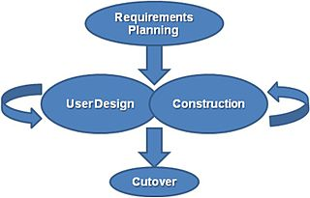

**3.5 Software Design Paradigm Applied**

**Rapid Application Development**

Rapid application development (RAD) describes a method of software development which heavily emphasizes rapid prototyping and iterative delivery. The RAD model is, therefore, a sharp alternative to the typical waterfall development model, which often focuses largely on planning and sequential design practices. First introduced in 1991 in [James Martin’s](https://en.wikipedia.org/wiki/James_Martin_(author)) [book by the same name](https://books.google.com/books/about/Rapid_Application_Development.html?id=o6FQAAAAMAAJ), rapid application development has become one of the most popular and powerful development methods, which falls under the parental category of [agile development techniques](https://en.wikipedia.org/wiki/Agile_software_development).

In general, RAD approaches to software development put less emphasis on planning and more emphasis on an adaptive process. [Prototypes](https://en.wikipedia.org/wiki/Software_prototype) are often used in addition to or sometimes even in place of design specifications.

RAD is especially well suited for (although not limited to) developing [software](https://en.wikipedia.org/wiki/Software) that is driven by [user interface](https://en.wikipedia.org/wiki/User_interface) [requirements](https://en.wikipedia.org/wiki/Software_requirements). [Graphical user interface builders](https://en.wikipedia.org/wiki/Graphical_user_interface_builder) are often called rapid application development tools. Other approaches to rapid development include the [adaptive](https://en.wikipedia.org/wiki/Adaptive_software_development), [agile](https://en.wikipedia.org/wiki/Agile_software_development), [spiral](https://en.wikipedia.org/wiki/Spiral_model), and [unified](https://en.wikipedia.org/wiki/Unified_Process) models.

In the slow, methodical software development methods of olde, receiving useful and concrete user feedback has been inherently difficult, costly, and time consuming. Long meetings and phone calls, and even longer design docs, were a necessary evil to lay out even the most basic concrete plans of proper software design. With typical waterfall methods, rudimentary user feedback was often many months if not years in the future, after all planning and most development had taken place.

In stark contrast, one of the biggest benefits to rapid application development is the ability to both easily and frequently receive feedback from users who are directly interfacing with the application during development and prototyping. While this advantage is most readily visible within the UI/UX components of the system, iterative design intrinsically means user feedback can be at the forefront of the process.

While various forms of RAD emphasize slightly different concepts and design methodologies, a common inclusion in most RAD systems is the heavy use of prototyping. As an alternative to heavy-handed design specifications, the use of prototypes throughout the development cycle provides for a number of unique benefits:

* User Involvement: Unlike a traditional waterfall model, which requires the design team to discuss with users what features or implementations might be required and plan specifications around those ideas, a rapid prototype allows users to actually use the software and provide feedback on a live system, rather than attempting to provide abstract evaluations of a design document.
* Feasibility: Prototyping allows the development team to quickly evaluate the feasibility of a particularly complex or risky component right out of the gate. By recognizing and working on complicated systems early in the development lifecycle, the software will be more robust, less error-prone, and better structured for future design additions.
* Error Reduction & Debugging: With rapid prototype releases during a project, it is far more likely that errors will be both discovered (and subsequently squashed) far earlier in the development cycle than with a typical waterfall approach.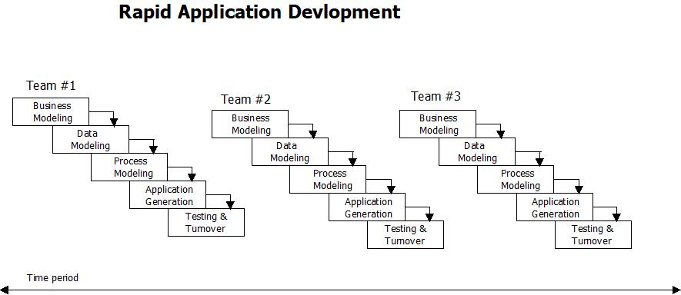The James Martin approach to RAD divides the process into four distinct phases:

1. **Requirements planning phase** – combines elements of the system planning and systems analysis phases of the [Systems Development Life Cycle](https://en.wikipedia.org/wiki/Systems_Development_Life_Cycle) (SDLC). Users, managers, and IT staff members discuss and agree on business needs, project scope, constraints, and system requirements. It ends when the team agrees on the key issues and obtains management authorization to continue.
2. **User design phase** – during this phase, users interact with systems analysts and develop models and prototypes that represent all system processes, inputs, and outputs. The RAD groups or subgroups typically use a combination of [Joint Application Development](https://en.wikipedia.org/wiki/Joint_Application_Design) (JAD) techniques and [CASE tools](https://en.wikipedia.org/wiki/CASE_tools) to translate user needs into working models. *User Design* is a continuous interactive process that allows users to understand, modify, and eventually approve a working model of the system that meets their needs.
3. **Construction phase** – focuses on program and application development task similar to the SDLC. In RAD, however, users continue to participate and can still suggest changes or improvements as actual screens or reports are developed. Its tasks are programming and application development, coding, unit-integration and system testing.
4. **Cutover phase** – resembles the final tasks in the SDLC implementation phase, including data conversion, testing, changeover to the new system, and user training. Compared with traditional methods, the entire process is compressed. As a result, the new system is built, delivered, and placed in operation much sooner

## Pros of Rapid Application Development

While there are a number of benefits to using a rapid application development method, we’ve highlighted a handful of the most crucial when considering whether RAD is the right choice for your next project.

* Measurable Progress: With frequent iterations, components, and prototypes coming down the pipe, progress on the overall project, as well as lesser segments, can be easily measured and evaluated to maintain schedules and budgets.
* Quickly Generate Productive Code: As a larger percentage of active software developers move into multi-discipline roles (i.e. full-stack developers), a RAD methodology allows skilled team members to quickly produce prototypes and working code to illustrate examples that might otherwise take weeks or months to see the light of day using a slower development technique.
* Compartmentalization of System Components: Much in the same way that object-oriented programming practices keep objects and components quarantined from one another, RAD inherently has the same beneficial impact on the components generated during development. By forcing designers and developers to create components that are functional and independent on their own, to be used in an iterative release or prototype, each element within the overall software system is compartmentalized and therefore easily modified as the needs of the software evolve.
* Rapid, Constant User Feedback: As discussed above, obtaining relevant user feedback during development is invaluable. RAD methodologies allow for near-constant user interfacing and feedback through frequent iterations and prototype releases, giving the entire team priceless evaluation and criticism when it’s needed most.
* Early Systems Integration: While most waterfall method software projects must, by their very nature, wait until the tail end of the lifecycle to begin integrations with other systems or services, a rapidly developed application becomes integrated almost immediately. By requiring early integrations within a prototype, a RAD system quickly identifies any errors or complications within integrations and forces immediate resolutions.
* Simple Adaptability: During development, software is a fairly malleable form. Since code can be changed that dramatically alters the entire system or generates new components, it is to the advantage of the development team to make use of this flexibility early and often, by iterating and prototyping potential concepts or ideas throughout development.

**4. Technical Specification**

**4.1 Backend**

**4.1.1 Java**

JAVA was developed by Sun Microsystems Inc in 1991, later acquired by Oracle Corporation. It was developed by James Gosling and Patrick Naughton. It is a simple programming language.  Writing, compiling and debugging a program is easy in java.  It helps to create modular programs and reusable code.

**Java Virtual Machine (JVM)**

This is generally referred as JVM. Before, we discuss about JVM lets see the phases of program execution. Phases are as follows: we write the program, then we compile the program and at last we run the program.  
1) Writing of the program is of course done by java programmer like you and me.  
2) Compilation of program is done by javac compiler, javac is the primary java compiler included in java development kit (JDK). It takes java program as input and generates java bytecode as output.  
3) In third phase, JVM executes the bytecode generated by compiler. This is called program run phase.

So, now that we understood that the primary function of JVM is to execute the bytecode produced by compiler. **Each operating system has different JVM, however the output they produce after execution of bytecode is same across all operating systems**. That is why we call java as platform independent language.

**Java Development Kit(JDK)**

While explaining JVM and bytecode, I have used the term JDK. Let’s discuss about it. As  
the name suggests this is complete java development kit that includes JRE (Java Runtime Environment), compilers and various tools like JavaDoc, Java debugger etc.  
In order to create, compile and run Java program you would need JDK installed on your computer.

**Java Runtime Environment(JRE)**  
JRE is a part of JDK which means that JDK includes JRE. When you have JRE installed on your system, you can run a java program however you won’t be able to compile it. JRE includes JVM, browser plugins and applets support. When you only need to run a java program on your computer, you would only need JRE.

## Main Features of JAVA

## ****1. Java is Simple:****

The Java programming language is easy to learn. Java code is easy to read and write.

## ****2. Java is Familiar:****

Java is similar to C/C++ but it removes the drawbacks and complexities of C/C++ like pointers and multiple inheritances. So if you have background in C/C++, you will find Java familiar and easy to learn.

**3. Java is an Object-Oriented programming language:**

Unlike C++ which is semi object-oriented, Java is a fully object-oriented programming language. It has all OOP features such as [abstraction](https://www.codejava.net/java-core/the-java-language/what-is-abstraction-in-java-the-why-and-the-truth), [encapsulation](https://www.codejava.net/java-core/the-java-language/what-is-encapsulation-in-java-the-what-why-and-how), [inheritance](https://www.codejava.net/java-core/the-java-language/what-is-inheritance-in-java-the-what-why-and-how) and [polymorphism](https://www.codejava.net/java-core/the-java-language/what-is-polymorphism-in-java-the-what-how-and-why).

**4. Java supports Functional programming:**

Since Java SE version 8 (JDK 8), Java is updated with functional programming feature like functional interfaces and Lambda Expressions. This increases the flexibility of Java.

**5. Java is Robust:**

With automatic garbage collection and simple memory management model (no pointers like C/C++), plus language features like [generics](https://www.codejava.net/java-core/collections/what-are-generics-in-java), [try-with-resources](https://www.codejava.net/java-core/the-java-language/using-try-with-resources-examples-java-7),… Java guides programmer toward reliable programming habits for creating highly reliable applications.

**6. Java is Secure:**

The Java platform is designed with security features built into the language and runtime system such as static type-checking at compile time and runtime checking (security manager), which let you creating applications that can’t be invaded from outside. You never hear about viruses attacking Java applications.

**7. Java is High Performance:**

Java code is compiled into bytecode which is highly optimized by the Java compiler, so that the Java virtual machine (JVM) can execute Java applications at full speed. In addition, compute-intensive code can be re-written in native code and interfaced with Java platform via *Java Native Interface* (JNI) thus improve the performance.

**8. Java is Multithreaded:**

The Java platform is designed with multithreading capabilities built into the language. That means you can build applications with many concurrent threads of activity, resulting in highly interactive and responsive applications.

## ****9. Java is Platform Independence:****

Java code is compiled into intermediate format (bytecode), which can be executed on any systems for which Java virtual machine is ported. That means you can write a Java program once and run it on Windows, Mac, Linux or Solaris without re-compiling. Thus the slogan “*Write once, run anywhere*” of Java.

Besides the above features, programmers can benefit from a strong and vibrant Java ecosystem:

* Java is powered by Oracle - one of the leaders in the industry. Java also gets enormous support from big technology companies like IBM, Google, Redhat,… so it has been always evolving over the years.
* There are a lot of open source libraries which you can choose for building your applications.
* There are many superior tools and IDEs that makes your Java development easier.
* There are many frameworks that help you build highly reliable applications quickly.
* The community around Java technology is very big and mature, so that you can get support easily.

**4.1.2 Spring Framework**

Spring Framework is a Java platform that provides comprehensive infrastructure support for developing Java applications. Spring handles the infrastructure so you can focus on your application.

Spring enables you to build applications from “plain old Java objects” (POJOs) and to apply enterprise services non-invasively to POJOs. This capability applies to the Java SE programming model and to full and partial Java EE.

Examples of how you, as an application developer, can use the Spring platform advantage:

* Make a Java method execute in a database transaction without having to deal with transaction APIs.
* Make a local Java method a remote procedure without having to deal with remote APIs.
* Make a local Java method a management operation without having to deal with JMX APIs.
* Make a local Java method a message handler without having to deal with JMS APIs.

**Dependency Injection and Inversion of Control**

Java applications -- a loose term that runs the gamut from constrained applets to n-tier server-side enterprise applications -- typically consist of objects that collaborate to form the application proper. Thus the objects in an application have dependencies on each other.

Although the Java platform provides a wealth of application development functionality, it lacks the means to organize the basic building blocks into a coherent whole, leaving that task to architects and developers. True, you can use design patterns such as Factory, Abstract Factory, Builder, Decorator, and Service Locator to compose the various classes and object instances that make up an application. However, these patterns are simply that: best practices given a name, with a description of what the pattern does, where to apply it, the problems it addresses, and so forth. Patterns are formalized best practices that you must implement yourself in your application.

The Spring Framework Inversion of Control (IoC) component addresses this concern by providing a formalized means of composing disparate components into a fully working application ready for use. The Spring Framework codifies formalized design patterns as first-class objects that you can integrate into your own application(s). Numerous organizations and institutions use the Spring Framework in this manner to engineer robust, maintainable applications.

## 1.2 Modules

The Spring Framework consists of features organized into about 20 modules. These modules are grouped into Core Container, Data Access/Integration, Web, AOP (Aspect Oriented Programming), Instrumentation, and Test, as shown in the following diagram.

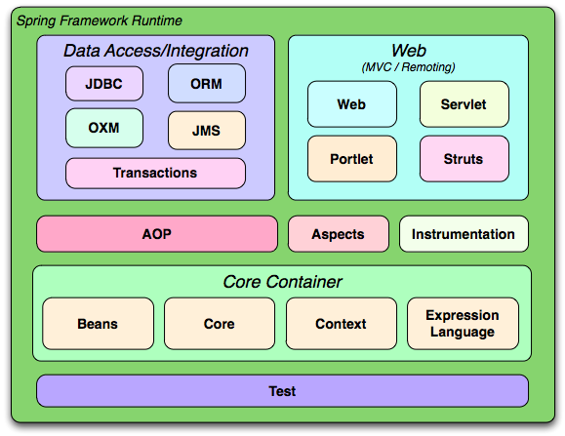

### 1.2.1 Core Container

The [Core Container](../beans) consists of the Core, Beans, Context, and Expression Language modules.

The [Core and Beans](../beans) modules provide the fundamental parts of the framework, including the IoC and Dependency Injection features. The BeanFactory is a sophisticated implementation of the factory pattern. It removes the need for programmatic singletons and allows you to decouple the configuration and specification of dependencies from your actual program logic.

The [Context](../ApplicationContext) module builds on the solid base provided by the [Core and Beans](../beans) modules: it is a means to access objects in a framework-style manner that is similar to a JNDI registry. The Context module inherits its features from the Beans module and adds support for internationalization (using, for example, resource bundles), event-propagation, resource-loading, and the transparent creation of contexts by, for example, a servlet container. The Context module also supports Java EE features such as EJB, JMX ,and basic remoting. The ApplicationContext interface is the focal point of the Context module.

The [Expression Language](https://docs.spring.io/spring/docs/3.0.x/spring-framework-reference/html/expressions.html) module provides a powerful expression language for querying and manipulating an object graph at runtime. It is an extension of the unified expression language (unified EL) as specified in the JSP 2.1 specification. The language supports setting and getting property values, property assignment, method invocation, accessing the context of arrays, collections and indexers, logical and arithmetic operators, named variables, and retrieval of objects by name from Spring's IoC container. It also supports list projection and selection as well as common list aggregations.

### 1.2.2 Data Access/Integration

The Data Access/Integration layer consists of the JDBC, ORM, OXM, JMS and Transaction modules.

The [JDBC](../JDBC) module provides a JDBC-abstraction layer that removes the need to do tedious JDBC coding and parsing of database-vendor specific error codes.

The [ORM](../Spring) module provides integration layers for popular object-relational mapping APIs, including [JPA](../13.5 JPA), [JDO](../13.4 JDO), [Hibernate](../13.3 Hibernate), and [iBatis](../Maps). Using the ORM package you can use all of these O/R-mapping frameworks in combination with all of the other features Spring offers, such as the simple declarative transaction management feature mentioned previously.

The [OXM](https://docs.spring.io/spring/docs/3.0.x/spring-framework-reference/html/oxm.html) module provides an abstraction layer that supports Object/XML mapping implementations for JAXB, Castor, XMLBeans, JiBX and XStream.

The Java Messaging Service ([JMS](https://docs.spring.io/spring/docs/3.0.x/spring-framework-reference/html/jms.html)) module contains features for producing and consuming messages.

The [Transaction](https://docs.spring.io/spring/docs/3.0.x/spring-framework-reference/html/transaction.html) module supports programmatic and declarative transaction management for classes that implement special interfaces and for all your POJOs (plain old Java objects).

### 1.2.3 Web

The Web layer consists of the Web, Web-Servlet, Web-Struts, and Web-Portlet modules.

Spring's Web module provides basic web-oriented integration features such as multipart file-upload functionality and the initialization of the IoC container using servlet listeners and a web-oriented application context. It also contains the web-related parts of Spring's remoting support.

The Web-Servlet module contains Spring's model-view-controller ([MVC](../framework)) implementation for web applications. Spring's MVC framework provides a clean separation between domain model code and web forms, and integrates with all the other features of the Spring Framework.

The Web-Struts module contains the support classes for integrating a classic Struts web tier within a Spring application. Note that this support is now deprecated as of Spring 3.0. Consider migrating your application to Struts 2.0 and its Spring integration or to a Spring MVC solution.

The Web-Portlet module provides the MVC implementation to be used in a portlet environment and mirrors the functionality of Web-Servlet module.

### 1.2.4 AOP and Instrumentation

Spring's [AOP](../7.1 Introduction) module provides an AOP Alliance-compliant aspect-oriented programming implementation allowing you to define, for example, method-interceptors and pointcuts to cleanly decouple code that implements functionality that should be separated. Using source-level metadata functionality, you can also incorporate behavioral information into your code, in a manner similar to that of .NET attributes.

The separate Aspects module provides integration with AspectJ.

The Instrumentation module provides class instrumentation support and classloader implementations to be used in certain application servers.

**4.1.3 Hibernate**

**Hibernate ORM** (or simply **Hibernate**) is an [object-relational mapping](https://en.wikipedia.org/wiki/Object-relational_mapping) tool for the [Java](https://en.wikipedia.org/wiki/Java_(programming_language)) programming language. It provides a [framework](https://en.wikipedia.org/wiki/Software_framework) for mapping an [object-oriented](https://en.wikipedia.org/wiki/Object-oriented_programming) domain model to a [relational database](https://en.wikipedia.org/wiki/Relational_database). Hibernate handles [object-relational impedance mismatch](https://en.wikipedia.org/wiki/Object-relational_impedance_mismatch) problems by replacing direct, [persistent](https://en.wikipedia.org/wiki/Persistence_(computer_science)) database accesses with high-level object handling functions.

Hibernate is [free software](https://en.wikipedia.org/wiki/Free_software) that is distributed under the [GNU Lesser General Public License](https://en.wikipedia.org/wiki/GNU_Lesser_General_Public_License) 2.1.

Hibernate's primary feature is mapping from Java classes to [database tables](https://en.wikipedia.org/wiki/Table_(database)), and mapping from Java data types to [SQL](https://en.wikipedia.org/wiki/SQL) data types. Hibernate also provides data query and retrieval facilities. It generates SQL calls and relieves the developer from the manual handling and object conversion of the result set.

## ORM Tool

An ORM tool simplifies the data creation, data manipulation and data access. It is a programming technique that maps the object to the data stored in the database.

## What is JPA?

Java Persistence API (JPA) is a Java specification that provides certain functionality and standard to ORM tools. The **javax.persistence** package contains the JPA classes and interfaces.

## Advantages of Hibernate Framework

Following are the advantages of hibernate framework:

### 1) Open Source and Lightweight

Hibernate framework is open source under the LGPL license and lightweight.

### 2) Fast Performance

The performance of hibernate framework is fast because cache is internally used in hibernate framework. There are two types of cache in hibernate framework first level cache and second level cache. First level cache is enabled by default.

### 3) Database Independent Query

HQL (Hibernate Query Language) is the object-oriented version of SQL. It generates the database independent queries. So you don't need to write database specific queries. Before Hibernate, if database is changed for the project, we need to change the SQL query as well that leads to the maintenance problem.

### 4) Automatic Table Creation

Hibernate framework provides the facility to create the tables of the database automatically. So there is no need to create tables in the database manually.5) Simplifies Complex Join

Fetching data from multiple tables is easy in hibernate framework.

### 6) Provides Query Statistics and Database Status

Hibernate supports Query cache and provide statistics about query and database status.

Hibernate has a layered architecture which helps the user to operate without having to know the underlying APIs. Hibernate makes use of the database and configuration data to provide persistence services (and persistent objects) to the application.

Following is a very high level view of the Hibernate Application Architecture.

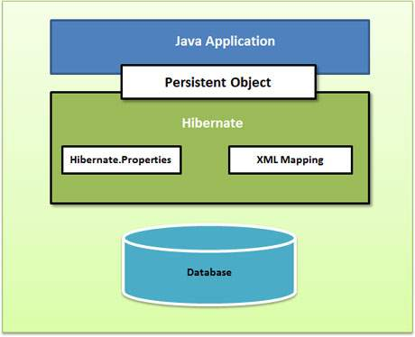

Following is a detailed view of the Hibernate Application Architecture with its important core classes.

Hibernate uses various existing Java APIs, like JDBC, Java Transaction API(JTA), and Java Naming and Directory Interface (JNDI). JDBC provides a rudimentary level of abstraction of functionality common to relational databases, allowing almost any database with a JDBC driver to be supported by Hibernate. JNDI and JTA allow Hibernate to be integrated with J2EE application servers.

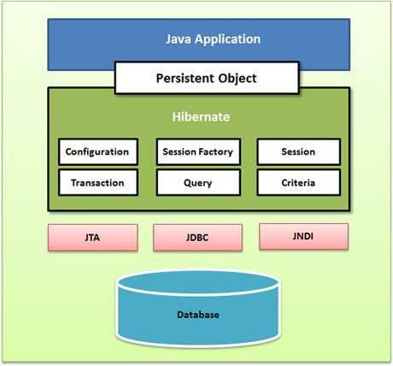

Following section gives brief description of each of the class objects involved in Hibernate Application Architecture.

## Configuration Object

The Configuration object is the first Hibernate object you create in any Hibernate application. It is usually created only once during application initialization. It represents a configuration or properties file required by the Hibernate.

The Configuration object provides two keys components −

* **Database Connection** − This is handled through one or more configuration files supported by Hibernate. These files are **hibernate.properties** and **hibernate.cfg.xml**.
* **Class Mapping Setup** − This component creates the connection between the Java classes and database tables.

## Session Factory Object

Configuration object is used to create a SessionFactory object which in turn configures Hibernate for the application using the supplied configuration file and allows for a Session object to be instantiated. The SessionFactory is a thread safe object and used by all the threads of an application.

The SessionFactory is a heavyweight object; it is usually created during application start up and kept for later use. You would need one SessionFactory object per database using a separate configuration file. So, if you are using multiple databases, then you would have to create multiple SessionFactory objects.

## Session Object

A Session is used to get a physical connection with a database. The Session object is lightweight and designed to be instantiated each time an interaction is needed with the database. Persistent objects are saved and retrieved through a Session object.

The session objects should not be kept open for a long time because they are not usually thread safe and they should be created and destroyed them as needed.

## Transaction Object

A Transaction represents a unit of work with the database and most of the RDBMS supports transaction functionality. Transactions in Hibernate are handled by an underlying transaction manager and transaction (from JDBC or JTA).

This is an optional object and Hibernate applications may choose not to use this interface, instead managing transactions in their own application code.

## Query Object

## Query objects use SQL or Hibernate Query Language (HQL) string to retrieve data from the database and create objects. A Query instance is used to bind query parameters, limit the number of results returned by the query, and finally to execute the query.

## Criteria Object

Criteria objects are used to create and execute object oriented criteria queries to retrieve objects.

**4.1.4 H2**

**H2** is a [relational database management system](https://en.wikipedia.org/wiki/Relational_database_management_system) written in [Java](https://en.wikipedia.org/wiki/Java_(programming_language)). It can be embedded in Java applications or run in client-server mode.

The software is available as [open source](https://en.wikipedia.org/wiki/Open-source_software) software [Mozilla Public License](https://en.wikipedia.org/wiki/Mozilla_Public_License) 2.0 or the original [Eclipse Public License](https://en.wikipedia.org/wiki/Eclipse_Public_License).

A subset of the [SQL](https://en.wikipedia.org/wiki/SQL) (Structured Query Language) standard is supported. The main programming APIs are SQL and [JDBC](https://en.wikipedia.org/wiki/JDBC), however the database also supports using the [PostgreSQL](https://en.wikipedia.org/wiki/PostgreSQL) [ODBC](https://en.wikipedia.org/wiki/ODBC) driver by acting like a PostgreSQL server.

It is possible to create both in-memory tables, as well as disk-based tables. Tables can be persistent or temporary. Index types are hash table and tree for in-memory tables, and [b-tree](https://en.wikipedia.org/wiki/B-tree) for disk-based tables. All data manipulation operations are [transactional](https://en.wikipedia.org/wiki/Database_transaction). Table level locking and [multiversion concurrency control](https://en.wikipedia.org/wiki/Multiversion_concurrency_control) are implemented. The [2-phase commit](https://en.wikipedia.org/wiki/2-phase_commit) protocol is supported as well, but no standard API for distributed transactions is implemented. The security features of the database are: [role based](../control) access rights, encryption of the password using [SHA-256](https://en.wikipedia.org/wiki/SHA-256) and data using the [AES](https://en.wikipedia.org/wiki/Advanced_Encryption_Standard) or the Tiny Encryption Algorithm, [XTEA](https://en.wikipedia.org/wiki/XTEA). The cryptographic features are available as functions inside the database as well. [SSL](https://en.wikipedia.org/wiki/Secure_Sockets_Layer) / [TLS](https://en.wikipedia.org/wiki/Transport_Layer_Security) connections are supported in the client-server mode, as well as when using the console application.

Two [full text search](https://en.wikipedia.org/wiki/Full_text_search) implementations are included, a native implementation and one using [Lucene](https://en.wikipedia.org/wiki/Lucene).

A simple form of high availability is implemented: when used in the client-server mode, the database engine supports hot failover (this is commonly known as clustering). However, the clustering mode must be enabled manually after a failure.

The database supports protection against [SQL injection](https://en.wikipedia.org/wiki/SQL_injection) by enforcing the use of parameterized statements. In H2, this feature is called 'disabling literals'.

Since version 1.1.111, H2 [in-memory database](https://en.wikipedia.org/wiki/In-memory_database) can run inside the [Google App Engine](https://en.wikipedia.org/wiki/Google_App_Engine).The H2 documentation explains in detail several ways in which problems in underlying hardware and in particular power systems can impact durability of relational databases.

According to the H2 documentation, such problems are related not only to the DB engine design, but also to the storage caching mechanism. As storage devices use write cache in order to increase speed, in a situation of power failure, data in the device's cache is lost. Administrators have then to assess the common trade off between speed and data loss risks in the context of the business requirements and must carefully consider the design of the power supply and UPS of critical servers.

It is possible in some cases to force the storage to write cache frequently or even immediately using [fsync](https://en.wikipedia.org/wiki/Sync_(Unix)) which slows the writing process or one can accept that caching in the device buffer introduces some risk of data loss in case of power failure. The effectiveness of using fsync is limited by the fact that many HDD have [write caching](https://en.wikipedia.org/wiki/Disk_buffer) enabled by factory default in which case there is nothing about the design or settings of the database nor OS level commands that will be able to completely eliminate the chance of lost or inconsistent data in the event of a sudden power failure. Working with the OS and hardware settings to disable all caching so as to write data in real time can have significant impacts on performance in that only around 100 [write operations per second](https://en.wikipedia.org/wiki/IOPS) would be achievable when using spinning disks.

The H2 documentation makes an effort to describe in detail  [potential problems with](https://en.wikipedia.org/wiki/H2_(DBMS)#cite_note-6) [durability](https://en.wikipedia.org/wiki/Durability_(database_systems)) (part of [ACID](https://en.wikipedia.org/wiki/ACID)) resulting from the potential [data loss](https://en.wikipedia.org/wiki/Data_loss) of [committed transactions](https://en.wikipedia.org/wiki/Database_transaction) in case of a [power failure](https://en.wikipedia.org/wiki/Power_outage).

Considering the hardware limitations regarding preservation of data in the event of sudden power loss and the ineffectiveness of approaches commonly employed by developers to prevent these sorts of losses, many database engines do not by default call FileDescriptor.sync() nor FileChannel.force() nor [fsync](https://en.wikipedia.org/wiki/Sync_(Unix)) or equivalents for every commit because they significantly degrade system performance without significantly increasing durability.

HSQLDB documentation references workarounds to a similar set of issues in their documentation.The Microsoft Knowledge Base describes the impact these issues, power failures, write caching, etc. can have on performance and durability. [The knowledge base discusses the trade offs between performance and the vulnerability of disk write caching as well as settings that an administrator can use to balance these.](https://en.wikipedia.org/wiki/H2_(DBMS)#cite_note-8)

**4.1.5 MySql**

**MySQL**  [is an](https://en.wikipedia.org/wiki/MySQL#cite_note-whatismysql-5) [open-source](https://en.wikipedia.org/wiki/Open-source_software) [relational database management system](https://en.wikipedia.org/wiki/Relational_database_management_system) (RDBMS). Its name is a combination of "My", the name of co-founder [Michael Widenius](https://en.wikipedia.org/wiki/Michael_Widenius)'s daughter,and "[SQL](https://en.wikipedia.org/wiki/SQL)", the abbreviation for [Structured Query Language](https://en.wikipedia.org/wiki/Structured_Query_Language).

MySQL is [free and open-source software](https://en.wikipedia.org/wiki/Free_and_open-source_software) under the terms of the [GNU General Public License](https://en.wikipedia.org/wiki/GNU_General_Public_License), and is also available under a variety of [proprietary](https://en.wikipedia.org/wiki/Proprietary_software) licenses. MySQL was owned and sponsored by the [Swedish](https://en.wikipedia.org/wiki/Sweden) company [MySQL AB](https://en.wikipedia.org/wiki/MySQL_AB), which was bought by [Sun Microsystems](https://en.wikipedia.org/wiki/Sun_Microsystems) (now [Oracle Corporation](https://en.wikipedia.org/wiki/Oracle_Corporation)). In 2010, when Oracle acquired Sun, Widenius [forked](https://en.wikipedia.org/wiki/Fork_(software_development)) the open-source MySQL project to create [MariaDB](https://en.wikipedia.org/wiki/MariaDB).

MySQL is a component of the [LAMP](https://en.wikipedia.org/wiki/LAMP_(software_bundle)) [web application](https://en.wikipedia.org/wiki/Web_application) [software stack](https://en.wikipedia.org/wiki/Software_stack) (and [others](https://en.wikipedia.org/wiki/List_of_AMP_packages)), which is an acronym for [*Linux*](https://en.wikipedia.org/wiki/Linux)*,* [*Apache*](https://en.wikipedia.org/wiki/Apache_HTTP_Server)*, MySQL,* [*Perl*](https://en.wikipedia.org/wiki/Perl)*/*[*PHP*](https://en.wikipedia.org/wiki/PHP)*/*[*Python*](https://en.wikipedia.org/wiki/Python_(programming_language)). MySQL is used by many database-driven web applications, including [Drupal](https://en.wikipedia.org/wiki/Drupal), [Joomla](https://en.wikipedia.org/wiki/Joomla), [phpBB](https://en.wikipedia.org/wiki/PhpBB), and [WordPress](https://en.wikipedia.org/wiki/WordPress). MySQL is also used by many popular [websites](https://en.wikipedia.org/wiki/Website), including [Facebook](https://en.wikipedia.org/wiki/Facebook), [Flickr](https://en.wikipedia.org/wiki/Flickr), [MediaWiki](https://en.wikipedia.org/wiki/MediaWiki), [Twitter](https://en.wikipedia.org/wiki/Twitter) and [YouTube](https://en.wikipedia.org/wiki/YouTube).

MySQL is written in [C](https://en.wikipedia.org/wiki/C_(programming_language)) and [C++](https://en.wikipedia.org/wiki/C++). Its SQL parser is written in [yacc](https://en.wikipedia.org/wiki/Yacc), but it uses a home-brewed [lexical analyzer](https://en.wikipedia.org/wiki/Lexical_analysis). [MySQL works on many](https://en.wikipedia.org/wiki/MySQL#cite_note-16) [system platforms](https://en.wikipedia.org/wiki/System_platform), including [AIX](https://en.wikipedia.org/wiki/AIX_operating_system), [BSDi](https://en.wikipedia.org/wiki/BSD/OS), [FreeBSD](https://en.wikipedia.org/wiki/FreeBSD), [HP-UX](https://en.wikipedia.org/wiki/HP-UX), [eComStation](https://en.wikipedia.org/wiki/EComStation), [i5/OS](https://en.wikipedia.org/wiki/IBM_i5/OS), [IRIX](https://en.wikipedia.org/wiki/IRIX), [Linux](https://en.wikipedia.org/wiki/Linux), [macOS](https://en.wikipedia.org/wiki/MacOS), [Microsoft Windows](https://en.wikipedia.org/wiki/Microsoft_Windows), [NetBSD](https://en.wikipedia.org/wiki/NetBSD), [Novell NetWare](https://en.wikipedia.org/wiki/Novell_NetWare), [OpenBSD](https://en.wikipedia.org/wiki/OpenBSD), [OpenSolaris](https://en.wikipedia.org/wiki/OpenSolaris), [OS/2](https://en.wikipedia.org/wiki/OS/2) Warp, [QNX](https://en.wikipedia.org/wiki/QNX), [Oracle Solaris](https://en.wikipedia.org/wiki/Solaris_(operating_system)), [Symbian](https://en.wikipedia.org/wiki/Symbian), [SunOS](https://en.wikipedia.org/wiki/SunOS), [SCO OpenServer](https://en.wikipedia.org/wiki/SCO_OpenServer), SCO [UnixWare](https://en.wikipedia.org/wiki/UnixWare), Sanos and [Tru64](https://en.wikipedia.org/wiki/Tru64_UNIX). A port of MySQL to [OpenVMS](https://en.wikipedia.org/wiki/OpenVMS) also exists.

The MySQL server software itself and the client libraries use [dual-licensing](https://en.wikipedia.org/wiki/Dual_license) distribution. They are offered under [GPL](https://en.wikipedia.org/wiki/GNU_General_Public_License) version 2, or a proprietary license.

Support can be obtained from the official manual. Free support additionally is available in different IRC channels and forums. Oracle offers paid support via its MySQL Enterprise products. They differ in the scope of services and in price. Additionally, a number of third party organisations exist to provide support and services, including [MariaDB](https://en.wikipedia.org/wiki/MariaDB) and [Percona](https://en.wikipedia.org/wiki/Percona).

MySQL has received positive reviews, and reviewers noticed it "performs extremely well in the average case" and that the "developer interfaces are there, and the documentation (not to mention feedback in the real world via Web sites and the like) is very, very good". It has also been tested to be a "fast, stable and true multi-user, multi-threaded sql database server".

MySQL is written in [C](https://en.wikipedia.org/wiki/C_(programming_language)) and [C++](https://en.wikipedia.org/wiki/C++). Its SQL parser is written in [yacc](https://en.wikipedia.org/wiki/Yacc), but it uses a home-brewed [lexical analyzer](https://en.wikipedia.org/wiki/Lexical_analysis). [MySQL works on many](https://en.wikipedia.org/wiki/MySQL#cite_note-16) [system platforms](https://en.wikipedia.org/wiki/System_platform), including [AIX](https://en.wikipedia.org/wiki/AIX_operating_system), [BSDi](https://en.wikipedia.org/wiki/BSD/OS), [FreeBSD](https://en.wikipedia.org/wiki/FreeBSD), [HP-UX](https://en.wikipedia.org/wiki/HP-UX), [eComStation](https://en.wikipedia.org/wiki/EComStation), [i5/OS](https://en.wikipedia.org/wiki/IBM_i5/OS), [IRIX](https://en.wikipedia.org/wiki/IRIX), [Linux](https://en.wikipedia.org/wiki/Linux), [macOS](https://en.wikipedia.org/wiki/MacOS), [Microsoft Windows](https://en.wikipedia.org/wiki/Microsoft_Windows), [NetBSD](https://en.wikipedia.org/wiki/NetBSD), [Novell NetWare](https://en.wikipedia.org/wiki/Novell_NetWare), [OpenBSD](https://en.wikipedia.org/wiki/OpenBSD), [OpenSolaris](https://en.wikipedia.org/wiki/OpenSolaris), [OS/2](https://en.wikipedia.org/wiki/OS/2) Warp, [QNX](https://en.wikipedia.org/wiki/QNX), [Oracle Solaris](https://en.wikipedia.org/wiki/Solaris_(operating_system)), [Symbian](https://en.wikipedia.org/wiki/Symbian), [SunOS](https://en.wikipedia.org/wiki/SunOS), [SCO OpenServer](https://en.wikipedia.org/wiki/SCO_OpenServer), SCO [UnixWare](https://en.wikipedia.org/wiki/UnixWare), Sanos and [Tru64](https://en.wikipedia.org/wiki/Tru64_UNIX). A port of MySQL to [OpenVMS](https://en.wikipedia.org/wiki/OpenVMS) also exists.

The MySQL server software itself and the client libraries use [dual-licensing](https://en.wikipedia.org/wiki/Dual_license) distribution. They are offered under [GPL](https://en.wikipedia.org/wiki/GNU_General_Public_License) version 2, or a proprietary license.

Support can be obtained from the official manual. Free support additionally is available in different IRC channels and forums. Oracle offers paid support via its MySQL Enterprise products. They differ in the scope of services and in price. Additionally, a number of third party organisations exist to provide support and services, including [MariaDB](https://en.wikipedia.org/wiki/MariaDB) and [Percona](https://en.wikipedia.org/wiki/Percona).

MySQL has received positive reviews, and reviewers noticed it "performs extremely well in the average case" and that the "developer interfaces are there, and the documentation (not to mention feedback in the real world via Web sites and the like) is very, very good". [It has also been tested to be a "fast, stable and true multi-user, multi-threaded sql database server".](https://en.wikipedia.org/wiki/MySQL#cite_note-20)

### Limitations

When using some storage engines other than the default of InnoDB, MySQL does not comply with the full [SQL](https://en.wikipedia.org/wiki/SQL) standard for some of the implemented functionality, including foreign key references. [Check constraints are parsed but ignored by all storage engines before MySQL version 8.0.15.](https://en.wikipedia.org/wiki/MySQL#cite_note-91)

Up until MySQL 5.7, triggers are limited to one per action / timing, meaning that at most one trigger can be defined to be executed after an INSERT operation, and one before INSERT on the same table. [No triggers can be defined on views.](https://en.wikipedia.org/wiki/MySQL#cite_note-dev.mysql.com-94)

MySQL database's inbuilt functions like UNIX_TIMESTAMP() will return 0 after 03:14:07 [UTC](https://en.wikipedia.org/wiki/UTC) on [19 January 2038](https://en.wikipedia.org/wiki/Year_2038_problem). Recently, there had been an attempt to solve the problem which had been assigned to the internal queue.

### Deployment

MySQL can be built and installed manually from source code, but it is more commonly installed from a binary package unless special customizations are required. On most [Linux distributions](https://en.wikipedia.org/wiki/Linux_distribution), the [package management system](https://en.wikipedia.org/wiki/Package_management_system) can download and install MySQL with minimal effort, though further configuration is often required to adjust security and optimization settings.

[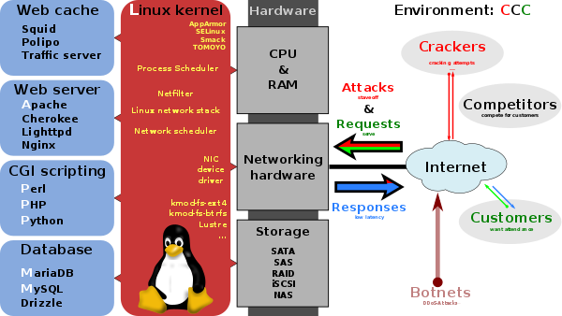](https://en.wikipedia.org/wiki/File:LAMP_software_bundle.svg)

[LAMP](https://en.wikipedia.org/wiki/LAMP_(software_bundle)) software bundle, displayed here together with [Squid](https://en.wikipedia.org/wiki/Squid_(software)).

Though MySQL began as a low-end alternative to more powerful proprietary databases, it has gradually evolved to support higher-scale needs as well. It is still most commonly used in small to medium scale single-server deployments, either as a component in a [LAMP](https://en.wikipedia.org/wiki/LAMP_(software_bundle))-based web application or as a standalone database server. Much of MySQL's appeal originates in its relative simplicity and ease of use, which is enabled by an ecosystem of open source tools such as [phpMyAdmin](https://en.wikipedia.org/wiki/PhpMyAdmin). In the medium range, MySQL can be scaled by deploying it on more powerful hardware, such as a multi-processor server with gigabytes of memory.

There are, however, limits to how far performance can scale on a single server ('scaling up'), so on larger scales, multi-server MySQL ('scaling out') deployments are required to provide improved performance and reliability. A typical high-end configuration can include a powerful master database which handles data write operations and is [replicated](https://en.wikipedia.org/wiki/Database_replication) to multiple slaves that handle all read operations. [The master server continually pushes binlog events to connected slaves so in the event of failure a slave can be promoted to become the new master, minimizing downtime. Further improvements in performance can be achieved by caching the results from database queries in memory using](https://en.wikipedia.org/wiki/MySQL#cite_note-97) [memcached](https://en.wikipedia.org/wiki/Memcached), or breaking down a database into smaller chunks called [shards](https://en.wikipedia.org/wiki/Shard_(database_architecture)) which can be spread across a number of distributed server clusters.

## User interfaces

### Graphical user interfaces

A [graphical user interface](https://en.wikipedia.org/wiki/Graphical_user_interface) (GUI) is a type of interface that allows users to interact with electronic devices or programs through graphical icons and visual indicators such as secondary notation, as opposed to text-based interfaces, typed command labels or text navigation. GUIs are easier to learn than command-line interfaces (CLIs), which require commands to be typed on the keyboard.

Third-party proprietary and free graphical administration applications (or "front ends") are available that integrate with MySQL and enable users to work with database structure and data visually. Some well-known front ends are:

[MySQL Workbench](https://en.wikipedia.org/wiki/MySQL_Workbench) running on macOS

**MySQL Workbench**

[MySQL Workbench](https://en.wikipedia.org/wiki/MySQL_Workbench) is the official integrated environment for MySQL. It was developed by MySQL AB, and enables users to graphically administer MySQL databases and visually design database structures. MySQL Workbench replaces the previous package of software, [MySQL GUI Tools](https://en.wikipedia.org/wiki/MySQL_GUI_Tools). Similar to other third-party packages, but still considered the authoritative MySQL front end, MySQL Workbench lets users manage database design & modeling, SQL development (replacing MySQL Query Browser) and Database administration (replacing MySQL Administrator).

MySQL Workbench is available in two editions, the regular [free and open source](https://en.wikipedia.org/wiki/Free_and_open_source_software) *Community Edition* which may be downloaded from the MySQL website, and the proprietary *Standard Edition* which extends and improves the feature set of the Community Edition.

**Adminer**

[Adminer](https://en.wikipedia.org/wiki/Adminer) (formerly known as phpMinAdmin) is a free MySQL front end for managing content in MySQL databases (since version 2, it also works on [PostgreSQL](https://en.wikipedia.org/wiki/PostgreSQL), [Microsoft SQL Server](https://en.wikipedia.org/wiki/Microsoft_SQL_Server), [SQLite](https://en.wikipedia.org/wiki/SQLite) and [Oracle](https://en.wikipedia.org/wiki/Oracle_Database) databases). Adminer is distributed under the [Apache License](https://en.wikipedia.org/wiki/Apache_License) (or GPL v2) in the form of a single PHP file (around 300 KiB in size), and is capable of managing multiple databases, with many [CSS](https://en.wikipedia.org/wiki/Cascading_Style_Sheets) skins available. Its author is Jakub Vrána who started to develop this tool as a light-weight alternative to phpMyAdmin, in July 2007.

**ClusterControl**

[ClusterControl](https://severalnines.com/product/clustercontrol) is an end-to-end MySQL management system GUI that provides the ability to deploy, monitor, manage and scale MySQL instances from a single interface. It is developed by Severalnines.

The Community version of ClusterControl is free to use and lets the user deploy and monitor their MySQL instances. Advanced features like load balancing, backup & restore, failover, etc are part of a paid offering.

**Database Workbench**

[Database Workbench](https://en.wikipedia.org/wiki/Database_Workbench) is a software application for development and administration of multiple relational databases using SQL, with interoperationality between different database systems, developed by Upscene Productions.

Because Databases Workbench supports multiple database systems, it can provide software developers with the same interface and development environment for these otherwise different database systems and also includes cross database tools.

Database Workbench supports the following relational databases: Oracle Database, Microsoft SQL Server, [SQL Anywhere](https://en.wikipedia.org/wiki/SQL_Anywhere), [Firebird](https://en.wikipedia.org/wiki/Firebird_(database_server)), [NexusDB](https://en.wikipedia.org/wiki/NexusDB), [InterBase](https://en.wikipedia.org/wiki/InterBase), MySQL and MariaDB. Database Workbench 5 runs on 32-bit or 64-bit Windows platforms. Under Linux, FreeBSD or macOS Database Workbench can operate using Wine.

**DBeaver**

[DBeaver](https://en.wikipedia.org/wiki/DBeaver) is an SQL client and a database administration tool. DBeaver includes extended support of following databases: MySQL and MariaDB, PostgreSQL, Oracle, [DB2](https://en.wikipedia.org/wiki/DB2) (LUW), [Exasol](https://en.wikipedia.org/wiki/Exasol), SQL Server, [Sybase](https://en.wikipedia.org/wiki/Sybase), Firebird, [Teradata](https://en.wikipedia.org/wiki/Teradata), [Vertica](https://en.wikipedia.org/wiki/Vertica), [Apache Phoenix](https://en.wikipedia.org/wiki/Apache_Phoenix), [Netezza](https://en.wikipedia.org/wiki/Netezza), [Informix](https://en.wikipedia.org/wiki/Informix), [Apache Derby](https://en.wikipedia.org/wiki/Apache_Derby), [H2](https://en.wikipedia.org/wiki/H2_(DBMS)), SQLite and any other database which has a [JDBC](https://en.wikipedia.org/wiki/JDBC) or [ODBC](https://en.wikipedia.org/wiki/ODBC) driver. DBeaver is free and open source software that is distributed under the Apache License 2.0. The source code is hosted on GitHub.

**DBEdit**

[DBEdit](https://en.wikipedia.org/wiki/DBEdit) is a database editor, which can connect to an Oracle, DB2, MySQL and any database that provides a JDBC driver. It runs on Windows, Linux and Solaris. DBEdit is free and open source software and distributed under the GNU General Public License. The source code is hosted on SourceForge.

**HeidiSQL**

[HeidiSQL](https://en.wikipedia.org/wiki/HeidiSQL), previously known as MySQL-Front, is a free and open source client, or frontend for MySQL (and for its forks like MariaDB and Percona Server), Microsoft SQL Server and PostgreSQL. HeidiSQL is developed by German programmer Ansgar Becker and a few other contributors in Delphi. To manage databases with HeidiSQL, users must login to a local or remote MySQL server with acceptable credentials, creating a session. Within this session users may manage MySQL Databases within the connected MySQL server, disconnecting from the server when done. Its feature set is sufficient for most common and advanced database, table and data record operations but remains in active development to move towards the full functionality expected in a MySQL Frontend.

**LibreOffice Base**

[LibreOffice](https://en.wikipedia.org/wiki/LibreOffice) Base allows the creation and management of databases, preparation of forms and reports that provide end users easy access to data. Like [Microsoft Access](https://en.wikipedia.org/wiki/Microsoft_Access), it can be used as a front-end for various database systems, including Access databases (JET), ODBC data sources, and MySQL or [PostgreSQL](https://en.wikipedia.org/wiki/PostgreSQL)

**Navicat**

[Navicat](https://en.wikipedia.org/wiki/Navicat) is a series of graphical database management and development software produced by PremiumSoft CyberTech Ltd. for MySQL, MariaDB, Oracle, SQLite, PostgreSQL and Microsoft SQL Server. It has an Explorer-like graphical user interface and supports multiple database connections for local and remote databases. Its design is made to meet the needs of a variety of audiences, from database administrators and programmers to various businesses/companies that serve clients and share information with partners.

Navicat is a cross-platform tool and works on Microsoft Windows, OS X and Linux platforms. Upon purchase, users are able to select a language for the software from eight available languages: English, French, German, Spanish, Japanese, Polish, Simplified Chinese and Traditional Chinese.

**OpenOffice.org**

[OpenOffice.org Base](https://en.wikipedia.org/wiki/OpenOffice.org_Base) is freely available and can manage MySQL databases if the entire suite is installed.

**phpMyAdmin**

[phpMyAdmin](https://en.wikipedia.org/wiki/PhpMyAdmin) is a free and open source tool written in PHP intended to handle the administration of MySQL with the use of a web browser. It can perform various tasks such as creating, modifying or deleting databases, tables, fields or rows; executing SQL statements; or managing users and permissions. The software, which is available in 78 languages,is maintained by *The phpMyAdmin Project*.

It can import data from CSV and SQL, and transform stored data into any format using a set of predefined functions, like displaying BLOB-data as images or download-links.

**Sequel Pro**

[Sequel Pro](https://en.wikipedia.org/w/index.php?title=Sequel_Pro&action=edit&redlink=1) is a free and open-source MacOS application for working with MySQL databases locally or remotely. It uses the freemium model, where the Gratis users are actually getting features to most of the basic services. It takes a SQL Table itself to manage these requests. It can handle the new "fun" UTF-8 features for newer unicode as well as having multiple GB tables without issue.

**SQLBuddy**

[SQLBuddy](https://en.wikipedia.org/wiki/SQLBuddy) is an open-source web-based application written in PHP intended to handle the administration of MySQL and SQLite with the use of a Web browser. The project places an emphasis on ease of installation and a simple user interface.

**SQLyog**

[SQLyog](https://en.wikipedia.org/wiki/SQLyog) is a GUI tool available in free as well as paid versions. Data manipulations (e.g., insert, update, and delete) may be done from a spreadsheet-like interface. Its editor has [syntax highlighting](https://en.wikipedia.org/wiki/Syntax_highlighting) and various automatic formatting options. Both raw table data and a result set from a query can be manipulated. Its data search feature uses Google-like search syntax and translates to SQL transparently for the user. It has a backup tool for performing unattended backups. Backups may be compressed and optionally stored as a file-per-table as well as identified with a timestamp.

**Toad for MySQL**

[Toad for MySQL](https://en.wikipedia.org/wiki/TOAD_(software)) is a software application from [Dell Software](https://en.wikipedia.org/wiki/Dell_Software) that database developers, database administrators and data analysts use to manage both relational and non-relational databases using SQL. Toad supports many databases and environments. It runs on all 32-bit/64-bit Windows platforms, including Microsoft Windows Server, Windows XP, Windows Vista, Windows 7 and 8 (32-Bit or 64-Bit). Dell Software has also released a Toad Mac Edition. Dell provides Toad in commercial and trial/freeware versions. The freeware version is available from the ToadWorld.com community.

**Webmin**

[Webmin](https://en.wikipedia.org/wiki/Webmin) is a web-based system configuration tool for Unix-like systems, although recent versions can also be installed and run on Windows. With it, it is possible to configure operating system internals, such as users, disk quotas, services or configuration files, as well as modify and control open source apps, such as the Apache HTTP Server, PHP or MySQL.

Webmin is largely based on Perl, running as its own process and web server. It defaults to TCP port 10000 for communicating, and can be configured to use [SSL](https://en.wikipedia.org/wiki/Transport_Layer_Security) if [OpenSSL](https://en.wikipedia.org/wiki/OpenSSL) is installed with additional required [Perl modules](https://en.wikipedia.org/wiki/Perl_module).

It is built around modules, which have an interface to the configuration files and the Webmin server. This makes it easy to add new functionality. Due to Webmin's modular design, it is possible for anyone who is interested to write plugins for desktop configuration.

Webmin also allows for controlling many machines through a single interface, or seamless login on other webmin hosts on the same subnet or LAN.

### Command-line interfaces

A [command-line interface](https://en.wikipedia.org/wiki/Command-line_interface) is a means of interacting with a computer program where the user issues commands to the program by typing in successive lines of text (command lines). MySQL ships with many [command line](https://en.wikipedia.org/wiki/Command_line) tools, from which the main interface is the mysql client.

MySQL Utilities is a set of utilities designed to perform common maintenance and administrative tasks. Originally included as part of the MySQL Workbench, the utilities are a stand-alone download available from Oracle.

Percona Toolkit is a cross-platform toolkit for MySQL, developed in [Perl](https://en.wikipedia.org/wiki/Perl).

Percona Toolkit can be used to prove replication is working correctly, fix corrupted data, automate repetitive tasks, and speed up servers. Percona Toolkit is included with several [Linux](https://en.wikipedia.org/wiki/Linux) distributions such as [CentOS](https://en.wikipedia.org/wiki/CentOS) and [Debian](https://en.wikipedia.org/wiki/Debian), and packages are available for [Fedora](https://en.wikipedia.org/wiki/Fedora_(operating_system)) and [Ubuntu](https://en.wikipedia.org/wiki/Ubuntu_(operating_system)) as well. Percona Toolkit was originally developed as Maatkit, but as of late 2011, Maatkit is no longer developed.

MySQL shell is a tool for interactive use and administration of the MySQL database. It supports JavaScript, Python or SQL modes and it can be used for administration and access purposes.

**4.2 Frontend**

**4.2.1 Thymeleaf**

**Thymeleaf** is a [Java](https://en.wikipedia.org/wiki/Java_(programming_language)) [XML](https://en.wikipedia.org/wiki/XML)/[XHTML](https://en.wikipedia.org/wiki/XHTML)/[HTML5](https://en.wikipedia.org/wiki/HTML5) [template engine](https://en.wikipedia.org/wiki/Template_engine_(web)) that can work both in web ([servlet](https://en.wikipedia.org/wiki/Servlet)-based) and non-web environments. It is better suited for serving XHTML/HTML5 at the view layer of [MVC](https://en.wikipedia.org/wiki/Model–view–controller)-based web applications, but it can process any XML file even in offline environments. It provides full [Spring Framework](https://en.wikipedia.org/wiki/Spring_Framework) integration.

In web applications Thymeleaf aims to be a complete substitute for [JavaServer Pages](https://en.wikipedia.org/wiki/JavaServer_Pages) (JSP), and implements the concept of *Natural Templates*: template files that can be directly opened in browsers and that still display correctly as web pages.

Thymeleaf is [Open-Source Software](https://en.wikipedia.org/wiki/Open_source_software), licensed under the [Apache License 2.0](https://en.wikipedia.org/wiki/Apache_License_2.0)

## Features

From the project's website:

* Java [template engine](https://en.wikipedia.org/wiki/Template_engine_(web)) for [XML](https://en.wikipedia.org/wiki/XML), [XHTML](https://en.wikipedia.org/wiki/XHTML) and [HTML5](https://en.wikipedia.org/wiki/HTML5).
* Works both in web and non-web (offline) environments. No hard dependency on the [Servlet](https://en.wikipedia.org/wiki/Servlet) API.
* Based on modular feature sets called *dialects*.
  + Dialect features (e.g.: evaluation, iteration, etc.) are applied by linking them to template's tags and/or attributes.
  + Two dialects available out-of-the-box: Standard and SpringStandard (for [Spring MVC](https://en.wikipedia.org/wiki/Spring_MVC) apps, same syntax as Standard).
  + Developers can extend and create custom dialects.
* Several template modes:
  + [**XML**](https://en.wikipedia.org/wiki/XML): validating against a [DTD](https://en.wikipedia.org/wiki/Document_Type_Definition) or not.
  + [**XHTML**](https://en.wikipedia.org/wiki/XHTML) **1.0 and 1.1**: validating against standard [DTDs](https://en.wikipedia.org/wiki/Document_Type_Definition) or not.
  + [**HTML5**](https://en.wikipedia.org/wiki/HTML5): both XML-formed code and legacy-based HTML5. Legacy non-XML code will be automatically cleaned and converted to [XML](https://en.wikipedia.org/wiki/XML) form.
* Full (and extensible) **internationalization** support.
* Configurable, high performance **parsed template cache** that reduces input/output to the minimum.
* Automatic DOCTYPE translations –from template [DTD](https://en.wikipedia.org/wiki/Document_Type_Definition) to result DTD– for (optional) validation of both template and result code.
* Extremely extensible: can be used as a template engine framework if needed.
* Complete documentation including several example applications.

**Thymeleaf** is a modern server-side Java template engine for both web and standalone environments.

Thymeleaf's main goal is to bring elegant natural templates to your development workflow — HTML that can be correctly displayed in browsers and also work as static prototypes, allowing for stronger collaboration in development teams.

With modules for Spring Framework, a host of integrations with your favourite tools, and the ability to plug in your own functionality, Thymeleaf is ideal for modern-day HTML5 JVM web development — although there is much more it can do.

The **Thymeleaf ecosystem** is composed of tools and extensions of two types:

* Official extensions (a.k.a. Thymeleaf Extras): created by the [Thymeleaf Team](https://www.thymeleaf.org/team.html) and supported as a part of the project.
* Unofficial or Community extensions: linked from this page but developed and maintained by Thymeleaf users outside of the Thymeleaf Project and distributed under their own license and support terms.

The Thymeleaf Testing library allows developers to create automated tests for Thymeleaf applications and extensions in a very easy and declarative way. Among its features:

* Works as an independent library, **callable from multiple testing frameworks** like e.g. JUnit.
* **Tests only the view layer**: template processing and its result.
* Allows specifying test input as markup fragments and also as links to the template files of a Thymeleaf-based application being developed, in order to **easily test its view layer**.
* Versatile testing artifacts: test sequences, iteration, concurrent execution...
* **Spring Framework** and **Spring Security** integration.

### *Thymeleaf Eclipse Plugin*

The Thymeleaf plugin for Eclipse IDE adds **content assist** features that make working in Thymeleaf templates nicer and much more comfortable.

* Code completion of **Thymeleaf attribute processors**.
* Detailed explanations for each attribute.
* Content assist inside expressions: **expression utility objects**.

### *Thymeleaf + Apache Tiles 2*

The Thymeleaf Extras Tiles 2 library provides a dialect that allows using Apache Tiles 2 as the layout method of Thymeleaf-based applications. Features:

* Use **Thymeleaf templates in Tiles definitions**.
* Use Thymeleaf template fragments in layout definitions, **natural templates** possible with Tiles!
* **Mix JSP and Thymeleaf** templates in the same layout if required.
* Optional **Spring MVC 3** and **Spring Web Flow 2.3** integrations.

### *Thymeleaf + Spring Security*

The Thymeleaf Extras Spring Security library provides a dialect that allows integrating several authorization and authentication aspects of Spring Security (versions 3.x, 4.x and 5.x) into Thymeleaf-based applications. Features:

* **Thymeleaf-based equivalent to the Spring Security JSP tag library**.
* Adds new expression utility objects like **#authentication** and **#authorization** for **integrating Spring Security capabilities into Thymeleaf expressions**.
* Adds new attributes like **sec:authentication** and **sec:authorized** for easier configuration of security.

With this library, role-based access restrictions defined in Spring Security can be easily used:

**Thymeleaf 3.0.11.RELEASE is the current stable version. It requires Java SE 6 or newer.**

**4.2.2 JavaScript**

**JavaScript**, [often abbreviated as](https://en.wikipedia.org/wiki/JavaScript#cite_note-6) **JS**, is a [programming language](https://en.wikipedia.org/wiki/Programming_language) that conforms to the [ECMAScript](https://en.wikipedia.org/wiki/ECMAScript) specification. JavaScript is [high-level](https://en.wikipedia.org/wiki/High-level_programming_language), often [just-in-time compiled](https://en.wikipedia.org/wiki/Just-in-time_compilation), and [multi-paradigm](https://en.wikipedia.org/wiki/Programming_paradigm). It has [curly-bracket syntax](../type), [dynamic typing](https://en.wikipedia.org/wiki/Dynamic_typing), [prototype-based](https://en.wikipedia.org/wiki/Prototype-based_programming) [object-orientation](https://en.wikipedia.org/wiki/Object-oriented_programming), and [first-class functions](https://en.wikipedia.org/wiki/First-class_function).

Alongside [HTML](https://en.wikipedia.org/wiki/HTML) and [CSS](https://en.wikipedia.org/wiki/CSS), JavaScript is one of the core technologies of the [World Wide Web](https://en.wikipedia.org/wiki/World_Wide_Web). [JavaScript enables interactive](https://en.wikipedia.org/wiki/JavaScript#cite_note-8) [web pages](https://en.wikipedia.org/wiki/Web_page) and is an essential part of [web applications](https://en.wikipedia.org/wiki/Web_application). The vast majority of [websites](https://en.wikipedia.org/wiki/Website) use it for [client-side](https://en.wikipedia.org/wiki/Client-side) page behavior, and all major [web browsers](https://en.wikipedia.org/wiki/Web_browser) have a dedicated [JavaScript engine](https://en.wikipedia.org/wiki/JavaScript_engine) to execute it.

As a multi-paradigm language, JavaScript supports [event-driven](https://en.wikipedia.org/wiki/Event-driven_programming), [functional](https://en.wikipedia.org/wiki/Functional_programming), and [imperative](https://en.wikipedia.org/wiki/Imperative_programming) [programming styles](https://en.wikipedia.org/wiki/Programming_paradigm). It has [application programming interfaces](https://en.wikipedia.org/wiki/Application_programming_interface) (APIs) for working with text, dates, [regular expressions](https://en.wikipedia.org/wiki/Regular_expression), standard [data structures](https://en.wikipedia.org/wiki/Data_structure), and the [Document Object Model](https://en.wikipedia.org/wiki/Document_Object_Model) (DOM). However, the language itself does not include any [input/output](https://en.wikipedia.org/wiki/Input/output) (I/O), such as [networking](https://en.wikipedia.org/wiki/Computer_network), [storage](https://en.wikipedia.org/wiki/Data_storage), or [graphics](https://en.wikipedia.org/wiki/Computer_graphics) facilities, as the host environment (usually a web browser) provides those APIs.

JavaScript engines were originally used only in web browsers, but they are now embedded in [server-side](https://en.wikipedia.org/wiki/Server-side) website deployments, usually via [Node.js](https://en.wikipedia.org/wiki/Node.js). They are also embedded in a variety of applications created with [frameworks](https://en.wikipedia.org/wiki/Software_framework) such as [Electron](https://en.wikipedia.org/wiki/Electron_(software_framework)) and [Cordova](https://en.wikipedia.org/wiki/Apache_Cordova).

Although there are similarities between JavaScript and [Java](https://en.wikipedia.org/wiki/Java_(programming_language)), including language name, [syntax](https://en.wikipedia.org/wiki/Syntax_(programming_languages)), and respective [standard libraries](https://en.wikipedia.org/wiki/Standard_library), the two languages are distinct and differ greatly in design.

History

### Creation at Netscape

The [Mosaic](https://en.wikipedia.org/wiki/Mosaic_(web_browser)) [web browser](https://en.wikipedia.org/wiki/Web_browser) was released in 1993. As the first browser with a [graphical user interface](https://en.wikipedia.org/wiki/Graphical_user_interface) accessible to non-technical people, it played a prominent role in the rapid growth of the nascent [World Wide Web](https://en.wikipedia.org/wiki/World_Wide_Web). [The lead developers of Mosaic then founded the](https://en.wikipedia.org/wiki/JavaScript#cite_note-10) [Netscape](https://en.wikipedia.org/wiki/Netscape) corporation, which released a more polished browser, [Netscape Navigator](https://en.wikipedia.org/wiki/Netscape_Navigator), in 1994. Navigator quickly became the most used browser.

During these formative years of the Web, [web pages](https://en.wikipedia.org/wiki/Web_page) could only be static, lacking the capability for dynamic behavior after the page was loaded in the browser. There was a desire in the burgeoning web development scene to remove this limitation, so in 1995, Netscape decided to add a [scripting language](https://en.wikipedia.org/wiki/Scripting_language) to Navigator. They pursued two routes to achieve this: collaborating with [Sun Microsystems](https://en.wikipedia.org/wiki/Sun_Microsystems) to embed the [Java](https://en.wikipedia.org/wiki/Java_(programming_language)) [programming language](https://en.wikipedia.org/wiki/Programming_language), while also hiring [Brendan Eich](https://en.wikipedia.org/wiki/Brendan_Eich) to embed the [Scheme](https://en.wikipedia.org/wiki/Scheme_(programming_language)) [language.](https://en.wikipedia.org/wiki/JavaScript#cite_note-origin-12)

Netscape management soon decided that the best option was for Eich to devise a new language, with syntax similar to Java and less like Scheme or other extant scripting languages. Although the new language and its [interpreter](https://en.wikipedia.org/wiki/Interpreter_(computing)) implementation were officially called LiveScript when first shipped as part of a Navigator release in September 1995, the name was changed to JavaScript three months later.

The choice of the JavaScript name has caused confusion, sometimes giving the impression that it is a spin-off of Java. Since Java was the hot new programming language at the time, this has been characterized as a marketing ploy by Netscape to give its own new language cachet

### Adoption by Microsoft

[Microsoft](https://en.wikipedia.org/wiki/Microsoft) debuted [Internet Explorer](https://en.wikipedia.org/wiki/Internet_Explorer) in 1995, leading to a [browser war](https://en.wikipedia.org/wiki/Browser_war) with Netscape. On the JavaScript front, Microsoft [reverse-engineered](../engineering) the Navigator [interpreter](https://en.wikipedia.org/wiki/Interpreter_(computing)) to create its own, called [JScript](https://en.wikipedia.org/wiki/JScript).

JScript was first released in 1996, alongside initial support for [CSS](https://en.wikipedia.org/wiki/CSS) and extensions to [HTML](https://en.wikipedia.org/wiki/HTML). Each of these implementations was noticeably different from their counterparts in Navigator. These differences made it difficult for developers to make their websites work well in both browsers, leading to widespread use of "best viewed in Netscape" and "best viewed in Internet Explorer" logos for several years.

### The rise of JScript

In November 1996, [Netscape](https://en.wikipedia.org/wiki/Netscape) submitted JavaScript to [ECMA International](https://en.wikipedia.org/wiki/Ecma_International), as the starting point for a standard specification that all browser vendors could conform to. This led to the official release of the first [ECMAScript](https://en.wikipedia.org/wiki/ECMAScript) language specification in June 1997.

The standards process continued for a few years, with the release of ECMAScript 2 in June 1998 and ECMAScript 3 in December 1999. Work on ECMAScript 4 began in 2000.

Meanwhile, [Microsoft](https://en.wikipedia.org/wiki/Microsoft) gained an increasingly dominant position in the browser market. By the early 2000s, Internet Explorer's market share reached 95%. This meant that [JScript](https://en.wikipedia.org/wiki/JScript) became the de facto standard for [client-side scripting](https://en.wikipedia.org/wiki/Client-side_scripting) on the Web.

Microsoft initially participated in the standards process and implemented some proposals in its JScript language, but eventually it stopped collaborating on ECMA work. Thus ECMAScript 4 was mothballed.

### Growth and standardization

During the period of [Internet Explorer](https://en.wikipedia.org/wiki/Internet_Explorer) dominance in the early 2000s, client-side scripting was stagnant. This started to change in 2004, when the successor of Netscape, [Mozilla](https://en.wikipedia.org/wiki/Mozilla), released the [Firefox](https://en.wikipedia.org/wiki/Firefox) browser. Firefox was well-received by many, taking significant market share from Internet Explorer.

In 2005, Mozilla joined ECMA International, and work started on the [ECMAScript for XML](https://en.wikipedia.org/wiki/ECMAScript_for_XML) (E4X) standard. This led to Mozilla working jointly with [Macromedia](https://en.wikipedia.org/wiki/Macromedia) (later acquired by [Adobe Systems](https://en.wikipedia.org/wiki/Adobe_Systems)), who were implementing E4X in their ActionScript 3 language, which was based on an ECMAScript 4 draft. The goal became standardizing ActionScript 3 as the new ECMAScript 4. To this end, Adobe Systems released the [Tamarin](https://en.wikipedia.org/wiki/Tamarin_(software)) implementation as an [open source](https://en.wikipedia.org/wiki/Open-source_model) project. However, Tamarin and ActionScript 3 were too different from established client-side scripting, and without cooperation from [Microsoft](https://en.wikipedia.org/wiki/Microsoft), ECMAScript 4 never reached fruition.

Meanwhile, very important developments were occurring in open source communities not affiliated with ECMA work. In 2005, [Jesse James Garrett](https://en.wikipedia.org/wiki/Jesse_James_Garrett) released a white paper in which he coined the term [Ajax](https://en.wikipedia.org/wiki/Ajax_(programming)) and described a set of technologies, of which JavaScript was the backbone, to create [web applications](https://en.wikipedia.org/wiki/Web_application) where data can be loaded in the background, avoiding the need for full page reloads. This sparked a renaissance period of JavaScript, spearheaded by open source libraries and the communities that formed around them. Many new libraries were created, including [jQuery](https://en.wikipedia.org/wiki/JQuery), [Prototype](https://en.wikipedia.org/wiki/Prototype_JavaScript_Framework), [Dojo Toolkit](https://en.wikipedia.org/wiki/Dojo_Toolkit), and [MooTools](https://en.wikipedia.org/wiki/MooTools).

[Google](https://en.wikipedia.org/wiki/Google) debuted its [Chrome](https://en.wikipedia.org/wiki/Google_Chrome) browser in 2008, with the [V8](https://en.wikipedia.org/wiki/V8_(JavaScript_engine)) JavaScript engine that was the first to use [just-in-time compilation](https://en.wikipedia.org/wiki/Just-in-time_compilation), significantly improving execution times.

Other browser vendors needed to overhaul their engines to compete.

In July 2008, these disparate parties came together for a conference in [Oslo](https://en.wikipedia.org/wiki/Oslo). This led to the eventual agreement in early 2009 to combine all relevant work and drive the language forward. The result was the ECMAScript 5 standard, released in December 2009.

### Reaching maturity

Ambitious work on the language continued for several years, culminating in an extensive collection of additions and refinements being formalized with the publication of [ECMAScript](https://en.wikipedia.org/wiki/ECMAScript) 6 in 2015.

From 2016 to 2019, a new version of the ECMAScript standard was published each year, but the scope of changes was much smaller than the 5th or 6th editions. Thus JavaScript can now be considered a mature language that has largely settled down.

The current JavaScript ecosystem has many [libraries and frameworks](https://en.wikipedia.org/wiki/List_of_JavaScript_libraries), established programming practices, and increased usage of JavaScript outside of web browsers. Plus, with the rise of [single-page applications](https://en.wikipedia.org/wiki/Single-page_application) and other JavaScript-heavy websites, a number of [transpilers](https://en.wikipedia.org/wiki/Source-to-source_compiler) have been created to aid the development process.

JavaScript is a script-based programming language that was developed by Netscape Communication Corporation. JavaScript was originally called Live Script and renamed as JavaScript to indicate its relationship with Java. JavaScript supports the development of both client and server components of Web-based applications. On the client side, it can be used to write programs that are executed by a Web browser within the context of a Web page. On the server side, it can be used to write Web server programs that can process information submitted by a Web browser and then update the browser’s display accordingly.Even though JavaScript supports both client and server Web programming, we prefer JavaScript at Client side programming since most of the browsers supports it. JavaScript is almost as easy to learn as HTML, and JavaScript statements can be included in HTML documents by enclosing the statements between a pair of scripting tags

<SCRIPTS>.. </SCRIPT>.

<SCRIPT LANGUAGE = “JavaScript”>

JavaScript statements

</SCRIPT>

Here are a few things we can do with JavaScript:

* Validate the contents of a form and make calculations.
* Add scrolling or changing messages to the Browser’s status line.
* Animate images or rotate images that change when we move the mouse over them.
* Detect the browser in use and display different content for different browsers.
* Detect installed plug-ins and notify the user if a plug-in is required.

We can do much more with JavaScript, including creating entire application.

Features

### Imperative and structured

JavaScript supports much of the [structured programming](https://en.wikipedia.org/wiki/Structured_programming) syntax from [C](https://en.wikipedia.org/wiki/C_(computer_language)) (e.g., if statements, while loops, switch statements, do while loops, etc.). One partial exception is [scoping](https://en.wikipedia.org/wiki/Scope_(computer_science)): JavaScript originally had only [function scoping](https://en.wikipedia.org/wiki/Function_scoping) with var. ECMAScript 2015 added keywords let and const for block scoping, meaning JavaScript now has both function and block scoping. Like C, JavaScript makes a distinction between [expressions](https://en.wikipedia.org/wiki/Expression_(computer_science)) and [statements](https://en.wikipedia.org/wiki/Statement_(computer_science)). One syntactic difference from C is [automatic semicolon insertion](https://en.wikipedia.org/wiki/Defensive_semicolon), which allows the semicolons that would normally terminate statements to be omitted.

### Weakly typed

JavaScript is [weakly typed](https://en.wikipedia.org/wiki/Strong_and_weak_typing), which means certain types are implicitly cast depending on the operation used. JavaScript has received criticism for the way it implements these conversions as well as the inconsistency between them. For example, when adding a number to a string, the number will be cast to a string before performing concatenation, but when subtracting a number from a string, the string is cast to a number before performing subtraction.

### Dynamic Typing

JavaScript is [dynamically typed](https://en.wikipedia.org/wiki/Dynamic_typing) like most other [scripting languages](https://en.wikipedia.org/wiki/Scripting_language). A [type](https://en.wikipedia.org/wiki/Type_system) is associated with a [value](https://en.wikipedia.org/wiki/Value_(computer_science)) rather than an expression. For example, a [variable](https://en.wikipedia.org/wiki/Variable_(programming)) initially bound to a number may be reassigned to a [string](https://en.wikipedia.org/wiki/String_(computer_science)). [JavaScript supports various ways to test the type of objects, including](https://en.wikipedia.org/wiki/JavaScript#cite_note-36) [duck typing](https://en.wikipedia.org/wiki/Duck_typing).

**Run-time evaluation**

JavaScript includes an [eval](https://en.wikipedia.org/wiki/Eval) function that can execute statements provided as strings at run-time.

### Object-orientation (prototype-based)

Prototypal inheritance in JavaScript is described by [Douglas Crockford](https://en.wikipedia.org/wiki/Douglas_Crockford) as:

You make prototype objects, and then … make new instances. Objects are mutable in JavaScript, so we can augment the new instances, giving them new fields and methods. These can then act as prototypes for even newer objects. We don't need classes to make lots of similar objects… Objects inherit from objects. What could be more object oriented than that?

In JavaScript, an [object](https://en.wikipedia.org/wiki/Object_(computer_science)) is an [associative array](https://en.wikipedia.org/wiki/Associative_array), augmented with a prototype (see below); each string key provides the name for an object property, and there are two syntactical ways to specify such a name: dot notation (obj.x = 10) and bracket notation (obj['x'] = 10). A property may be added, rebound, or deleted at run-time. Most properties of an object (and any property that belongs to an object's prototype inheritance chain) can be enumerated using a for in loop.

JavaScript has a small number of built-in objects, including Function and Date.

**Prototypes**

JavaScript uses [prototypes](https://en.wikipedia.org/wiki/Prototype-based_programming) where many other object-oriented languages use [classes](https://en.wikipedia.org/wiki/Class_(computer_science)) for [inheritance](https://en.wikipedia.org/wiki/Inheritance_(computer_science)). [It is possible to simulate many class-based features with prototypes in JavaScript.](https://en.wikipedia.org/wiki/JavaScript#cite_note-39)

**Functions as object constructors**

Functions double as object constructors, along with their typical role. Prefixing a function call with *new* will create an instance of a prototype, inheriting properties and methods from the constructor (including properties from the Object prototype).

ECMAScript 5 offers the Object.create method, allowing explicit creation of an instance without automatically inheriting from the Object prototype (older environments can assign the prototype to null). The constructor's prototype property determines the object used for the new object's internal prototype. New methods can be added by modifying the prototype of the function used as a constructor. JavaScript's built-in constructors, such as Array or Object, also have prototypes that can be modified. While it is possible to modify the Object prototype, it is generally considered bad practice because most objects in JavaScript will inherit methods and properties from the Object prototype, and they may not expect the prototype to be modified.

**Functions as methods**

Unlike many object-oriented languages, there is no distinction between a function definition and a [method](https://en.wikipedia.org/wiki/Method_(computer_science)) definition. Rather, the distinction occurs during function calling; when a function is called as a method of an object, the function's local *this* keyword is bound to that object for that invocation.

### Functional

A [function](https://en.wikipedia.org/wiki/Subroutine) is [first-class](https://en.wikipedia.org/wiki/First-class_function); a function is considered to be an object. As such, a function may have properties and methods, such as .call() and .bind().A *nested* function is a function defined within another function. It is created each time the outer function is invoked. In addition, each nested function forms a [lexical closure](https://en.wikipedia.org/wiki/Closure_(computer_programming)): The [lexical scope](../(programming)) of the outer function (including any constant, local variable, or argument value) becomes part of the internal state of each inner function object, even after execution of the outer function concludes. JavaScript also supports [anonymous functions](https://en.wikipedia.org/wiki/Anonymous_function).

### Delegative

JavaScript supports implicit and explicit [delegation](https://en.wikipedia.org/wiki/Delegation_(object-oriented_programming)).

**Functions as roles (Traits and Mixins)**

JavaScript natively supports various function-based implementations of [Role](https://en.wikipedia.org/wiki/Role-oriented_programming)patterns like [Traits](https://en.wikipedia.org/wiki/Traits_(computer_science)) and [Mixins](https://en.wikipedia.org/wiki/Mixin). [Such a function defines additional behavior by at least one method bound to the](https://en.wikipedia.org/wiki/JavaScript#cite_note-49) this keyword within its function body. A Role then has to be delegated explicitly via call or apply to objects that need to feature additional behavior that is not shared via the prototype chain.

**Object composition and inheritance**

Whereas explicit function-based delegation does cover [composition](https://en.wikipedia.org/wiki/Object_composition) in JavaScript, implicit delegation already happens every time the prototype chain is walked in order to, e.g., find a method that might be related to but is not directly owned by an object. Once the method is found it gets called within this object's context. Thus [inheritance](https://en.wikipedia.org/wiki/Inheritance_(computer_science)) in JavaScript is covered by a delegation automatism that is bound to the prototype property of constructor functions.

### Miscellaneous Run-time environment

JavaScript typically relies on a run-time environment (e.g., a [Web browser](https://en.wikipedia.org/wiki/Web_browser)) to provide objects and methods by which scripts can interact with the environment (e.g., a webpage [DOM](https://en.wikipedia.org/wiki/Document_Object_Model)). It also relies on the run-time environment to provide the ability to include/import scripts (e.g., [HTML](https://en.wikipedia.org/wiki/HTML) <script> elements). This is not a language feature per se, but it is common in most JavaScript implementations. JavaScript processes [messages](https://en.wikipedia.org/wiki/Message_(computer_science)) from a [queue](https://en.wikipedia.org/wiki/Queue_(abstract_data_type)) one at a time. JavaScript calls a [function](https://en.wikipedia.org/wiki/Subroutine) associated with each new message, creating a [call stack](https://en.wikipedia.org/wiki/Call_stack) frame with the function's [arguments](https://en.wikipedia.org/wiki/Parameter_(computer_programming)) and [local variables](https://en.wikipedia.org/wiki/Local_variable). The call stack shrinks and grows based on the function's needs. When the call stack is empty upon function completion, JavaScript proceeds to the next message in the queue. This is called the [event loop](https://en.wikipedia.org/wiki/Event_loop), described as "run to completion" because each message is fully processed before the next message is considered. However, the language's [concurrency model](https://en.wikipedia.org/wiki/Concurrency_(computer_science)) describes the event loop as [non-blocking](https://en.wikipedia.org/wiki/Asynchronous_I/O): program [input/output](https://en.wikipedia.org/wiki/Input/output) is performed using [events](https://en.wikipedia.org/wiki/Event_(computing)) and [callback functions](https://en.wikipedia.org/wiki/Callback_(computer_programming)). This means, for instance, that JavaScript can process a mouse click while waiting for a database query to return information.

**Variadic functions**

An indefinite number of parameters can be passed to a function. The function can access them through [formal parameters](https://en.wikipedia.org/wiki/Formal_parameter) and also through the local arguments object. [Variadic functions](https://en.wikipedia.org/wiki/Variadic_functions) can also be created by using the [bind](https://developer.mozilla.org/en-US/docs/Web/JavaScript/Reference/Global_Objects/Function/bind) method.

**Array and object literals**

Like many scripting languages, arrays and objects ([associative arrays](https://en.wikipedia.org/wiki/Associative_arrays) in other languages) can each be created with a succinct shortcut syntax. In fact, these [literals](https://en.wikipedia.org/wiki/Object_literal) form the basis of the [JSON](https://en.wikipedia.org/wiki/JSON) data format.

**Regular expressions**

JavaScript also supports [regular expressions](https://en.wikipedia.org/wiki/Regular_expression) in a manner similar to [Perl](https://en.wikipedia.org/wiki/Perl), which provide a concise and powerful syntax for text manipulation that is more sophisticated than the built-in string functions.

**Promises**

JavaScript also supports promises which is its way of handling asynchronous operations. There's a built-in Promise object that gives access to a lot of functionalities for handling promises and defines how they should be handled. It allows you to associate handlers with an asynchronous action's eventual success value or failure reason. This lets asynchronous methods return values like synchronous methods: instead of immediately returning the final value, the asynchronous method returns a promise to supply the value at some point in the future. Recently, combinator methods were introduced in the JavaScript specification which allows developers to combine multiple JavaScript promises and do operations on the basis of different scenarios. The methods introduced are: Promise.race, Promise.all, Promise.allSettled and Promise.any.

### Vendor-specific extensions

Historically, some [JavaScript engines](https://en.wikipedia.org/wiki/JavaScript_engine) supported these non-standard features: conditional catch clauses (like Java)

* [array comprehensions](https://en.wikipedia.org/wiki/List_comprehension) and generator expressions (like Python)
* concise function expressions (function(args) expr; this experimental syntax predated arrow functions)
* [ECMAScript for XML](https://en.wikipedia.org/wiki/ECMAScript_for_XML) (E4X), an extension that adds native XML support to ECMAScript (unsupported in Firefox since version 21[)](https://en.wikipedia.org/wiki/JavaScript#cite_note-52)

**4.2.3 CSS**

**Cascading Style Sheets** (**CSS**) is Stylesheet language used to describe the presentation of a document written in HTML or XML (including XML dialects such as SVG, MathML or XHTML). CSS describes how elements should be rendered on screen, on paper, in speech, or on other media.

CSS is one of the core languages of the **open Web** and is standardized across Web browsers according to the W3C specification. Developed in levels, CSS1 is now obsolete, CSS2.1 is a recommendation, and CSS3, now split into smaller modules, is progressing on the standardization track.

**Cascading Style Sheets** (**CSS**) is a [style sheet language](https://en.wikipedia.org/wiki/Style_sheet_language) used for describing the [presentation](https://en.wikipedia.org/wiki/Presentation_semantics) of a document written in a [markup language](https://en.wikipedia.org/wiki/Markup_language) like [HTML](https://en.wikipedia.org/wiki/HTML). [CSS is a cornerstone technology of the](https://en.wikipedia.org/wiki/Cascading_Style_Sheets#cite_note-1) [World Wide Web](https://en.wikipedia.org/wiki/World_Wide_Web), alongside HTML and [JavaScript](https://en.wikipedia.org/wiki/JavaScript).

CSS is designed to enable the separation of presentation and content, including [layout](https://en.wikipedia.org/wiki/Page_layout), [colors](https://en.wikipedia.org/wiki/Color), and [fonts](https://en.wikipedia.org/wiki/Typeface).This separation can improve content [accessibility](https://en.wikipedia.org/wiki/Accessibility), provide more flexibility and control in the specification of presentation characteristics, enable multiple [web pages](https://en.wikipedia.org/wiki/Web_page) to share formatting by specifying the relevant CSS in a separate .css file, and reduce complexity and repetition in the structural content.

Separation of formatting and content also makes it feasible to present the same markup page in different styles for different rendering methods, such as on-screen, in print, by voice (via speech-based browser or [screen reader](https://en.wikipedia.org/wiki/Screen_reader)), and on [Braille-based](https://en.wikipedia.org/wiki/Braille_display) tactile devices. CSS also has rules for alternate formatting if the content is accessed on a [mobile device](https://en.wikipedia.org/wiki/Mobile_device).

The name *cascading* comes from the specified priority scheme to determine which style rule applies if more than one rule matches a particular element. This cascading priority scheme is predictable.

The CSS specifications are maintained by the [World Wide Web Consortium](https://en.wikipedia.org/wiki/World_Wide_Web_Consortium) (W3C). Internet media type ([MIME type](https://en.wikipedia.org/wiki/MIME_media_type)) text/css is registered for use with CSS by [RFC 2318](https://tools.ietf.org/html/rfc2318) (March 1998). The W3C operates a free [CSS validation service](../Service) for CSS documents.

In addition to HTML, otr markup languages support the use of CSS including [XHTML](https://en.wikipedia.org/wiki/XHTML), [plain XML](https://en.wikipedia.org/wiki/Plain_Old_XML), [SVG](https://en.wikipedia.org/wiki/Scalable_Vector_Graphics), and [XUL](https://en.wikipedia.org/wiki/XUL).

## History

[Håkon Wium Lie](https://en.wikipedia.org/wiki/Håkon_Wium_Lie), chief technical officer of the Opera Software company and co-creator of the CSS web standards

CSS was first proposed by [Håkon Wium Lie](https://en.wikipedia.org/wiki/Håkon_Wium_Lie) on October 10, 1994. [At the time, Lie was working with](https://en.wikipedia.org/wiki/Cascading_Style_Sheets#cite_note-chss-proposal-21) [Tim Berners-Lee](https://en.wikipedia.org/wiki/Tim_Berners-Lee) at [CERN](https://en.wikipedia.org/wiki/CERN). Several other style sheet languages for the web were proposed around the same time, and discussions on public mailing lists and inside [World Wide Web Consortium](https://en.wikipedia.org/wiki/World_Wide_Web_Consortium) resulted in the first W3C CSS Recommendation (CSS1) being released in 1996. In particular, a proposal by [Bert Bos](https://en.wikipedia.org/wiki/Bert_Bos) was influential; he became co-author of CSS1, and is regarded as co-creator of CSS.

Style sheets have existed in one form or another since the beginnings of Standard Generalized Markup Language ([SGML](https://en.wikipedia.org/wiki/SGML)) in the 1980s, and CSS was developed to provide style sheets for the web. One requirement for a web style sheet language was for style sheets to come from different sources on the web. Therefore, existing style sheet languages like [DSSSL](https://en.wikipedia.org/wiki/Document_Style_Semantics_and_Specification_Language) and [FOSI](https://en.wikipedia.org/wiki/Formatting_Output_Specification_Instance) were not suitable. CSS, on the other hand, let a document's style be influenced by multiple style sheets by way of "cascading" styles.

As HTML grew, it came to encompass a wider variety of stylistic capabilities to meet the demands of [web developers](https://en.wikipedia.org/wiki/Web_development). This evolution gave the designer more control over site appearance, at the cost of more complex HTML. Variations in [web browser](https://en.wikipedia.org/wiki/Web_browser) implementations, such as [ViolaWWW](https://en.wikipedia.org/wiki/ViolaWWW) and [WorldWideWeb](https://en.wikipedia.org/wiki/WorldWideWeb),made consistent site appearance difficult, and users had less control over how web content was displayed. The browser/editor developed by Tim Berners-Lee had style sheets that were hard-coded into the program. The style sheets could therefore not be linked to documents on the web.[Robert Cailliau](https://en.wikipedia.org/wiki/Robert_Cailliau), also of CERN, wanted to separate the structure from the presentation so that different style sheets could describe different presentation for printing, screen-based presentations, and editors.

Improving web presentation capabilities was a topic of interest to many in the web community and nine different style sheet languages were proposed on the www-style mailing list. Of these nine proposals, two were especially influential on what became CSS: Cascading HTML Style Sheets and Stream-based Style Sheet Proposal (SSP). Two browsers served as testbeds for the initial proposals; Lie worked with [Yves Lafon](https://en.wikipedia.org/w/index.php?title=Yves_Lafon&action=edit&redlink=1) to implement CSS in [Dave Raggett](https://en.wikipedia.org/wiki/Dave_Raggett)'s [Arena](https://en.wikipedia.org/wiki/Arena_(web_browser)) browser. Bert Bos implemented his own SSP proposal in the [Argo](https://en.wikipedia.org/wiki/Argo_(web_browser)) browser.Thereafter, Lie and Bos worked together to develop the CSS standard (the 'H' was removed from the name because these style sheets could also be applied to other markup languages besides HTML).

Lie's proposal was presented at the "[Mosaic and the Web](https://en.wikipedia.org/w/index.php?title=Mosaic_and_the_Web&action=edit&redlink=1)" conference (later called WWW2) in Chicago, Illinois in 1994, and again with Bert Bos in 1995. Around this time the W3C was already being established, and took an interest in the development of CSS. It organized a workshop toward that end chaired by [Steven Pemberton](https://en.wikipedia.org/wiki/Steven_Pemberton). This resulted in W3C adding work on CSS to the deliverables of the HTML editorial review board (ERB). Lie and Bos were the primary technical staff on this aspect of the project, with additional members, including [Thomas Reardon](https://en.wikipedia.org/wiki/Thomas_Reardon) of Microsoft, participating as well. In August 1996, [Netscape Communication Corporation](https://en.wikipedia.org/wiki/Netscape) presented an alternative style sheet language called [JavaScript Style Sheets](https://en.wikipedia.org/wiki/JavaScript_Style_Sheets) (JSSS). The spec was never finished, and is deprecated. By the end of 1996, CSS was ready to become official, and the CSS level 1 Recommendation was published in December.

Development of HTML, CSS, and the [DOM](https://en.wikipedia.org/wiki/Document_Object_Model) had all been taking place in one group, the HTML Editorial Review Board (ERB). Early in 1997, the ERB was split into three working groups: [HTML Working group](https://en.wikipedia.org/wiki/HTML_Working_group), chaired by [Dan Connolly](https://en.wikipedia.org/wiki/Dan_Connolly_(computer_scientist)) of W3C; DOM Working group, chaired by Lauren Wood of [SoftQuad](https://en.wikipedia.org/wiki/SoftQuad); and [CSS Working group](https://en.wikipedia.org/wiki/CSS_Working_group), chaired by [Chris Lilley](https://en.wikipedia.org/wiki/Chris_Lilley_(W3C)) of W3C.

The CSS Working Group began tackling issues that had not been addressed with CSS level 1, resulting in the creation of CSS level 2 on November 4, 1997. It was published as a W3C Recommendation on May 12, 1998. CSS level 3, which was started in 1998, is still under development as of 2014.

In 2005, the CSS Working Groups decided to enforce the requirements for standards more strictly. This meant that already published standards like CSS 2.1, CSS 3 Selectors, and CSS 3 Text were pulled back from Candidate Recommendation to Working Draft level.

**4.2.4 Bootstrap**

Bootstrap is a sleek, intuitive, and powerful, mobile first front-end framework for faster and easier web development. It uses HTML, CSS and Javascript.

## History

Bootstrap was developed by *Mark Otto* and *Jacob Thornton* at *Twitter*. It was released as an open source product in August 2011 on GitHub.

## Use of Bootstrap

* **Mobile first approach** − Bootstrap 3, framework consists of Mobile first styles throughout the entire library instead them of in separate files.
* **Browser Support** − It is supported by all popular browsers.



* **Easy to get started** − With just the knowledge of HTML and CSS anyone can get started with Bootstrap. Also the Bootstrap official site has a good documentation.
* **Responsive design** − Bootstrap's responsive CSS adjusts to Desktops, Tablets and Mobiles. More about the responsive design is in the chapter [Bootstrap Responsive Design.](https://www.tutorialspoint.com/bootstrap/bootstrap_responsive_utilities.htm)
* Provides a clean and uniform solution for building an interface for developers.
* It contains beautiful and functional built-in components which are easy to customize.
* It also provides web based customization.
* And best of all it is an open source.

**Bootstrap** is a [free and open-source](https://en.wikipedia.org/wiki/Free_and_open-source) [CSS framework](https://en.wikipedia.org/wiki/CSS_framework) directed at responsive, [mobile-first](../design) [front-end web development](https://en.wikipedia.org/wiki/Front-end_web_development). It contains [CSS](https://en.wikipedia.org/wiki/CSS)- and (optionally) [JavaScript](https://en.wikipedia.org/wiki/JavaScript)-based design templates for [typography](../design), [forms](https://en.wikipedia.org/wiki/Form_(HTML)), [buttons](../(computing)), [navigation](../navigation), and other interface components.

Bootstrap is the sixth-most-starred project on [GitHub](https://en.wikipedia.org/wiki/GitHub), with more than 135,000 stars, behind [freeCodeCamp](https://en.wikipedia.org/wiki/FreeCodeCamp) (almost 307,000 stars) and marginally behind [Vue.js](https://en.wikipedia.org/wiki/Vue.js) framework. According to [Alexa Rank](https://en.wikipedia.org/wiki/Alexa_Internet), Bootstrap [getbootstrap.com](https://getbootstrap.com/) is in the top-2000 in US while vuejs.org is in top-7000 in US.

**Bootstrap Package**

* **Scaffolding** − Bootstrap provides a basic structure with Grid System, link styles, and background. This is covered in detail in the section Bootstrap Basic Structure.
* **CSS** − Bootstrap comes with the feature of global CSS settings, fundamental HTML elements styled and enhanced with extensible classes, and an advanced grid system. This is covered in detail in the section Bootstrap with CSS.
* **Components** − Bootstrap contains over a dozen reusable components built to provide iconography, dropdowns, navigation, alerts, pop-overs, and much more. This is covered in detail in the section Layout Components.
* **JavaScript Plugins** − Bootstrap contains over a dozen custom jQuery plugins. You can easily include them all, or one by one. This is covered in details in the section Bootstrap Plugins.
* **Customize** − You can customize Bootstrap's components, LESS variables, and jQuery plugins to get your very own version

## History

Early beginnings

Bootstrap, originally named Twitter Blueprint, was developed by Mark Otto and Jacob Thornton at [Twitter](https://en.wikipedia.org/wiki/Twitter) as a framework to encourage consistency across internal tools. Before Bootstrap, various libraries were used for interface development, which led to inconsistencies and a high maintenance burden. According to [Twitter](https://en.wikipedia.org/wiki/Twitter) developer Mark Otto:

A super small group of developers and I got together to design and build a new internal tool and saw an opportunity to do something more. Through that process, we saw ourselves build something much more substantial than another internal tool. Months later, we ended up with an early version of Bootstrap as a way to document and share common design patterns and assets within the company.

After a few months of development by a small group, many developers at Twitter began to contribute to the project as a part of Hack Week, a [hackathon](https://en.wikipedia.org/wiki/Hackathon)-style week for the Twitter development team. It was renamed from Twitter Blueprint to Bootstrap, and released as an open source project on August 19, 2011. [It has continued to be maintained by Mark Otto, Jacob Thornton, and a small group of core developers, as well as a large community of contributors.](https://en.wikipedia.org/wiki/Bootstrap_(front-end_framework)#cite_note-v1-release-5)

**Bootstrap 2 and 3**

On January 31, 2012, Bootstrap 2 was released, which added built-in support for Glyphicons, several new components, as well as changes to many of the existing components. This version supports [responsive web design](https://en.wikipedia.org/wiki/Responsive_Web_Design). This means the layout of web pages adjusts dynamically, taking into account the characteristics of the device used (desktop, tablet, mobile phone).

The next major version, Bootstrap 3, was released on August 19, 2013. It redesigned components to use [flat design](https://en.wikipedia.org/wiki/Flat_design), and a [mobile first](../design) approach.

## Features

Bootstrap is a web framework that focuses on simplifying the development of informative web pages (as opposed to [web apps](https://en.wikipedia.org/wiki/Web_Apps)). The primary purpose of adding it to a web project is to apply Bootstrap's choices of color, size, font and layout to that project. As such, the primary factor is whether the developers in charge find those choices to their liking. Once added to a project, Bootstrap provides basic style definitions for all [HTML elements](https://en.wikipedia.org/wiki/HTML_element). The result is a uniform appearance for prose, tables and form elements across [web browsers](https://en.wikipedia.org/wiki/Web_browser). In addition, developers can take advantage of CSS classes defined in Bootstrap to further customize the appearance of their contents. For example, Bootstrap has provisioned for light- and dark-colored tables, page headings, more prominent pull quotes, and text with a highlight.

Bootstrap also comes with several JavaScript components in the form of [jQuery](https://en.wikipedia.org/wiki/JQuery) plugins. They provide additional user interface elements such as [dialog boxes](https://en.wikipedia.org/wiki/Dialog_box), [tooltips](https://en.wikipedia.org/wiki/Tooltip), and carousels. Each Bootstrap component consists of an HTML structure, CSS declarations, and in some cases accompanying JavaScript code. They also extend the functionality of some existing interface elements, including for example an auto-complete function for input fields.

Example of a webpage using Bootstrap framework rendered in [Firefox](https://en.wikipedia.org/wiki/Firefox)

The most prominent components of Bootstrap are its layout components, as they affect an entire web page. The basic layout component is called "Container", as every other element in the page is placed in it. Developers can choose between a fixed-width container and a fluid-width container. While the latter always fills the width of the web page, the former uses one of the four predefined fixed widths, depending on the size of the screen showing the page:

* Smaller than 576 pixels
* 576–768 pixels
* 768–992 pixels
* 992–1200 pixels
* Larger than 1200 pixels

Once a container is in place, other Bootstrap layout components implement a [CSS grid layout](https://en.wikipedia.org/wiki/CSS_grid_layout) through defining rows and columns.

A precompiled version of Bootstrap is available in the form of one CSS file and three JavaScript files that can be readily added to any project. The raw form of Bootstrap, however, enables developers to implement further customization and size optimizations. This raw form is modular, meaning that the developer can remove unneeded components, apply a theme and modify the uncompiled [Sass](https://en.wikipedia.org/wiki/Sass_(stylesheet_language)) files.

**4.2.5 AJAX**

AJAX stands for **A**synchronous **Ja**vaScript and **X**ML. AJAX is a new technique for creating better, faster, and more interactive web applications with the help of XML, HTML, CSS, and Java Script.

* Ajax uses XHTML for content, CSS for presentation, along with Document Object Model and JavaScript for dynamic content display.
* Conventional web applications transmit information to and from the sever using synchronous requests. It means you fill out a form, hit submit, and get directed to a new page with new information from the server.
* With AJAX, when you hit submit, JavaScript will make a request to the server, interpret the results, and update the current screen. In the purest sense, the user would never know that anything was even transmitted to the server.
* XML is commonly used as the format for receiving server data, although any format, including plain text, can be used.
* AJAX is a web browser technology independent of web server software.
* A user can continue to use the application while the client program requests information from the server in the background.
* Intuitive and natural user interaction. Clicking is not required, mouse movement is a sufficient event trigger.
* Data-driven as opposed to page-driven.

It is a set of [web development](https://en.wikipedia.org/wiki/Web_development) techniques using many web technologies on the [client side](https://en.wikipedia.org/wiki/Client_side) to create [asynchronous](https://en.wikipedia.org/wiki/Asynchronous_I/O) [web applications](https://en.wikipedia.org/wiki/Web_application). With Ajax, web applications can send and retrieve data from a [server](https://en.wikipedia.org/wiki/Web_server) asynchronously (in the background) without interfering with the display and behavior of the existing page. By decoupling the data interchange layer from the presentation layer, Ajax allows web pages and, by extension, web applications, to change content dynamically without the need to reload the entire page. [In practice, modern implementations commonly utilize](https://en.wikipedia.org/wiki/Ajax_(programming)#cite_note-wrox-3) [JSON](https://en.wikipedia.org/wiki/JSON) instead of XML.

Ajax is not a single technology, but rather a group of technologies. [HTML](https://en.wikipedia.org/wiki/Hypertext_Markup_Language) and [CSS](https://en.wikipedia.org/wiki/Cascading_Style_Sheets) can be used in combination to mark up and style information. The webpage can then be modified by JavaScript to dynamically display—and allow the user to interact with—the new information. The built-in [XMLHttpRequest](https://en.wikipedia.org/wiki/XMLHttpRequest) object, or since 2017 the new "fetch()" function within JavaScript, is commonly used to execute Ajax on webpages allowing websites to load content onto the screen without refreshing the page. Ajax is not a new technology, or different language, just existing technologies used in new ways.

## History

In the early-to-mid 1990s, most [Web](https://en.wikipedia.org/wiki/World_Wide_Web) sites were based on complete HTML pages. Each user action required that a complete new page be loaded from the server. This process was inefficient, as reflected by the user experience: all page content disappeared, then the new page appeared. Each time the browser reloaded a page because of a partial change, all of the content had to be re-sent, even though only some of the information had changed. This placed additional load on the server and made [bandwidth](https://en.wikipedia.org/wiki/Bandwidth_(computing)) a limiting factor on performance.

In 1996, the [iframe](../Iframe) tag was introduced by [Internet Explorer](https://en.wikipedia.org/wiki/Internet_Explorer); like the [object](../element) element, it can load or fetch content asynchronously. In 1998, the Microsoft [Outlook Web Access](https://en.wikipedia.org/wiki/Outlook_Web_Access) team developed the concept behind the [XMLHttpRequest](https://en.wikipedia.org/wiki/XMLHttpRequest) scripting object.It appeared as XMLHTTP in the second version of the [MSXML](https://en.wikipedia.org/wiki/MSXML) library, which shipped with [Internet Explorer 5.0](https://en.wikipedia.org/wiki/Internet_Explorer_5.0) in March 1999.

The functionality of the XMLHTTP [ActiveX](https://en.wikipedia.org/wiki/ActiveX) control in IE 5 was later implemented by [Mozilla](https://en.wikipedia.org/wiki/Mozilla), [Safari](https://en.wikipedia.org/wiki/Safari_(web_browser)), [Opera](https://en.wikipedia.org/wiki/Opera_(web_browser)) and other browsers as the XMLHttpRequest [JavaScript](https://en.wikipedia.org/wiki/JavaScript) object. Microsoft adopted the native XMLHttpRequest model as of [Internet Explorer 7](https://en.wikipedia.org/wiki/Internet_Explorer_7). The ActiveX version is still supported in Internet Explorer, but not in [Microsoft Edge](https://en.wikipedia.org/wiki/Microsoft_Edge). The utility of these background [HTTP](https://en.wikipedia.org/wiki/HTTP) requests and asynchronous Web technologies remained fairly obscure until it started appearing in large scale online applications such as Outlook Web Access (2000) and [Oddpost](https://en.wikipedia.org/wiki/Oddpost) (2002).

[Google](https://en.wikipedia.org/wiki/Google) made a wide deployment of standards-compliant, [cross browser](https://en.wikipedia.org/wiki/Cross_browser) Ajax with [Gmail](https://en.wikipedia.org/wiki/Gmail) (2004) and [Google Maps](https://en.wikipedia.org/wiki/Google_Maps) (2005). In October 2004 [Kayak.com](https://en.wikipedia.org/wiki/Kayak.com)'s public beta release was among the first large-scale e-commerce uses of what their developers at that time called "the xml http thing". This increased interest in AJAX among web program developers.

The term *AJAX* was publicly used on 18 February 2005 by [Jesse James Garrett](https://en.wikipedia.org/wiki/Jesse_James_Garrett) in an article titled *Ajax: A New Approach to Web Applications*, based on techniques used on Google pages.

On 5 April 2006, the [World Wide Web Consortium](https://en.wikipedia.org/wiki/World_Wide_Web_Consortium) (W3C) released the first draft specification for the XMLHttpRequest object in an attempt to create an official [Web standard](https://en.wikipedia.org/wiki/Web_standard). The latest draft of the XMLHttpRequest object was published on 6 October 2016.

The term *Ajax* has come to represent a broad group of Web technologies that can be used to implement a Web application that communicates with a server in the background, without interfering with the current state of the page. In the article that coined the term Ajax, Jesse James Garrett explained that the following technologies are incorporated:

* [HTML](https://en.wikipedia.org/wiki/HTML) (or [XHTML](https://en.wikipedia.org/wiki/XHTML)) and [CSS](https://en.wikipedia.org/wiki/CSS) for presentation
* The [Document Object Model](https://en.wikipedia.org/wiki/Document_Object_Model) (DOM) for dynamic display of and interaction with data
* [JSON](https://en.wikipedia.org/wiki/JSON) or [XML](https://en.wikipedia.org/wiki/XML) for the interchange of data, and [XSLT](https://en.wikipedia.org/wiki/XSLT) for its manipulation
* The [XMLHttpRequest](https://en.wikipedia.org/wiki/XMLHttpRequest) object for asynchronous communication
* [JavaScript](https://en.wikipedia.org/wiki/JavaScript) to bring these technologies together

Since then, however, there have been a number of developments in the technologies used in an Ajax application, and in the definition of the term Ajax itself. XML is no longer required for data interchange and, therefore, XSLT is no longer required for the manipulation of data. [JavaScript Object Notation](https://en.wikipedia.org/wiki/JSON) (JSON) is often used as an alternative format for data interchange, [although other formats such as preformatted HTML or plain text can also be used. A variety of popular JavaScript libraries, including JQuery, include abstractions to assist in executing Ajax requests.](https://en.wikipedia.org/wiki/Ajax_(programming)#cite_note-tapestry-13)

Rich Internet Application Technology

AJAX is the most viable Rich Internet Application (RIA) technology so far. It is getting tremendous industry momentum and several tool kit and frameworks are emerging. But at the same time, AJAX has browser incompatibility and it is supported by JavaScript, which is hard to maintain and debug.

AJAX is Based on Open Standards

AJAX is based on the following open standards −

* Browser-based presentation using HTML and Cascading Style Sheets (CSS).
* Data is stored in XML format and fetched from the server.
* Behind-the-scenes data fetches using XMLHttpRequest objects in the browser.

JavaScript to make everything happen.

**4.2.6 Jquery**

**jQuery** is a [JavaScript library](https://en.wikipedia.org/wiki/JavaScript_library) designed to simplify [HTML](https://en.wikipedia.org/wiki/HTML) [DOM](https://en.wikipedia.org/wiki/Document_Object_Model) tree traversal and manipulation, as well as [event handling](https://en.wikipedia.org/wiki/Event_handling), [CSS animation](https://en.wikipedia.org/wiki/CSS_animation), and [Ajax](https://en.wikipedia.org/wiki/Ajax_(programming)). [It is](https://en.wikipedia.org/wiki/JQuery#cite_note-jquery.com-2) [free](https://en.wikipedia.org/wiki/Free_and_open_source_software), open-source software using the permissive [MIT License](https://en.wikipedia.org/wiki/MIT_License). As of May 2019, jQuery is used by 73% of the 10 million most popular websites. [Web](https://en.wikipedia.org/wiki/World_Wide_Web) analysis indicates that it is the most widely deployed JavaScript library by a large margin, having 3 to 4 times more usage than any other JavaScript library.

jQuery's syntax is designed to make it easier to navigate a document, select [DOM](https://en.wikipedia.org/wiki/Document_Object_Model) elements, create [animations](https://en.wikipedia.org/wiki/Animation), handle [events](https://en.wikipedia.org/wiki/Event_(computing)), and develop [Ajax](https://en.wikipedia.org/wiki/Ajax_(programming)) applications. jQuery also provides capabilities for developers to create [plug-ins](https://en.wikipedia.org/wiki/Plug-in_(computing)) on top of the JavaScript library. This enables developers to create [abstractions](https://en.wikipedia.org/wiki/Abstraction_(computer_science)) for low-level interaction and animation, advanced effects and high-level, themeable widgets. The modular approach to the jQuery library allows the creation of powerful [dynamic web pages](https://en.wikipedia.org/wiki/Dynamic_web_page) and Web applications.

The set of [jQuery core features](https://en.wikipedia.org/wiki/JQuery#Features)—DOM element selections, traversal and manipulation—enabled by its *selector engine* (named "Sizzle" from v1.3), created a new "programming style", fusing algorithms and DOM data structures. This style influenced the architecture of other [JavaScript frameworks](https://en.wikipedia.org/wiki/Comparison_of_JavaScript_frameworks) like [YUI v3](https://en.wikipedia.org/wiki/YUI_Library) and [Dojo](https://en.wikipedia.org/wiki/Dojo_Toolkit), later stimulating the creation of the standard *Selectors API*. [Later, this style has been enhanced with a deeper algorithm-data fusion in an heir of jQuery, the](https://en.wikipedia.org/wiki/JQuery#cite_note-6) [D3.js](https://en.wikipedia.org/wiki/D3.js) framework.

[Microsoft](https://en.wikipedia.org/wiki/Microsoft) and [Nokia](https://en.wikipedia.org/wiki/Nokia) bundle jQuery on their platforms. [Microsoft includes it with](https://en.wikipedia.org/wiki/JQuery#cite_note-2008-09-28-7) [Visual Studio](https://en.wikipedia.org/wiki/Microsoft_Visual_Studio) [for use within Microsoft's](https://en.wikipedia.org/wiki/JQuery#cite_note-8) [ASP.NET AJAX](https://en.wikipedia.org/wiki/ASP.NET_AJAX) and [ASP.NET MVC](https://en.wikipedia.org/wiki/ASP.NET_MVC) frameworks while Nokia has integrated it into the Web Run-Time widget development platform.

jQuery, at its core, is a [Document Object Model](https://en.wikipedia.org/wiki/Document_Object_Model) (DOM) manipulation library. The DOM is a tree-structure representation of all the elements of a Web page. jQuery simplifies the syntax for finding, selecting, and manipulating these DOM elements. For example, jQuery can be used for finding an element in the document with a certain property (e.g. all elements with an [h1](../element) tag), changing one or more of its attributes (e.g. color, visibility), or making it respond to an event (e.g. a mouse click).

jQuery also provides a paradigm for event handling that goes beyond basic DOM element selection and manipulation. The event assignment and the event callback function definition are done in a single step in a single location in the code. jQuery also aims to incorporate other highly used JavaScript functionality (e.g. fade ins and fade outs when hiding elements, animations by manipulating [CSS](https://en.wikipedia.org/wiki/Cascading_Style_Sheets) properties). The principles of developing with jQuery are:

* Separation of JavaScript and HTML: The jQuery library provides simple syntax for adding [event](https://en.wikipedia.org/wiki/Event_(computing)) handlers to the [DOM](https://en.wikipedia.org/wiki/Document_Object_Model) using JavaScript, rather than adding [HTML event attributes](../attribute) to call JavaScript functions. Thus, it encourages developers to [completely separate](https://en.wikipedia.org/wiki/Separation_of_concerns) JavaScript code from HTML markup.
* Brevity and clarity: jQuery promotes brevity and clarity with features like "chainable" functions and shorthand function names.
* Elimination of cross-browser incompatibilities: The JavaScript engines of different browsers differ slightly so JavaScript code that works for one browser may not work for another. Like other JavaScript toolkits, jQuery handles all these cross-browser inconsistencies and provides a consistent interface that works across different browsers.
* Extensibility: New events, elements, and methods can be easily added and then reused as a plugin.

## History

jQuery was originally created in January 2006 at [BarCamp](https://en.wikipedia.org/wiki/BarCamp) NYC by [John Resig](https://en.wikipedia.org/wiki/John_Resig), influenced by Dean Edwards' earlier [cssQuery](https://en.wikipedia.org/wiki/CssQuery) library. It is currently maintained by a team of developers led by Timmy Willison (with the jQuery selector engine, Sizzle, being led by Richard Gibson).

jQuery was originally licensed under the [CC BY-SA 2.5](https://en.wikipedia.org/wiki/CC_BY-SA_2.5), and [relicensed](https://en.wikipedia.org/wiki/Software_relicensing) to the [MIT license](https://en.wikipedia.org/wiki/MIT_license) in 2006. [At the end of 2006, it was](https://en.wikipedia.org/wiki/JQuery#cite_note-13) [dual-licensed](https://en.wikipedia.org/wiki/Dual-license) under [GPL](https://en.wikipedia.org/wiki/GPL) and MIT licenses. As this led to some confusion, in 2012 the GPL was dropped and is now only licensed under the MIT license.jQuery is a fast and concise JavaScript Library created by John Resig in 2006 with a nice motto: Write  less, do more.jQuery simplifies HTML document traversing, event handling, animating, and Ajax interactions for rapid web development. jQuery is a JavaScript toolkit designed to simplify various tasks by writing less code. Here is the list of important core features supported by jQuery −

**manipulation** − The jQuery made it easy to select DOM elements, negotiate them and modifying their content by using cross-browser open source selector engine called **Sizzle**.

* **Event handling** − The jQuery offers an elegant way to capture a wide variety of events, such as a user clicking on a link, without the need to clutter the HTML code itself with event handlers.
* **AJAX Support** − The jQuery helps you a lot to develop a responsive and featurerich site using AJAX technology.
* **Animations** − The jQuery comes with plenty of built-in animation effects which you can use in your websites.
* **Lightweight** − The jQuery is very lightweight library - about 19KB in size (Minified and gzipped).
* **Cross Browser Support** − The jQuery has cross-browser support, and works well in IE 6.0+, FF 2.0+, Safari 3.0+, Chrome and Opera 9.0+
* **Latest Technology** − The jQuery supports CSS3 selectors and basic XPath syntax.

## Features

jQuery includes the following features:

* [DOM](https://en.wikipedia.org/wiki/Document_Object_Model) element selections using the multi-browser open source selector engine *Sizzle*, a spin-off of the jQuery project DOM manipulation based on CSS selectors that uses elements' names and attributes, such as id and class, as criteria to select nodes in the DOM
* Events
* Effects and animations
* [Ajax](https://en.wikipedia.org/wiki/Ajax_(programming))
* [Deferred and Promise](https://en.wikipedia.org/wiki/Futures_and_promises) objects to control asynchronous processing
* [JSON](https://en.wikipedia.org/wiki/JSON) parsing
* [Extensibility](https://en.wikipedia.org/wiki/Extensibility) through plug-ins
* Tilities, such as feature detection

**5. System Design**

**5.1 Data Flow Daigram**

A **data-flow diagram** (**DFD**) is a way of representing a flow of a data of a process or a system (usually an information system). The **DFD** also provides information about the outputs and inputs of each entity and the process itself. The **data-flow diagram** is part of the structured-analysis modelling tools.

The traditional tools of data gathering have limitations. An English narrative description is often vague and difficult for the user to grasp. System flowcharts focus more on physical than on logical implementation of the candidate system. Because of these drawbacks, structured tools were introduced for analysis. Structured analysis is a set of techniques and graphical tools (DFD) that allow the analyst to develop a new kind of system specifications that are easily understandable to the user.

Data Flow Diagram is a diagrammatic representation of data movement through a system –manual or automated - from inputs to outputs through processing. The data flow diagrams help in the analysis of the flow of data through a system and thus help in identifying the system requirements. These are of two types – Logical Data Flow Diagrams and Physical Data Flow Diagrams. **T**he Data Flow Diagram (DFD) clarifies system requirements and identifies major transformations that will become programs in system design. It is the starting point of system design that decomposes the requirements specifications down to the lowest level of detail.

As we know that the software development is a cyclic process. Testing and Maintenance is the core heart of the software development cycle. This project is going to help the System while Testing and Maintenance of the software. Bug Tracking System is web-based application designed to help a work group keep track of the issue and task via a shared central resource. The system was designed specifically with the IT department in mind, where quick access to shared data and the history is a requirement, both from the internal organization perspective, as well as to fulfill the needs of the customer.

The proposed centralized computerized system is intended to reduce the inconvenience faced by the work group by providing them information they want. The proposed system is faster, because time taken for data movement with paper is substituted by computer network. The movement of the data through computerized network becomes faster.

**Logical Data Flow Diagrams**

The Logical Data Flow Diagrams represent the transformation of the data from input to output through processing logically and independently of the physical components that may be associated with the system.

**Physical Data Flow Diagrams**

The Physical Dataflow Diagrams show the actual implementation and movement of data between people, departments, and workstations. Each component of a DFD is labeled with a descriptive name. Process names are further numbered that will be used for identification purposes. The number assigned to a specific process does not correspond to the sequence of processes. It is strictly for identification purposes. A data flow diagram allows parallel activities i.e. a number of data-flows coming out from the source and going into the destination. A DFD concentrates on the data moving through the system and not on the devices or equipments. A DFD may consist of a number of levels. The top-level diagram is called the Context Diagram, which consists of a single process and plays a very important role in studying the system. It gives the most general and broadest view of the system. Move over it gives the pictorial representation of the scope boundaries of the system under study.

**Rules for creating DFD**

Entity names should be comprehensible without further comments. DFD is a system created by analysts based on interviews with system users. It is determined for system developers, on one hand, project contractor on the other, so the entity names should be adapted for model domain or amateur users or professionals. Entity names should be general (independent, e.g. specific individuals carrying out the activity), but should clearly specify the entity. Processes should be numbered for easier mapping and referral to specific processes. The numbering is random, however, it is necessary to maintain consistency across all DFD levels (see DFD Hierarchy). DFD should be clear, as the maximum number of processes in one DFD is recommended to be from 6 to 9, minimum is 3 processes in one DFD. The exception is the so-called contextual diagram where the only process symbolizes the model system and all terminators with which the system communicates.

**DFD consistency**

DFD must be consistent with other models of the system - ERD, STD, Data Dictionary, and Process Specification models. Each process must have its name, inputs and outputs. Each flow should have its name (exception see Flow). Each Data store must have input and output flow. Input and output flows do not have to be displayed in one DFD - but they must exist in another DFD describing the same system. An exception is warehouse standing outside the system (external storage) with which the system communicates.

**DFD hierarchy**

To make the DFD more transparent (i.e. not too many processes), multi-level DFDs can be created. DFDs that are at a higher level are less detailed (aggregate more detailed DFD at lower levels). The contextual DFD is the highest in the hierarchy (see DFD Creation Rules). The so-called zero level is followed by DFD 0, starting with process numbering (e.g., process 1, process 2). In the next, the so-called first level - DFD 1 - the numbering continues. E.g. process 1 is divided into the first three levels of the DFD, which are numbered 1.1, 1.2 and 1.3. Similarly, processes in the second level (DFD 2) are numbered eg 1.1.1, 1.1.2, 1.1.3 and 1.1.4.

The number of levels depends on the size of the model system. DFD 0 processes may not have the same number of decomposition levels. DFD 0 contains the most important (aggregated) system functions.

The lowest level should include processes that make it possible to create a process specification (Process Specification) for roughly one A4 page. If the mini-specification should be longer, it is appropriate to create an additional level for the process where it will be decomposed into multiple processes. For a clear overview of the entire DFD hierarchy, a vertical (cross-sectional) diagram can be created.

The warehouse is displayed at the highest level where it is first used and at every lower level as well.

|  |  |
| --- | --- |
| **Notation** | **Description** |
| **Data flow** | Data-Flows show the movement of data in a specific direction from the source to the destination. It represents a packet of data |
| (process) | Processes show the operations performed on the data, which transform it from input to output |
| (External Entity) | Sources and Destinations of data are the external sources and destinations of data, which may be people, programs, organizations or other entities interacting with the system, but are outside its boundary. |
| (Data Store) | Data Stores are places where data are stored such as files and tables. |

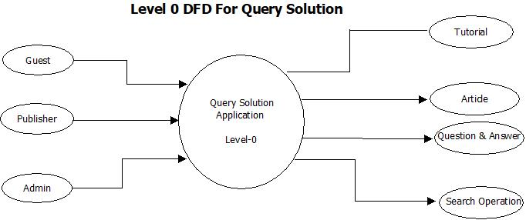

The level 0 data flow diagram (DFD) also known as a context diagram shows a data system as a whole and emphasizes the way it interacts with external entities.

Here in level 0 DFD three models are there:

1. GUEST: -

Guest can visit tutorial and also read everything present inside tutorial. Read questions and answers and also articles. He can also perform search operation.

1. PUBLISHER: -

A publisher can write an Article. He can answer the questions and also can vote the answer.

1. ADMIN: -Admin can manage the tutorial.

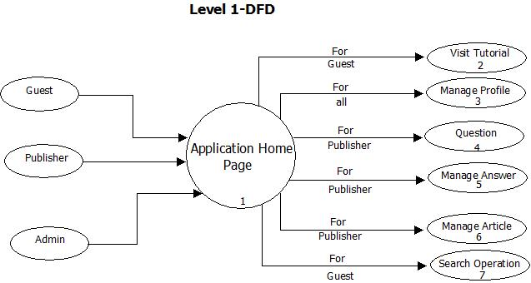

The level 1 DFD notates each of the main sub-processes that together form the complete system.

* Admin monitors the publisher’s performance.
* Everyone has writes to manage the profile.
* Publisher has writes to manage the questions, answers, and articles.
* Guest can perform search operation

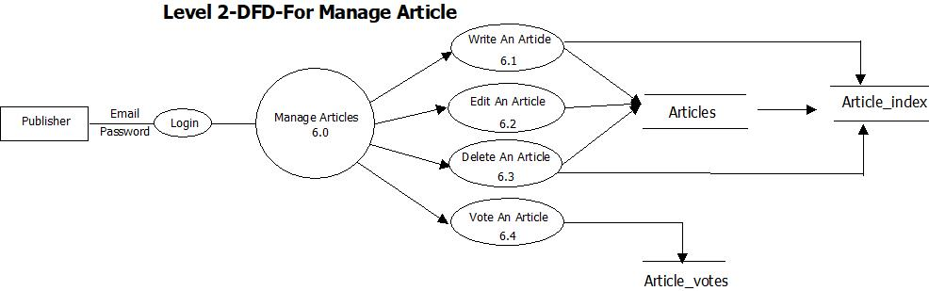

For the Level 2 DFD Manage Article when a publisher enters his email and password and click the login button then he will get the facility to write an article. He can Edit, Delete and even can vote an article. After the article been written, the article’s topic and hashtag gets tokenized and gets stored to the ‘Article_Index’ table.

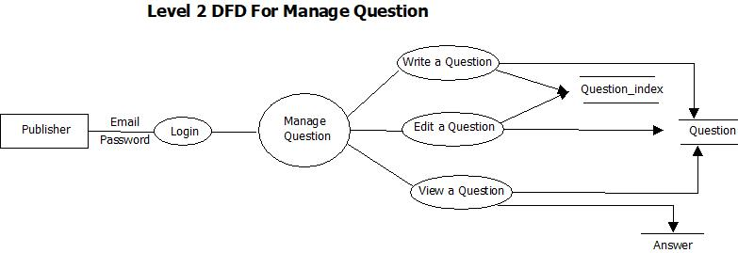

According to level 2 DFD for manage Question, when a publisher enters his email id and password and click the login button, he will get the facility to write, edit and view a question. When we write or edit a question it will be stored inside the “question” table. After that, each of its word present in the Topic and hash Tag gets tokenized and gets added to “question_Index”. When we perform view operation, we need the answer of the question that’s why we go to the answer table. Here we didn’t add the delete operation because when a publisher writes a question. Other publisher willing to write answer, will answer that question. And once the question is deleted then all the answer 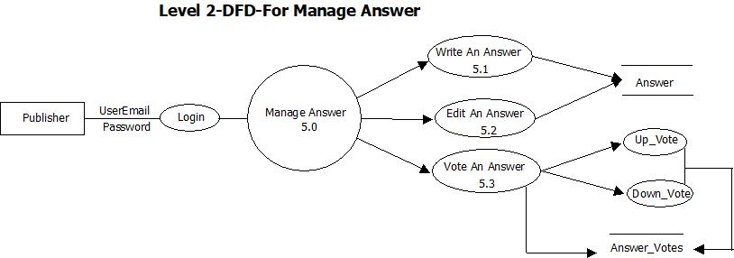gets wasted.

For Level 2 DFD for Manage Answer, after the publisher has logged in, he/she can write an answer to any particular question. He can even vote an answer.A publisher can vote as “like” or “dislike” and result stored in the “Answer_Vote” table in a Boolean format.

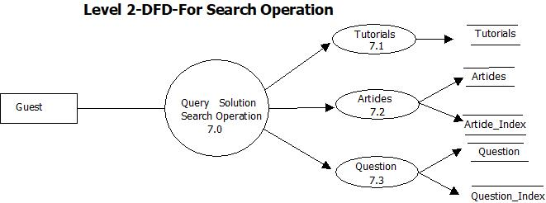

A guest doesn’t need any email id and password to use the search operation. When search operation is being performed first of all the search query is get searched inside the “Article_Index” and “Question_Index”. After getting the words, where they are actually located through there article and question ids, we retrieve the articles and questions respectively. After using certain algorithms, we display out the desired contents to the user.

**5.2 Use Case Diagram**

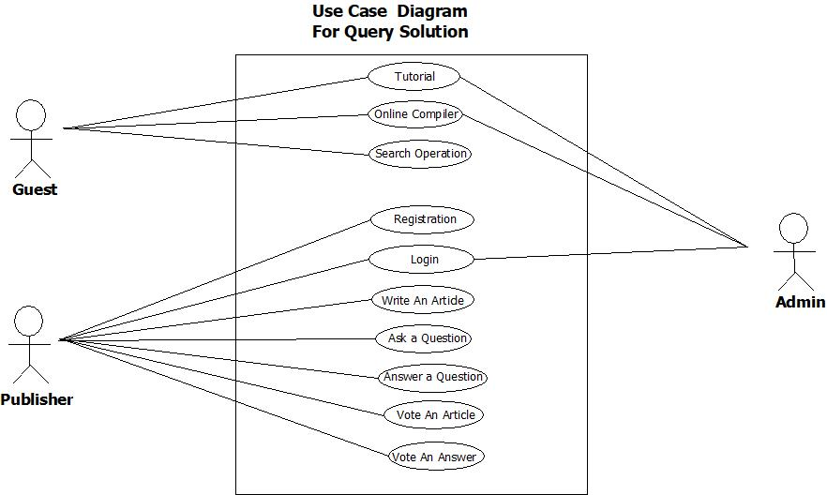

A **use case diagram** at its simplest is a representation of a user's interaction with the system that shows the relationship between the user and the different use cases in which the user is involved.

In use case diagram three models are there:

* Guest- When a guest visits our website, he can perform different operations like he can visit tutorial, can use online compiler and also perform search operation to read the articles, Questions and followed by answer.
* Publisher- When a publisher visits our website and wants to publish something, he needs to write his desired contents (like can ask any question or publish an article) and even he can answer a question available on the site. After writing some contents, our security system asks them to register/login. Publisher’s gets the rights to vote other publisher’s contents.
* Admin- Admin can perform login and monitor activities of the publishers.
  1. 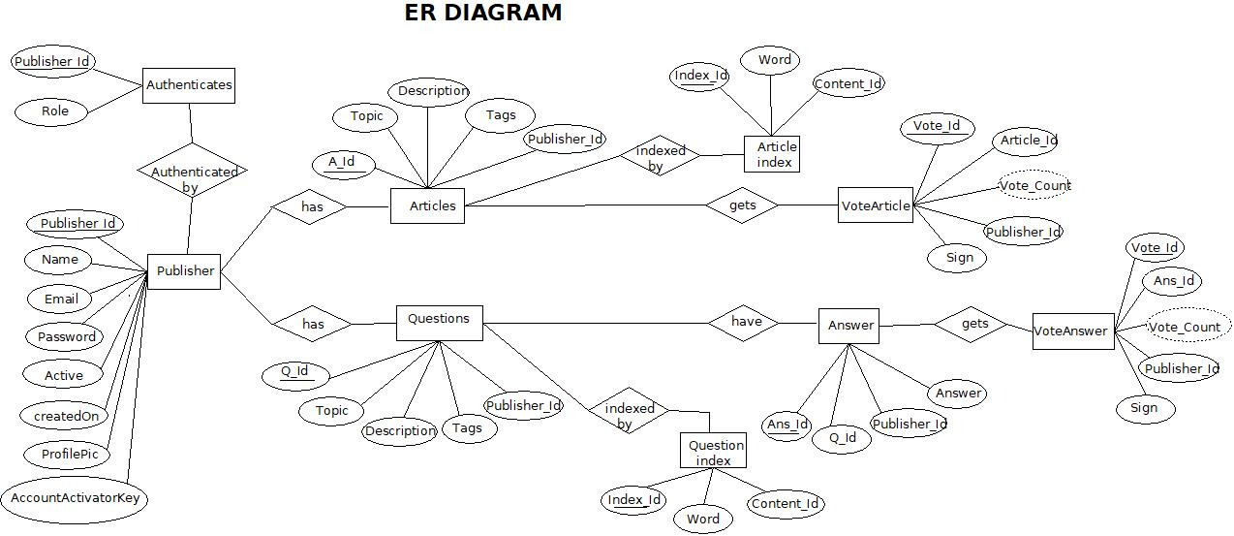**Entity Relationship Diagram**

We do have a user table. The user table consist of four attributes. They are Publisher_Id, Name, Email, Password. From which Publisher_Id is recognized as a primary key.

User can have a relationship with authorities table through Authenticated by. Through which we know that a user is Publisher or Admin. When it is found out that the user is the publisher then he is given his related work. When it is found out that the user is the Admin then he is given his related work.

Publisher he can write articles. Article consist of five attributes. These are A_Id,Topic,Description,Tags,Publisher_Id. From which A_Id is recognized as a Primary key. When a user goes to write an article at that time Publisher­_Id stored in the database and the written articles retrieve through A_Id. When a publisher completes his writing, the article moves to the article index and each of its word get tokenized and get stored in the article index.

Article index consist of three attributes. These are Index_Id, Word, Content_Id. From which Index_Id recognized as Primary key and Content_Id is recognized as Foreign key.

Questions consist of five attributes. These are Q_Id, Topic, Description, Tags, Publisher_Id. From which Q_Id is recognized as a Foreign key. When a user goes to write a question at that time Publisher_Id stored in the database and the written question retrieve through Q_Id.

When a publisher completes his writing, the question moves to the question index and each of its word get tokenized and get stored in the question index. Question index consist of three attributes. These are Index_Id, Word, Content_Id. From which Index_Id recognized as Primary key and Content_Id is recognized as Foreign key.

Answer consist of four attributes. These are A_Id, Q_Id, Publisher_Id, Answer. From which A_Id is recognized as Primary key and Q_Id is recognized as Foreign key.The publisher who will come and give the answer then we will be stored the Publisher_Id of that publisher in Answer table. When answer session of questions and Article session will be finished then different user will come and give their vote.

In vote article there are Five attributes. These are Vote_Id, Article_Id, Publisher_id, Sign. From which Vote_Id is recognized as a primary key and Article_Id is recognized as a Foreign key.

When a publisher wants to vote an article, he has two option either like or dislike. If he chooses one like option o then the result will show in Boolean like 1and if he chooses dislike the result will show 0.

In vote answer there are five attributes. These are Vote_Id, Ans_Id, Publisher_id, Sign. From which Vote_Id is recognized as a primary key and Ans_Id is recognized as a Foreign key. When a publisher wants to vote an article, he has two option either like or dislike. If he chooses one like option o then the result will show in Boolean like 1and if he chooses dislike the result will show 0.

**6. Sample Coding**

**Entity classes**

@Entity

@Table

public class Publisher {

@Id

@GeneratedValue(strategy = GenerationType.*SEQUENCE*)

private Long id;

private String name;

private String username;

private String password;

private String uniqueId;

@Transient

private String confirmPassword;

@Column(nullable = false, columnDefinition = "TINYINT(1)")

private boolean active;

@CreationTimestamp

private Date createdOn;

private String profilePic;

//settters and getters…

@Entity

@Table

public class Question {

@Id

@GeneratedValue(strategy = GenerationType.*SEQUENCE*)

private Long qId;

private String topic;

@Lob

private String description;

private String tags;

private String publisherEmail;

@CreationTimestamp

private Date createdOn;

//settters and getters…

@Entity

@Table

public class Answers {

@Id

@GeneratedValue(strategy = GenerationType.*SEQUENCE*)

private Long id;

private String publisherEmail;

private Long questionId;

@Lob

private String answer;

//settters and getters…

@Entity

@Table

public class AnswerVotes {

@Id

@GeneratedValue(strategy = GenerationType.*SEQUENCE*)

private Long voteId;

private String publisherEmail;

private Integer sign; // positive/like = 1 & negative/dislike = 0

private Long answerId;

private Long questionId;

//settters and getters…

@Entity

@Table

public class QuestionIndex {

@Id

@GeneratedValue(strategy = GenerationType.*SEQUENCE*)

private Long id;

private String word;

private String questionIds;

//settters and getters…@Entity

@Entity

@Table

public class Article {

@Id

@GeneratedValue(strategy = GenerationType.*SEQUENCE*)

private Long articleId;

private String topic;

@Lob

private String content;

private String tags;

private String publisherEmail;

@CreationTimestamp

private Date createdOn;

//settters and getters…

@Entity

@Table

public class ArticleVotes {

@Id

@GeneratedValue(strategy = GenerationType.*SEQUENCE*)

private Long voteId;

private Long articleId;

private String publisherEmail;

private Integer sign;

//settters and getters…

@Entity

@Table

public class ArticleIndex {

@Id

@GeneratedValue(strategy = GenerationType.*SEQUENCE*)

private Long id;

private String word;

private String articleIds;

//settters and getters…

**Controller’s classes**

@RestController

public class **loginController** {

@Autowired

QuestionRepo questionRepo;

@Autowired

PublisherService publisherService;

@Autowired

ArticleRepo articleRepo;

@Autowired

PublisherRepo publisherRepo;

// handling home page

@RequestMapping(value = { "/", "/page/{QuesPageNumber}/{ArticlePageNumber}" })

public ModelAndView welcome(@PathVariable Optional<Integer> QuesPageNumber,

@PathVariable Optional<Integer> ArticlePageNumber) {

ModelAndView modelandview = new ModelAndView();

modelandview.setViewName("home");

// for questions

List<Question> questions = publisherService.allQuestions(QuesPageNumber);

modelandview.addObject("questions", questions);

// get current page and all pages size for pagination

List<Question> allQuestions = questionRepo.findAll();

int size = allQuestions.size();

int pageSize = size / 5;// I want to display 5 contents in a single page

if (size % 5 != 0) {

pageSize += 1; // the remaining pages are added here

}

modelandview.addObject("ques_pageSize", pageSize);

if (QuesPageNumber.isPresent()) {

modelandview.addObject("QuesCurrentPage", QuesPageNumber.get().intValue());

} else {

modelandview.addObject("QuesCurrentPage", 0);

}

// for articles

List<Article> articles = publisherService.allArticles(ArticlePageNumber);

modelandview.addObject("articles", articles);

// get current page and all pages size for pagination

List<Article> allArticles = articleRepo.findAll();

int artSize = allArticles.size();

int artPageSize = artSize / 5;// I want to display 5 contents in a single page

if (artSize % 5 != 0) {

artPageSize += 1; // the remaining pages are added here

}

modelandview.addObject("art_pageSize", artPageSize);

if (ArticlePageNumber.isPresent()) {

modelandview.addObject("ArtCurrentPage", ArticlePageNumber.get().intValue());

} else {

modelandview.addObject("ArtCurrentPage", 0);

}

return modelandview;

}

@RequestMapping("/course")

public ModelAndView course() {

ModelAndView modelandview = new ModelAndView();

modelandview.setViewName("course");

return modelandview;

}

//---------------------------- admin pages-----------------------

@RequestMapping("/adminLogin")

public ModelAndView secureAdmin() {

ModelAndView mv = new ModelAndView();

mv.setViewName("adminLogin");

return mv;

}

@RequestMapping("/admin/dashboard")

public ModelAndView welcomeAdmin() {

ModelAndView mv = new ModelAndView();

mv.setViewName("dashboard");

return mv;

}

// --------------------------- user pages-----------------------

@RequestMapping("/login")

public ModelAndView secureUser(@RequestParam(value = "error", required = false) String error,

@RequestParam(value = "logout", required = false) String logout) {

ModelAndView model = new ModelAndView();

if (error != null) {

model.addObject("error", "Invalid username and password!");

}

if (logout != null) {

model.addObject("logout", "You've been logged out successfully.");

}

model.setViewName("login");

return model;

}

@RequestMapping("/registrationPage")

public ModelAndView registrationPage() {

ModelAndView mv = new ModelAndView();

mv.setViewName("registrationPage");

return mv;

}

// --------------------------- Publisher Registration-----------------------

@RequestMapping("/register")

public ModelAndView register(@ModelAttribute Publisher publisher, BindingResult bindingResult,

HttpServletRequest request) {

ModelAndView mv = new ModelAndView();

String uniqueId = UUID.*randomUUID*().toString();

if (!publisher.getConfirmPassword().equals(publisher.getPassword())) {

bindingResult.reject("password");

mv.addObject("passwordNotSame", "Oops! The password and confirm password are not same.");

mv.setViewName("registrationPage");

} // validate the email

else if (publisherRepo.findByUsername(publisher.getUsername()) != null) {

bindingResult.reject("email");

mv.addObject("alreadyRegisteredMessage",

"Oops! There is already a user registered with the email provided.");

mv.setViewName("registrationPage");

} else {

// save publisher details.

publisher.setUniqueId(uniqueId);

publisher.setPassword(encoder().encode(publisher.getPassword()));

publisherRepo.save(publisher);

publisherService.mailToValidate(publisher, request);

mv.addObject("confirmationMessage", "A confirmation email has been sent to " + publisher.getUsername());

mv.setViewName("login");

}

return mv;

}

private BCryptPasswordEncoder encoder() {

return new BCryptPasswordEncoder();

}

@RequestMapping("/validateAccount")

public ModelAndView register(ModelAndView modelAndView, @RequestParam("uniqueId") String uniqueId,

@RequestParam("publisherId") Long publisherId) {

// link verification

modelAndView = publisherService.verifyLink(uniqueId, publisherId);

return modelAndView;

}

}

@RestController

@RequestMapping("/publisher")

public class **PublisherController** {

@Autowired

QuestionRepo questionRepo;

@Autowired

PublisherService publisherService;

@Autowired

PublisherRepo publisherRepo;

@Autowired

AnswerRepo answerRepo;

@Autowired

AnswerVoteService voteService;

@Autowired

ArticleRepo articleRepo;

@Autowired

ArticleVoteService articleVoteService;

@Autowired

SearchService searchService;

@Autowired

IndexService indexService;

@RequestMapping(value = { "/welcome", "/welcome/{QuestionPageNumber}/{ArticlePageNumber}" })

public ModelAndView page(Authentication authentication, @PathVariable Optional<Integer> QuestionPageNumber,

@PathVariable Optional<Integer> ArticlePageNumber) {

ModelAndView mv = publisherService.userPageContents(authentication, QuestionPageNumber, ArticlePageNumber);

return mv;

}

/* save the Question */

@PostMapping("/saveQuestion")

public ModelAndView saveQuestion(@ModelAttribute Question question, Authentication authentication, HttpServletResponse response) {

// attach the user name and save the question

question.setPublisherEmail(authentication.getName());

Question savedQuestion = questionRepo.save(question);

// save the Question in QuestionTopicIndex

indexService.saveQuestionTopicsAndTags(savedQuestion);

response.setHeader("Cache-Control", "no-store, max-age=0, must-revalidate");

Optional<Integer> questionPageNumber = Optional.*ofNullable*(null); // nothing to done here

Optional<Integer> articlepageNumber = Optional.*ofNullable*(null); // nothing to done here

ModelAndView mv = publisherService.userPageContents(authentication, questionPageNumber, articlepageNumber);

return mv;

}

/* save the answer */

@RequestMapping(value = "/saveAnswer")

public ModelAndView viewQuestion(@RequestParam("id") long id, @ModelAttribute Answers answer,

Authentication authentication, HttpServletRequest request, HttpServletResponse response) {

// here the id is the questionId

answer.setPublisherEmail(authentication.getName());

answer.setQuestionId(id);

answerRepo.save(answer);

ModelAndView mv = new ModelAndView();

Question thisQuestion = questionRepo.findById(id).get();

mv.addObject("allAnswer", answerRepo.findByQuestionId(id)); // all previous answers

mv.addObject("question", thisQuestion); // this Question

// the tags associated with question

Set<String> tags = indexService.separateTags(thisQuestion.getTags(), "[#,@]");

mv.addObject("tags", tags);

response.setHeader("Cache-Control", "no-store, max-age=0, must-revalidate");

mv.setViewName("viewQuestion");

/*

* mail the users -> who have asked that question, who have voted for that

* answer earlier, who have previously given the answer to that question

*/

publisherService.mailTheSpectators(thisQuestion, authentication.getName(), request);

return mv;

}

/* like the answer */

@ResponseBody

@PostMapping("/like-this-answer/{queId}/{ansId}")

public ResponseEntity<?> likeAnswer(Authentication authentication, @PathVariable("queId") Long queId,

@PathVariable("ansId") Long ansId) {

int voteDecision = voteService.makeVoteCount(authentication.getName(), ansId, queId, 1);// 1 means the publisher

// liked the content

/*

* makeVoteCount will be returning 3 values 0 -> if publisher isn't eligble to

* vote 1 -> if publisher has already given the vote as like - then the vote

* will be disabled 2 -> if publisher is voting for the first time. 3 -> if

* publisher changes his vote.

*/

try {

return ResponseEntity.*status*(200).body(voteDecision);

} catch (Exception e) {

return ResponseEntity.*status*(HttpStatus.*UNAUTHORIZED*).body(4);

}

}

/* dislike the answer */

@ResponseBody

@PostMapping("/dislike-this-answer/{queId}/{ansId}")

public int dislikeAnswer(Authentication authentication, @PathVariable("queId") Long queId,

@PathVariable("ansId") Long ansId) {

int voteDecision = voteService.makeVoteCount(authentication.getName(), ansId, queId, 0);// 0 means the publisher

// disliked the content

/*

* makeVoteCount will be returning 3 values 0 -> if publisher isn't eligble to

* vote 1 -> if publisher has already given the vote as like - then the vote

* will be disabled 2 -> if publisher is voting for the first time.

*/

return voteDecision;

}

/* save the Article */

@RequestMapping("/saveArticle")

public ModelAndView saveArticle(@ModelAttribute Article article, Authentication authentication, HttpServletResponse response) {

article.setPublisherEmail(authentication.getName());

Article savedArticle = articleRepo.save(article);

// save articles topics and tags in the indexes class

indexService.saveArticleTopicsAndTags(savedArticle);

response.setHeader("Cache-Control", "no-store, max-age=0, must-revalidate");

Optional<Integer> recommendedpageNumber = Optional.*ofNullable*(null); // nothing to done here

Optional<Integer> ownpageNumber = Optional.*ofNullable*(null); // nothing to done here

ModelAndView mv = publisherService.userPageContents(authentication, recommendedpageNumber, ownpageNumber);

return mv;

}

/* like the article */

@ResponseBody

@PostMapping("/like-this-article/{artId}")

public ResponseEntity<?> likeArticle(Authentication authentication, @PathVariable("artId") Long artId) {

int voteDecision = articleVoteService.makeVoteCountForArticle(authentication.getName(), artId, 1);// 1 means the

/*

* makeVoteCount will be returning 3 values 0 -> if publisher isn't eligble to

* vote 1 -> if publisher has already given the vote as like - then the vote

* will be disabled 2 -> if publisher is voting for the first time. 3 -> if

* publisher changes his vote.

*/

return ResponseEntity.*status*(200).body(voteDecision);

}

/* dislike the article */

@ResponseBody

@PostMapping("/dislike-this-article/{artId}")

public ResponseEntity<?> dislikeArticle(Authentication authentication, @PathVariable("artId") Long artId) {

int voteDecision = articleVoteService.makeVoteCountForArticle(authentication.getName(), artId, 0);// 0 means the

/*

* makeVoteCount will be returning 3 values 0 -> if publisher isn't eligble to

* vote 1 -> if publisher has already given the vote as like - then the vote

* will be disabled 2 -> if publisher is voting for the first time. 3 -> if

* publisher changes his vote.

*/

return ResponseEntity.*status*(200).body(voteDecision);

}

/* profile photo upload */

@PostMapping("/uploadProfilePic")

public ModelAndView uploadProfilePic(@RequestParam("profilePic") MultipartFile profilePic,

Authentication authentication, HttpServletResponse response) {

ModelAndView mv = new ModelAndView();

File file = new File(profilePic.getOriginalFilename());

String mimetype = null;

try {

mimetype = Files.*probeContentType*(file.toPath());

} catch (IOException e) {

e.printStackTrace();

}

// checking it is a image file or not

if (mimetype != null && mimetype.split("/")[0].equals("image")) {

try {

Path currentPath = Paths.*get*(".");

Path absolutePath = currentPath.toAbsolutePath();

// save the photo name in dB

int returned = publisherRepo.UpdateProfilePic(profilePic.getOriginalFilename(),

authentication.getName());

byte[] bytes = profilePic.getBytes();

// save the photo actually in this location

Path path = Paths.*get*(

absolutePath + "/src/main/resources/static/profilePhoto/" + profilePic.getOriginalFilename());

Files.*write*(path, bytes);

// if photo saved successfully

if (returned != 0) {

// mv.addObject("saved", "Photo Saved");

// mv.addObject("image", Base64.getMimeEncoder().encodeToString(profilePic.getBytes()));

response.setHeader("Cache-Control", "no-store, max-age=0, must-revalidate");

Optional<Integer> questionPageNumber = Optional.*ofNullable*(null); // nothing to done here

Optional<Integer> articlepageNumber = Optional.*ofNullable*(null); // nothing to done here

mv = publisherService.userPageContents(authentication, questionPageNumber, articlepageNumber);

return mv;

}

} catch (Exception e) {

mv.addObject("error", "Error Occured While Saving the photo" + e);

}

} else {

mv.addObject("notImage", profilePic.getOriginalFilename() + " is not an image file");

}

mv.setViewName("temp");

return mv;

}

}

@RequestMapping("/view")

@RestController

public class **ResultController** {

@Autowired

QuestionRepo questionRepo;

@Autowired

AnswerRepo answerRepo;

@Autowired

ArticleRepo articleRepo;

@Autowired

SearchService searchService;

@Autowired

IndexService indexService;

@RequestMapping(value = "/Question")

public ModelAndView viewQuestion(@RequestParam("id") long id) {

Question thisQuestion = questionRepo.findById(id).get();

ModelAndView mv = new ModelAndView();

mv.setViewName("viewQuestion");

mv.addObject("question", thisQuestion); //this question

mv.addObject("tags", indexService.separateTags(thisQuestion.getTags(),"[#,@]")); //the tags

mv.addObject("allAnswer", answerRepo.findByQuestionId(id)); //all previous answers

return mv;

}

@RequestMapping(value = "/Article")

public ModelAndView viewArticle(@RequestParam("id") long id) {

ModelAndView mv = new ModelAndView();

mv.setViewName("viewArticle");

Article article = articleRepo.findById(id).get();

mv.addObject("article", article); //this article

mv.addObject("tags", indexService.separateTags(article.getTags(),"[#,@]")); //tags

return mv;

}

@RequestMapping(value = "/searchResult")

public ModelAndView viewSearchResult(@RequestParam("search") String search) {

Long start = System.*currentTimeMillis*();//starting time

ModelAndView mv = searchService.searchOperation(search);

String totalTime = "0.00,000"+Long.*toString*(System.*currentTimeMillis*() - start)+" seconds";

//ending time

mv.addObject("totalTime", totalTime);

return mv;

}

}

**Security configurations**

@EnableWebSecurity

public class SecurityConfig extends WebSecurityConfigurerAdapter {

@Autowired

static DataSource *dataSource*;

// admin login class

@Configuration

@Order(1)

public static class AdminAuthorization extends WebSecurityConfigurerAdapter {

@Override

protected void configure(HttpSecurity http) throws Exception {

http.antMatcher("/admin/**").authorizeRequests().anyRequest().hasRole("ADMIN")

.and().formLogin().loginPage("/adminLogin").loginProcessingUrl("/admin/dashboard").and().csrf()

.disable();

}

// for authentication

@Autowired

public void configure(AuthenticationManagerBuilder auth) throws Exception {

auth.inMemoryAuthentication().withUser("admin").password(*encoder*().encode("admin"))

.roles("ADMIN");

}

}

// Publisher login class

@Configuration

@Order(2)

public static class PublisherAuthorization extends WebSecurityConfigurerAdapter {

@Override

protected void configure(HttpSecurity http) throws Exception {

http.csrf().disable().httpBasic().and().authorizeRequests().antMatchers("/publisher/**")

.hasRole("PUBLISHER").and().formLogin().loginPage("/login").loginProcessingUrl("/login");

}

// for authentication

@Autowired

public void configure(AuthenticationManagerBuilder auth) throws Exception {

try {

auth.jdbcAuthentication().dataSource(dataSource)

.usersByUsernameQuery("select username, password, active" + " from publisher where username=?")

.authoritiesByUsernameQuery("select username, authority " + "from authorities where username=?");

} catch (Exception e) {

e.printStackTrace();

}

}

}

@Bean

public static PasswordEncoder encoder() {

return new BCryptPasswordEncoder();

}

}

**Services classes**

@Service

public class PublisherService {

@Autowired

PublisherService publisherService;

@Autowired

PublisherRepo publisherRepo;

@Autowired

AuthoritiesRepo authoritiesRepo;

@Autowired

QuestionRepo questionRepo;

@Autowired

ArticleRepo articleRepo;

@Autowired

private JavaMailSender sender;

@Autowired

AnswerRepo answerRepo;

@Autowired

AnswerVotesRepo answerVotesRepo;

@Autowired

ArticleVotesRepo articleVotesRepo;

public List<Question> modify(List<Question> contents) {

List<Question> modifiedList = new ArrayList<Question>();

for (int i = 0; i < contents.size(); i++) {

String description = contents.get(i).getDescription();

if (description.length() > 200) {

description = description.substring(0, 200) + "...";

}

modifiedList.add(new Question(contents.get(i).getqId(), contents.get(i).getTopic(), description,

contents.get(i).getTags(), contents.get(i).getPublisherEmail(), contents.get(i).getCreatedOn()));

}

return modifiedList;

}

public List<Article> modifyArticle(List<Article> contentsOfUser) {

List<Article> modifiedList = new ArrayList<Article>();

for (int i = 0; i < contentsOfUser.size(); i++) {

String description = contentsOfUser.get(i).getContent();

if (description.length() > 200) {

description = description.substring(0, 200) + "...";

}

modifiedList.add(new Article(contentsOfUser.get(i).getArticleId(), contentsOfUser.get(i).getTopic(),

description, contentsOfUser.get(i).getTags(), contentsOfUser.get(i).getPublisherEmail(),

contentsOfUser.get(i).getCreatedOn()));

}

return modifiedList;

}

public ModelAndView userPageContents(Authentication authentication, Optional<Integer> QuestionPageNumber,

Optional<Integer> ArticlePageNumber) {

// return the userIntro page

ModelAndView mv = new ModelAndView();

mv.setViewName("userIntro");

// publisher's own Asked Questions ********************************************************

// pagination for user written questions

PageRequest pageReq;

Sort sort = Sort.*by*("createdOn").descending();

if (QuestionPageNumber.isPresent()) {

pageReq = PageRequest.*of*(QuestionPageNumber.get().intValue(), 2, sort);

} else {

pageReq = PageRequest.*of*(0, 2, sort);

}

List<Question> modifiedUsersquestions = publisherService

.modify(questionRepo.findContentsOfUserOnPage(authentication.getName(), pageReq).toList());

mv.addObject("questions", modifiedUsersquestions);

// get current page and all pages size for pagination-- publisher Own content

List<Question> allQuestions = questionRepo.findContentsOfUser(authentication.getName());

int size = allQuestions.size();

int pageSize = size / 2;// I want to display 2 contents in a single page

if (size % 2 != 0) {

pageSize += 1; // the remaining pages are added here

}

mv.addObject("quePageSize", pageSize);

if (QuestionPageNumber.isPresent()) {

mv.addObject("queCurrentPage", QuestionPageNumber.get().intValue());

} else {

mv.addObject("queCurrentPage", 0);

}

// publisher's own Written Articles ******************************************

// pagination for user written articles

PageRequest pageReqArt;

Sort sortArt = Sort.*by*("createdOn").descending();

if (ArticlePageNumber.isPresent()) {

pageReqArt = PageRequest.*of*(ArticlePageNumber.get().intValue(), 2, sortArt);

} else {

pageReqArt = PageRequest.*of*(0, 2, sortArt);

}

// pagination for user written content

List<Article> modifiedArticles = publisherService

.modifyArticle(articleRepo.findArticleOfUserOnPage(authentication.getName(), pageReqArt).toList());

mv.addObject("articles", modifiedArticles);

// get current page and all pages size for pagination-- publisher Own content

List<Article> allArticles = articleRepo.findByPublisherEmail(authentication.getName());

int artSize = allArticles.size();

int artPageSize = artSize / 2;// I want to display 2 contents in a single page

if (artSize % 2 != 0) {

artPageSize += 1; // the remaining pages are added here

}

mv.addObject("artPageSize", artPageSize);

if (ArticlePageNumber.isPresent()) {

mv.addObject("artCurrentPage", ArticlePageNumber.get().intValue());

} else {

mv.addObject("artCurrentPage", 0);

}

// publisher profile

Publisher publisher = publisherRepo.findByUsername(authentication.getName());

// mv.addObject("src", "/img/mike.jpg");

mv.addObject("name", publisher.getName());

// user asked no. of question

mv.addObject("contributedQuestion", size);

// user asked no. of Articles

mv.addObject("contributedArticle", artSize);

// got total Likes

mv.addObject("TotaLikes", answerVotesRepo.findByPublisherEmailOfLike(authentication.getName()).size()+

articleVotesRepo.findByPublisherEmailOfLike(authentication.getName()).size());

// got total disLikes

mv.addObject("TotaDisLikes", answerVotesRepo.findByPublisherEmailOfdisLike(authentication.getName()).size()+

articleVotesRepo.findByPublisherEmailOfdisLike(authentication.getName()).size());

// user's profile photo

String image = (publisher.getProfilePic() == null)?null: publisher.getProfilePic();

mv.addObject("image",image);

return mv;

}

public List<Question> allQuestions(Optional<Integer> pageNumber) {

// pagination

PageRequest pageReq;

Sort sort = Sort.*by*("createdOn").descending();

if (pageNumber.isPresent()) {

pageReq = PageRequest.*of*(pageNumber.get().intValue(), 5, sort);

} else {

pageReq = PageRequest.*of*(0, 5, sort);

}

Page<Question> page = questionRepo.findAll(pageReq);

// convert Page to List

List<Question> questions = publisherService.modify(page.toList());

return questions;

}

public List<Article> allArticles(Optional<Integer> artilcePageNumber) {

// pagination

PageRequest pageReq;

Sort sort = Sort.*by*("createdOn").descending();

if (artilcePageNumber.isPresent()) {

pageReq = PageRequest.*of*(artilcePageNumber.get().intValue(), 5, sort);

} else {

pageReq = PageRequest.*of*(0, 5, sort);

}

Page<Article> page = articleRepo.findAll(pageReq);

// convert Page to List

List<Article> articles = publisherService.modifyArticle(page.toList());

return articles;

}

/*

* mail the users -> who have asked that question, who have voted for that

* answer earlier, who have previously given the answer to that question

*/

public void mailTheSpectators(Question thisQuestion, String answeredNow, HttpServletRequest request) {

MimeMessage msg = sender.createMimeMessage();

MimeMessageHelper helper = new MimeMessageHelper(msg);

List<String> spectators = new ArrayList<String>();

// The publisher who asked that question

spectators.add(thisQuestion.getPublisherEmail());

// The publisher those who have answered that question, and

// the situation can be like question haven't been answered yet

List<Answers> answers = answerRepo.findByQuestionId(thisQuestion.getqId());

// remember the list can be empty too

if (answers != null) {

for (Iterator iterator = answers.iterator(); iterator.hasNext();) {

Answers answer = (Answers) iterator.next();

spectators.add(answer.getPublisherEmail());

// find the votes of the publisher

List<AnswerVotes> votes = answerVotesRepo.findAllByAnswerId(answer.getId());

// the list can be empty too

if (votes != null) {

for (Iterator iterator2 = votes.iterator(); iterator2.hasNext();) {

AnswerVotes vote = (AnswerVotes) iterator2.next();

spectators.add(vote.getPublisherEmail());

}

}

}

}

try {

// send mail.. to the respective publishers

String link = request.getScheme() + "://" + request.getServerName() + ":" + request.getServerPort()

+ request.getContextPath() + "/view/Question?id=" + thisQuestion.getqId();

for (Iterator iterator = spectators.iterator(); iterator.hasNext();) {

String publisherEmail = (String) iterator.next();

helper.setTo(publisherEmail);

helper.setSubject("A new answer found to your question, have a look..");

helper.setText("<!DOCTYPE html PUBLIC \"-//W3C//DTD XHTML 1.0 Strict//EN\" \"http://www.w3.org/TR/xhtml1/DTD/xhtml1-strict.dtd\">\r\n"

+ "\r\n" + "<html xmlns=\"http://www.w3.org/1999/xhtml\">\r\n" + "<head>\r\n"

+ " <meta http-equiv=\"Content-Type\" content=\"text/html; charset=utf-8\" />\r\n"

+ " <meta name=\"viewport\" content=\"width=device-width, initial-scale=1.0\"/>\r\n"

+ " <title>[SUBJECT]</title>\r\n" + " <style type=\"text/css\">\r\n" + "\r\n"

+ "@media screen and (max-width: 600px) {\r\n" + " table[class=\"container\"] {\r\n"

+ " width: 95% !important;\r\n" + " }\r\n" + "}\r\n" + "\r\n"

+ " #outlook a {padding:0;}\r\n"+ " <p >Hi ,\r\n"

+ " <br/>\r\n"

+ " <br/>We Got A New Answer To Your Question.'"

+ thisQuestion.getTopic() + "'.\r\n"

+ " Click on the link below to view your searched Question. </p>\r\n"

+ " </div>\r\n"

+ " </div>\r\n"

+ " </td>\r\n"

+ " <td width=\"100\">&nbsp;</td>\r\n"

+ " </tr>\r\n" + " </table>\r\n"

+ " <table cellpadding=\"0\" cellspacing=\"0\" border=\"0\" align=\"center\" width=\"600\" class=\"container\">\r\n"

+ " <tr>\r\n"

+ " <td width=\"200\">&nbsp;</td>\r\n"

+ " <td width=\"200\" align=\"center\" style=\"padding-top:25px;\">\r\n"

+ " <table cellpadding=\"0\" cellspacing=\"0\" border=\"0\" align=\"center\" width=\"200\" height=\"50\">\r\n"

+ " <tr>\r\n"

+ " <td bgcolor=\"#1beb11\" align=\"center\" style=\"border-radius:4px;\" width=\"200\" height=\"50\">\r\n"

+ " <div class=\"contentEditableContainer contentTextEditable\">\r\n"

+ " <div class=\"contentEditable\" align='center' >\r\n"

+ " <a target='_blank' href='"

+ link + "' class='link2'>Go To Site</a>\r\n"

+ " </div>\r\n"

+ " </div>\r\n"

+ " </td>\r\n"

+ " </tr>\r\n"

+ " </table>\r\n"

+ " </td>\r\n"

+ " <td width=\"200\">&nbsp;</td>\r\n"

+ " </tr>\r\n" + " </table>\r\n"

+ " </div>\r\n" + " </div>\r\n"

+ " </td>\r\n" + " </tr>\r\n" + " </table>\r\n"

+ " </div>\r\n" + "\r\n" + "\r\n" + "\r\n" + "\r\n" + "-->\r\n"

+ "<!--Default Zone End-->\r\n" + "\r\n" + "</body>\r\n" + "</html>",

true);

sender.send(msg);

}

} catch (Exception e) {

e.printStackTrace();

}

}

public void mailToValidate(Publisher publisher, HttpServletRequest request) {

MimeMessage msg = sender.createMimeMessage();

MimeMessageHelper helper = new MimeMessageHelper(msg);

try {

// send mail.. to the respective publisher

String link = request.getScheme() + "://" + request.getServerName() + ":" + request.getServerPort()

+ request.getContextPath() + "/validateAccount?uniqueId=" + publisher.getUniqueId() +"&publisherId="+ publisher.getId();

helper.setTo(publisher.getUsername());

helper.setSubject("Hi From QuerySolutions.");

helper.setText(

"<!DOCTYPE html PUBLIC \"-//W3C//DTD XHTML 1.0 Strict//EN\" \"http://www.w3.org/TR/xhtml1/DTD/xhtml1-strict.dtd\">\r\n"

+ "\r\n" + "<html xmlns=\"http://www.w3.org/1999/xhtml\">\r\n" + "<head>\r\n"

+ " <meta http-equiv=\"Content-Type\" content=\"text/html; charset=utf-8\" />\r\n"

+ " </div>\r\n" + " </div>\r\n"

+ " </td>\r\n" + " </tr>\r\n" + " </table>\r\n"

+ " </div>\r\n" + "\r\n" + "\r\n" + "\r\n" + "\r\n" + "-->\r\n"

+ "<!--Default Zone End-->\r\n" + "\r\n" + "</body>\r\n" + "</html>",

true);

sender.send(msg);

} catch (Exception e) {

e.printStackTrace();

}

}

public ModelAndView verifyLink(String uniqueId, Long publisherId) {

ModelAndView modelAndView = new ModelAndView();

Publisher publisher = null;

try {

publisher = publisherRepo.findById(publisherId).get();

}catch (Exception e) {

modelAndView.addObject("malicious","Malicious Activity Detected, Please Register again.");

modelAndView.setViewName("registrationPage");

publisherRepo.deleteById(publisherId);

return modelAndView;

}

//does this link belongs to this publisher

if(!publisher.getUniqueId().equals(uniqueId)) {

modelAndView.addObject("malicious","Malicious Activity Detected, Please Register again.");

modelAndView.setViewName("registrationPage");

publisherRepo.deleteById(publisherId);

}else {

//Is this link opened after 24hrs

Date createdDate = publisher.getCreatedOn();

Calendar calender = Calendar.*getInstance*();

calender.setTime(createdDate);

calender.add(Calendar.*HOUR*, 24);

Date currentDt = calender.getTime();

if(new Date().before(currentDt)) {

modelAndView.addObject("Success","Account activated successfully please login.");

//activate the publisher

publisherRepo.changeStatePublisher(true, publisherId);

// authorize to the publisher

Authorities authorities = new Authorities();

authorities.setUsername(publisher.getUsername());

authoritiesRepo.save(authorities);

modelAndView.setViewName("login");

}

else

{

modelAndView.addObject("LinkExpired","The link has been expired, Please Register again.");

modelAndView.setViewName("registrationPage");

publisherRepo.deleteById(publisherId);

}

}

return modelAndView;

}

}

@Service

public class AnswerVoteService {

@Autowired

AnswerRepo answerRepo;

@Autowired

AnswerVotesRepo answerVotesRepo;

@Autowired

AnswerRepo articleRepo;

public int makeVoteCount(String publisherEmail, Long ansId, Long queId, int likeOrDislike) {

/*

* makeVoteCount will be returning 3 values

* 0 -> if publisher isn't eligble to vote

* 1 -> if publisher has already given the vote as like - then the vote will be disabled

* 2 -> if publisher is voting for the first time.

* 3 -> if publisher changes his vote.

*

*/

//when publisher isn't eligble

if((articleRepo.findByPublisherEmail(publisherEmail).size() < 2) || (answerRepo.findByPublisherEmail(publisherEmail).size() < 2)) {

return 0;

}//when the publisher has already given the same vote earlier

else if(checkPubliserHasVotedEarlier(publisherEmail, ansId, queId)) {

//discard publisher's vote if is the same vote again

Optional<AnswerVotes> vote = answerVotesRepo.checkSign(publisherEmail, ansId, queId);

Long voteId = answerVotesRepo.findByPublisherEmailAndAnswerId(publisherEmail, ansId).get().getVoteId();

if(vote.get().getSign() == likeOrDislike) {

answerVotesRepo.deleteById(voteId);

}else {

answerVotesRepo.updatePublisherVote(likeOrDislike, voteId);

return 3;

}

return 1;

}//make your vote count

else {

AnswerVotes vote = new AnswerVotes();

vote.setAnswerId(ansId);

vote.setQuestionId(queId);

vote.setPublisherEmail(publisherEmail);

vote.setSign(likeOrDislike);

answerVotesRepo.save(vote);

return 2;

}

}

private boolean checkPubliserHasVotedEarlier(String publisherEmail, Long ansId, Long queId) {

Optional<AnswerVotes> answerVote = answerVotesRepo.checkSign(publisherEmail, ansId, queId);

if(answerVote.isPresent()) {

return true;

}else {

return false;

}

}

}

@Service

public class ArticleVoteService {

@Autowired

ArticleRepo articleRepo;

@Autowired

ArticleRepo answerRepo;

@Autowired

ArticleVotesRepo articleVotesRepo;

public int makeVoteCountForArticle(String publisherEmail, Long artId, int likeOrDislike) {

/*

* makeVoteCount will be returning 3 values

* 0 -> if publisher isn't eligble to vote

* 1 -> if publisher has already given the vote as like - then the vote will be disabled

* 2 -> if publisher is voting for the first time.

* 3 -> if publisher changes his vote.

*

*/

//when publisher isn't eligble

if((articleRepo.findByPublisherEmail(publisherEmail).size() < 2) ||

(answerRepo.findByPublisherEmail(publisherEmail).size() < 2)) {

return 0;

}//when the publisher has already given the same vote earlier

else if(checkPubliserHasVotedEarlierForThisArticle(publisherEmail, artId)) {

//discard publisher's vote, if he gives the same vote again

Optional<ArticleVotes> vote = articleVotesRepo.checkSign(publisherEmail, artId);

Long voteId = articleVotesRepo.findByPublisherEmailAndArticleId(publisherEmail, artId).get().getVoteId();

if(vote.get().getSign() == likeOrDislike) {

articleVotesRepo.deleteById(voteId);

return 1;

}else {

articleVotesRepo.updatePublisherVote(likeOrDislike, voteId);

return 3;

}

}//make your vote count

else {

ArticleVotes vote = new ArticleVotes();

vote.setArticleId(artId);

vote.setPublisherEmail(publisherEmail);

vote.setSign(likeOrDislike);

articleVotesRepo.save(vote);

return 2;

}

}

private boolean checkPubliserHasVotedEarlierForThisArticle(String publisherEmail, Long artId) {

Optional<ArticleVotes> articleVote = articleVotesRepo.checkSign(publisherEmail, artId);

if(articleVote.isPresent()) {

return true;

}else {

return false;

}

}

}

@Service

public class IndexService {

@Autowired

IndexService indexService;

@Autowired

QuestionIndexRepo questionIndexRepo;

@Autowired

ArticleIndexRepo articleIndexRepo;

String[] auxilaryVerbs = { "i", "a", "in", "am", "of", "is", "are", "was", "and", "were", "being", "been", "be",

"having", "have", "has", "had", "do", "does", "did", "will", "would", "shall", "should", "may", "might",

"must", "can", "could", "they", "you", "we", "it", "to", "for", "the", "he", "she", "?", "how", "what",

"why", "who", "when", "(", ")", "{", "}" };

//----------------------------------- Tokenization Operations ---------------------------------------------

// a simple tokenizer method

public Set<String> separateTags(String tags, String delimiter) {

Set<String> tagsList = new HashSet<String>();

StringTokenizer tokens = new StringTokenizer(tags.trim(), delimiter);

while (tokens.hasMoreTokens()) {

String token = tokens.nextToken();

tagsList.add(token);

}

return tagsList;

}

// tokenize as well as remove auxilary words

public Set<String> tokenizeAndRemoveAuxilaryWords(String tags, String delimiter) {

Set<String> tokenizedTags = indexService.separateTags(tags, delimiter);

for (Iterator<String> iterator = tokenizedTags.iterator(); iterator.hasNext();) {

String string = (String) iterator.next().replace("_", " ");

for (int i = 0; i < auxilaryVerbs.length; i++) {

if (string.toLowerCase().equals(auxilaryVerbs[i])) {

iterator.remove();

}

}

}

return tokenizedTags;

}

// tokenize the tags

public Set<String> tokenizeTags(String tags, String delimiter) {

Set<String> tokens = indexService.tokenizeAndRemoveAuxilaryWords(tags, delimiter);

for (Iterator<String> iterator = tokens.iterator(); iterator.hasNext();) {

String string = (String) iterator.next().replace("_", " ");

for (int i = 0; i < auxilaryVerbs.length; i++) {

if (string.toLowerCase().equals(auxilaryVerbs[i])) {

iterator.remove();

}

}

}

return tokens;

}

//----------------------------------- Other Operations ---------------------------------------------

// convert list<Long> 1,2,3.. to string

public String convertListToString(List<Long> listOfLong) {

String str = listOfLong.stream().map(String::*valueOf*).collect(Collectors.*joining*(","));

return str;

}

//----------------------------------- Question Index Operations ---------------------------------------------

// save Question's topic and tags to QuestionIndex

public void saveQuestionTopicsAndTags(Question question) {

// topic is been tokenized

String topic = question.getTopic();

// tags are been tokenized

Set<String> tokenizedTags = indexService.tokenizeTags(question.getTags(), "[#]");

// remove auxilary words

Set<String> tokenized = indexService.tokenizeAndRemoveAuxilaryWords(topic, " ");

Long questionId = question.getqId();

// save topics to QuestionIndex

for (Iterator<String> iterator = tokenized.iterator(); iterator.hasNext();) {

String wordOfTopic = (String) iterator.next().toLowerCase();

indexService.saveToQuestionIndex(questionId, wordOfTopic);

}

// save tags as well, to QuestionIndex

for (Iterator<String> iterator = tokenizedTags.iterator(); iterator.hasNext();) {

String tagOfTopic = (String) iterator.next().toLowerCase();

indexService.saveToQuestionIndex(questionId, tagOfTopic);

}

}

// save Or update -- QuestionIndex

private void saveToQuestionIndex(Long questionId, String wordOfTopic) {

Optional<QuestionIndex> word = questionIndexRepo.findByWord(wordOfTopic);

if (word.isPresent()) {

List<Long> presentIds = word.get().getQuestionIds();

if (!presentIds.contains(questionId)) {

presentIds.add(questionId); // add this question's id to the already present ids,

// if and only it is not present earlier

}

questionIndexRepo.updateQuestionIds(indexService.convertListToString(presentIds), wordOfTopic);

} else {

QuestionIndex questionIndex = new QuestionIndex();

questionIndex.setWord(wordOfTopic);

questionIndex.setQuestionIds(questionId.toString());

questionIndexRepo.save(questionIndex);

}

}

//----------------------------------- Article Index Operations ---------------------------------------------

// save Article's topic and tags to ArticleIndex

public void saveArticleTopicsAndTags(Article article) {

// topic is been tokenized

String topic = article.getTopic();

// tags are been tokenized

Set<String> tokenizedTags = indexService.tokenizeTags(article.getTags(), "[#]");

// remove auxilary words

Set<String> tokenized = indexService.tokenizeAndRemoveAuxilaryWords(topic, " ");

Long articleId = article.getArticleId();

// save topics to QuestionIndex

for (Iterator<String> iterator = tokenized.iterator(); iterator.hasNext();) {

String wordOfTopic = (String) iterator.next().toLowerCase();

indexService.saveToArticleIndex(articleId, wordOfTopic);

}

// save tags as well, to QuestionIndex

for (Iterator<String> iterator = tokenizedTags.iterator(); iterator.hasNext();) {

String tagOfTopic = (String) iterator.next().toLowerCase();

indexService.saveToArticleIndex(articleId, tagOfTopic);

}

}

// save Or update -- ArticleIndex

private void saveToArticleIndex(Long articleId, String wordOfTopic) {

Optional<ArticleIndex> word = articleIndexRepo.findByWord(wordOfTopic);

if (word.isPresent()) {

List<Long> presentIds = word.get().getArticleIds();

if (!presentIds.contains(articleId)) {

presentIds.add(articleId); // add this article's id to the already present ids, if and only it doesn't

// have that earlier

}

articleIndexRepo.updateArticleIds(indexService.convertListToString(presentIds), wordOfTopic);

} else {

ArticleIndex articleIndex = new ArticleIndex();

articleIndex.setWord(wordOfTopic);

articleIndex.setArticleIds(articleId.toString());

articleIndexRepo.save(articleIndex);

}

}

}

@Service

public class SearchService {

@Autowired

SearchService searchService;

@Autowired

QuestionRepo questionRepo;

@Autowired

ArticleRepo articleRepo;

@Autowired

IndexService indexService;

@Autowired

ArticleIndexRepo articleIndexRepo;

@Autowired

PublisherService publisherService;

@Autowired

QuestionIndexRepo questionIndexRepo;

// List of recommended articles

List<Article> recommendedArticles = new ArrayList<Article>();

// List of recommended questions

List<Question> recommendedQuestions = new ArrayList<Question>();

public ModelAndView searchOperation(String search) {

ModelAndView mv = new ModelAndView();

mv.setViewName("searchResult");

mv.addObject("searchedQuery", search);// searched Query for title purpose

// convert to tokens and remove auxilary words

Set<String> searchedTokens = indexService.tokenizeAndRemoveAuxilaryWords(search, " ");

// find match from articles

List<Article> articleList = new ArrayList<Article>(

searchService.findFromArticles(search, searchedTokens).keySet());

// find match from Questions

List<Question> questionList = new ArrayList<Question>(

searchService.findFromQuestions(search, searchedTokens).keySet());

/*-----------------------------------display what you found---------------------------*/

// display found articles

mv.addObject("articleList", publisherService.modifyArticle(articleList));

// display found questions

mv.addObject("questionList", publisherService.modify(questionList));

// Tutorial suggestion

mv.addObject("tutorial", searchService.tutorial(search));

// display recommended Articles

mv.addObject("recommendedArticles", recommendedArticles);

// display recommended Questions

mv.addObject("recommendedQuestions", recommendedQuestions);

return mv;

}

// --------------------------------------------------- Question ------------------------------------------ //

// find contents from Question table

@SuppressWarnings("unchecked")

private HashMap<Question, Integer> findFromQuestions(String search, Set<String> searchedTokens) {

// counterTable<ContentReference, No. of count>

HashMap<Long, Integer> counterTable = new HashMap<Long, Integer>();

for (Iterator iterator = searchedTokens.iterator(); iterator.hasNext();) {

String searchedToken = (String) iterator.next().toString().toLowerCase();

// retrieve matched token from Question Index

Optional<QuestionIndex> matchedWordObject = questionIndexRepo.findByWord(searchedToken);

if (matchedWordObject.isPresent()) {

/*

* a list of ids are attached to the 'matchedWordObject'. Now, they are

* separated and stored in a counterTable.

*/

List<Long> matchedIds = matchedWordObject.get().getQuestionIds();

for (Iterator iterator2 = matchedIds.iterator(); iterator2.hasNext();) {

Long id = (Long) iterator2.next();

// add the Id, if the counter table don't have that yet..

counterTable.putIfAbsent(id, 1);

// and increment the counter, if the counter table have it earlier

counterTable.computeIfPresent(id, (reference, counter) -> counter + 1);

}

}

}

// get perfectly matchedContents and sort those in descending order

HashMap<Question, Integer> matchedQuestion = (HashMap<Question, Integer>) searchService

.sortByValue(searchService.getPerfectionInQuestion(counterTable, search));

return matchedQuestion;

}

// final check in question table

private HashMap<Question, Integer> getPerfectionInQuestion(HashMap<Long, Integer> counterTable, String rawSearch) {

HashMap<Question, Integer> matchedQuestion = new HashMap<Question, Integer>();

Set<Long> questionIds = counterTable.keySet();

int i = 0;

// make -- simple tokens of rawSearch

List<String> rawTokens = Arrays.*asList*(rawSearch.toLowerCase().split(" "));

int quotient = 100 / rawTokens.size();

// make recommended Questions as empty before adding new content to those.

recommendedQuestions.clear();

// iterate through the question dB display only 5 contents

for (Iterator iterator = questionIds.iterator(); (iterator.hasNext()) && (i < 5); i++) {

Long id = (Long) iterator.next();

Optional<Question> question = questionRepo.findById(id);

int matchPercent = 0;

if(question.isPresent()) {

// visit article topic to find a perfect match

List<String> topic = Arrays.*asList*(question.get().getTopic().toLowerCase().split(" "));

// Iterate over the topic and check which word of search token get matches with this

for (Iterator iterator2 = topic.iterator(); iterator2.hasNext();) {

String eachTopic = (String) iterator2.next();

if (rawTokens.contains(eachTopic)) {

matchPercent += quotient;

}

}

// priority chart

if (matchPercent >= 95) {

matchedQuestion.put(question.get(), 10);

} else if ((matchPercent < 95) && (matchPercent >= 85)) {

matchedQuestion.put(question.get(), 9);

} else if ((matchPercent < 85) && (matchPercent >= 65)) {

matchedQuestion.put(question.get(), 8);

} else {

recommendedQuestions.add(question.get());

}

if (i > counterTable.size() - 1) { // when value of i exceedes more than its size

break;

}

}

}

return matchedQuestion;

}

// --------------------------------------------------- Article ------------------------------------------ //

// find contents from article table

@SuppressWarnings("unchecked")

private HashMap<Article, Integer> findFromArticles(String search, Set<String> searchedTokens) {

// counterTable<ContentReference, No. of count>

HashMap<Long, Integer> counterTable = new HashMap<Long, Integer>();

for (Iterator iterator = searchedTokens.iterator(); iterator.hasNext();) {

String searchedToken = (String) iterator.next().toString().toLowerCase();

// retrieve matched token from Article Index

Optional<ArticleIndex> matchedWordObject = articleIndexRepo.findByWord(searchedToken);

if (matchedWordObject.isPresent()) {

/*

* a list of ids are attached to the 'matchedWordObject'. Now, they are

* separated and stored in a counterTable.

*/

List<Long> matchedIds = matchedWordObject.get().getArticleIds();

for (Iterator iterator2 = matchedIds.iterator(); iterator2.hasNext();) {

Long id = (Long) iterator2.next();

// add the Id, if the counter table don't have that yet..

counterTable.putIfAbsent(id, 1);

// and increment the counter, if the counter table have it earlier

counterTable.computeIfPresent(id, (reference, counter) -> counter + 1);

}

}

}

// get perfectly matchedContents and sort those in descending order

HashMap<Article, Integer> matchedArticles = (HashMap<Article, Integer>) searchService

.sortByValue(searchService.getPerfectionInArticles(counterTable, search));

return matchedArticles;

}

// final check in article table

private HashMap<Article, Integer> getPerfectionInArticles(HashMap<Long, Integer> counterTable, String rawSearch) {

HashMap<Article, Integer> matchedArticles = new HashMap<Article, Integer>();

Set<Long> articleIds = counterTable.keySet();

int i = 0;

// make -- simple tokens of rawSearch

List<String> rawTokens = Arrays.*asList*(rawSearch.toLowerCase().split(" "));

int quotient = 100 / rawTokens.size();

// make the recommeded article list as empty before adding any new content to it.

recommendedArticles.clear();

// iterate through the article dB display only 5 contents

for (Iterator iterator = articleIds.iterator(); (iterator.hasNext()) && (i < 5); i++) {

Long id = (Long) iterator.next();

Optional<Article> article = articleRepo.findById(id);

int matchPercent = 0;

if(article.isPresent()) {

// visit article topic to find a perfect match

List<String> topic = Arrays.*asList*(article.get().getTopic().toLowerCase().split(" "));

// Iterate over the topic and check which word of search token get matches with this

for (Iterator iterator2 = topic.iterator(); iterator2.hasNext();) {

String eachTopic = (String) iterator2.next();

if (rawTokens.contains(eachTopic)) {

matchPercent += quotient;

}

}

// priority chart

if (matchPercent >= 95) {

matchedArticles.put(article.get(), 10);

} else if ((matchPercent < 95) && (matchPercent >= 85)) {

matchedArticles.put(article.get(), 9);

} else if ((matchPercent < 85) && (matchPercent >= 65)) {

matchedArticles.put(article.get(), 8);

} else {

// add them as recommended articles

recommendedArticles.add(article.get());

}

if (i > counterTable.size() - 1) { // when value of i exceedes more than its size

break;

}

}

}

return matchedArticles;

}

// function to sort hashmap by values - descending order -- universal function

public HashMap<?, Integer> sortByValue(HashMap<?, Integer> hm) {

// Create a list from elements of HashMap

List<Map.Entry<?, Integer>> list = new LinkedList<Map.Entry<?, Integer>>(hm.entrySet());

// Sort the list

Collections.*sort*(list, new Comparator<Map.Entry<?, Integer>>() {

public int compare(Map.Entry<?, Integer> o1, Map.Entry<?, Integer> o2) {

return (o2.getValue()).compareTo(o1.getValue());

}

});

// put data from sorted list to hashmap

HashMap<Object, Integer> temp = new LinkedHashMap<Object, Integer>();

for (Entry<?, Integer> aa : list) {

temp.put(aa.getKey(), aa.getValue());

}

return temp;

}

// tutorial's help

public String tutorial(String searchQuery) {

if ((searchQuery.contains("java")) && !(searchQuery.contains("javascript"))) {

if (searchQuery.contains("conditional operators") || searchQuery.contains("decision making")

|| searchQuery.contains("if else"))

return "java";

else if (searchQuery.contains("object") || searchQuery.contains("object class")) {

return "objectClass_java";

} else {

return "java";

}

} else if (searchQuery.contains("python")) {

if (searchQuery.contains("dictionary")) {

return "python";

} else if (searchQuery.contains("json")) {

return "python_json";

} else if (searchQuery.contains("exception") || searchQuery.contains("handling")) {

return "python_exception";

} else {

return "python";

}

} else if (searchQuery.contains("c language")) {

if (searchQuery.contains("pointers") || searchQuery.contains("structure")) {

return "c";

}

return "c";

} else if (searchQuery.contains("sql")) {

if (searchQuery.contains("syntax") || searchQuery.contains("operations")) {

return "sql";

}

return "sql";

} else if (searchQuery.contains("cpp") || searchQuery.contains("c++")) {

if (searchQuery.contains("friend function") || searchQuery.contains("string")) {

return "cpp";

}

return "cpp";

} else if (searchQuery.contains("angular")) {

if (searchQuery.contains("modules")) {

return "arngular";

} else if (searchQuery.contains("directives")) {

return "directives_angular";

} else {

return "angular";

}

}

return null;

}

}

**Repository Interfaces**

public interface PublisherRepo extends JpaRepository<Publisher, Long>{

Publisher findByUsername(String username);

@Modifying(clearAutomatically = true)

@Transactional

@Query("update Publisher p set p.active =:active where p.id =:id")

void changeStatePublisher(@Param("active") boolean active, Long id);

@Modifying(clearAutomatically = true)

@Transactional

@Query("update Publisher p set p.profilePic =:profilePic where p.username =:username")

int UpdateProfilePic(@Param("profilePic") String profilePic, String username);

}

public interface AuthoritiesRepo extends JpaRepository<Authorities, String> {

}

public interface QuestionRepo extends JpaRepository<Question, Long>{

@Query("SELECT u FROM Question u WHERE u.publisherEmail = ?1")

List<Question> findContentsOfUser(String publisherEmail);

@Query("SELECT u FROM Question u WHERE u.publisherEmail = ?1")

Page<Question> findContentsOfUserOnPage(String publisherEmail, PageRequest pageRequest);

}

public interface AnswerRepo extends JpaRepository<Answers, Long>{

@Query("SELECT a FROM Answers a WHERE a.questionId = ?1")

List<Answers> findByQuestionId(Long questionId);

@Query("SELECT a FROM Answers a WHERE a.publisherEmail = ?1")

List<Answers> findByPublisherEmail(String publisherEmail);

}

public interface AnswerVotesRepo extends JpaRepository<AnswerVotes, Long>{

@Query("SELECT a FROM AnswerVotes a WHERE (a.publisherEmail = ?1 and a.answerId = ?2 ) and a.questionId = ?3")

Optional<AnswerVotes> checkSign(String publisherEmail, Long answerId, Long questionId);

@Modifying(clearAutomatically = true)

@Transactional

@Query("update AnswerVotes a set a.sign =:sign where a.voteId =:voteId")

void updatePublisherVote(@Param("sign") Integer sign, @Param("voteId") Long voteId);

Optional<AnswerVotes> findByPublisherEmailAndAnswerId(String publisherEmail, Long answerId);

List<AnswerVotes> findAllByAnswerId(Long answerId);

@Query("SELECT a FROM AnswerVotes a WHERE (a.publisherEmail = ?1 and a.sign = 1)")

List<AnswerVotes> findByPublisherEmailOfLike(String publisherEmail);

@Query("SELECT a FROM AnswerVotes a WHERE (a.publisherEmail = ?1 and a.sign = 0)")

List<AnswerVotes> findByPublisherEmailOfdisLike(String publisherEmail);

}

public interface ArticleIndexRepo extends JpaRepository<ArticleIndex, Long>{

Optional<ArticleIndex> findByWord(String word);

@Modifying(clearAutomatically = true)

@Transactional

@Query("update ArticleIndex a set a.articleIds =:articleIds where a.word =:word")

void updateArticleIds(@Param("articleIds")String articleIds,@Param("word") String word);

}

public interface ArticleRepo extends JpaRepository<Article, Long>{

@Query("SELECT a FROM Article a WHERE a.publisherEmail = ?1")

List<Article> findByPublisherEmail(String publisherEmail);

@Query("SELECT u FROM Article u WHERE u.publisherEmail = ?1")

Page<Article> findArticleOfUserOnPage(String publisherEmail, PageRequest pageRequest);

}

public interface ArticleVotesRepo extends JpaRepository<ArticleVotes, Long>{

@Query("SELECT a FROM ArticleVotes a WHERE a.publisherEmail = ?1 and a.articleId = ?2 ")

Optional<ArticleVotes> checkSign(String publisherEmail, Long articleId);

@Modifying(clearAutomatically = true)

@Transactional

@Query("update ArticleVotes a set a.sign =:sign where a.voteId =:voteId")

void updatePublisherVote(@Param("sign") Integer sign, @Param("voteId") Long voteId);

Optional<ArticleVotes> findByPublisherEmailAndArticleId(String publisherEmail, Long articleId);

@Query("SELECT a FROM ArticleVotes a WHERE (a.publisherEmail = ?1 and a.sign = 1)")

List<ArticleVotes> findByPublisherEmailOfLike(String publisherEmail);

@Query("SELECT a FROM ArticleVotes a WHERE (a.publisherEmail = ?1 and a.sign = 0)")

List<ArticleVotes> findByPublisherEmailOfdisLike(String publisherEmail);

}

public interface QuestionIndexRepo extends JpaRepository<QuestionIndex, Long>{

Optional<QuestionIndex> findByWord(String word);

@Modifying(clearAutomatically = true)

@Transactional

@Query("update QuestionIndex q set q.questionIds =:questionIds where q.word =:word")

void updateQuestionIds(@Param("questionIds")String questionIds,@Param("word") String word);

}

**Application.properties**

server.port=7878

server.servlet.context-path=/QuerySolutions

spring.datasource.username=root

spring.datasource.password=root

spring.datasource.url=jdbc:mysql://localhost:3306/query_solutions?createDatabaseIfNotExist=true

spring.datasource.driver-class-name=com.mysql.jdbc.Driver

spring.jpa.properties.hibernate.hbm2ddl.auto=update

#mail

spring.mail.host=smtp.gmail.com

spring.mail.port=587

spring.mail.username=querysolutions2020@gmail.com

spring.mail.password=#########

spring.mail.properties.mail.smtp.starttls.enable=true

spring.mail.properties.mail.smtp.starttls.requied=true

spring.mail.properties.mail.smtp.auth=true

spring.mail.properties.mail.stmp.connectiontimeout=5000

spring.mail.properties.mail.smtp.timeout=5000

spring.mail.properties.mail.smtp.writetimeout=5000

**Template**

<!DOCTYPE html>

<html xmlns:th=*"http://www.thymeleaf.org"*>

<head>

<title>Admin Login Page</title>

<meta charset=*"UTF-8"*>

<meta name=*"viewport"* content=*"width=device-width, initial-scale=1"*>

<!--===============================================================================================-->

<link rel=*"icon"* type=*"image/png"* th:href=*"@{login/images/icons/favicon.ico}"*/>

<!--===============================================================================================-->

<link rel=*"stylesheet"* type=*"text/css"* th:href=*"@{login/vendor/bootstrap/css/bootstrap.min.css}"*>

<!--===============================================================================================-->

<link rel=*"stylesheet"* type=*"text/css"* th:href=*"@{login/fonts/font-awesome-4.7.0/css/font-awesome.min.css}"*>

<!--===============================================================================================-->

<link rel=*"stylesheet"* type=*"text/css"* th:href=*"@{login/fonts/iconic/css/material-design-iconic-font.min.css}"*>

<!--===============================================================================================-->

<link rel=*"stylesheet"* type=*"text/css"* th:href=*"@{login/vendor/animate/animate.css}"*>

<!--===============================================================================================-->

<link rel=*"stylesheet"* type=*"text/css"* th:href=*"@{login/vendor/css-hamburgers/hamburgers.min.css}"*>

<!--===============================================================================================-->

<link rel=*"stylesheet"* type=*"text/css"* th:href=*"@{login/vendor/animsition/css/animsition.min.css}"*>

<!--===============================================================================================-->

<link rel=*"stylesheet"* type=*"text/css"* th:href=*"@{login/vendor/select2/select2.min.css}"*>

<!--===============================================================================================-->

<link rel=*"stylesheet"* type=*"text/css"* th:href=*"@{vendor/daterangepicker/daterangepicker.css}"*>

<!--===============================================================================================-->

<link rel=*"stylesheet"* type=*"text/css"* th:href=*"@{login/css/util.css}"*>

<link rel=*"stylesheet"* type=*"text/css"* th:href=*"@{login/css/main.css}"*>

<!--===============================================================================================-->

</head>

<body>

<div class=*"limiter"*>

<div class=*"container-login100"*>

<div class=*"wrap-login100 p-t-85 p-b-20"*>

<form class=*"login100-form validate-form"* th:action=*"@{/admin/dashboard}"* autocomplete=*"off"* method=*"post"*>

<span class=*"login100-form-title p-b-70"*>

Welcome

</span>

<span class=*"login100-form-avatar"*>

<img th:src=*"@{login/images/admin.png}"* alt=*"AVATAR"*>

</span>

<div class=*"wrap-input100 validate-input m-t-85 m-b-35"* data-validate = *"Enter username"*>

<input class=*"input100"* type=*"text"* name=*"username"*>

<span class=*"focus-input100"* data-placeholder=*"Username"*></span>

</div>

<div class=*"wrap-input100 validate-input m-b-50"* data-validate=*"Enter password"*>

<input class=*"input100"* type=*"password"* name=*"password"*>

<span class=*"focus-input100"* data-placeholder=*"Password"*></span>

</div>

<div class=*"container-login100-form-btn"*>

<button class=*"login100-form-btn"* type=*"submit"*>

Login

</button>

</div>

<ul class=*"login-more p-t-190"*>

<li class=*"m-b-8"*>

<span class=*"txt1"*>

Forgot

</span>

<a th:href=*"@{#}"* class=*"txt2"*>

Username / Password?

</a>

</li>

<li>

<span class=*"txt1"*>

Don’t have an account?

</span>

<a th:href=*"@{#}"* class=*"txt2"*>

Sign up

</a>

</li>

</ul>

</form>

</div>

</div>

</div>

<div id=*"dropDownSelect1"*></div>

<!--===============================================================================================-->

<script th:src=*"@{login/vendor/jquery/jquery-3.2.1.min.js}"*></script>

<!--===============================================================================================-->

<script th:src=*"@{login/vendor/animsition/js/animsition.min.js}"*></script>

<!--===============================================================================================-->

<script th:src=*"@{login/vendor/bootstrap/js/popper.js}"*></script>

<script th:src=*"@{login/vendor/bootstrap/js/bootstrap.min.js}"*></script>

<!--===============================================================================================-->

<script th:src=*"@{login/vendor/select2/select2.min.js}"*></script>

<!--===============================================================================================-->

<script th:src=*"@{login/vendor/daterangepicker/moment.min.js}"*></script>

<script th:src=*"@{login/vendor/daterangepicker/daterangepicker.js}"*></script>

<!--===============================================================================================-->

<script th:src=*"@{login/vendor/countdowntime/countdowntime.js}"*></script>

<!--===============================================================================================-->

<script th:src=*"@{login/js/main.js}"*></script>

</body>

</html>

<!DOCTYPE html>

<html xmlns:th=*"http://www.thymeleaf.org"*>

<head>

<title>Login</title>

<meta charset=*"UTF-8"*>

<meta name=*"viewport"* content=*"width=device-width, initial-scale=1"*>

<!--===============================================================================================-->

<link rel=*"icon"* type=*"image/png"*

th:href=*"@{login/images/icons/favicon.ico}"* />

<!--===============================================================================================-->

<link rel=*"stylesheet"* type=*"text/css"*

th:href=*"@{login/vendor/bootstrap/css/bootstrap.min.css}"*>

<!--===============================================================================================-->

<link rel=*"stylesheet"* type=*"text/css"*

th:href=*"@{login/fonts/font-awesome-4.7.0/css/font-awesome.min.css}"*>

<!--===============================================================================================-->

<link rel=*"stylesheet"* type=*"text/css"*

th:href=*"@{login/fonts/iconic/css/material-design-iconic-font.min.css}"*>

<!--===============================================================================================-->

<link rel=*"stylesheet"* type=*"text/css"*

th:href=*"@{login/vendor/animate/animate.css}"*>

<!--===============================================================================================-->

<link rel=*"stylesheet"* type=*"text/css"*

th:href=*"@{login/vendor/css-hamburgers/hamburgers.min.css}"*>

<!--===============================================================================================-->

<link rel=*"stylesheet"* type=*"text/css"*

th:href=*"@{login/vendor/animsition/css/animsition.min.css}"*>

<!--===============================================================================================-->

<link rel=*"stylesheet"* type=*"text/css"*

th:href=*"@{login/vendor/select2/select2.min.css}"*>

<!--===============================================================================================-->

<link rel=*"stylesheet"* type=*"text/css"*

th:href=*"@{vendor/daterangepicker/daterangepicker.css}"*>

<!--===============================================================================================-->

<link rel=*"stylesheet"* type=*"text/css"* th:href=*"@{login/css/util.css}"*>

<link rel=*"stylesheet"* type=*"text/css"* th:href=*"@{login/css/main.css}"*>

<!--===============================================================================================-->

</head>

<body>

<div class=*"limiter"*>

<div class=*"container-login100"*>

<div class=*"wrap-login100 p-t-85 p-b-20"*>

<form class=*"login100-form validate-form"* th:action=*"@{/login}"*

method=*"post"* >

<span class=*"login100-form-title p-b-70"*> Welcome </span> <span

class=*"login100-form-avatar"*> <img

th:src=*"@{login/images/master.png}"* alt=*"AVATAR"*>

</span>

<div th:if=*"${confirmationMessage}"* class=*"alert alert-success"*

role=*"alert"* th:text=*${confirmationMessage}*></div>

<div th:if=*"${Success}"* class=*"alert alert-success"*

role=*"alert"* th:text=*${Success}*></div>

<div th:if=*"${error}"* class=*"alert alert-success"*

role=*"alert"* th:text=*${error}*></div>

<div th:if=*"${logout}"* class=*"alert alert-success"*

role=*"alert"* th:text=*${logout}*></div>

<div class=*"wrap-input100 validate-input m-t-85 m-b-35"*

data-validate=*"Enter email"*>

<input class=*"input100"* type=*"text"* name=*"username"*> <span

class=*"focus-input100"* data-placeholder=*"Email"*></span>

</div>

<div class=*"wrap-input100 validate-input m-b-50"*

data-validate=*"Enter password"*>

<input class=*"input100"* type=*"password"* name=*"password"*> <span

class=*"focus-input100"* data-placeholder=*"Password"*></span>

</div>

<div class=*"container-login100-form-btn"*>

<input type=*"submit"* class=*"login100-form-btn"* value=*"Login"* />

</div>

<ul class=*"login-more p-t-190"*>

<li class=*"m-b-8"*><span class=*"txt1"*> Forgot </span> <a

th:href=*"@{#}"* class=*"txt2"*> Username / Password? </a></li>

<li><span class=*"txt1"*> Don’t have an account? </span> <a

th:href=*"@{/registrationPage}"* class=*"txt2"*> Sign up </a></li>

</ul>

</form>

</div>

</div>

</div>

<div id=*"dropDownSelect1"*></div>

<!--===============================================================================================-->

<script th:src=*"@{login/vendor/jquery/jquery-3.2.1.min.js}"*></script>

<!--===============================================================================================-->

<script th:src=*"@{login/vendor/animsition/js/animsition.min.js}"*></script>

<!--===============================================================================================-->

<script th:src=*"@{login/vendor/bootstrap/js/popper.js}"*></script>

<script th:src=*"@{login/vendor/bootstrap/js/bootstrap.min.js}"*></script>

<!--===============================================================================================-->

<script th:src=*"@{login/vendor/select2/select2.min.js}"*></script>

<!--===============================================================================================-->

<script th:src=*"@{login/vendor/daterangepicker/moment.min.js}"*></script>

<script th:src=*"@{login/vendor/daterangepicker/daterangepicker.js}"*></script>

<!--===============================================================================================-->

<script th:src=*"@{login/vendor/countdowntime/countdowntime.js}"*></script>

<!--===============================================================================================-->

<script th:src=*"@{login/js/main.js}"*></script>

</body>

</html>

<!DOCTYPE html>

<html xmlns:th=*"http://www.thymeleaf.org"*>

<head>

<meta charset=*"utf-8"* />

<link rel=*"apple-touch-icon"* sizes=*"76x76"* th:href=*"@{/img/apple-icon.png}"*>

<link rel=*"icon"* type=*"image/png"* th:href=*"@{/img/trans.png}"*>

<meta http-equiv=*"X-UA-Compatible"* content=*"IE=edge,chrome=1"* />

<title>Query Solutions - C Tutorial</title>

<meta

content=*'width=device-width, initial-scale=1.0, maximum-scale=1.0, user-scalable=0, shrink-to-fit=no'*

name=*'viewport'* />

<!-- Fonts and icons -->

<link

th:href=*"@{https://fonts.googleapis.com/css?family=Montserrat:400,700,200}"*

rel=*"stylesheet"* />

<link rel=*"stylesheet"*

th:href=*"@{https://use.fontawesome.com/releases/v5.7.1/css/all.css}"*

integrity=*"sha384-fnmOCqbTlWIlj8LyTjo7mOUStjsKC4pOpQbqyi7RrhN7udi9RwhKkMHpvLbHG9Sr"*

crossorigin=*"anonymous"*>

<!-- CSS Files -->

<link th:href=*"@{/css/bootstrap.min.css}"* rel=*"stylesheet"* />

<link th:href=*"@{/css/now-ui-dashboard.css?v=1.5.0}"* rel=*"stylesheet"* />

<!-- Bootstrap core CSS -->

<link th:href=*"@{https://fonts.googleapis.com/icon?family=Material+Icons}"*

rel=*"stylesheet"*>

</head>

<body class=*"user-profile"*>

<div class=*"wrapper "*>

<div class=*"sidebar"* data-color=*"green"*>

<!--

Tip 1: You can change the color of the sidebar using: data-color="blue | green | orange | red | yellow"

-->

<div class=*"logo"*>

<a href=*"#"* class=*"simple-text logo-mini"*>

<div class=*"logo-image-small"*>

<img th:src=*"@{/img/trans.png}"*>

</div>

</a> <a th:href=*"@{/}"* class=*"simple-text logo-normal"*> Query

Solutions </a>

</div>

<div class=*"sidebar-wrapper"* id=*"sidebar-wrapper"*>

<ul class=*"nav"*>

<li class=*"active "*><a th:href=*"@{#}"*> <i

class=*"now-ui-icons design_vector"*></i>

<p>Pointers</p>

</a></li>

<li><a th:href=*"@{/static/python}"*> <i

class=*"now-ui-icons design_bullet-list-67"*></i>

<p>Structure</p>

</a></li>

</ul>

</div>

</div>

<div class=*"main-panel"* id=*"main-panel"*>

<!-- Navbar -->

<nav

class=*"navbar navbar-expand-lg navbar-transparent bg-primary navbar-absolute"*>

<div class=*"container-fluid"*>

<div class=*"navbar-wrapper"*>

<div class=*"navbar-toggle"*>

<button type=*"button"* class=*"navbar-toggler"*>

<span class=*"navbar-toggler-bar bar1"*></span> <span

class=*"navbar-toggler-bar bar2"*></span> <span

class=*"navbar-toggler-bar bar3"*></span>

</button>

</div>

<a class=*"navbar-brand"* href=*"#pablo"*>C Tutorial</a>

</div>

<button class=*"navbar-toggler"* type=*"button"* data-toggle=*"collapse"*

data-target=*"#navigation"* aria-controls=*"navigation-index"*

aria-expanded=*"false"* aria-label=*"Toggle navigation"*>

<span class=*"navbar-toggler-bar navbar-kebab"*></span> <span

class=*"navbar-toggler-bar navbar-kebab"*></span> <span

class=*"navbar-toggler-bar navbar-kebab"*></span>

</button>

<div class=*"collapse navbar-collapse justify-content-end"*

id=*"navigation"*>

<form>

<div class=*"input-group no-border"*>

<input type=*"text"* value=*""* class=*"form-control"*

placeholder=*"Search..."*>

<div class=*"input-group-append"*>

<div class=*"input-group-text"*>

<i class=*"now-ui-icons ui-1_zoom-bold"*></i>

</div>

</div>

</div>

</form>

<ul class=*"navbar-nav"*>

<li class=*"nav-item dropdown"*><a

class=*"nav-link dropdown-toggle"* id=*"navbarDropdownMenuLink"*

data-toggle=*"dropdown"* aria-haspopup=*"true"*

aria-expanded=*"false"*> <i

class=*"now-ui-icons location_world"*></i>

<p>

<span class=*"d-lg-none d-md-block"*>Some Actions</span>

</p>

</a>

<div class=*"dropdown-menu dropdown-menu-right"*

aria-labelledby=*"navbarDropdownMenuLink"*>

<a class=*"dropdown-item"* href=*"#"*>Action</a> <a

class=*"dropdown-item"* href=*"#"*>Another action</a> <a

class=*"dropdown-item"* href=*"#"*>Something else here</a>

</div></li>

<li class=*"nav-item"*><a class=*"nav-link"* href=*"#pablo"*>

<i class=*"now-ui-icons users_single-02"*></i>

<p>

<span class=*"d-lg-none d-md-block"*>Account</span>

</p>

</a></li>

</ul>

</div>

</div>

</nav>

<!-- End Navbar -->

<div class=*"panel-header panel-header-sm"*></div>

<div class=*"content"*>

<div class=*"row"*>

<div class=*"col-md-12"*>

<div class=*"card"*>

<div class=*"card-header"*>

<h5 class=*"title"*>Pointers</h5>

</div>

<div class=*"card-body"*>

<div class=*"col-lg-12 pr-1"*>

<div class=*"row"*>To use pointers in C, we must understand

below two operators. To access address of a variable to a

pointer, we use the unary operator & (ampersand) that returns

the address of that variable. For example &x gives us address

of variable x.One more operator is unary * (Asterisk) which is

used for two things : To declare a pointer variable: When a

pointer variable is declared in C/C++, there must a * before

its name.</div>

</div>

<div class=*"col-lg-12 pr-1"*>

<div class=*"row"*>These statements allow you to control

the flow of your program’s execution based upon conditions

known only during run time. if: if statement is the most

simple decision making statement. It is used to decide whether

a certain statement or block of statements will be executed or

not i.e if a certain condition is true then a block of

statement is executed otherwise not.</div>

</div>

<div class=*"row"*>

<!----------------- program -->

<div class=*"col-lg-12 pr-1"* style="background-color: *#dbcfce*;">

<div data-pym-src=*"https://www.jdoodle.com/embed/v0/1UJU"*></div>

</div>

</div>

<div class=*"col-lg-12 pr-1"*>

<div class=*"row"*>These statements allow you to control

the flow of your program’s execution based upon conditions

known only during run time. if: if statement is the most

simple decision making statement. It is used to decide whether

a certain statement or block of statements will be executed or

not i.e if a certain condition is true then a block of

statement is executed otherwise not.</div>

</div>

<!--card body ends -->

</div>

</div>

</div>

</div>

<footer class=*"footer"*>

<div class=*" container-fluid "*>

<nav>

<ul>

<li><a th:href=*"@{https://www.creative-tim.com}"*> Creative Tim

</a></li>

<li><a th:href=*"@{/http://presentation.creative-tim.com}"*>

About Us </a></li>

<li><a th:href=*"@{/http://blog.creative-tim.com}"*> Blog </a></li>

</ul>

</nav>

<div class=*"copyright"* id=*"copyright"*>

&copy;

<script>

document.getElementById('copyright').appendChild(

document.createTextNode(new Date()

.getFullYear()))

</script>

, Designed by <a th:href=*"@{https://www.invisionapp.com}"*

target=*"_blank"*>Invision</a>. Coded by <a

th:href=*"@{https://www.creative-tim.com}"* target=*"_blank"*>Creative

Tim</a>.

</div>

</div>

</footer>

</div>

</div>

<!-- Core JS Files -->

<script th:src=*"@{https://www.jdoodle.com/assets/jdoodle-pym.min.js}"*

type=*"text/javascript"*></script>

<!-- <script th:src="@{/js/core/jquery.min.js}"></script> -->

<script th:src=*"@{/js/core/popper.min.js}"*></script>

<script th:src=*"@{/js/core/bootstrap.min.js}"*></script>

<script th:src=*"@{/js/plugins/perfect-scrollbar.jquery.min.js}"*></script>

<!-- Notifications Plugin -->

<script th:src=*"@{/js/plugins/bootstrap-notify.js}"*></script>

<!-- Control Center for Now Ui Dashboard: parallax effects, scripts for the example pages etc -->

<script th:src=*"@{/js/now-ui-dashboard.min.js?v=1.5.0}"*

type=*"text/javascript"*></script>

</body>

</html>

<!DOCTYPE html>

<html xmlns:th=*"http://www.thymeleaf.org"*>

<head>

<meta charset=*"utf-8"* />

<link rel=*"apple-touch-icon"* sizes=*"76x76"* th:href=*"@{/img/apple-icon.png}"*>

<link rel=*"icon"* type=*"image/png"* th:href=*"@{/img/trans.png}"*>

<meta http-equiv=*"X-UA-Compatible"* content=*"IE=edge,chrome=1"* />

<title>Query Solutions</title>

<meta

content=*'width=device-width, initial-scale=1.0, maximum-scale=1.0, user-scalable=0, shrink-to-fit=no'*

name=*'viewport'* />

<!-- Fonts and icons -->

<link

th:href=*"@{https://fonts.googleapis.com/css?family=Montserrat:400,700,200}"*

rel=*"stylesheet"* />

<link rel=*"stylesheet"*

th:href=*"@{https://use.fontawesome.com/releases/v5.7.1/css/all.css}"*

integrity=*"sha384-fnmOCqbTlWIlj8LyTjo7mOUStjsKC4pOpQbqyi7RrhN7udi9RwhKkMHpvLbHG9Sr"*

crossorigin=*"anonymous"*>

<!-- CSS Files -->

<link th:href=*"@{/css/bootstrap.min.css}"* rel=*"stylesheet"* />

<link th:href=*"@{/css/now-ui-dashboard.css?v=1.5.0}"* rel=*"stylesheet"* />

<!-- Bootstrap core CSS -->

<link th:href=*"@{https://fonts.googleapis.com/icon?family=Material+Icons}"*

rel=*"stylesheet"*>

<!-- search -->

<link th:href=*"@{/search/css/main.css}"* rel=*"stylesheet"* />

<script th:src=*"@{/search/js/searchjs.js}"*></script>

</head>

<body class=*""*>

<div class=*"wrapper "*>

<div class=*"sidebar"* data-color=*"green"*>

<!--

Tip 1: You can change the color of the sidebar using: data-color="blue | green | orange | red | yellow"

-->

<div class=*"logo"*>

<a href=*"#"* class=*"simple-text logo-mini"*>

<div class=*"logo-image-small"*>

<img src=*"img/trans.png"*>

</div>

</a> <a th:href=*"@{/}"* class=*"simple-text logo-normal"*> Query

Solutions </a>

</div>

<div class=*"sidebar-wrapper"* id=*"sidebar-wrapper"*>

<ul class=*"nav"*>

<li><a th:href=*"@{/}"*> <i class=*"now-ui-icons design_app"*></i>

<p>Home</p>

</a></li>

<li class=*"active "*><a th:href=*"@{/course}"*> <i

class=*"now-ui-icons education_atom"*></i>

<p>Courses</p>

</a></li>

<li><a th:href=*"@{/publisher/welcome}"*> <i

class=*"now-ui-icons users_single-02"*></i>

<p>User Profile</p>

</a></li>

</ul>

</div>

</div>

<div class=*"main-panel"* id=*"main-panel"*>

<!-- Navbar -->

<nav

class=*"navbar navbar-expand-lg navbar-transparent bg-primary navbar-absolute"*>

<div class=*"container-fluid"*>

<div class=*"navbar-wrapper"*>

<div class=*"navbar-toggle"*>

<button type=*"button"* class=*"navbar-toggler"*>

<span class=*"navbar-toggler-bar bar1"*></span> <span

class=*"navbar-toggler-bar bar2"*></span> <span

class=*"navbar-toggler-bar bar3"*></span>

</button>

</div>

<a class=*"navbar-brand"* href=*"#pablo"*>Courses Details</a>

</div>

<button class=*"navbar-toggler"* type=*"button"* data-toggle=*"collapse"*

data-target=*"#navigation"* aria-controls=*"navigation-index"*

aria-expanded=*"false"* aria-label=*"Toggle navigation"*>

<span class=*"navbar-toggler-bar navbar-kebab"*></span> <span

class=*"navbar-toggler-bar navbar-kebab"*></span> <span

class=*"navbar-toggler-bar navbar-kebab"*></span>

</button>

<div class=*"collapse navbar-collapse justify-content-end"*

id=*"navigation"*>

<ul class=*"navbar-nav"*>

<li class=*"nav-item"*><a class=*"nav-link"* href=*"#pablo"*>

<i class=*"now-ui-icons users_single-02"*></i>

<p>

<span class=*"d-lg-none d-md-block"*>Account</span>

</p>

</a></li>

</ul>

</div>

</div>

</nav>

<!-- End Navbar -->

<div class=*"panel-header panel-header-lg"*>

<!-- search bar -->

<form th:action=*"@{/search}"* method=*"post"* autocomplete=*"off"*>

<div style="padding-left: *420px*;padding-top: *40px*;">

<div class=*"search-box"*>

<input type=*"text"* placeholder=*"Search.."* name=*"search"* />

<span></span>

</div>

</div>

</form>

<!-- search bar end -->

</div>

<div class=*"content"*>

<div class=*"row"*>

<div class=*"col-lg-4"*>

<a th:href=*"@{/static/java}"*>

<div class=*"card card-chart"*>

<div class=*"card-header"*>

<h5 class=*"card-category"*></h5>

<h4 class=*"card-title"*>Java</h4>

</div>

<div class=*"card-body"*>

<img src=*"img/java.jpg"* style="height: *190px*; width: *350px*;">

</div>

</div>

</a>

</div>

<div class=*"col-lg-4 col-md-6"*>

<a th:href=*"@{/static/python}"*>

<div class=*"card card-chart"*>

<div class=*"card-header"*>

<h5 class=*"card-category"*></h5>

<h4 class=*"card-title"*>Python</h4>

</div>

<div class=*"card-body"*>

<img src=*"img/python.png"*

style="padding-left: *40px*; height: *188px*; width: *250px*;">

</div>

</div>

</a>

</div>

<div class=*"col-lg-4 col-md-6"*>

<a th:href=*"@{/static/sql}"*>

<div class=*"card card-chart"*>

<div class=*"card-header"*>

<h5 class=*"card-category"*></h5>

<h4 class=*"card-title"*>SQL</h4>

</div>

<div class=*"card-body"*>

<img src=*"img/sql.png"*

style="padding-left: *70px*; height: *188px*; width: *250px*;">

</div>

</div>

</a>

</div>

<div class=*"col-lg-4 col-md-6"*>

<a th:href=*"@{/static/c}"*>

<div class=*"card card-chart"*>

<div class=*"card-header"*>

<h5 class=*"card-category"*></h5>

<h4 class=*"card-title"*>C</h4>

</div>

<div class=*"card-body"*>

<img src=*"img/c.png"*

style="padding-left: *70px*; height: *188px*; width: *250px*;">

</div>

</div>

</a>

</div>

<div class=*"col-lg-4 col-md-6"*>

<a th:href=*"@{/static/cpp}"*>

<div class=*"card card-chart"*>

<div class=*"card-header"*>

<h5 class=*"card-category"*></h5>

<h4 class=*"card-title"*>C++</h4>

</div>

<div class=*"card-body"*>

<img src=*"img/cpp.png"*

style="padding-left: *70px*; height: *188px*; width: *250px*;">

</div>

</div>

</a>

</div>

<div class=*"col-lg-4 col-md-6"*>

<a th:href=*"@{/static/angular}"*>

<div class=*"card card-chart"*>

<div class=*"card-header"*>

<h5 class=*"card-category"*></h5>

<h4 class=*"card-title"*>Angular</h4>

</div>

<div class=*"card-body"*>

<img src=*"img/ang.svg"*

style="padding-left: *70px*; height: *188px*; width: *250px*;">

</div>

</div>

</div>

</a>

</div>

</div>

<footer class=*"footer"*>

<div class=*" container-fluid "*>

<nav>

<ul>

<li><a th:href=*"@{https://www.creative-tim.com}"*> Creative Tim

</a></li>

<li><a th:href=*"@{/http://presentation.creative-tim.com}"*>

About Us </a></li>

<li><a th:href=*"@{/http://blog.creative-tim.com}"*> Blog </a></li>

</ul>

</nav>

<div class=*"copyright"* id=*"copyright"*>

&copy;

<script>

document.getElementById('copyright').appendChild(

document.createTextNode(new Date()

.getFullYear()))

</script>

, Designed by <a th:href=*"@{https://www.invisionapp.com}"*

target=*"_blank"*>Invision</a>. Coded by <a

th:href=*"@{https://www.creative-tim.com}"* target=*"_blank"*>Creative

Tim</a>.

</div>

</div>

</footer>

</div>

</div>

<!-- Core JS Files -->

<script th:src=*"@{https://www.jdoodle.com/assets/jdoodle-pym.min.js}"*

type=*"text/javascript"*></script>

<!-- <script th:src="@{/js/core/jquery.min.js}"></script> -->

<script th:src=*"@{/js/core/popper.min.js}"*></script>

<script th:src=*"@{/js/core/bootstrap.min.js}"*></script>

<script th:src=*"@{/js/plugins/perfect-scrollbar.jquery.min.js}"*></script>

<!-- Notifications Plugin -->

<script th:src=*"@{/js/plugins/bootstrap-notify.js}"*></script>

<!-- Control Center for Now Ui Dashboard: parallax effects, scripts for the example pages etc -->

<script th:src=*"@{/js/now-ui-dashboard.min.js?v=1.5.0}"*

type=*"text/javascript"*></script>

</body>

</html>

<!DOCTYPE html>

<html xmlns:th=*"http://www.thymeleaf.org"*>

<head>

<meta charset=*"utf-8"* />

<link rel=*"apple-touch-icon"* sizes=*"76x76"*

th:href=*"@{/img/apple-icon.png}"*>

<link rel=*"icon"* type=*"image/png"* th:href=*"@{/img/trans.png}"*>

<meta http-equiv=*"X-UA-Compatible"* content=*"IE=edge,chrome=1"* />

<title>Query Solutions</title>

<meta

content=*'width=device-width, initial-scale=1.0, maximum-scale=1.0, user-scalable=0, shrink-to-fit=no'*

name=*'viewport'* />

<!-- Fonts and icons -->

<link

th:href=*"@{https://fonts.googleapis.com/css?family=Montserrat:400,700,200}"*

rel=*"stylesheet"* />

<link rel=*"stylesheet"*

th:href=*"@{https://use.fontawesome.com/releases/v5.7.1/css/all.css}"*

integrity=*"sha384-fnmOCqbTlWIlj8LyTjo7mOUStjsKC4pOpQbqyi7RrhN7udi9RwhKkMHpvLbHG9Sr"*

crossorigin=*"anonymous"*>

<!-- CSS Files -->

<link th:href=*"@{/css/bootstrap.min.css}"* rel=*"stylesheet"* />

<link th:href=*"@{/css/now-ui-dashboard.css?v=1.5.0}"* rel=*"stylesheet"* />

<!-- Bootstrap core CSS -->

<link

th:href=*"@{https://fonts.googleapis.com/icon?family=Material+Icons}"*

rel=*"stylesheet"*>

<!-- jquery -->

<script th:src=*"@{https://code.jquery.com/jquery-3.3.1.min.js}"*></script>

<!-- pagination -->

<link th:href=*"@{/css/pagination.css}"* rel=*"stylesheet"* />

<!-- search -->

<link th:href=*"@{/search/css/main.css}"* rel=*"stylesheet"* />

<script th:src=*"@{/search/js/searchjs.js}"*></script>

</head>

<body class=*""*>

<div class=*"wrapper "*>

<div class=*"sidebar"* data-color=*"green"*>

<!--

Tip 1: You can change the color of the sidebar using: data-color="blue | green | orange | red | yellow"

-->

<div class=*"logo"*>

<a href=*"#"* class=*"simple-text logo-mini"*>

<div class=*"logo-image-small"*>

<img th:src=*"@{/img/trans.png}"*>

</div>

</a> <a th:href=*"@{/}"* class=*"simple-text logo-normal"*> Query

Solutions </a>

</div>

<div class=*"sidebar-wrapper"* id=*"sidebar-wrapper"*>

<ul class=*"nav"*>

<li class=*"active "*><a th:href=*"@{/}"*> <i

class=*"now-ui-icons design_app"*></i>

<p>Home</p>

</a></li>

<li><a th:href=*"@{/course}"*> <i

class=*"now-ui-icons education_atom"*></i>

<p>Courses</p>

</a></li>

<li><a th:href=*"@{/publisher/welcome}"*> <i

class=*"now-ui-icons users_single-02"*></i>

<p>User Profile</p>

</a></li>

</ul>

</div>

</div>

<div class=*"main-panel"* id=*"main-panel"*>

<!-- Navbar -->

<nav

class=*"navbar navbar-expand-lg navbar-transparent bg-primary navbar-absolute"*>

<div class=*"container-fluid"*>

<div class=*"navbar-wrapper"*>

<div class=*"navbar-toggle"*>

<button type=*"button"* class=*"navbar-toggler"*>

<span class=*"navbar-toggler-bar bar1"*></span> <span

class=*"navbar-toggler-bar bar2"*></span> <span

class=*"navbar-toggler-bar bar3"*></span>

</button>

</div>

<a class=*"navbar-brand"* href=*"#pablo"*>Home</a>

</div>

<button class=*"navbar-toggler"* type=*"button"* data-toggle=*"collapse"*

data-target=*"#navigation"* aria-controls=*"navigation-index"*

aria-expanded=*"false"* aria-label=*"Toggle navigation"*>

<span class=*"navbar-toggler-bar navbar-kebab"*></span> <span

class=*"navbar-toggler-bar navbar-kebab"*></span> <span

class=*"navbar-toggler-bar navbar-kebab"*></span>

</button>

<div class=*"collapse navbar-collapse justify-content-end"*

id=*"navigation"*>

<ul class=*"navbar-nav"*>

<li class=*"nav-item"*><a class=*"nav-link"*

th:href=*"@{/publisher/welcome}"*> <i

class=*"now-ui-icons users_single-02"*></i>

<p>

<span class=*"d-lg-none d-md-block"*>Account</span>

</p>

</a></li>

</ul>

</div>

</div>

</nav>

<!-- End Navbar -->

<div class=*"panel-header panel-header-lg"*>

<!-- search bar -->

<form th:action=*"@{/view/searchResult}"* method=*"get"*

autocomplete=*"off"*>

<div style="padding-left: *420px*; padding-top: *40px*;">

<div class=*"search-box"*>

<input type=*"text"* placeholder=*"Search.."* name=*"search"* /> <span></span>

</div>

</div>

</form>

<!-- search bar end -->

<!-- ask a question -->

<div class=*"text-right"*

style="padding-left: *500px*; padding-top: *-20px*;">

<a th:href=*"@{/static/Question}"* class=*"btn btn-success active"*>Ask

A Question</a>

</div>

<!-- write an article -->

<div class=*"text-right"* style="padding-left: *500px*">

<a th:href=*"@{/static/Article}"* class=*"btn btn-success active"*>Write

An Article</a>

</div>

</div>

<div class=*"content"*>

<div class=*"row"*>

<!-- Questions -->

<div class=*"col-lg-12"*>

<div class=*"card"*>

<div class=*"card-header"*>

<h5 class=*"card-category"*></h5>

<h4 class=*"card-title"*>Top Questions</h4>

</div>

<div class=*"card-body"*>

<tr th:each=*"question : ${questions}"*>

<td>

<h6 style="padding-top: *10px*;">

<a class=*"card-title"*

th:href=*"@{/view/Question(id=${question.qId})}"*

th:text=*"${question.topic}"*>Question</a>

</h6>

</td>

<td><div class=*"col-lg-12 "*

th:text=*"${question.description}"*

style="background-color: *#ece7e7*; width: *100%*;">answer</div>

</td>

</tr>

</div>

<div class=*"card-footer"*>

<hr>

<!-- pagination start-->

<div class=*"pagination-wrapper"*>

<div class=*"pagination"*>

<tr th:each=*"i : ${#numbers.sequence(0,ques_pageSize-1)}"*>

<a

th:classappend=*"${QuesCurrentPage}==${i}?'page-numbers current':'page-numbers'"*

th:href=*"@{/page/{i}/{ArtCurrentPage} ( ArtCurrentPage = ${ArtCurrentPage} , i = ${i} ) }"*

th:text=*"${i+1}"*></a>

</tr>

</div>

</div>

<!-- pagination end-->

</div>

</div>

</div>

<!-- Question ends -->

<!-- Tutorials -->

<div class=*"col-md-12"*>

<div class=*"card"*>

<div class=*"card-header"*>

<h4 class=*"card-title"*>Tutorials</h4>

</div>

<div class=*"card-body all-icons"*>

<div class=*"row"*>

<div class=*"font-icon-list "*>

<a th:href=*"@{/static/python}"*>

<div class=*"font-icon-detail"*>

<img th:src=*"@{/img/python.png}"*>

<h5>Python</h5>

</div>

</a>

</div>

<div class=*"font-icon-list "*>

<a th:href=*"@{/static/java}"*>

<div class=*"java"*>

<img th:src=*"@{/img/java.jpg}"*

style="padding-left: *30px*; height: *150px*; width: *250px*;">

<h5>Java</h5>

</div>

</a>

</div>

<div class=*"font-icon-list "*>

<a th:href=*"@{/static/sql}"*>

<div class=*"font-icon-detail"*>

<img th:src=*"@{/img/sql.png}"*>

<h5>SQL</h5>

</div>

</a>

</div>

<div class=*"font-icon-list "*>

<a th:href=*"@{/static/angular}"*>

<div class=*"java"*>

<img th:src=*"@{/img/ang.svg}"*

style="padding-left: *50px*; height: *150px*; width: *250px*;">

<h5>Angular</h5>

</div>

</a>

</div>

<div class=*"font-icon-list "*>

<div class=*"java"* style="padding-top: *80px*;">

<h1>...</h1>

</div>

</div>

</div>

<a th:href=*"@{/course}"*>

<div class=*"text-danger text-right"*>

<h6>. . . and more</h6>

</div>

</a>

</div>

</div>

</div>

<!-- Articles -->

<div class=*"col-lg-12"*>

<div class=*"card"*>

<div class=*"card-header"*>

<h5 class=*"card-category"*></h5>

<h4 class=*"card-title"*>Recommended Articles</h4>

</div>

<div class=*"card-body"*>

<tr th:each=*"article : ${articles}"*>

<td>

<h6 style="padding-top: *10px*;">

<a class=*"card-title"*

th:href=*"@{/view/Article(id=${article.articleId})}"*

th:text=*"${article.topic}"*>Article topic</a>

</h6>

</td>

<td><div class=*"col-lg-12 "*

th:text=*"${article.content}"*

style="background-color: *#ece7e7*; width: *100%*;">description</div>

</td>

</tr>

</div>

<div class=*"card-footer"*>

<hr>

<!-- pagination start-->

<div class=*"pagination-wrapper"*>

<div class=*"pagination"*>

<tr th:each=*"i : ${#numbers.sequence(0,art_pageSize-1)}"*>

<a

th:classappend=*"${ArtCurrentPage}==${i}?'page-numbers current':'page-numbers'"*

th:href=*"@{/page/{QuesCurrentPage}/{i} ( QuesCurrentPage = ${QuesCurrentPage} , i = ${i} ) }"*

th:text=*"${i+1}"*></a>

</tr>

</div>

</div>

<!-- pagination end-->

</div>

</div>

</div>

</div>

</div>

<footer class=*"footer"*>

<div class=*" container-fluid "*>

<nav>

<ul>

<li><a th:href=*"@{https://www.creative-tim.com}"*>

Creative Tim </a></li>

<li><a th:href=*"@{/http://presentation.creative-tim.com}"*>

About Us </a></li>

<li><a th:href=*"@{/http://blog.creative-tim.com}"*> Blog

</a></li>

</ul>

</nav>

<div class=*"copyright"* id=*"copyright"*>

&copy;

<script>

document.getElementById('copyright').appendChild(

document.createTextNode(new Date()

.getFullYear()))

</script>

, Designed by <a th:href=*"@{https://www.invisionapp.com}"*

target=*"_blank"*>Invision</a>. Coded by <a

th:href=*"@{https://www.creative-tim.com}"* target=*"_blank"*>Creative

Tim</a>.

</div>

</div>

</footer>

</div>

</div>

<!-- Core JS Files -->

<script th:src=*"@{/js/core/popper.min.js}"*></script>

<script th:src=*"@{/js/core/bootstrap.min.js}"*></script>

<script th:src=*"@{/js/plugins/perfect-scrollbar.jquery.min.js}"*></script>

<!-- Notifications Plugin -->

<script th:src=*"@{/js/plugins/bootstrap-notify.js}"*></script>

<!-- Control Center for Now Ui Dashboard: parallax effects, scripts for the example pages etc -->

<script th:src=*"@{/js/now-ui-dashboard.min.js?v=1.5.0}"*

type=*"text/javascript"*></script>

</body>

</html>

<!DOCTYPE html>

<html xmlns:th=*"http://www.thymeleaf.org"*>

<head>

<meta charset=*"utf-8"* />

<link rel=*"apple-touch-icon"* sizes=*"76x76"* href=*" img/apple-icon.png"*>

<link rel=*"icon"* type=*"image/png"* th:href=*" @{/img/trans.png}"*>

<meta http-equiv=*"X-UA-Compatible"* content=*"IE=edge,chrome=1"* />

<title>Ask A Question</title>

<meta

content=*'width=device-width, initial-scale=1.0, maximum-scale=1.0, user-scalable=0, shrink-to-fit=no'*

name=*'viewport'* />

<!-- Fonts and icons -->

<link

th:href=*"@{https://fonts.googleapis.com/css?family=Montserrat:400,700,200}"*

rel=*"stylesheet"* />

<link rel=*"stylesheet"*

th:href=*"@{https://use.fontawesome.com/releases/v5.7.1/css/all.css}"*

integrity=*"sha384-fnmOCqbTlWIlj8LyTjo7mOUStjsKC4pOpQbqyi7RrhN7udi9RwhKkMHpvLbHG9Sr"*

crossorigin=*"anonymous"*>

<!-- CSS Files -->

<link th:href=*"@{/css/bootstrap.min.css}"* rel=*"stylesheet"* />

<link th:href=*"@{/css/now-ui-dashboard.css?v=1.5.0}"* rel=*"stylesheet"* />

<!-- Bootstrap core CSS -->

<link

th:href=*"@{https://fonts.googleapis.com/icon?family=Material+Icons}"*

rel=*"stylesheet"*>

<!-- jquery

<script

th:src="@{https://ajax.googleapis.com/ajax/libs/jquery/3.4.1/jquery.min.js}"

type="text/javascript"></script>-->

<!-- hashtags -->

<link th:href=*"@{/css/jquery.hashtags.css}"* media=*"all"* rel=*"stylesheet"*

type=*"text/css"* />

<script th:src=*"@{http://code.jquery.com/jquery-1.11.3.min.js}"*></script>

<script th:src=*"@{/js/autosize.min.js}"* type=*"text/javascript"*></script>

<script th:src=*"@{/js/jquery.hashtags.js}"* type=*"text/javascript"*></script>

<!-- toaster -->

<link rel=*"stylesheet"* type=*"text/css"*

th:href=*"@{https://cdnjs.cloudflare.com/ajax/libs/toastr.js/latest/toastr.min.css}"* />

<script

th:src=*"@{https://cdnjs.cloudflare.com/ajax/libs/toastr.js/latest/toastr.min.js}"*></script>

<script th:src=*"@{https://use.fontawesome.com/e344ad35b2.js}"*></script>

</head>

<body class=*"user-profile"*>

<div class=*"wrapper "*>

<div class=*"sidebar"* data-color=*"green"*>

<!--

Tip 1: You can change the color of the sidebar using: data-color="blue | green | orange | red | yellow"

-->

<div class=*"logo"*>

<a href=*"#"* class=*"simple-text logo-mini"*>

<div class=*"logo-image-small"*>

<img th:src=*"@{/img/trans.png}"*>

</div>

</a> <a th:href=*"@{/}"* class=*"simple-text logo-normal"*> Query

Solutions </a>

</div>

<div class=*"sidebar-wrapper"* id=*"sidebar-wrapper"*>

<div class=*"sidebar-wrapper"* id=*"sidebar-wrapper"*>

<ul class=*"nav"*>

<li><a th:href=*"@{/}"*> <i class=*"now-ui-icons design_app"*></i>

<p>Home</p>

</a></li>

<li><a th:href=*"@{/course}"*> <i

class=*"now-ui-icons education_atom"*></i>

<p>Courses</p>

</a></li>

<li class=*"active "*><a th:href=*"@{/publisher/welcome}"*> <i

class=*"now-ui-icons users_single-02"*></i>

<p>User Profile</p>

</a></li>

</ul>

</div>

</div>

</div>

<div class=*"main-panel"* id=*"main-panel"*>

<!-- Navbar -->

<nav

class=*"navbar navbar-expand-lg navbar-transparent bg-primary navbar-absolute"*>

<div class=*"container-fluid"*>

<div class=*"navbar-wrapper"*>

<div class=*"navbar-toggle"*>

<button type=*"button"* class=*"navbar-toggler"*>

<span class=*"navbar-toggler-bar bar1"*></span> <span

class=*"navbar-toggler-bar bar2"*></span> <span

class=*"navbar-toggler-bar bar3"*></span>

</button>

</div>

<a class=*"navbar-brand"* href=*"#"*>Note: Do register a question,

if and only if it has not been registered before.</a>

</div>

<button class=*"navbar-toggler"* type=*"button"* data-toggle=*"collapse"*

data-target=*"#navigation"* aria-controls=*"navigation-index"*

aria-expanded=*"false"* aria-label=*"Toggle navigation"*>

<span class=*"navbar-toggler-bar navbar-kebab"*></span> <span

class=*"navbar-toggler-bar navbar-kebab"*></span> <span

class=*"navbar-toggler-bar navbar-kebab"*></span>

</button>

<div class=*"collapse navbar-collapse justify-content-end"*

id=*"navigation"*>

<form>

<div class=*"input-group no-border"*>

<input type=*"text"* value=*""* class=*"form-control"*

placeholder=*"Search..."*>

<div class=*"input-group-append"*>

<div class=*"input-group-text"*>

<i class=*"now-ui-icons ui-1_zoom-bold"*></i>

</div>

</div>

</div>

</form>

<ul class=*"navbar-nav"*>

<li class=*"nav-item dropdown"*><a

class=*"nav-link dropdown-toggle"* id=*"navbarDropdownMenuLink"*

data-toggle=*"dropdown"* aria-haspopup=*"true"*

aria-expanded=*"false"*> <i

class=*"now-ui-icons location_world"*></i>

<p>

<span class=*"d-lg-none d-md-block"*>Some Actions</span>

</p>

</a>

<div class=*"dropdown-menu dropdown-menu-right"*

aria-labelledby=*"navbarDropdownMenuLink"*>

<a class=*"dropdown-item"* href=*"#"*>Action</a> <a

class=*"dropdown-item"* href=*"#"*>Another action</a> <a

class=*"dropdown-item"* href=*"#"*>Something else here</a>

</div></li>

<li class=*"nav-item"*><a class=*"nav-link"* href=*"#pablo"*>

<i class=*"now-ui-icons users_single-02"*></i>

<p>

<span class=*"d-lg-none d-md-block"*>Account</span>

</p>

</a></li>

</ul>

</div>

</div>

</nav>

<!-- End Navbar -->

<div class=*"panel-header panel-header-sm"*></div>

<!-- script>

$('#input-tags').selectize({

delimiter : ',',

persist : false,

create : function(input) {

return {

value : input,

text : input

}

}

});

</script-->

<div class=*"content"*>

<div class=*"row"*>

<div class=*"col-md-12"*>

<div class=*"card"*>

<div class=*"card-header"*>

<h5 class=*"title"*>Ask A Question</h5>

</div>

<div class=*"card-body"*>

<form method=*"Post"* name=*"ask"*

action=*"/QuerySolutions/publisher/saveQuestion"*>

<div class=*"row"*>

<div class=*"col-md-12 pr-1"*>

<div class=*"form-group"*>

<label>Topic </label> <input type=*"text"*

class=*"form-control"* name=*"topic"* required=*"required"* autocomplete=*"off"*

onkeypress="checkForAbusiveLanguages(document.ask.topic)"

placeholder=*"Give a suitable topic for your Query"*>

</div>

</div>

</div>

<div class=*"row"*>

<div class=*"col-md-12 pr-1"*>

<div class=*"form-group"*>

<label>Description</label>

<textarea rows=*"10"* cols=*"80"* class=*"form-control"*

name=*"description"* required=*"required"*

onkeypress="checkForAbusiveLanguages(document.ask.description)"

placeholder=*"Here can be your description"*></textarea>

</div>

</div>

</div>

<div class=*"row"*>

<div class=*"col-md-12 pr-1"*>

<div class=*"form-group"*>

<label> Enter Tags To Make Your Question Easily

Searched (e.g. <span style="color: *blue*"> #java

#exceptions_in_java </span>)

</label> <input type=*"text"* name=*"tags"* id=*"tagsInColors"*

class=*"form-control"* required=*"required"* autocomplete=*"off"*

onkeypress="checkForAbusiveLanguages(document.ask.tags)"

placeholder=*"Enter appropriate tags for your question"*>

</div>

</div>

</div>

<div class=*"row"*>

<div class=*"update ml-auto mr-auto"*>

<input type=*"submit"*

class=*"btn btn-success btn-round btn-wd "* value=*"Post"*>

</div>

</div>

</form>

</div>

</div>

</div>

</div>

</div>

<script type=*"text/javascript"*>

$(document).ready(function() {

$("#tagsInColors").hashtags();

});

function checkForAbusiveLanguages(someTexts) {

var slangs = /(Fuck|Fuck you|Shit|Piss off|Dick head|Asshole|Son of a bitch|Bastard|Bitch|Damn)/gmi;

var result = someTexts.value.match(slangs);

console.log(result);

if (result.length > 0) {

toastr.error('Abusive words are strictly prohibited');

}

}

</script>

<footer class=*"footer"*>

<div class=*" container-fluid "*>

<nav>

<ul>

<li><a th:href=*"@{https://www.creative-tim.com}"*>

Creative Tim </a></li>

<li><a th:href=*"@{/http://presentation.creative-tim.com}"*>

About Us </a></li>

<li><a th:href=*"@{/http://blog.creative-tim.com}"*> Blog

</a></li>

</ul>

</nav>

<div class=*"copyright"* id=*"copyright"*>

&copy;

<script>

document.getElementById('copyright').appendChild(

document.createTextNode(new Date()

.getFullYear()))

</script>

, Designed by <a th:href=*"@{https://www.invisionapp.com}"*

target=*"_blank"*>Invision</a>. Coded by <a

th:href=*"@{https://www.creative-tim.com}"* target=*"_blank"*>Creative

Tim</a>.

</div>

</div>

</footer>

</div>

</div>

<!-- Core JS Files -->

<!-- <script th:src="@{/js/core/jquery.min.js}"></script> -->

<script th:src=*"@{/js/core/popper.min.js}"*></script>

<script th:src=*"@{/js/core/bootstrap.min.js}"*></script>

<script th:src=*"@{/js/plugins/perfect-scrollbar.jquery.min.js}"*></script>

<!-- Notifications Plugin -->

<script th:src=*"@{/js/plugins/bootstrap-notify.js}"*></script>

<!-- Control Center for Now Ui Dashboard: parallax effects, scripts for the example pages etc -->

<script th:src=*"@{/js/now-ui-dashboard.min.js?v=1.5.0}"*

type=*"text/javascript"*></script>

</body>

</html>

<!DOCTYPE html>

<html xmlns:th=*"http://www.thymeleaf.org"*>

<head>

<meta charset=*"utf-8"* />

<link rel=*"apple-touch-icon"* sizes=*"76x76"*

th:href=*"@{/img/apple-icon.png}"*>

<link rel=*"icon"* type=*"image/png"* th:href=*"@{/img/trans.png}"*>

<meta http-equiv=*"X-UA-Compatible"* content=*"IE=edge,chrome=1"* />

<title>Write An Article</title>

<meta

content=*'width=device-width, initial-scale=1.0, maximum-scale=1.0, user-scalable=0, shrink-to-fit=no'*

name=*'viewport'* />

<!-- Fonts and icons -->

<link

th:href=*"@{https://fonts.googleapis.com/css?family=Montserrat:400,700,200}"*

rel=*"stylesheet"* />

<link rel=*"stylesheet"*

th:href=*"@{https://use.fontawesome.com/releases/v5.7.1/css/all.css}"*

integrity=*"sha384-fnmOCqbTlWIlj8LyTjo7mOUStjsKC4pOpQbqyi7RrhN7udi9RwhKkMHpvLbHG9Sr"*

crossorigin=*"anonymous"*>

<!-- CSS Files -->

<link th:href=*"@{/css/bootstrap.min.css}"* rel=*"stylesheet"* />

<link th:href=*"@{/css/now-ui-dashboard.css?v=1.5.0}"* rel=*"stylesheet"* />

<!-- Bootstrap core CSS -->

<link

th:href=*"@{https://fonts.googleapis.com/icon?family=Material+Icons}"*

rel=*"stylesheet"*>

<!-- jquery

<script

th:src="@{https://ajax.googleapis.com/ajax/libs/jquery/3.4.1/jquery.min.js}"

type="text/javascript"></script>-->

<!-- hashtags -->

<link th:href=*"@{/css/jquery.hashtags.css}"* media=*"all"* rel=*"stylesheet"*

type=*"text/css"* />

<script th:src=*"@{http://code.jquery.com/jquery-1.11.3.min.js}"*></script>

<script th:src=*"@{/js/autosize.min.js}"* type=*"text/javascript"*></script>

<script th:src=*"@{/js/jquery.hashtags.js}"* type=*"text/javascript"*></script>

<!-- toaster -->

<link rel=*"stylesheet"* type=*"text/css"*

th:href=*"@{https://cdnjs.cloudflare.com/ajax/libs/toastr.js/latest/toastr.min.css}"* />

<script

th:src=*"@{https://cdnjs.cloudflare.com/ajax/libs/toastr.js/latest/toastr.min.js}"*></script>

<script th:src=*"@{https://use.fontawesome.com/e344ad35b2.js}"*></script>

</head>

<body class=*"user-profile"*>

<div class=*"wrapper "*>

<div class=*"sidebar"* data-color=*"green"*>

<!--

Tip 1: You can change the color of the sidebar using: data-color="blue | green | orange | red | yellow"

-->

<div class=*"logo"*>

<a th:href=*"@{/#}"* class=*"simple-text logo-mini"*>

<div class=*"logo-image-small"*>

<img th:src=*"@{/img/trans.png}"*>

</div>

</a> <a th:href=*"@{/}"* class=*"simple-text logo-normal"*> Query

Solutions </a>

</div>

<div class=*"sidebar-wrapper"* id=*"sidebar-wrapper"*>

<div class=*"sidebar-wrapper"* id=*"sidebar-wrapper"*>

<ul class=*"nav"*>

<li><a th:href=*"@{/}"*> <i class=*"now-ui-icons design_app"*></i>

<p>Home</p>

</a></li>

<li><a th:href=*"@{/course}"*> <i

class=*"now-ui-icons education_atom"*></i>

<p>Courses</p>

</a></li>

<li class=*"active "*><a th:href=*"@{/publisher/welcome}"*> <i

class=*"now-ui-icons users_single-02"*></i>

<p>User Profile</p>

</a></li>

</ul>

</div>

</div>

</div>

<div class=*"main-panel"* id=*"main-panel"*>

<!-- Navbar -->

<nav

class=*"navbar navbar-expand-lg navbar-transparent bg-primary navbar-absolute"*>

<div class=*"container-fluid"*>

<div class=*"navbar-wrapper"*>

<div class=*"navbar-toggle"*>

<button type=*"button"* class=*"navbar-toggler"*>

<span class=*"navbar-toggler-bar bar1"*></span> <span

class=*"navbar-toggler-bar bar2"*></span> <span

class=*"navbar-toggler-bar bar3"*></span>

</button>

</div>

</div>

<button class=*"navbar-toggler"* type=*"button"* data-toggle=*"collapse"*

data-target=*"#navigation"* aria-controls=*"navigation-index"*

aria-expanded=*"false"* aria-label=*"Toggle navigation"*>

<span class=*"navbar-toggler-bar navbar-kebab"*></span> <span

class=*"navbar-toggler-bar navbar-kebab"*></span> <span

class=*"navbar-toggler-bar navbar-kebab"*></span>

</button>

<div class=*"collapse navbar-collapse justify-content-end"*

id=*"navigation"*>

<form>

<div class=*"input-group no-border"*>

<input type=*"text"* value=*""* class=*"form-control"*

placeholder=*"Search..."*>

<div class=*"input-group-append"*>

<div class=*"input-group-text"*>

<i class=*"now-ui-icons ui-1_zoom-bold"*></i>

</div>

</div>

</div>

</form>

<ul class=*"navbar-nav"*>

<li class=*"nav-item dropdown"*><a

class=*"nav-link dropdown-toggle"* id=*"navbarDropdownMenuLink"*

data-toggle=*"dropdown"* aria-haspopup=*"true"*

aria-expanded=*"false"*> <i

class=*"now-ui-icons location_world"*></i>

<p>

<span class=*"d-lg-none d-md-block"*>Some Actions</span>

</p>

</a>

<div class=*"dropdown-menu dropdown-menu-right"*

aria-labelledby=*"navbarDropdownMenuLink"*>

<a class=*"dropdown-item"* th:href=*"@{/#}"*>Action</a> <a

class=*"dropdown-item"* th:href=*"@{/#}"*>Another action</a> <a

class=*"dropdown-item"* th:href=*"@{/#}"*>Something else here</a>

</div></li>

<li class=*"nav-item"*><a class=*"nav-link"*

th:href=*"@{/#pablo}"*> <i

class=*"now-ui-icons users_single-02"*></i>

<p>

<span class=*"d-lg-none d-md-block"*>Account</span>

</p>

</a></li>

</ul>

</div>

</div>

</nav>

<!-- End Navbar -->

<div class=*"panel-header panel-header-sm"*></div>

<!-- script>

$('#input-tags').selectize({

delimiter : ',',

persist : false,

create : function(input) {

return {

value : input,

text : input

}

}

});

</script-->

<div class=*"content"*>

<div class=*"row"*>

<div class=*"col-md-12"*>

<div class=*"card"*>

<div class=*"card-header"*>

<h5 class=*"title"*>Write An Article</h5>

</div>

<div class=*"card-body"*>

<form method=*"Post"* name=*"write"*

action=*"/QuerySolutions/publisher/saveArticle"*>

<div class=*"row"*>

<div class=*"col-md-12 pr-1"*>

<div class=*"form-group"*>

<label>Topic </label> <input type=*"text"* autocomplete=*"off"*

class=*"form-control"* name=*"topic"* required=*"required"*

onkeypress="checkForAbusiveLanguages(document.write.topic)"

placeholder=*"Give a suitable topic for your Article"*>

</div>

</div>

</div>

<div class=*"row"*>

<div class=*"col-md-12 pr-1"*>

<div class=*"form-group"*>

<label>Content</label>

<textarea class=*"form-control"*

name=*"content"* required=*"required"*

onkeypress="checkForAbusiveLanguages(document.write.description)"

style="height: *500px*;" placeholder=*"Write Your Content.. "*></textarea>

</div>

</div>

</div>

<div class=*"row"*>

<div class=*"col-md-12 pr-1"*>

<div class=*"form-group"*>

<label> Enter Tags To Make Your Content Easily

Searched (e.g. <span style="color: *blue*"> #java

#exceptions_in_java </span>)

</label> <input type=*"text"* name=*"tags"* id=*"tagsInColors"*

class=*"form-control"* required=*"required"* autocomplete=*"off"*

onkeypress="checkForAbusiveLanguages(document.write.tags)"

placeholder=*"Enter appropriate tags for your Article"*>

</div>

</div>

</div>

<div class=*"row"*>

<div class=*"update ml-auto mr-auto"*>

<input type=*"submit"*

class=*"btn btn-success btn-round btn-wd "* value=*"Post"*>

</div>

</div>

</form>

</div>

</div>

</div>

</div>

</div>

<script type=*"text/javascript"*>

$(document).ready(function() {

$("#tagsInColors").hashtags();

});

function checkForAbusiveLanguages(someTexts) {

var slangs = /(Fuck|Fuck you|Shit|Piss off|Dick head|Asshole|Son of a bitch|Bastard|Bitch|Damn)/gmi;

var result = someTexts.value.match(slangs);

console.log(result);

if (result.length > 0) {

toastr.error('Abusive words are strictly prohibited');

}

}

</script>

<footer class=*"footer"*>

<div class=*" container-fluid "*>

<nav>

<ul>

<li><a th:href=*"@{https://www.creative-tim.com}"*>

Creative Tim </a></li>

<li><a th:href=*"@{/http://presentation.creative-tim.com}"*>

About Us </a></li>

<li><a th:href=*"@{/http://blog.creative-tim.com}"*> Blog

</a></li>

</ul>

</nav>

<div class=*"copyright"* id=*"copyright"*>

&copy;

<script>

document.getElementById('copyright').appendChild(

document.createTextNode(new Date()

.getFullYear()))

</script>

, Designed by <a th:href=*"@{https://www.invisionapp.com}"*

target=*"_blank"*>Invision</a>. Coded by <a

th:href=*"@{https://www.creative-tim.com}"* target=*"_blank"*>Creative

Tim</a>.

</div>

</div>

</footer>

</div>

</div>

<!-- Core JS Files -->

<script th:src=*"@{https://www.jdoodle.com/assets/jdoodle-pym.min.js}"*

type=*"text/javascript"*></script>

<!-- <script th:src="@{/js/core/jquery.min.js}"></script> -->

<script th:src=*"@{/js/core/popper.min.js}"*></script>

<script th:src=*"@{/js/core/bootstrap.min.js}"*></script>

<script th:src=*"@{/js/plugins/perfect-scrollbar.jquery.min.js}"*></script>

<!-- Notifications Plugin -->

<script th:src=*"@{/js/plugins/bootstrap-notify.js}"*></script>

<!-- Control Center for Now Ui Dashboard: parallax effects, scripts for the example pages etc -->

<script th:src=*"@{/js/now-ui-dashboard.min.js?v=1.5.0}"*

type=*"text/javascript"*></script>

</body>

</html>

<!DOCTYPE html>

<html xmlns:th=*"http://www.thymeleaf.org"*>

<head>

<meta charset=*"utf-8"* />

<link rel=*"apple-touch-icon"* sizes=*"76x76"*

th:href=*"@{/img/apple-icon.png}"*>

<link rel=*"icon"* type=*"image/png"* th:href=*"@{/img/trans.png}"*>

<meta http-equiv=*"X-UA-Compatible"* content=*"IE=edge,chrome=1"* />

<title th:text=*"${question.topic}"*></title>

<meta

content=*'width=device-width, initial-scale=1.0, maximum-scale=1.0, user-scalable=0, shrink-to-fit=no'*

name=*'viewport'* />

<!-- Fonts and icons -->

<link

th:href=*"@{https://fonts.googleapis.com/css?family=Montserrat:400,700,200}"*

rel=*"stylesheet"* />

<link rel=*"stylesheet"*

th:href=*"@{https://use.fontawesome.com/releases/v5.7.1/css/all.css}"*

integrity=*"sha384-fnmOCqbTlWIlj8LyTjo7mOUStjsKC4pOpQbqyi7RrhN7udi9RwhKkMHpvLbHG9Sr"*

crossorigin=*"anonymous"*>

<!-- CSS Files -->

<link th:href=*"@{/css/bootstrap.min.css}"* rel=*"stylesheet"* />

<link th:href=*"@{/css/now-ui-dashboard.css?v=1.5.0}"* rel=*"stylesheet"* />

<!-- Bootstrap core CSS -->

<link

th:href=*"@{https://fonts.googleapis.com/icon?family=Material+Icons}"*

rel=*"stylesheet"*>

<!-- hashtags CSS -->

<link

th:href=*"@{/css/jquery.hashtags.css}"*

rel=*"stylesheet"*>

<!-- jquery -->

<script th:src=*"@{http://code.jquery.com/jquery-1.11.3.min.js}"*></script>

<!-- ajax-->

<script th:src=*"@{https://ajax.googleapis.com/ajax/libs/jquery/3.4.1/jquery.min.js}"*></script>

<!-- toaster -->

<link rel=*"stylesheet"* type=*"text/css"*

th:href=*"@{https://cdnjs.cloudflare.com/ajax/libs/toastr.js/latest/toastr.min.css}"* />

<script

th:src=*"@{https://cdnjs.cloudflare.com/ajax/libs/toastr.js/latest/toastr.min.js}"*></script>

<script th:src=*"@{https://use.fontawesome.com/e344ad35b2.js}"*></script>

<!-- like dislike -->

<script th:src=*"@{/js/like_dislike.js}"*></script>

</head>

<body class=*"user-profile"*>

<div class=*"wrapper "*>

<div class=*"sidebar"* data-color=*"green"*>

<!--

Tip 1: You can change the color of the sidebar using: data-color="blue | green | orange | red | yellow"

-->

<div class=*"logo"*>

<a href=*"#"* class=*"simple-text logo-mini"*>

<div class=*"logo-image-small"*>

<img th:src=*"@{/img/trans.png}"*>

</div>

</a> <a th:href=*"@{/}"* class=*"simple-text logo-normal"*> Query

Solutions </a>

</div>

<div class=*"sidebar-wrapper"* id=*"sidebar-wrapper"*>

<ul class=*"nav"*>

<li><a th:href=*"@{/}"*> <i class=*"now-ui-icons design_app"*></i>

<p>Home</p>

</a></li>

<li><a th:href=*"@{/course}"*> <i

class=*"now-ui-icons education_atom"*></i>

<p>Courses</p>

</a></li>

<li class=*"active "*><a th:href=*"@{/publisher/welcome}"*> <i

class=*"now-ui-icons users_single-02"*></i>

<p>User Profile</p>

</a></li>

</ul>

</div>

</div>

<div class=*"main-panel"* id=*"main-panel"*>

<!-- Navbar -->

<nav

class=*"navbar navbar-expand-lg navbar-transparent bg-primary navbar-absolute"*>

<div class=*"container-fluid"*>

<div class=*"navbar-wrapper"*>

<div class=*"navbar-toggle"*>

<button type=*"button"* class=*"navbar-toggler"*>

<span class=*"navbar-toggler-bar bar1"*></span> <span

class=*"navbar-toggler-bar bar2"*></span> <span

class=*"navbar-toggler-bar bar3"*></span>

</button>

</div>

<a class=*"navbar-brand"* href=*"#pablo"*>Ask!! Write!! and

Explore!! </a>

</div>

<button class=*"navbar-toggler"* type=*"button"* data-toggle=*"collapse"*

data-target=*"#navigation"* aria-controls=*"navigation-index"*

aria-expanded=*"false"* aria-label=*"Toggle navigation"*>

<span class=*"navbar-toggler-bar navbar-kebab"*></span> <span

class=*"navbar-toggler-bar navbar-kebab"*></span> <span

class=*"navbar-toggler-bar navbar-kebab"*></span>

</button>

<div class=*"collapse navbar-collapse justify-content-end"*

id=*"navigation"*>

<form>

<div class=*"input-group no-border"*>

<input type=*"text"* value=*""* class=*"form-control"*

placeholder=*"Search..."*>

<div class=*"input-group-append"*>

<div class=*"input-group-text"*>

<i class=*"now-ui-icons ui-1_zoom-bold"*></i>

</div>

</div>

</div>

</form>

<ul class=*"navbar-nav"*>

<li class=*"nav-item dropdown"*><a

class=*"nav-link dropdown-toggle"* id=*"navbarDropdownMenuLink"*

data-toggle=*"dropdown"* aria-haspopup=*"true"*

aria-expanded=*"false"*> <i

class=*"now-ui-icons location_world"*></i>

<p>

<span class=*"d-lg-none d-md-block"*>Some Actions</span>

</p>

</a>

<div class=*"dropdown-menu dropdown-menu-right"*

aria-labelledby=*"navbarDropdownMenuLink"*>

<a class=*"dropdown-item"* th:href=*"@{/}"*>Home</a> <a

class=*"dropdown-item"* th:href=*"@{/logout}"*>Logout</a>

</div></li>

<li class=*"nav-item"*><a class=*"nav-link"* href=*"#pablo"*>

<i class=*"now-ui-icons users_single-02"*></i>

<p>

<span class=*"d-lg-none d-md-block"*>Account</span>

</p>

</a></li>

</ul>

</div>

</div>

</nav>

<!-- End Navbar -->

<div class=*"panel-header panel-header-sm"*></div>

<div class=*"content"*>

<div class=*"row"*>

<!-- whole division -->

<div class=*"col-md-12"*>

<div class=*"card"*>

<!-- question explained -->

<div class=*"card-header"*>

<h5 class=*"title"*>

<span th:text=*"${question.topic}"*></span>

</h5>

<p class=*"text-info text-right"*

th:text=*"'Last Modified On :'+' '+ ${question.createdOn}"*></p>

</div>

<div class=*"card-body"*>

<div class=*"pre_box"* style="background-color: *#dbcfce*;">

<div style="padding: *2em*;" th:text=*"${question.description}"*></div>

</div>

<div style="margin-top: *20px*;">

<span th:each=*"tag, iterstat: ${tags}"* style="padding: *20px 10px 0px 0px*;">

<td>

<span class=*"tags-display"* th:text=*"${tag}"*></span>

</td>

</span>

</div>

</div>

<!-- question end -->

<!-- stored answers -->

<tr th:each=*"storedAnswer : ${allAnswer}"*>

<div class=*"card-body"* style="margin: *3em*;">

<td>

<div class=*"pre_box_article"* th:text=*"${storedAnswer.answer}"*></div>

</td>

<!-- like -->

<a th:onclick=*"|likedAnswer(${question.qId}, ${storedAnswer.id})|"*

th:href=*"@{#}"*

class=*"now-ui-icons arrows-1_minimal-up icon-color"*></a>

<a th:onclick=*"|dislikedAnswer(${question.qId}, ${storedAnswer.id})|"*

th:href=*"@{#}"*

class=*"now-ui-icons arrows-1_minimal-down icon-color"*></a>

<p class=*"text-info text-right"*

th:text=*"'By ~ ' + ' '+${storedAnswer.publisherEmail}"*></p>

</div>

</tr>

<!-- stored answers -->

<!-- write your answer-->

<form th:action=*"@{/publisher/saveAnswer(id=${question.qId})}"*

name=*"ans"* method=*"post"*>

<div class=*"card-body"*>

<label>Write An Appropriate Answer</label>

<textarea rows=*"10"* cols=*"80"* class=*"form-control"*

name=*"answer"* required=*"required"*

onkeypress="checkForAbusiveLanguages(document.ans.answer)"

onpaste=*"checkForAbusiveLanguages(document.ans.answer)"*

placeholder=*"Here can be your answer"*></textarea>

<div class=*"row"*>

<div class=*"update ml-auto mr-auto"*>

<input type=*"submit"*

class=*"btn btn-success btn-round btn-wd "* value=*"Post"*>

</div>

</div>

</div>

</form>

<!-- your answer end -->

</div>

</div>

<!-- whole division end -->

</div>

</div>

<script type=*"text/javascript"*>

function checkForAbusiveLanguages(someTexts) {

var slangs = /(Fuck|Fuck you|Shit|Piss off|Dick head|Asshole|Son of a bitch|Bastard|Bitch|Damn)/gmi;

var question = someTexts.value.match(slangs);

if (question.length > 0) {

toastr.error('Abusive words are strictly prohibited');

}

}

</script>

<footer class=*"footer"*>

<div class=*" container-fluid "*>

<nav>

<ul>

<li><a href=*"https://www.creative-tim.com"*> Creative Tim

</a></li>

<li><a href=*"http://presentation.creative-tim.com"*>

About Us </a></li>

<li><a href=*"http://blog.creative-tim.com"*> Blog </a></li>

</ul>

</nav>

<div class=*"copyright"* id=*"copyright"*>

&copy;

<script>

document.getElementById('copyright').appendChild(

document.createTextNode(new Date()

.getFullYear()))

</script>

, Designed by <a href=*"https://www.invisionapp.com"*

target=*"_blank"*>Invision</a>. Coded by <a

href=*"https://www.creative-tim.com"* target=*"_blank"*>Creative

Tim</a>.

</div>

</div>

</footer>

</div>

</div>

<!-- Core JS Files -->

<!-- <script th:src="@{/js/core/jquery.min.js}"></script> -->

<script th:src=*"@{/js/core/popper.min.js}"*></script>

<script th:src=*"@{/js/core/bootstrap.min.js}"*></script>

<script th:src=*"@{/js/plugins/perfect-scrollbar.jquery.min.js}"*></script>

<!-- Notifications Plugin -->

<script th:src=*"@{/js/plugins/bootstrap-notify.js}"*></script>

<!-- Control Center for Now Ui Dashboard: parallax effects, scripts for the example pages etc -->

<script th:src=*"@{/js/now-ui-dashboard.min.js?v=1.5.0}"*

type=*"text/javascript"*></script>

</body>

</html>

<!DOCTYPE html>

<html xmlns:th=*"http://www.thymeleaf.org"*>

<head>

<meta charset=*"utf-8"* />

<link rel=*"apple-touch-icon"* sizes=*"76x76"*

th:href=*"@{/img/apple-icon.png}"*>

<link rel=*"icon"* type=*"image/png"* th:href=*"@{/img/trans.png}"*>

<meta http-equiv=*"X-UA-Compatible"* content=*"IE=edge,chrome=1"* />

<title th:text=*"${article.topic}"*></title>

<meta

content=*'width=device-width, initial-scale=1.0, maximum-scale=1.0, user-scalable=0, shrink-to-fit=no'*

name=*'viewport'* />

<!-- Fonts and icons -->

<link

th:href=*"@{https://fonts.googleapis.com/css?family=Montserrat:400,700,200}"*

rel=*"stylesheet"* />

<link rel=*"stylesheet"*

th:href=*"@{https://use.fontawesome.com/releases/v5.7.1/css/all.css}"*

integrity=*"sha384-fnmOCqbTlWIlj8LyTjo7mOUStjsKC4pOpQbqyi7RrhN7udi9RwhKkMHpvLbHG9Sr"*

crossorigin=*"anonymous"*>

<!-- CSS Files -->

<link th:href=*"@{/css/bootstrap.min.css}"* rel=*"stylesheet"* />

<link th:href=*"@{/css/now-ui-dashboard.css?v=1.5.0}"* rel=*"stylesheet"* />

<!-- Bootstrap core CSS -->

<link

th:href=*"@{https://fonts.googleapis.com/icon?family=Material+Icons}"*

rel=*"stylesheet"*>

<!-- jquery -->

<script th:src=*"@{http://code.jquery.com/jquery-1.11.3.min.js}"*></script>

<!-- ajax-->

<script

th:src=*"@{https://ajax.googleapis.com/ajax/libs/jquery/3.4.1/jquery.min.js}"*></script>

<!-- toaster -->

<link rel=*"stylesheet"* type=*"text/css"*

th:href=*"@{https://cdnjs.cloudflare.com/ajax/libs/toastr.js/latest/toastr.min.css}"* />

<script

th:src=*"@{https://cdnjs.cloudflare.com/ajax/libs/toastr.js/latest/toastr.min.js}"*></script>

<script th:src=*"@{https://use.fontawesome.com/e344ad35b2.js}"*></script>

<!-- like dislike -->

<script th:src=*"@{/js/like_dislike.js}"*></script>

</head>

<body class=*"user-profile"*>

<div class=*"wrapper "*>

<div class=*"sidebar"* data-color=*"green"*>

<!--

Tip 1: You can change the color of the sidebar using: data-color="blue | green | orange | red | yellow"

-->

<div class=*"logo"*>

<a href=*"#"* class=*"simple-text logo-mini"*>

<div class=*"logo-image-small"*>

<img th:src=*"@{/img/trans.png}"*>

</div>

</a> <a th:href=*"@{/}"* class=*"simple-text logo-normal"*> Query

Solutions </a>

</div>

<div class=*"sidebar-wrapper"* id=*"sidebar-wrapper"*>

<ul class=*"nav"*>

<li><a th:href=*"@{/}"*> <i class=*"now-ui-icons design_app"*></i>

<p>Home</p>

</a></li>

<li><a th:href=*"@{/course}"*> <i

class=*"now-ui-icons education_atom"*></i>

<p>Courses</p>

</a></li>

<li class=*"active "*><a th:href=*"@{/publisher/welcome}"*> <i

class=*"now-ui-icons users_single-02"*></i>

<p>User Profile</p>

</a></li>

</ul>

</div>

</div>

<div class=*"main-panel"* id=*"main-panel"*>

<!-- Navbar -->

<nav

class=*"navbar navbar-expand-lg navbar-transparent bg-primary navbar-absolute"*>

<div class=*"container-fluid"*>

<div class=*"navbar-wrapper"*>

<div class=*"navbar-toggle"*>

<button type=*"button"* class=*"navbar-toggler"*>

<span class=*"navbar-toggler-bar bar1"*></span> <span

class=*"navbar-toggler-bar bar2"*></span> <span

class=*"navbar-toggler-bar bar3"*></span>

</button>

</div>

<a class=*"navbar-brand"* href=*"#pablo"*>Ask!! Write!! and

Explore!! </a>

</div>

<button class=*"navbar-toggler"* type=*"button"* data-toggle=*"collapse"*

data-target=*"#navigation"* aria-controls=*"navigation-index"*

aria-expanded=*"false"* aria-label=*"Toggle navigation"*>

<span class=*"navbar-toggler-bar navbar-kebab"*></span> <span

class=*"navbar-toggler-bar navbar-kebab"*></span> <span

class=*"navbar-toggler-bar navbar-kebab"*></span>

</button>

<div class=*"collapse navbar-collapse justify-content-end"*

id=*"navigation"*>

<form>

<div class=*"input-group no-border"*>

<input type=*"text"* value=*""* class=*"form-control"*

placeholder=*"Search..."*>

<div class=*"input-group-append"*>

<div class=*"input-group-text"*>

<i class=*"now-ui-icons ui-1_zoom-bold"*></i>

</div>

</div>

</div>

</form>

<ul class=*"navbar-nav"*>

<li class=*"nav-item dropdown"*><a

class=*"nav-link dropdown-toggle"* id=*"navbarDropdownMenuLink"*

data-toggle=*"dropdown"* aria-haspopup=*"true"*

aria-expanded=*"false"*> <i

class=*"now-ui-icons location_world"*></i>

<p>

<span class=*"d-lg-none d-md-block"*>Some Actions</span>

</p>

</a>

<div class=*"dropdown-menu dropdown-menu-right"*

aria-labelledby=*"navbarDropdownMenuLink"*>

<a class=*"dropdown-item"* th:href=*"@{/}"*>Home</a> <a

class=*"dropdown-item"* th:href=*"@{/logout}"*>Logout</a>

</div></li>

<li class=*"nav-item"*><a class=*"nav-link"* href=*"#pablo"*>

<i class=*"now-ui-icons users_single-02"*></i>

<p>

<span class=*"d-lg-none d-md-block"*>Account</span>

</p>

</a></li>

</ul>

</div>

</div>

</nav>

<!-- End Navbar -->

<div class=*"panel-header panel-header-sm"*></div>

<div class=*"content"*>

<div class=*"row"*>

<!-- whole division -->

<div class=*"col-md-12"*>

<div class=*"card"*>

<!-- Article explained -->

<div class=*"card-header"*>

<h5 class=*"title"*>

<span th:text=*"${article.topic}"*>

</h5>

<p class=*"text-info text-right"*

th:text=*"'Last Modified On :'+' '+ ${article.createdOn}"*></p>

</div>

<div class=*"card-body"*>

<div class=*"pre_box_article"*>

<div th:text=*"${article.content}"*></div>

</div>

<div style="margin-top: *20px*;">

<span th:each=*"tag, iterstat: ${tags}"* style="padding: *20px 10px 0px 0px*;">

<td>

<span class=*"tags-display"* th:text=*"${tag}"*></span>

</td>

</span>

</div>

<div style="margin-top: *40px*;">

<a

th:onclick=*"|likedArticle(${article.articleId})|"*

th:href=*"@{#}"*

class=*"now-ui-icons arrows-1_minimal-up icon-color"*></a>

<a

th:onclick=*"|dislikedArticle(${article.articleId})|"*

th:href=*"@{#}"*

class=*"now-ui-icons arrows-1_minimal-down icon-color"*></a>

</div>

<div style="padding-left: *19em*;color: *#186C99*;">

<p class=*"text-info text-right"*

th:text=*"'By ~ '+' '+ ${article.publisherEmail}"*></p>

</div>

</div>

<!-- Article end -->

</div>

</div>

<!-- whole division end -->

</div>

</div>

<footer class=*"footer"*>

<div class=*" container-fluid "*>

<nav>

<ul>

<li><a href=*"https://www.creative-tim.com"*> Creative Tim

</a></li>

<li><a href=*"http://presentation.creative-tim.com"*>

About Us </a></li>

<li><a href=*"http://blog.creative-tim.com"*> Blog </a></li>

</ul>

</nav>

<div class=*"copyright"* id=*"copyright"*>

&copy;

<script>

document.getElementById('copyright').appendChild(

document.createTextNode(new Date()

.getFullYear()))

</script>

, Designed by <a href=*"https://www.invisionapp.com"*

target=*"_blank"*>Invision</a>. Coded by <a

href=*"https://www.creative-tim.com"* target=*"_blank"*>Creative

Tim</a>.

</div>

</div>

</footer>

</div>

</div>

<!-- Core JS Files -->

<!-- <script th:src="@{/js/core/jquery.min.js}"></script> -->

<script th:src=*"@{/js/core/popper.min.js}"*></script>

<script th:src=*"@{/js/core/bootstrap.min.js}"*></script>

<script th:src=*"@{/js/plugins/perfect-scrollbar.jquery.min.js}"*></script>

<!-- Notifications Plugin -->

<script th:src=*"@{/js/plugins/bootstrap-notify.js}"*></script>

<!-- Control Center for Now Ui Dashboard: parallax effects, scripts for the example pages etc -->

<script th:src=*"@{/js/now-ui-dashboard.min.js?v=1.5.0}"*

type=*"text/javascript"*></script>

</body>

</html>

<!DOCTYPE html>

<html xmlns:th=*"http://www.thymeleaf.org"*

xmlns:sec=*"https://www.thymeleaf.org/thymeleaf-extras-springsecurity5"*>

<head>

<meta charset=*"utf-8"* />

<link rel=*"apple-touch-icon"* sizes=*"76x76"*

th:href=*"@{/img/apple-icon.png}"*>

<link rel=*"icon"* type=*"image/png"* th:href=*"@{/img/trans.png}"*>

<meta http-equiv=*"X-UA-Compatible"* content=*"IE=edge,chrome=1"* />

<title>My Space</title>

<meta

content=*'width=device-width, initial-scale=1.0, maximum-scale=1.0, user-scalable=0, shrink-to-fit=no'*

name=*'viewport'* />

<!-- like - dislike library -->

<link rel=*"stylesheet"*

th:href=*"@{https://cdnjs.cloudflare.com/ajax/libs/font-awesome/4.7.0/css/font-awesome.min.css}"*>

<!-- Fonts and icons -->

<link

th:href=*"@{https://fonts.googleapis.com/css?family=Montserrat:400,700,200}"*

rel=*"stylesheet"* />

<link rel=*"stylesheet"*

th:href=*"@{https://use.fontawesome.com/releases/v5.7.1/css/all.css}"*

integrity=*"sha384-fnmOCqbTlWIlj8LyTjo7mOUStjsKC4pOpQbqyi7RrhN7udi9RwhKkMHpvLbHG9Sr"*

crossorigin=*"anonymous"*>

<!-- CSS Files -->

<link th:href=*"@{/css/bootstrap.min.css}"* rel=*"stylesheet"* />

<link th:href=*"@{/css/now-ui-dashboard.css?v=1.5.0}"* rel=*"stylesheet"* />

<!-- Bootstrap core CSS -->

<link

th:href=*"@{https://fonts.googleapis.com/icon?family=Material+Icons}"*

rel=*"stylesheet"*>

<!-- pagination -->

<link th:href=*"@{/css/pagination.css}"* rel=*"stylesheet"* />

</head>

<body class=*"user-profile"*>

<div class=*"wrapper "*>

<div class=*"sidebar"* data-color=*"green"*>

<!--

Tip 1: You can change the color of the sidebar using: data-color="blue | green | orange | red | yellow"

-->

<div class=*"logo"*>

<a href=*"#"* class=*"simple-text logo-mini"*>

<div class=*"logo-image-small"*>

<img th:src=*"@{/img/trans.png}"*>

</div>

</a> <a th:href=*"@{/}"* class=*"simple-text logo-normal"*> Query

Solutions </a>

</div>

<div class=*"sidebar-wrapper"* id=*"sidebar-wrapper"*>

<ul class=*"nav"*>

<li><a th:href=*"@{/}"*> <i class=*"now-ui-icons design_app"*></i>

<p>Home</p>

</a></li>

<li><a th:href=*"@{/course}"*> <i

class=*"now-ui-icons education_atom"*></i>

<p>Courses</p>

</a></li>

<li class=*"active "*><a th:href=*"@{#}"*> <i

class=*"now-ui-icons users_single-02"*></i>

<p>User Profile</p>

</a></li>

</ul>

</div>

</div>

<div class=*"main-panel"* id=*"main-panel"*>

<!-- Navbar -->

<nav

class=*"navbar navbar-expand-lg navbar-transparent bg-primary navbar-absolute"*>

<div class=*"container-fluid"*>

<div class=*"navbar-wrapper"*>

<div class=*"navbar-toggle"*>

<button type=*"button"* class=*"navbar-toggler"*>

<span class=*"navbar-toggler-bar bar1"*></span> <span

class=*"navbar-toggler-bar bar2"*></span> <span

class=*"navbar-toggler-bar bar3"*></span>

</button>

</div>

<a class=*"navbar-brand"*>Ask!! Write!! and Explore!! </a>

</div>

<button class=*"navbar-toggler"* type=*"button"* data-toggle=*"collapse"*

data-target=*"#navigation"* aria-controls=*"navigation-index"*

aria-expanded=*"false"* aria-label=*"Toggle navigation"*>

<span class=*"navbar-toggler-bar navbar-kebab"*></span> <span

class=*"navbar-toggler-bar navbar-kebab"*></span> <span

class=*"navbar-toggler-bar navbar-kebab"*></span>

</button>

<div class=*"collapse navbar-collapse justify-content-end"*

id=*"navigation"*>

<form>

<div class=*"input-group no-border"*>

<input type=*"text"* value=*""* class=*"form-control"*

placeholder=*"Search..."*>

<div class=*"input-group-append"*>

<div class=*"input-group-text"*>

<i class=*"now-ui-icons ui-1_zoom-bold"*></i>

</div>

</div>

</div>

</form>

<ul class=*"navbar-nav"*>

<li class=*"nav-item dropdown"*><a

class=*"nav-link dropdown-toggle"* id=*"navbarDropdownMenuLink"*

data-toggle=*"dropdown"* aria-haspopup=*"true"*

aria-expanded=*"false"*> <i

class=*"now-ui-icons location_world"*></i>

<p>

<span class=*"d-lg-none d-md-block"*>Some Actions</span>

</p>

</a>

<div class=*"dropdown-menu dropdown-menu-right"*

aria-labelledby=*"navbarDropdownMenuLink"*>

<a class=*"dropdown-item"* th:href=*"@{/}"*>Home</a> <a

class=*"dropdown-item"* th:href=*"@{/logout}"*>Logout</a>

</div></li>

<li class=*"nav-item"*><a class=*"nav-link"* href=*"#pablo"*>

<i class=*"now-ui-icons users_single-02"*></i>

<p>

<span class=*"d-lg-none d-md-block"*>Account</span>

</p>

</a></li>

</ul>

</div>

</div>

</nav>

<!-- End Navbar -->

<div class=*"panel-header panel-header-sm"*></div>

<div class=*"content"*>

<div class=*"row"*>

<!-- user's shelf -->

<div class=*"col-md-8"*>

<div class=*"card"*>

<div class=*"card-header"*>

<h5 class=*"title"*>My Stuffs</h5>

</div>

<div class=*"card-body"*>

<h6>Questions & Answers</h6>

<div th:if=*"${questions.size() == 0}"*>

<div class=*"text-right"*>

<a th:href=*"@{/static/Question}"*

class=*"btn btn-success active"*>Ask A Question</a>

</div>

</div>

<div th:unless=*"${questions.size() == 0}"*>

<tr th:each=*"question : ${questions}"*>

<h6>

<td><a th:href=*"@{/view/Question(id=${question.qId})}"*

th:text=*"${question.topic}"* style="padding-top: *50px*;">Title

...</a><span class=*"btn-lg"* style="padding-left: *730px*;"><i

class=*"now-ui-icons ui-2_settings-90"*></i></span></td>

</h6>

<p class=*"text-info text-right"*>

<td th:text=*"${question.createdOn}"*

style="padding-top: *50px*;">Date:</td>

</p>

<p class=*"blockquote.blockquote-danger "*>

<td th:text=*"${question.description}"*

style="padding-top: *50px*;">Text ...</td>

</p>

</tr>

</div>

</div>

<hr th:if=*"${questions.size() != 0}"*>

<!-- pagination start-->

<div class=*"pagination-wrapper"*>

<div class=*"pagination"*>

<tr th:if=*"${questions.size() != 0}"*

th:each=*"i : ${#numbers.sequence(0,quePageSize-1)}"*>

<a

th:classappend=*"${queCurrentPage}==${i}?'page-numbers current':'page-numbers'"*

th:href=*"@{/publisher/welcome/{i}/{artCurrentPage} ( i = ${i}, artCurrentPage = ${artCurrentPage}) }"*

th:text=*"${i+1}"*></a>

</tr>

</div>

</div>

<!-- pagination end-->

<hr>

<div class=*"card-body"*>

<h6>Articles</h6>

<div th:if=*"${articles.size() == 0}"*>

<div class=*"text-right"*>

<a th:href=*"@{/static/Article}"* class=*"btn btn-success active"*>Write

An Article</a>

</div>

</div>

<div th:unless=*"${articles.size() == 0}"*>

<tr th:each=*"article : ${articles}"*>

<h6>

<td><a

th:href=*"@{/view/Article(id=${article.articleId})}"*

th:text=*"${article.topic}"* style="padding-top: *50px*;">Title

...</a><span class=*"btn-lg"* style="padding-left: *730px*;"><i

class=*"now-ui-icons ui-2_settings-90"*></i></span></td>

</h6>

<p class=*"text-info text-right"*>

<td th:text=*"${article.createdOn}"* style="padding-top: *50px*;">Date:

</td>

</p>

<p class=*"blockquote.blockquote-danger "*>

<td th:text=*"${article.content}"* style="padding-top: *50px*;">Text

...</td>

</p>

</tr>

</div>

<hr th:if=*"${articles.size() != 0}"*>

<!-- pagination start-->

<div class=*"pagination-wrapper"*>

<div class=*"pagination"*>

<tr th:if=*"${articles.size() != 0}"*

th:each=*"i : ${#numbers.sequence(0,artPageSize-1)}"*>

<a

th:classappend=*"${artCurrentPage}==${i}?'page-numbers current':'page-numbers'"*

th:href=*"@{/publisher/welcome/{queCurrentPage}/{i} (queCurrentPage = ${queCurrentPage}, i = ${i}) }"*

th:text=*"${i+1}"*></a>

</tr>

</div>

</div>

<!-- pagination end-->

</div>

</div>

</div>

<!-- user's shelf end -->

<!-- image uploading -->

<style>

*.wrapperfile* {

width: *100%*;

height: *100%*;

display: *flex*;

align-items: *center*;

justify-content: *center*;

}

*.wrapperfile* *.file-upload* {

height: *150px*;

width: *150px*;

border-radius: *100px*;

position: *relative*;

display: *flex*;

justify-content: *center*;

align-items: *center*;

border: *4px solid #fff*;

overflow: *hidden*;

background-image: *linear-gradient(to bottom, #2590eb 50%, #fff 50%)*;

background-size: *100% 200%*;

transition: *all 1s*;

color: *#fff*;

font-size: *100px*;

}

*.wrapperfile* *.file-upload* input[type='file'] {

height: *150px*;

width: *150px*;

position: *absolute*;

top: *0*;

left: *0*;

opacity: *0*;

cursor: *pointer*;

}

*.wrapperfile* *.file-upload:hover* {

background-position: *0 -100%*;

color: *#2590eb*;

}

</style>

<!-- user's profile -->

<div class=*"col-md-4"*>

<div class=*"card card-user"*>

<form method=*"post"* enctype=*"multipart/form-data"*

th:action=*"@{/publisher/uploadProfilePic}"*>

<div class=*"image"*>

<img th:src=*"@{/img/bg5.jpg}"* alt=*"..."*>

</div>

<div class=*"card-body"*>

<div class=*"author"*>

<!-- file upload -->

<div th:if=*"${image == null}"* class=*"wrapperfile"*>

<div class=*"file-upload"*>

<input type=*"file"* name=*"profilePic"*> <i

class=*"now-ui-icons users_single-02"*></i>

</div>

<h3 th:text=*"${error}"*></h3>

<h3 th:text=*"${empty}"*></h3>

<h3 th:text=*"${notImage}"*></h3>

</div>

<div th:unless=*"${image == null}"*>

<img class=*"avatar border-gray"*

th:src=*"@{${'/profilePhoto/'+image}}"* alt=*"..."*>

</div>

<h4 style="padding-top: *20px*;" class=*"title"* th:text=*"${name}"*></h4>

<p class=*"description"*>

<div sec:authorize=*"isAuthenticated()"*>

<span sec:authentication=*"name"*></span>

</div>

<br> <br>

<p class=*"text-muted"*>My Contributions</p>

<p class=*"blockquote blockquote-primary"*>

Asked Questions : <small th:text=*" ${contributedQuestion}"*></small>

<br> <br> Written Articles : <small

th:text=*"${contributedArticle}"*></small> <br> <br>

<a class=*"fa fa-thumbs-up fa-2x"* title=*"Total Likes"*

style="color: *#18ce0f*;"></a> <small th:text=*"${TotaLikes}"*></small>

<a style="padding-left: *200px*; color: *#295484*;"

class=*"fa fa-thumbs-down fa-2x"* title=*"Total Dislikes"*></a>

<small th:text=*"${TotaDisLikes}"*></small>

</p>

</div>

</div>

<hr>

<div class=*"button-container"*>

<button class=*"btn btn-success btn-icon btn-lg"* type=*"submit"*>

<i class=*"now-ui-icons arrows-1_cloud-upload-94"*></i>

</button>

</div>

</form>

</div>

</div>

<!-- user's shelf end -->

</div>

</div>

<footer class=*"footer"*>

<div class=*" container-fluid "*>

<nav>

<ul>

<li><a href=*"https://www.creative-tim.com"*> Creative Tim

</a></li>

<li><a href=*"http://presentation.creative-tim.com"*>

About Us </a></li>

<li><a href=*"http://blog.creative-tim.com"*> Blog </a></li>

</ul>

</nav>

<div class=*"copyright"* id=*"copyright"*>

&copy;

<script>

document.getElementById('copyright').appendChild(

document.createTextNode(new Date()

.getFullYear()))

</script>

, Designed by <a href=*"https://www.invisionapp.com"*

target=*"_blank"*>Invision</a>. Coded by <a

href=*"https://www.creative-tim.com"* target=*"_blank"*>Creative

Tim</a>.

</div>

</div>

</footer>

</div>

</div>

<!-- Core JS Files -->

<script th:src=*"@{/js/core/jquery.min.js}"*></script>

<script th:src=*"@{/js/core/popper.min.js}"*></script>

<script th:src=*"@{/js/core/bootstrap.min.js}"*></script>

<script th:src=*"@{/js/plugins/perfect-scrollbar.jquery.min.js}"*></script>

<!-- Notifications Plugin -->

<script th:src=*"@{/js/plugins/bootstrap-notify.js}"*></script>

<!-- Control Center for Now Ui Dashboard: parallax effects, scripts for the example pages etc -->

<script th:src=*"@{/js/now-ui-dashboard.min.js?v=1.5.0}"*

type=*"text/javascript"*></script>

</body>

</html><!DOCTYPE html>

<html xmlns:th=*"http://www.thymeleaf.org"*>

<head>

<meta charset=*"utf-8"* />

<link rel=*"apple-touch-icon"* sizes=*"76x76"* th:href=*"@{/img/apple-icon.png}"*>

<link rel=*"icon"* type=*"image/png"* th:href=*"@{/img/trans.png}"*><meta http-equiv=*"X-UA-Compatible"* content=*"IE=edge,chrome=1"* />

<title>Admin Dashboard</title>

<meta

content=*'width=device-width, initial-scale=1.0, maximum-scale=1.0, user-scalable=0, shrink-to-fit=no'*

name=*'viewport'* />

<!-- Fonts and icons -->

<link

th:href=*"@{https://fonts.googleapis.com/css?family=Montserrat:400,700,200}"*

rel=*"stylesheet"* />

<link rel=*"stylesheet"*

th:href=*"@{https://use.fontawesome.com/releases/v5.7.1/css/all.css}"*

integrity=*"sha384-fnmOCqbTlWIlj8LyTjo7mOUStjsKC4pOpQbqyi7RrhN7udi9RwhKkMHpvLbHG9Sr"*

crossorigin=*"anonymous"*>

<!-- CSS Files -->

<link th:href=*"@{/css/bootstrap.min.css}"* rel=*"stylesheet"* />

<link th:href=*"@{/css/now-ui-dashboard.css?v=1.5.0}"* rel=*"stylesheet"* />

<!-- Bootstrap core CSS -->

<link th:href=*"@{https://fonts.googleapis.com/icon?family=Material+Icons}"*

rel=*"stylesheet"*>

</head>

<body class=*""*>

<div class=*"wrapper "*>

<div class=*"sidebar"* data-color=*"green"*>

<!--

Tip 1: You can change the color of the sidebar using: data-color="blue | green | orange | red | yellow"

-->

<div class=*"logo"*>

<a href=*"#"* class=*"simple-text logo-mini"*>

<div class=*"logo-image-small"*>

<img th:src=*"@{/img/trans.png}"*>

</div>

</a> <a th:href=*"@{/}"* class=*"simple-text logo-normal"*> Query

Solutions </a>

</div>

<div class=*"sidebar-wrapper"* id=*"sidebar-wrapper"*>

<ul class=*"nav"*>

<li class=*"active "*><a th:href=*"@{#}"*> <i

class=*"now-ui-icons design_app"*></i>

<p>Dashboard</p>

</a></li>

</ul>

</div>

</div>

<div class=*"main-panel"* id=*"main-panel"*>

<!-- Navbar -->

<nav class=*"navbar navbar-expand-lg navbar-transparent bg-primary navbar-absolute"*>

<div class=*"container-fluid"*>

<div class=*"navbar-wrapper"*>

<div class=*"navbar-toggle"*>

<button type=*"button"* class=*"navbar-toggler"*>

<span class=*"navbar-toggler-bar bar1"*></span>

<span class=*"navbar-toggler-bar bar2"*></span>

<span class=*"navbar-toggler-bar bar3"*></span>

</button>

</div>

<a class=*"navbar-brand"* href=*"#"*>Dashboard</a>

</div>

<button class=*"navbar-toggler"* type=*"button"* data-toggle=*"collapse"* data-target=*"#navigation"* aria-controls=*"navigation-index"* aria-expanded=*"false"* aria-label=*"Toggle navigation"*>

<span class=*"navbar-toggler-bar navbar-kebab"*></span>

<span class=*"navbar-toggler-bar navbar-kebab"*></span>

<span class=*"navbar-toggler-bar navbar-kebab"*></span>

</button>

<div class=*"collapse navbar-collapse justify-content-end"* id=*"navigation"*>

<ul class=*"navbar-nav"*>

<li class=*"nav-item dropdown"*>

<a class=*"nav-link dropdown-toggle"* id=*"navbarDropdownMenuLink"* data-toggle=*"dropdown"* aria-haspopup=*"true"* aria-expanded=*"false"*>

<i class=*"now-ui-icons location_world"*></i>

<p>

<span class=*"d-lg-none d-md-block"*>Some Actions</span>

</p>

</a>

<div class=*"dropdown-menu dropdown-menu-right"* aria-labelledby=*"navbarDropdownMenuLink"*>

<a class=*"dropdown-item"* th:href=*"@{/logout}"*>Logout</a>

</div>

</li>

</ul>

</div>

</div>

</nav>

<!-- End Navbar -->

<div class=*"panel-header panel-header-lg"*>

<canvas id=*"bigDashboardChart"*></canvas>

</div>

<div class=*"content"*>

<div class=*"row"*>

<div class=*"col-lg-4"*>

<div class=*"card card-chart"*>

<div class=*"card-header"*>

<h4 class=*"card-title"*>Articles</h4>

</div>

<div class=*"card-body"*>

<div class=*"chart-area"*>

<canvas id=*"lineChartExample"*></canvas>

</div>

</div>

</div>

</div>

<div class=*"col-lg-4 col-md-6"*>

<div class=*"card card-chart"*>

<div class=*"card-header"*>

<h4 class=*"card-title"*>Questions</h4>

</div>

<div class=*"card-body"*>

<div class=*"chart-area"*>

<canvas id=*"lineChartExampleWithNumbersAndGrid"*></canvas>

</div>

</div>

</div>

</div>

<div class=*"col-lg-4 col-md-6"*>

<div class=*"card card-chart"*>

<div class=*"card-header"*>

<h4 class=*"card-title"*>Tutorials</h4>

</div>

<div class=*"card-body"*>

<div class=*"chart-area"*>

<canvas id=*"barChartSimpleGradientsNumbers"*></canvas>

</div>

</div>

</div>

</div>

</div>

<div class=*"row"*>

<div class=*"col-md-12"*>

<div class=*"card"*>

<div class=*"card-header"*>

<h4 class=*"card-title"*> Publisher's List</h4>

</div>

<div class=*"card-body"*>

<div class=*"table-responsive"*>

<table class=*"table"*>

<thead class=*" text-primary"*>

<th>

Name

</th>

<th>

Asked Questions

</th>

<th>

Answered Questions

</th>

<th>

Wrote Articles

</th>

<th class=*"text-right"*>

Total Likes

</th>

</thead>

<tbody>

<tr>

<td>

Dakota Rice

</td>

<td>

12

</td>

<td>

2

</td>

<td>

3

</td>

<td class=*"text-right"*>

23

</td>

</tr>

<tr>

<td>

Mike Andrew

</td>

<td>

13

</td>

<td>

25

</td>

<td>

8

</td>

<td class=*"text-right"*>

33

</td>

</tr>

<tr>

<td>

Anew Joseph

</td>

<td>

4

</td>

<td>

19

</td>

<td>

6

</td>

<td class=*"text-right"*>

9

</td>

</tr>

<tr>

<td>

Nuclier some

</td>

<td>

1

</td>

<td>

11

</td>

<td>

5

</td>

<td class=*"text-right"*>

15

</td>

</tr>

</tbody>

</table>

</div>

</div>

</div>

</div>

</div>

</div>

<footer class=*"footer"*>

<div class=*" container-fluid "*>

<nav>

<ul>

<li>

<a href=*"https://www.creative-tim.com"*>

Creative Tim

</a>

</li>

<li>

<a href=*"http://presentation.creative-tim.com"*>

About Us

</a>

</li>

<li>

<a href=*"http://blog.creative-tim.com"*>

Blog

</a>

</li>

</ul>

</nav>

<div class=*"copyright"* id=*"copyright"*>

&copy; <script>

document.getElementById('copyright').appendChild(document.createTextNode(new Date().getFullYear()))

</script>, Designed by <a href=*"https://www.invisionapp.com"* target=*"_blank"*>Invision</a>. Coded by <a href=*"https://www.creative-tim.com"* target=*"_blank"*>Creative Tim</a>.

</div>

</div>

</footer>

</div>

</div>

<!-- Core JS Files -->

<script th:src=*"@{/js/core/jquery.min.js}"*></script>

<script th:src=*"@{/js/core/popper.min.js}"*></script>

<script th:src=*"@{/js/core/bootstrap.min.js}"*></script>

<script th:src=*"@{/js/plugins/perfect-scrollbar.jquery.min.js}"*></script>

<!-- Chart JS -->

<script th:src=*"@{/js/plugins/chartjs.min.js}"*></script>

<!-- Notifications Plugin -->

<script th:src=*"@{/js/plugins/bootstrap-notify.js}"*></script>

<!-- Control Center for Now Ui Dashboard: parallax effects, scripts for the example pages etc -->

<script th:src=*"@{/js/now-ui-dashboard.min.js?v=1.5.0}"* type=*"text/javascript"*></script><!-- Now Ui Dashboard DEMO methods, don't include it in your project! -->

<script th:src=*"@{/demo/demo.js}"*></script>

<script>

$(document).ready(function() {

// Javascript method's body can be found in assets/js/demos.js

demo.initDashboardPageCharts();

});

</script>

</body>

</html>

<!DOCTYPE html>

<html xmlns:th=*"http://www.thymeleaf.org"*>

<head>

<meta charset=*"utf-8"* />

<link rel=*"apple-touch-icon"* sizes=*"76x76"*

th:href=*"@{/img/apple-icon.png}"*>

<link rel=*"icon"* type=*"image/png"* th:href=*"@{/img/trans.png}"*>

<meta http-equiv=*"X-UA-Compatible"* content=*"IE=edge,chrome=1"* />

<title th:text=*"${searchedQuery+'...'}"*></title>

<meta

content=*'width=device-width, initial-scale=1.0, maximum-scale=1.0, user-scalable=0, shrink-to-fit=no'*

name=*'viewport'* />

<!-- Fonts and icons -->

<link

th:href=*"@{https://fonts.googleapis.com/css?family=Montserrat:400,700,200}"*

rel=*"stylesheet"* />

<link rel=*"stylesheet"*

th:href=*"@{https://use.fontawesome.com/releases/v5.7.1/css/all.css}"*

integrity=*"sha384-fnmOCqbTlWIlj8LyTjo7mOUStjsKC4pOpQbqyi7RrhN7udi9RwhKkMHpvLbHG9Sr"*

crossorigin=*"anonymous"*>

<!-- CSS Files -->

<link th:href=*"@{/css/bootstrap.min.css}"* rel=*"stylesheet"* />

<link th:href=*"@{/css/now-ui-dashboard.css?v=1.5.0}"* rel=*"stylesheet"* />

<!-- Bootstrap core CSS -->

<link

th:href=*"@{https://fonts.googleapis.com/icon?family=Material+Icons}"*

rel=*"stylesheet"*>

<!-- pagination -->

<link th:href=*"@{/css/pagination.css}"* rel=*"stylesheet"* />

<!-- search -->

<link th:href=*"@{/search/css/main.css}"* rel=*"stylesheet"* />

<script th:src=*"@{/search/js/searchjs.js}"*></script>

</head>

<body class=*"user-profile"*>

<div class=*"wrapper "*>

<div class=*"sidebar"* data-color=*"green"*>

<!--

Tip 1: You can change the color of the sidebar using: data-color="blue | green | orange | red | yellow"

-->

<div class=*"logo"*>

<a href=*"#"* class=*"simple-text logo-mini"*>

<div class=*"logo-image-small"*>

<img th:src=*"@{/img/trans.png}"*>

</div>

</a> <a th:href=*"@{/}"* class=*"simple-text logo-normal"*> Query

Solutions </a>

</div>

<div class=*"sidebar-wrapper"* id=*"sidebar-wrapper"*>

<ul class=*"nav"*>

<li><a th:href=*"@{/}"*> <i class=*"now-ui-icons design_app"*></i>

<p>Home</p>

</a></li>

<li><a th:href=*"@{/course}"*> <i

class=*"now-ui-icons education_atom"*></i>

<p>Courses</p>

</a></li>

<li class=*"active "*><a th:href=*"@{/publisher/welcome}"*> <i

class=*"now-ui-icons users_single-02"*></i>

<p>User Profile</p>

</a></li>

</ul>

</div>

</div>

<div class=*"main-panel"* id=*"main-panel"*>

<!-- Navbar -->

<nav

class=*"navbar navbar-expand-lg navbar-transparent bg-primary navbar-absolute"*>

<div class=*"container-fluid"*>

<div class=*"navbar-wrapper"*>

<div class=*"navbar-toggle"*>

<button type=*"button"* class=*"navbar-toggler"*>

<span class=*"navbar-toggler-bar bar1"*></span> <span

class=*"navbar-toggler-bar bar2"*></span> <span

class=*"navbar-toggler-bar bar3"*></span>

</button>

</div>

<a class=*"navbar-brand"* href=*"#"*>Ask!! Write!! and Explore!! </a>

</div>

<button class=*"navbar-toggler"* type=*"button"* data-toggle=*"collapse"*

data-target=*"#navigation"* aria-controls=*"navigation-index"*

aria-expanded=*"false"* aria-label=*"Toggle navigation"*>

<span class=*"navbar-toggler-bar navbar-kebab"*></span> <span

class=*"navbar-toggler-bar navbar-kebab"*></span> <span

class=*"navbar-toggler-bar navbar-kebab"*></span>

</button>

<div class=*"collapse navbar-collapse justify-content-end"*

id=*"navigation"*>

<ul class=*"navbar-nav"*>

<li class=*"nav-item dropdown"*><a

class=*"nav-link dropdown-toggle"* id=*"navbarDropdownMenuLink"*

data-toggle=*"dropdown"* aria-haspopup=*"true"*

aria-expanded=*"false"*> <i

class=*"now-ui-icons location_world"*></i>

<p>

<span class=*"d-lg-none d-md-block"*>Some Actions</span>

</p>

</a>

<div class=*"dropdown-menu dropdown-menu-right"*

aria-labelledby=*"navbarDropdownMenuLink"*>

<a class=*"dropdown-item"* th:href=*"@{/}"*>Home</a> <a

class=*"dropdown-item"* th:href=*"@{/logout}"*>Logout</a>

</div></li>

<li class=*"nav-item"*><a class=*"nav-link"* href=*"#pablo"*>

<i class=*"now-ui-icons users_single-02"*></i>

<p>

<span class=*"d-lg-none d-md-block"*>Account</span>

</p>

</a></li>

</ul>

</div>

</div>

</nav>

<!-- End Navbar -->

<div class=*"panel-header panel-header-md"*>

<!-- search bar -->

<form th:action=*"@{/view/searchResult}"* method=*"get"*

autocomplete=*"off"*>

<div style="padding-left: *420px*; padding-top: *20px*;">

<div class=*"search-box"*>

<input type=*"text"* placeholder=*"Search.."*

th:value=*"${searchedQuery}"* name=*"search"* /> <span></span>

</div>

</div>

</form>

<!-- search bar end -->

</div>

<div class=*"content"*>

<div class=*"row"*>

<!-- search result -->

<div class=*"col-md-12"*>

<div class=*"card"*>

<div class=*"card-header"*>

<!-- Timing -->

<div class=*"category text-right"* th:text=*"${totalTime}"*></div>

<!-- Timing end -->

<h5 class=*"card-title"*></h5>

</div>

<div class=*"card-body "*>

<!-- A: Results from Articles -->

<div class=*"row"*>

<div class=*"col-md-8"*>

<div th:if=*"${articleList.size() > 0}"*>

<div class=*"card-category text-right"*>Matching Articles</div>

<hr>

<tr th:each=*"article : ${articleList}"*>

<td>

<h6 style="padding-top: *10px*;">

<a class=*"card-title"*

th:href=*"@{/view/Article(id=${article.articleId})}"*

th:text=*"${article.topic}"*>heading</a>

</h6>

</td>

<td>

<div class=*"card-category"* th:text=*"${article.content}"*

style="background-color: *#ece7e7*; width: *100%*;">content</div>

</td>

</tr>

<hr>

</div>

</div>

<!-- A - end: Results from topic -->

<!-- B: Tutorials -->

<div class=*"col-md-4"*>

<div th:if=*"${tutorial != null}"*>

<div class=*"card-category text-right"*>Our Tutorials</div>

<hr>

<h4>

<a class=*"card-title"*

th:href=*"@{|/static/${tutorial}|}"*

th:text=*"${tutorial.toUpperCase() + ' Tutorial'}"*>tutorial</a></h1>

<hr>

</div>

</div>

</div>

<!-- B - end: Tutorials -->

<!-- C: Results from tags -->

<div class=*"row"*>

<div class=*"col-md-8"*>

<div th:if=*"${questionList.size() > 0}"*>

<div class=*"card-category text-right"*>Matching Questions</div>

<hr>

<tr th:each=*"question : ${questionList}"*>

<td>

<h6 style="padding-top: *10px*;">

<a class=*"card-title"*

th:href=*"@{/view/Question(id=${question.qId})}"*

th:text=*"${question.topic}"*>heading</a>

</h6>

</td>

<td>

<div class=*"card-category"* th:text=*"${question.description}"*

style="background-color: *#ece7e7*; width: *100%*;">content</div>

</td>

</tr>

<hr>

</div>

</div>

<!-- C - end: Results from tags -->

<!-- D: Recommended Links-->

<div class=*"col-md-4"*>

<div th:if=*"${(recommendedQuestions.size() > 0)||(recommendedArticles.size() > 0) }"*>

<div class=*"card-category"*>

<div class=*"card-category text-right"*>Recommended</div>

<hr>

<!-- Recommended Articles list -->

<tr th:each=*"recArticle : ${recommendedArticles}"*>

<td>

<h6 style="padding-top: *10px*;">

<a th:href=*"@{/view/Article(id=${recArticle.articleId})}"*

th:text=*"${recArticle.topic}"*>heading</a>

</h6>

</td>

</tr>

<!-- Recommended Questions list -->

<tr th:each=*"recQues : ${recommendedQuestions}"*>

<td>

<h6 style="padding-top: *10px*;">

<a th:href=*"@{/view/Question(id=${recQues.qId})}"*

th:text=*"${recQues.topic}"*>heading</a>

</h6>

</td>

</tr>

</div>

</div>

</div>

</div>

<!-- D - end: Recommended Links-->

</div>

</div>

</div>

<!-- search result end -->

</div>

</div>

<footer class=*"footer"*>

<div class=*" container-fluid "*>

<nav>

<ul>

<li><a href=*"https://www.creative-tim.com"*> Creative Tim

</a></li>

<li><a href=*"http://presentation.creative-tim.com"*>

About Us </a></li>

<li><a href=*"http://blog.creative-tim.com"*> Blog </a></li>

</ul>

</nav>

<div class=*"copyright"* id=*"copyright"*>

&copy;

<script>

document.getElementById('copyright').appendChild(

document.createTextNode(new Date()

.getFullYear()))

</script>

, Designed by <a href=*"https://www.invisionapp.com"*

target=*"_blank"*>Invision</a>. Coded by <a

href=*"https://www.creative-tim.com"* target=*"_blank"*>Creative

Tim</a>.

</div>

</div>

</footer>

</div>

</div>

<!-- Core JS Files -->

<script th:src=*"@{/js/core/jquery.min.js}"*></script>

<script th:src=*"@{/js/core/popper.min.js}"*></script>

<script th:src=*"@{/js/core/bootstrap.min.js}"*></script>

<script th:src=*"@{/js/plugins/perfect-scrollbar.jquery.min.js}"*></script>

<!-- Notifications Plugin -->

<script th:src=*"@{/js/plugins/bootstrap-notify.js}"*></script>

<!-- Control Center for Now Ui Dashboard: parallax effects, scripts for the example pages etc -->

<script th:src=*"@{/js/now-ui-dashboard.min.js?v=1.5.0}"*

type=*"text/javascript"*></script>

</body>

</html>

**CSS**

*.animated* {

-webkit-animation-duration: *1s*;

animation-duration: *1s*;

-webkit-animation-fill-mode: *both*;

animation-fill-mode: *both*;

}

*.animated.infinite* {

-webkit-animation-iteration-count: *infinite*;

animation-iteration-count: *infinite*;

}

*.animated.hinge* {

-webkit-animation-duration: *2s*;

animation-duration: *2s*;

}

*.animated.bounceIn*,

*.animated.bounceOut* {

-webkit-animation-duration: *.75s*;

animation-duration: *.75s*;

}

*.animated.flipOutX*,

*.animated.flipOutY* {

-webkit-animation-duration: *.75s*;

animation-duration: *.75s*;

}

@-webkit-keyframes shake {

from,

to {

-webkit-transform: *translate3d(0,* *0,* *0)*;

transform: *translate3d(0,* *0,* *0)*;

}

10%,

30%,

50%,

70%,

90% {

-webkit-transform*:* translate3d(-10px, 0, 0);

transform*:* translate3d(-10px, 0, 0);

}

20%,

40%,

60%,

80% {

-webkit-transform*:* translate3d(10px, 0, 0);

transform*:* translate3d(10px, 0, 0);

}

}

@keyframes shake {

from,

to {

-webkit-transform: *translate3d(0,* *0,* *0)*;

transform: *translate3d(0,* *0,* *0)*;

}

10%,

30%,

50%,

70%,

90% {

-webkit-transform*:* translate3d(-10px, 0, 0);

transform*:* translate3d(-10px, 0, 0);

}

20%,

40%,

60%,

80% {

-webkit-transform*:* translate3d(10px, 0, 0);

transform*:* translate3d(10px, 0, 0);

}

}

*.shake* {

-webkit-animation-name: *shake*;

animation-name: *shake*;

}

@-webkit-keyframes fadeInDown {

from {

opacity: *0*;

-webkit-transform: *translate3d(0,* *-100%,* *0)*;

transform: *translate3d(0,* *-100%,* *0)*;

}

to {

opacity: *1*;

-webkit-transform: *none*;

transform: *none*;

}

}

@keyframes fadeInDown {

from {

opacity: *0*;

-webkit-transform: *translate3d(0,* *-100%,* *0)*;

transform: *translate3d(0,* *-100%,* *0)*;

}

to {

opacity: *1*;

-webkit-transform: *none*;

transform: *none*;

}

}

*.fadeInDown* {

-webkit-animation-name: *fadeInDown*;

animation-name: *fadeInDown*;

}

@-webkit-keyframes fadeOut {

from {

opacity: *1*;

}

to {

opacity: *0*;

}

}

@keyframes fadeOut {

from {

opacity: *1*;

}

to {

opacity: *0*;

}

}

*.fadeOut* {

-webkit-animation-name: *fadeOut*;

animation-name: *fadeOut*;

}

@-webkit-keyframes fadeOutDown {

from {

opacity: *1*;

}

to {

opacity: *0*;

-webkit-transform: *translate3d(0,* *100%,* *0)*;

transform: *translate3d(0,* *100%,* *0)*;

}

}

@keyframes fadeOutDown {

from {

opacity: *1*;

}

to {

opacity: *0*;

-webkit-transform: *translate3d(0,* *100%,* *0)*;

transform: *translate3d(0,* *100%,* *0)*;

}

}

*.fadeOutDown* {

-webkit-animation-name: *fadeOutDown*;

animation-name: *fadeOutDown*;

}

@-webkit-keyframes fadeOutUp {

from {

opacity: *1*;

}

to {

opacity: *0*;

-webkit-transform: *translate3d(0,* *-100%,* *0)*;

transform: *translate3d(0,* *-100%,* *0)*;

}

}

@keyframes fadeOutUp {

from {

opacity: *1*;

}

to {

opacity: *0*;

-webkit-transform: *translate3d(0,* *-100%,* *0)*;

transform: *translate3d(0,* *-100%,* *0)*;

}

}

*.fadeOutUp* {

-webkit-animation-name: *fadeOutUp*;

animation-name: *fadeOutUp*;

}

/*

* Container style

*/

*.ps* {

overflow: *hidden* *!important*;

overflow-anchor: *none*;

-ms-overflow-style: *none*;

touch-action: *auto*;

-ms-touch-action: *auto*;

}

*.icon-color*{

font-size: *30px* *!important*;

color: *#007bff*;

}

/*

* Scrollbar rail styles

*/

*.ps__rail-x* {

display: *none*;

opacity: *0*;

transition: *background-color* *.2s* *linear,* *opacity* *.2s* *linear*;

-webkit-transition: *background-color* *.2s* *linear,* *opacity* *.2s* *linear*;

height: *15px*;

/* there must be 'bottom' or 'top' for ps__rail-x */

bottom: *0px*;

/* please don't change 'position' */

position: *absolute*;

}

*.ps__rail-y* {

display: *none*;

opacity: *0*;

transition: *background-color* *.2s* *linear,* *opacity* *.2s* *linear*;

-webkit-transition: *background-color* *.2s* *linear,* *opacity* *.2s* *linear*;

width: *15px*;

/* there must be 'right' or 'left' for ps__rail-y */

right: *0*;

/* please don't change 'position' */

position: *absolute*;

}

*.ps--active-x*>*.ps__rail-x*,

*.ps--active-y*>*.ps__rail-y* {

display: *block*;

background-color: *transparent*;

}

*.ps:hover*>*.ps__rail-x*,

*.ps:hover*>*.ps__rail-y*,

*.ps--focus*>*.ps__rail-x*,

*.ps--focus*>*.ps__rail-y*,

*.ps--scrolling-x*>*.ps__rail-x*,

*.ps--scrolling-y*>*.ps__rail-y* {

opacity: *0.6*;

}

*.ps* *.ps__rail-x:hover*,

*.ps* *.ps__rail-y:hover*,

*.ps* *.ps__rail-x:focus*,

*.ps* *.ps__rail-y:focus*,

*.ps* *.ps__rail-x.ps--clicking*,

*.ps* *.ps__rail-y.ps--clicking* {

background-color: *#eee*;

opacity: *0.9*;

}

/*

* Scrollbar thumb styles

*/

*.ps__thumb-x* {

background-color: *#aaa*;

border-radius: *6px*;

transition: *background-color* *.2s* *linear,* *height* *.2s* *ease-in-out*;

-webkit-transition: *background-color* *.2s* *linear,* *height* *.2s* *ease-in-out*;

height: *6px*;

/* there must be 'bottom' for ps__thumb-x */

bottom: *2px*;

/* please don't change 'position' */

position: *absolute*;

}

*.ps__thumb-y* {

background-color: *#aaa*;

border-radius: *6px*;

transition: *background-color* *.2s* *linear,* *width* *.2s* *ease-in-out*;

-webkit-transition: *background-color* *.2s* *linear,* *width* *.2s* *ease-in-out*;

width: *6px*;

/* there must be 'right' for ps__thumb-y */

right: *2px*;

/* please don't change 'position' */

position: *absolute*;

}

*.ps__rail-x:hover*>*.ps__thumb-x*,

*.ps__rail-x:focus*>*.ps__thumb-x*,

*.ps__rail-x.ps--clicking* *.ps__thumb-x* {

background-color: *#999*;

height: *11px*;

}

*.ps__rail-y:hover*>*.ps__thumb-y*,

*.ps__rail-y:focus*>*.ps__thumb-y*,

*.ps__rail-y.ps--clicking* *.ps__thumb-y* {

background-color: *#999*;

width: *11px*;

}

/* MS supports */

@supports (-ms-overflow-style*:* none) {

.ps {

overflow: *auto* *!important*;

}

}

@media screen and (-ms-high-contrast: active),

(-ms-high-contrast: none) {

*.ps* {

overflow: *auto* *!important*;

}

}

*.btn*,

*.navbar* *.navbar-nav*>a*.btn* {

border-width: *2px*;

font-weight: *400*;

font-size: *0.8571em*;

line-height: *1.35em*;

border: *none*;

margin: *10px* *1px*;

border-radius: *0.1875rem*;

padding: *11px* *22px*;

cursor: *pointer*;

background-color: *#888*;

color: *#FFFFFF*;

}

*.btn:hover*,

*.btn:focus*,

*.btn:not*(*:disabled*)*:not*(*.disabled*)*:active*,

*.btn:not*(*:disabled*)*:not*(*.disabled*)*.active*,

*.btn:not*(*:disabled*)*:not*(*.disabled*)*:active:focus*,

*.btn:not*(*:disabled*)*:not*(*.disabled*)*.active:focus*,

*.btn:active:hover*,

*.btn.active:hover*,

*.show*>*.btn.dropdown-toggle*,

*.show*>*.btn.dropdown-toggle:focus*,

*.show*>*.btn.dropdown-toggle:hover*,

*.navbar* *.navbar-nav*>a*.btn:hover*,

*.navbar* *.navbar-nav*>a*.btn:focus*,

*.navbar* *.navbar-nav*>a*.btn:not*(*:disabled*)*:not*(*.disabled*)*:active*,

*.navbar* *.navbar-nav*>a*.btn:not*(*:disabled*)*:not*(*.disabled*)*.active*,

*.navbar* *.navbar-nav*>a*.btn:not*(*:disabled*)*:not*(*.disabled*)*:active:focus*,

*.navbar* *.navbar-nav*>a*.btn:not*(*:disabled*)*:not*(*.disabled*)*.active:focus*,

*.navbar* *.navbar-nav*>a*.btn:active:hover*,

*.navbar* *.navbar-nav*>a*.btn.active:hover*,

*.show*>*.navbar* *.navbar-nav*>a*.btn.dropdown-toggle*,

*.show*>*.navbar* *.navbar-nav*>a*.btn.dropdown-toggle:focus*,

*.show*>*.navbar* *.navbar-nav*>a*.btn.dropdown-toggle:hover* {

background-color: *#979797*;

color: *#FFFFFF*;

box-shadow: *none*;

border-color: *#979797*;

}

*.btn:not*([data-action])*:not*([class*="btn-outline-"])*:hover*,

*.navbar* *.navbar-nav*>a*.btn:not*([data-action])*:not*([class*="btn-outline-"])*:hover* {

box-shadow: *0* *3px* *8px* *0* *rgba(0,* *0,* *0,* *0.17)*;

}

*.btn.disabled*,

*.btn.disabled:hover*,

*.btn.disabled:focus*,

*.btn.disabled.focus*,

*.btn.disabled:active*,

*.btn.disabled.active*,

*.btn:disabled*,

*.btn:disabled:hover*,

*.btn:disabled:focus*,

*.btn:disabled.focus*,

*.btn:disabled:active*,

*.btn:disabled.active*,

*.btn*[disabled],

*.btn*[disabled]*:hover*,

*.btn*[disabled]*:focus*,

*.btn*[disabled]*.focus*,

*.btn*[disabled]*:active*,

*.btn*[disabled]*.active*,

fieldset[disabled] *.btn*,

fieldset[disabled] *.btn:hover*,

fieldset[disabled] *.btn:focus*,

fieldset[disabled] *.btn.focus*,

fieldset[disabled] *.btn:active*,

fieldset[disabled] *.btn.active*,

*.navbar* *.navbar-nav*>a*.btn.disabled*,

*.navbar* *.navbar-nav*>a*.btn.disabled:hover*,

*.navbar* *.navbar-nav*>a*.btn.disabled:focus*,

*.navbar* *.navbar-nav*>a*.btn.disabled.focus*,

*.navbar* *.navbar-nav*>a*.btn.disabled:active*,

*.navbar* *.navbar-nav*>a*.btn.disabled.active*,

*.navbar* *.navbar-nav*>a*.btn:disabled*,

*.navbar* *.navbar-nav*>a*.btn:disabled:hover*,

*.navbar* *.navbar-nav*>a*.btn:disabled:focus*,

*.navbar* *.navbar-nav*>a*.btn:disabled.focus*,

*.navbar* *.navbar-nav*>a*.btn:disabled:active*,

*.navbar* *.navbar-nav*>a*.btn:disabled.active*,

*.navbar* *.navbar-nav*>a*.btn*[disabled],

*.navbar* *.navbar-nav*>a*.btn*[disabled]*:hover*,

*.navbar* *.navbar-nav*>a*.btn*[disabled]*:focus*,

*.navbar* *.navbar-nav*>a*.btn*[disabled]*.focus*,

*.navbar* *.navbar-nav*>a*.btn*[disabled]*:active*,

*.navbar* *.navbar-nav*>a*.btn*[disabled]*.active*,

fieldset[disabled] *.navbar* *.navbar-nav*>a*.btn*,

fieldset[disabled] *.navbar* *.navbar-nav*>a*.btn:hover*,

fieldset[disabled] *.navbar* *.navbar-nav*>a*.btn:focus*,

fieldset[disabled] *.navbar* *.navbar-nav*>a*.btn.focus*,

fieldset[disabled] *.navbar* *.navbar-nav*>a*.btn:active*,

fieldset[disabled] *.navbar* *.navbar-nav*>a*.btn.active* {

background-color: *#888*;

border-color: *#888*;

}

*.btn.btn-link*,

*.navbar* *.navbar-nav*>a*.btn.btn-link* {

color: *#888*;

}

*.btn.btn-link:hover*,

*.btn.btn-link:focus*,

*.btn.btn-link:active*,

*.navbar* *.navbar-nav*>a*.btn.btn-link:hover*,

*.navbar* *.navbar-nav*>a*.btn.btn-link:focus*,

*.navbar* *.navbar-nav*>a*.btn.btn-link:active* {

background-color: *transparent*;

color: *#979797*;

text-decoration: *none*;

box-shadow: *none*;

}

*.btn:hover*,

*.btn:focus*,

*.navbar* *.navbar-nav*>a*.btn:hover*,

*.navbar* *.navbar-nav*>a*.btn:focus* {

opacity: *1*;

filter: *alpha(opacity*=*100)*;

outline: *0* *!important*;

}

*.btn:active*,

*.btn.active*,

*.open*>*.btn.dropdown-toggle*,

*.navbar* *.navbar-nav*>a*.btn:active*,

*.navbar* *.navbar-nav*>a*.btn.active*,

*.open*>*.navbar* *.navbar-nav*>a*.btn.dropdown-toggle* {

-webkit-box-shadow: *none*;

box-shadow: *none*;

outline: *0* *!important*;

}

*.btn* *.badge*,

*.navbar* *.navbar-nav*>a*.btn* *.badge* {

margin: *0*;

}

*.btn.btn-icon*,

*.navbar* *.navbar-nav*>a*.btn.btn-icon* {

height: *2.375rem*;

min-width: *2.375rem*;

width: *2.375rem*;

padding: *0*;

font-size: *0.9375rem*;

overflow: *hidden*;

position: *relative*;

line-height: *normal*;

}

*.btn.btn-icon*[class*="btn-outline-"],

*.navbar* *.navbar-nav*>a*.btn.btn-icon*[class*="btn-outline-"] {

padding: *0* *!important*;

}

*.btn.btn-icon.btn-sm*,

*.navbar* *.navbar-nav*>a*.btn.btn-icon.btn-sm* {

height: *1.875rem*;

min-width: *1.875rem*;

width: *1.875rem*;

}

*.btn.btn-icon.btn-sm* *.fa*,

*.btn.btn-icon.btn-sm* *.far*,

*.btn.btn-icon.btn-sm* *.fas*,

*.btn.btn-icon.btn-sm* *.now-ui-icons*,

*.navbar* *.navbar-nav*>a*.btn.btn-icon.btn-sm* *.fa*,

*.navbar* *.navbar-nav*>a*.btn.btn-icon.btn-sm* *.far*,

*.navbar* *.navbar-nav*>a*.btn.btn-icon.btn-sm* *.fas*,

*.navbar* *.navbar-nav*>a*.btn.btn-icon.btn-sm* *.now-ui-icons* {

font-size: *0.6875rem*;

}

*.btn.btn-icon.btn-lg*,

*.navbar* *.navbar-nav*>a*.btn.btn-icon.btn-lg* {

height: *3.6rem*;

min-width: *3.6rem*;

width: *3.6rem*;

}

*.btn.btn-icon.btn-lg* *.fa*,

*.btn.btn-icon.btn-lg* *.far*,

*.btn.btn-icon.btn-lg* *.fas*,

*.btn.btn-icon.btn-lg* *.now-ui-icons*,

*.navbar* *.navbar-nav*>a*.btn.btn-icon.btn-lg* *.fa*,

*.navbar* *.navbar-nav*>a*.btn.btn-icon.btn-lg* *.far*,

*.navbar* *.navbar-nav*>a*.btn.btn-icon.btn-lg* *.fas*,

*.navbar* *.navbar-nav*>a*.btn.btn-icon.btn-lg* *.now-ui-icons* {

font-size: *1.325rem*;

}

*.btn.btn-icon:not*(*.btn-footer*) *.now-ui-icons*,

*.btn.btn-icon:not*(*.btn-footer*) *.fa*,

*.btn.btn-icon:not*(*.btn-footer*) *.far*,

*.btn.btn-icon:not*(*.btn-footer*) *.fas*,

*.navbar* *.navbar-nav*>a*.btn.btn-icon:not*(*.btn-footer*) *.now-ui-icons*,

*.navbar* *.navbar-nav*>a*.btn.btn-icon:not*(*.btn-footer*) *.fa*,

*.navbar* *.navbar-nav*>a*.btn.btn-icon:not*(*.btn-footer*) *.far*,

*.navbar* *.navbar-nav*>a*.btn.btn-icon:not*(*.btn-footer*) *.fas* {

position: *absolute*;

top: *50%*;

left: *50%*;

transform: *translate(-12px,* *-12px)*;

line-height: *1.5626rem*;

width: *24px*;

}

*.btn:not*(*.btn-icon*) *.now-ui-icons*,

*.navbar* *.navbar-nav*>a*.btn:not*(*.btn-icon*) *.now-ui-icons* {

position: *relative*;

top: *1px*;

}

*.btn-primary* {

background-color: *#f96332*;

color: *#FFFFFF*;

}

*.btn-primary:hover*,

*.btn-primary:focus*,

*.btn-primary:not*(*:disabled*)*:not*(*.disabled*)*:active*,

*.btn-primary:not*(*:disabled*)*:not*(*.disabled*)*.active*,

*.btn-primary:not*(*:disabled*)*:not*(*.disabled*)*:active:focus*,

*.btn-primary:not*(*:disabled*)*:not*(*.disabled*)*.active:focus*,

*.btn-primary:active:hover*,

*.btn-primary.active:hover*,

*.show*>*.btn-primary.dropdown-toggle*,

*.show*>*.btn-primary.dropdown-toggle:focus*,

*.show*>*.btn-primary.dropdown-toggle:hover* {

background-color: *#fa7a50*;

color: *#FFFFFF*;

box-shadow: *none*;

border-color: *#fa7a50*;

}

*.btn-primary:not*([data-action])*:not*([class*="btn-outline-"])*:hover* {

box-shadow: *0* *3px* *8px* *0* *rgba(0,* *0,* *0,* *0.17)*;

}

*.btn-primary.disabled*,

*.btn-primary.disabled:hover*,

*.btn-primary.disabled:focus*,

*.btn-primary.disabled.focus*,

*.btn-primary.disabled:active*,

*.btn-primary.disabled.active*,

*.btn-primary:disabled*,

*.btn-primary:disabled:hover*,

*.btn-primary:disabled:focus*,

*.btn-primary:disabled.focus*,

*.btn-primary:disabled:active*,

*.btn-primary:disabled.active*,

*.btn-primary*[disabled],

*.btn-primary*[disabled]*:hover*,

*.btn-primary*[disabled]*:focus*,

*.btn-primary*[disabled]*.focus*,

*.btn-primary*[disabled]*:active*,

*.btn-primary*[disabled]*.active*,

fieldset[disabled] *.btn-primary*,

fieldset[disabled] *.btn-primary:hover*,

fieldset[disabled] *.btn-primary:focus*,

fieldset[disabled] *.btn-primary.focus*,

fieldset[disabled] *.btn-primary:active*,

fieldset[disabled] *.btn-primary.active* {

background-color: *#f96332*;

border-color: *#f96332*;

}

*.btn-primary.btn-link* {

color: *#f96332*;

}

*.btn-primary.btn-link:hover*,

*.btn-primary.btn-link:focus*,

*.btn-primary.btn-link:active* {

background-color: *transparent*;

color: *#fa7a50*;

text-decoration: *none*;

box-shadow: *none*;

}

*.btn-success* {

background-color: *#18ce0f*;

color: *#FFFFFF*;

}

*.btn-success:hover*,

*.btn-success:focus*,

*.btn-success:not*(*:disabled*)*:not*(*.disabled*)*:active*,

*.btn-success:not*(*:disabled*)*:not*(*.disabled*)*.active*,

*.btn-success:not*(*:disabled*)*:not*(*.disabled*)*:active:focus*,

*.btn-success:not*(*:disabled*)*:not*(*.disabled*)*.active:focus*,

*.btn-success:active:hover*,

*.btn-success.active:hover*,

*.show*>*.btn-success.dropdown-toggle*,

*.show*>*.btn-success.dropdown-toggle:focus*,

*.show*>*.btn-success.dropdown-toggle:hover* {

background-color: *#1beb11*;

color: *#FFFFFF*;

box-shadow: *none*;

border-color: *#1beb11*;

}

*.btn-success:not*([data-action])*:not*([class*="btn-outline-"])*:hover* {

box-shadow: *0* *3px* *8px* *0* *rgba(0,* *0,* *0,* *0.17)*;

}

*.btn-success.disabled*,

*.btn-success.disabled:hover*,

*.btn-success.disabled:focus*,

*.btn-success.disabled.focus*,

*.btn-success.disabled:active*,

*.btn-success.disabled.active*,

*.btn-success:disabled*,

*.btn-success:disabled:hover*,

*.btn-success:disabled:focus*,

*.btn-success:disabled.focus*,

*.btn-success:disabled:active*,

*.btn-success:disabled.active*,

*.btn-success*[disabled],

*.btn-success*[disabled]*:hover*,

*.btn-success*[disabled]*:focus*,

*.btn-success*[disabled]*.focus*,

*.btn-success*[disabled]*:active*,

*.btn-success*[disabled]*.active*,

fieldset[disabled] *.btn-success*,

fieldset[disabled] *.btn-success:hover*,

fieldset[disabled] *.btn-success:focus*,

fieldset[disabled] *.btn-success.focus*,

fieldset[disabled] *.btn-success:active*,

fieldset[disabled] *.btn-success.active* {

background-color: *#18ce0f*;

border-color: *#18ce0f*;

}

*.btn-success.btn-link* {

color: *#18ce0f*;

}

*.btn-success.btn-link:hover*,

*.btn-success.btn-link:focus*,

*.btn-success.btn-link:active* {

background-color: *transparent*;

color: *#1beb11*;

text-decoration: *none*;

box-shadow: *none*;

}

*.btn-info* {

background-color: *#2CA8FF*;

color: *#FFFFFF*;

}

*.btn-info:hover*,

*.btn-info:focus*,

*.btn-info:not*(*:disabled*)*:not*(*.disabled*)*:active*,

*.btn-info:not*(*:disabled*)*:not*(*.disabled*)*.active*,

*.btn-info:not*(*:disabled*)*:not*(*.disabled*)*:active:focus*,

*.btn-info:not*(*:disabled*)*:not*(*.disabled*)*.active:focus*,

*.btn-info:active:hover*,

*.btn-info.active:hover*,

*.show*>*.btn-info.dropdown-toggle*,

*.show*>*.btn-info.dropdown-toggle:focus*,

*.show*>*.btn-info.dropdown-toggle:hover* {

background-color: *#4bb5ff*;

color: *#FFFFFF*;

box-shadow: *none*;

border-color: *#4bb5ff*;

}

*.btn-info:not*([data-action])*:not*([class*="btn-outline-"])*:hover* {

box-shadow: *0* *3px* *8px* *0* *rgba(0,* *0,* *0,* *0.17)*;

}

*.btn-info.disabled*,

*.btn-info.disabled:hover*,

*.btn-info.disabled:focus*,

*.btn-info.disabled.focus*,

*.btn-info.disabled:active*,

*.btn-info.disabled.active*,

*.btn-info:disabled*,

*.btn-info:disabled:hover*,

*.btn-info:disabled:focus*,

*.btn-info:disabled.focus*,

*.btn-info:disabled:active*,

*.btn-info:disabled.active*,

*.btn-info*[disabled],

*.btn-info*[disabled]*:hover*,

*.btn-info*[disabled]*:focus*,

*.btn-info*[disabled]*.focus*,

*.btn-info*[disabled]*:active*,

*.btn-info*[disabled]*.active*,

fieldset[disabled] *.btn-info*,

fieldset[disabled] *.btn-info:hover*,

fieldset[disabled] *.btn-info:focus*,

fieldset[disabled] *.btn-info.focus*,

fieldset[disabled] *.btn-info:active*,

fieldset[disabled] *.btn-info.active* {

background-color: *#2CA8FF*;

border-color: *#2CA8FF*;

}

*.btn-info.btn-link* {

color: *#2CA8FF*;

}

*.btn-info.btn-link:hover*,

*.btn-info.btn-link:focus*,

*.btn-info.btn-link:active* {

background-color: *transparent*;

color: *#4bb5ff*;

text-decoration: *none*;

box-shadow: *none*;

}

*.btn-warning* {

background-color: *#FFB236*;

color: *#FFFFFF*;

}

*.btn-warning:hover*,

*.btn-warning:focus*,

*.btn-warning:not*(*:disabled*)*:not*(*.disabled*)*:active*,

*.btn-warning:not*(*:disabled*)*:not*(*.disabled*)*.active*,

*.btn-warning:not*(*:disabled*)*:not*(*.disabled*)*:active:focus*,

*.btn-warning:not*(*:disabled*)*:not*(*.disabled*)*.active:focus*,

*.btn-warning:active:hover*,

*.btn-warning.active:hover*,

*.show*>*.btn-warning.dropdown-toggle*,

*.show*>*.btn-warning.dropdown-toggle:focus*,

*.show*>*.btn-warning.dropdown-toggle:hover* {

background-color: *#ffbe55*;

color: *#FFFFFF*;

box-shadow: *none*;

border-color: *#ffbe55*;

}

*.btn-warning:not*([data-action])*:not*([class*="btn-outline-"])*:hover* {

box-shadow: *0* *3px* *8px* *0* *rgba(0,* *0,* *0,* *0.17)*;

}

*.btn-warning.disabled*,

*.btn-warning.disabled:hover*,

*.btn-warning.disabled:focus*,

*.btn-warning.disabled.focus*,

*.btn-warning.disabled:active*,

*.btn-warning.disabled.active*,

*.btn-warning:disabled*,

*.btn-warning:disabled:hover*,

*.btn-warning:disabled:focus*,

*.btn-warning:disabled.focus*,

*.btn-warning:disabled:active*,

*.btn-warning:disabled.active*,

*.btn-warning*[disabled],

*.btn-warning*[disabled]*:hover*,

*.btn-warning*[disabled]*:focus*,

*.btn-warning*[disabled]*.focus*,

*.btn-warning*[disabled]*:active*,

*.btn-warning*[disabled]*.active*,

fieldset[disabled] *.btn-warning*,

fieldset[disabled] *.btn-warning:hover*,

fieldset[disabled] *.btn-warning:focus*,

fieldset[disabled] *.btn-warning.focus*,

fieldset[disabled] *.btn-warning:active*,

fieldset[disabled] *.btn-warning.active* {

background-color: *#FFB236*;

border-color: *#FFB236*;

}

*.btn-warning.btn-link* {

color: *#FFB236*;

}

*.btn-warning.btn-link:hover*,

*.btn-warning.btn-link:focus*,

*.btn-warning.btn-link:active* {

background-color: *transparent*;

color: *#ffbe55*;

text-decoration: *none*;

box-shadow: *none*;

}

*.btn-danger* {

background-color: *#FF3636*;

color: *#FFFFFF*;

}

*.btn-danger:hover*,

*.btn-danger:focus*,

*.btn-danger:not*(*:disabled*)*:not*(*.disabled*)*:active*,

*.btn-danger:not*(*:disabled*)*:not*(*.disabled*)*.active*,

*.btn-danger:not*(*:disabled*)*:not*(*.disabled*)*:active:focus*,

*.btn-danger:not*(*:disabled*)*:not*(*.disabled*)*.active:focus*,

*.btn-danger:active:hover*,

*.btn-danger.active:hover*,

*.show*>*.btn-danger.dropdown-toggle*,

*.show*>*.btn-danger.dropdown-toggle:focus*,

*.show*>*.btn-danger.dropdown-toggle:hover* {

background-color: *#ff5555*;

color: *#FFFFFF*;

box-shadow: *none*;

border-color: *#ff5555*;

}

*.btn-danger:not*([data-action])*:not*([class*="btn-outline-"])*:hover* {

box-shadow: *0* *3px* *8px* *0* *rgba(0,* *0,* *0,* *0.17)*;

}

*.btn-danger.disabled*,

*.btn-danger.disabled:hover*,

*.btn-danger.disabled:focus*,

*.btn-danger.disabled.focus*,

*.btn-danger.disabled:active*,

*.btn-danger.disabled.active*,

*.btn-danger:disabled*,

*.btn-danger:disabled:hover*,

*.btn-danger:disabled:focus*,

*.btn-danger:disabled.focus*,

*.btn-danger:disabled:active*,

*.btn-danger:disabled.active*,

*.btn-danger*[disabled],

*.btn-danger*[disabled]*:hover*,

*.btn-danger*[disabled]*:focus*,

*.btn-danger*[disabled]*.focus*,

*.btn-danger*[disabled]*:active*,

*.btn-danger*[disabled]*.active*,

fieldset[disabled] *.btn-danger*,

fieldset[disabled] *.btn-danger:hover*,

fieldset[disabled] *.btn-danger:focus*,

fieldset[disabled] *.btn-danger.focus*,

fieldset[disabled] *.btn-danger:active*,

fieldset[disabled] *.btn-danger.active* {

background-color: *#FF3636*;

border-color: *#FF3636*;

}

*.btn-danger.btn-link* {

color: *#FF3636*;

}

*.btn-danger.btn-link:hover*,

*.btn-danger.btn-link:focus*,

*.btn-danger.btn-link:active* {

background-color: *transparent*;

color: *#ff5555*;

text-decoration: *none*;

box-shadow: *none*;

}

*.btn-neutral* {

background-color: *#FFFFFF*;

color: *#f96332*;

}

*.btn-neutral:hover*,

*.btn-neutral:focus*,

*.btn-neutral:not*(*:disabled*)*:not*(*.disabled*)*:active*,

*.btn-neutral:not*(*:disabled*)*:not*(*.disabled*)*.active*,

*.btn-neutral:not*(*:disabled*)*:not*(*.disabled*)*:active:focus*,

*.btn-neutral:not*(*:disabled*)*:not*(*.disabled*)*.active:focus*,

*.btn-neutral:active:hover*,

*.btn-neutral.active:hover*,

*.show*>*.btn-neutral.dropdown-toggle*,

*.show*>*.btn-neutral.dropdown-toggle:focus*,

*.show*>*.btn-neutral.dropdown-toggle:hover* {

background-color: *#FFFFFF*;

color: *#FFFFFF*;

box-shadow: *none*;

border-color: *#FFFFFF*;

}

*.btn-neutral:not*([data-action])*:not*([class*="btn-outline-"])*:hover* {

box-shadow: *0* *3px* *8px* *0* *rgba(0,* *0,* *0,* *0.17)*;

}

*.btn-neutral.disabled*,

*.btn-neutral.disabled:hover*,

*.btn-neutral.disabled:focus*,

*.btn-neutral.disabled.focus*,

*.btn-neutral.disabled:active*,

*.btn-neutral.disabled.active*,

*.btn-neutral:disabled*,

*.btn-neutral:disabled:hover*,

*.btn-neutral:disabled:focus*,

*.btn-neutral:disabled.focus*,

*.btn-neutral:disabled:active*,

*.btn-neutral:disabled.active*,

*.btn-neutral*[disabled],

*.btn-neutral*[disabled]*:hover*,

*.btn-neutral*[disabled]*:focus*,

*.btn-neutral*[disabled]*.focus*,

*.btn-neutral*[disabled]*:active*,

*.btn-neutral*[disabled]*.active*,

fieldset[disabled] *.btn-neutral*,

fieldset[disabled] *.btn-neutral:hover*,

fieldset[disabled] *.btn-neutral:focus*,

fieldset[disabled] *.btn-neutral.focus*,

fieldset[disabled] *.btn-neutral:active*,

fieldset[disabled] *.btn-neutral.active* {

background-color: *#FFFFFF*;

border-color: *#FFFFFF*;

}

*.btn-neutral.btn-danger* {

color: *#FF3636*;

}

*.btn-neutral.btn-danger:hover*,

*.btn-neutral.btn-danger:focus*,

*.btn-neutral.btn-danger:active*,

*.btn-neutral.btn-danger:active:focus* {

color: *#ff5555* *!important*;

}

*.btn-neutral.btn-info* {

color: *#2CA8FF*;

}

*.btn-neutral.btn-info:hover*,

*.btn-neutral.btn-info:focus*,

*.btn-neutral.btn-info:active*,

*.btn-neutral.btn-info:active:focus* {

color: *#4bb5ff* *!important*;

}

*.btn-neutral.btn-warning* {

color: *#FFB236*;

}

*.btn-neutral.btn-warning:hover*,

*.btn-neutral.btn-warning:focus*,

*.btn-neutral.btn-warning:active*,

*.btn-neutral.btn-warning:active:focus* {

color: *#ffbe55* *!important*;

}

*.btn-neutral.btn-success* {

color: *#18ce0f*;

}

*.btn-neutral.btn-success:hover*,

*.btn-neutral.btn-success:focus*,

*.btn-neutral.btn-success:active*,

*.btn-neutral.btn-success:active:focus* {

color: *#1beb11* *!important*;

}

*.btn-neutral.btn-default* {

color: *#888*;

}

*.btn-neutral.btn-default:hover*,

*.btn-neutral.btn-default:focus*,

*.btn-neutral.btn-default:active*,

*.btn-neutral.btn-default:active:focus* {

color: *#979797* *!important*;

}

*.btn-neutral.active*,

*.btn-neutral:active*,

*.btn-neutral:active:focus*,

*.btn-neutral:active:hover*,

*.btn-neutral.active:focus*,

*.btn-neutral.active:hover*,

*.show*>*.btn-neutral.dropdown-toggle*,

*.show*>*.btn-neutral.dropdown-toggle:focus*,

*.show*>*.btn-neutral.dropdown-toggle:hover* {

background-color: *#FFFFFF*;

color: *#fa7a50* *!important*;

box-shadow: *none*;

}

*.btn-neutral:hover*,

*.btn-neutral:focus* {

color: *#fa7a50*;

}

*.btn-neutral:hover:not*(*.nav-link*),

*.btn-neutral:focus:not*(*.nav-link*) {

box-shadow: *none* *!important*;

}

*.btn-neutral.btn-link* {

color: *#FFFFFF*;

}

*.btn-neutral.btn-link:hover*,

*.btn-neutral.btn-link:focus*,

*.btn-neutral.btn-link:active* {

background-color: *transparent*;

color: *#FFFFFF*;

text-decoration: *none*;

box-shadow: *none*;

}

*.btn-outline-primary* {

color: *#f96332*;

border-color: *#f96332*;

}

*.btn-outline-primary:hover*,

*.btn-outline-primary:focus*,

*.btn-outline-primary:not*(*:disabled*)*:not*(*.disabled*)*:active*,

*.btn-outline-primary:not*(*:disabled*)*:not*(*.disabled*)*.active*,

*.btn-outline-primary:not*(*:disabled*)*:not*(*.disabled*)*:active:focus*,

*.btn-outline-primary:not*(*:disabled*)*:not*(*.disabled*)*.active:focus*,

*.btn-outline-primary:active:hover*,

*.btn-outline-primary.active:hover*,

*.show*>*.btn-outline-primary.dropdown-toggle*,

*.show*>*.btn-outline-primary.dropdown-toggle:focus*,

*.show*>*.btn-outline-primary.dropdown-toggle:hover* {

background-color: *transparent*;

color: *#fa7a50*;

border-color: *#fa7a50*;

box-shadow: *none*;

}

*.btn-outline-success* {

color: *#18ce0f*;

border-color: *#18ce0f*;

}

*.btn-outline-success:hover*,

*.btn-outline-success:focus*,

*.btn-outline-success:not*(*:disabled*)*:not*(*.disabled*)*:active*,

*.btn-outline-success:not*(*:disabled*)*:not*(*.disabled*)*.active*,

*.btn-outline-success:not*(*:disabled*)*:not*(*.disabled*)*:active:focus*,

*.btn-outline-success:not*(*:disabled*)*:not*(*.disabled*)*.active:focus*,

*.btn-outline-success:active:hover*,

*.btn-outline-success.active:hover*,

*.show*>*.btn-outline-success.dropdown-toggle*,

*.show*>*.btn-outline-success.dropdown-toggle:focus*,

*.show*>*.btn-outline-success.dropdown-toggle:hover* {

background-color: *transparent*;

color: *#1beb11*;

border-color: *#1beb11*;

box-shadow: *none*;

}

*.btn-outline-info* {

color: *#2CA8FF*;

border-color: *#2CA8FF*;

}

*.btn-outline-info:hover*,

*.btn-outline-info:focus*,

*.btn-outline-info:not*(*:disabled*)*:not*(*.disabled*)*:active*,

*.btn-outline-info:not*(*:disabled*)*:not*(*.disabled*)*.active*,

*.btn-outline-info:not*(*:disabled*)*:not*(*.disabled*)*:active:focus*,

*.btn-outline-info:not*(*:disabled*)*:not*(*.disabled*)*.active:focus*,

*.btn-outline-info:active:hover*,

*.btn-outline-info.active:hover*,

*.show*>*.btn-outline-info.dropdown-toggle*,

*.show*>*.btn-outline-info.dropdown-toggle:focus*,

*.show*>*.btn-outline-info.dropdown-toggle:hover* {

background-color: *transparent*;

color: *#4bb5ff*;

border-color: *#4bb5ff*;

box-shadow: *none*;

}

*.btn-outline-warning* {

color: *#FFB236*;

border-color: *#FFB236*;

}

*.btn-outline-warning:hover*,

*.btn-outline-warning:focus*,

*.btn-outline-warning:not*(*:disabled*)*:not*(*.disabled*)*:active*,

*.btn-outline-warning:not*(*:disabled*)*:not*(*.disabled*)*.active*,

*.btn-outline-warning:not*(*:disabled*)*:not*(*.disabled*)*:active:focus*,

*.btn-outline-warning:not*(*:disabled*)*:not*(*.disabled*)*.active:focus*,

*.btn-outline-warning:active:hover*,

*.btn-outline-warning.active:hover*,

*.show*>*.btn-outline-warning.dropdown-toggle*,

*.show*>*.btn-outline-warning.dropdown-toggle:focus*,

*.show*>*.btn-outline-warning.dropdown-toggle:hover* {

background-color: *transparent*;

color: *#ffbe55*;

border-color: *#ffbe55*;

box-shadow: *none*;

}

*.btn-outline-danger* {

color: *#FF3636*;

border-color: *#FF3636*;

}

*.btn-outline-danger:hover*,

*.btn-outline-danger:focus*,

*.btn-outline-danger:not*(*:disabled*)*:not*(*.disabled*)*:active*,

*.btn-outline-danger:not*(*:disabled*)*:not*(*.disabled*)*.active*,

*.btn-outline-danger:not*(*:disabled*)*:not*(*.disabled*)*:active:focus*,

*.btn-outline-danger:not*(*:disabled*)*:not*(*.disabled*)*.active:focus*,

*.btn-outline-danger:active:hover*,

*.btn-outline-danger.active:hover*,

*.show*>*.btn-outline-danger.dropdown-toggle*,

*.show*>*.btn-outline-danger.dropdown-toggle:focus*,

*.show*>*.btn-outline-danger.dropdown-toggle:hover* {

background-color: *transparent*;

color: *#ff5555*;

border-color: *#ff5555*;

box-shadow: *none*;

}

*.btn-outline-default* {

color: *#888*;

border-color: *#888*;

}

*.btn-outline-default:hover*,

*.btn-outline-default:focus*,

*.btn-outline-default:not*(*:disabled*)*:not*(*.disabled*)*:active*,

*.btn-outline-default:not*(*:disabled*)*:not*(*.disabled*)*.active*,

*.btn-outline-default:not*(*:disabled*)*:not*(*.disabled*)*:active:focus*,

*.btn-outline-default:not*(*:disabled*)*:not*(*.disabled*)*.active:focus*,

*.btn-outline-default:active:hover*,

*.btn-outline-default.active:hover*,

*.show*>*.btn-outline-default.dropdown-toggle*,

*.show*>*.btn-outline-default.dropdown-toggle:focus*,

*.show*>*.btn-outline-default.dropdown-toggle:hover* {

background-color: *transparent*;

color: *#979797*;

border-color: *#979797*;

box-shadow: *none*;

}

*.btn:disabled*,

*.btn*[disabled],

*.btn.disabled* {

opacity: *0.5*;

filter: *alpha(opacity*=*50)*;

pointer-events: *none*;

}

[class*="btn-outline-"] {

border: *1px* *solid*;

padding: *10px* *22px*;

background-color: *transparent*;

}

[class*="btn-outline-"]*.disabled*,

[class*="btn-outline-"]*.disabled:hover*,

[class*="btn-outline-"]*.disabled:focus*,

[class*="btn-outline-"]*.disabled.focus*,

[class*="btn-outline-"]*.disabled:active*,

[class*="btn-outline-"]*.disabled.active*,

[class*="btn-outline-"]*:disabled*,

[class*="btn-outline-"]*:disabled:hover*,

[class*="btn-outline-"]*:disabled:focus*,

[class*="btn-outline-"]*:disabled.focus*,

[class*="btn-outline-"]*:disabled:active*,

[class*="btn-outline-"]*:disabled.active*,

[class*="btn-outline-"][disabled],

[class*="btn-outline-"][disabled]*:hover*,

[class*="btn-outline-"][disabled]*:focus*,

[class*="btn-outline-"][disabled]*.focus*,

[class*="btn-outline-"][disabled]*:active*,

[class*="btn-outline-"][disabled]*.active*,

fieldset[disabled] [class*="btn-outline-"],

fieldset[disabled] [class*="btn-outline-"]*:hover*,

fieldset[disabled] [class*="btn-outline-"]*:focus*,

fieldset[disabled] [class*="btn-outline-"]*.focus*,

fieldset[disabled] [class*="btn-outline-"]*:active*,

fieldset[disabled] [class*="btn-outline-"]*.active*,

*.btn-link.disabled*,

*.btn-link.disabled:hover*,

*.btn-link.disabled:focus*,

*.btn-link.disabled.focus*,

*.btn-link.disabled:active*,

*.btn-link.disabled.active*,

*.btn-link:disabled*,

*.btn-link:disabled:hover*,

*.btn-link:disabled:focus*,

*.btn-link:disabled.focus*,

*.btn-link:disabled:active*,

*.btn-link:disabled.active*,

*.btn-link*[disabled],

*.btn-link*[disabled]*:hover*,

*.btn-link*[disabled]*:focus*,

*.btn-link*[disabled]*.focus*,

*.btn-link*[disabled]*:active*,

*.btn-link*[disabled]*.active*,

fieldset[disabled] *.btn-link*,

fieldset[disabled] *.btn-link:hover*,

fieldset[disabled] *.btn-link:focus*,

fieldset[disabled] *.btn-link.focus*,

fieldset[disabled] *.btn-link:active*,

fieldset[disabled] *.btn-link.active* {

background-color: *transparent*;

}

*.btn-link* {

border: *0*;

padding: *0.5rem* *0.7rem*;

background-color: *transparent*;

}

*.btn-lg* {

font-size: *1em*;

border-radius: *0.25rem*;

padding: *15px* *48px*;

}

*.btn-lg*[class*="btn-outline-"] {

padding: *14px* *47px*;

}

*.btn-sm* {

font-size: *14px*;

border-radius: *0.1875rem*;

padding: *5px* *15px*;

}

*.btn-sm*[class*="btn-outline-"] {

padding: *4px* *14px*;

}

*.btn-wd* {

min-width: *140px*;

}

*.btn-group.select* {

width: *100%*;

}

*.btn-group.select* *.btn* {

text-align: *left*;

}

*.btn-group.select* *.caret* {

position: *absolute*;

top: *50%*;

margin-top: *-1px*;

right: *8px*;

}

*.btn-round* {

border-width: *1px*;

border-radius: *30px*;

padding-right: *23px*;

padding-left: *23px*;

}

*.btn-round*[class*="btn-outline-"]*:not*(*.btn-sm*)*:not*(*.btn-lg*) {

padding: *10px* *22px*;

}

*.no-caret.dropdown-toggle::after* {

display: *none*;

}

*.form-control::-moz-placeholder* {

color: *#888*;

opacity: *1*;

filter: *alpha(opacity*=*100)*;

}

*.form-control:-moz-placeholder* {

color: *#888*;

opacity: *1*;

filter: *alpha(opacity*=*100)*;

}

*.form-control::-webkit-input-placeholder* {

color: *#888*;

opacity: *1*;

filter: *alpha(opacity*=*100)*;

}

*.form-control:-ms-input-placeholder* {

color: *#888*;

opacity: *1*;

filter: *alpha(opacity*=*100)*;

}

*.form-control* {

background-color: *transparent*;

border: *1px* *solid* *#E3E3E3*;

border-radius: *30px*;

color: *#2c2c2c*;

line-height: *normal*;

height: *auto*;

font-size: *0.8571em*;

-webkit-transition: *color* *0.3s* *ease-in-out,* *border-color* *0.3s* *ease-in-out,* *background-color* *0.3s* *ease-in-out*;

-moz-transition: *color* *0.3s* *ease-in-out,* *border-color* *0.3s* *ease-in-out,* *background-color* *0.3s* *ease-in-out*;

-o-transition: *color* *0.3s* *ease-in-out,* *border-color* *0.3s* *ease-in-out,* *background-color* *0.3s* *ease-in-out*;

-ms-transition: *color* *0.3s* *ease-in-out,* *border-color* *0.3s* *ease-in-out,* *background-color* *0.3s* *ease-in-out*;

transition: *color* *0.3s* *ease-in-out,* *border-color* *0.3s* *ease-in-out,* *background-color* *0.3s* *ease-in-out*;

-webkit-box-shadow: *none*;

box-shadow: *none*;

}

*.form-control:focus* {

border: *1px* *solid* *#f96332*;

-webkit-box-shadow: *none*;

box-shadow: *none*;

outline: *0* *!important*;

color: *#2c2c2c*;

}

*.form-control:focus*+*.input-group-append* *.input-group-text*,

*.form-control:focus*~*.input-group-append* *.input-group-text*,

*.form-control:focus*+*.input-group-prepend* *.input-group-text*,

*.form-control:focus*~*.input-group-prepend* *.input-group-text* {

border: *1px* *solid* *#f96332*;

border-left: *none*;

background-color: *transparent*;

}

*.has-success* *.form-control*,

*.has-error* *.form-control*,

*.has-success* *.form-control:focus*,

*.has-error* *.form-control:focus* {

-webkit-box-shadow: *none*;

box-shadow: *none*;

}

*.has-danger* *.form-control.form-control-success*,

*.has-danger* *.form-control.form-control-danger*,

*.has-success* *.form-control.form-control-success*,

*.has-success* *.form-control.form-control-danger* {

background-image: *none*;

}

*.form-control*+*.form-control-feedback* {

border-radius: *0.25rem*;

font-size: *14px*;

margin-top: *-7px*;

position: *absolute*;

right: *10px*;

top: *50%*;

vertical-align: *middle*;

}

*.open* *.form-control* {

border-radius: *0.25rem* *0.25rem* *0* *0*;

border-bottom-color: *transparent*;

}

*.form-control*+*.input-group-append* *.input-group-text*,

*.form-control*+*.input-group-prepend* *.input-group-text* {

background-color: *#FFFFFF*;

}

*.has-success* *.input-group-append* *.input-group-text*,

*.has-success* *.input-group-prepend* *.input-group-text*,

*.has-success* *.form-control* {

border-color: *#E3E3E3*;

}

*.has-success* *.form-control:focus*,

*.has-success.input-group-focus* *.input-group-append* *.input-group-text*,

*.has-success.input-group-focus* *.input-group-prepend* *.input-group-text* {

border-color: *#1be611*;

}

*.has-danger* *.form-control*,

*.has-danger* *.input-group-append* *.input-group-text*,

*.has-danger* *.input-group-prepend* *.input-group-text*,

*.has-danger.input-group-focus* *.input-group-prepend* *.input-group-text*,

*.has-danger.input-group-focus* *.input-group-append* *.input-group-text* {

border-color: *#ffcfcf*;

color: *#FF3636*;

background-color: *rgba(222,* *222,* *222,* *0.1)*;

}

*.has-danger* *.form-control:focus*,

*.has-danger* *.input-group-append* *.input-group-text:focus*,

*.has-danger* *.input-group-prepend* *.input-group-text:focus*,

*.has-danger.input-group-focus* *.input-group-prepend* *.input-group-text:focus*,

*.has-danger.input-group-focus* *.input-group-append* *.input-group-text:focus* {

background-color: *#FFFFFF*;

}

*.has-success:after*,

*.has-danger:after* {

font-family: *'Nucleo Outline'*;

content: *"\ea22"*;

display: *inline-block*;

position: *absolute*;

right: *20px*;

bottom: *10px*;

color: *#18ce0f*;

font-size: *11px*;

}

*.has-success.form-control-lg:after*,

*.has-danger.form-control-lg:after* {

font-size: *13px*;

top: *24px*;

}

*.has-success.has-label:after*,

*.has-danger.has-label:after* {

top: *35px*;

}

*.has-success* *.form-control*+label,

*.has-success.form-check* *.form-check-label* label,

*.has-success.form-check:after*,

*.has-danger* *.form-control*+label,

*.has-danger.form-check* *.form-check-label* label,

*.has-danger.form-check:after* {

display: *none* *!important*;

}

*.has-success.form-check* *.form-check-label*,

*.has-danger.form-check* *.form-check-label* {

color: *#18ce0f*;

}

*.has-danger:after* {

content: *"\ea53"*;

color: *#FF3636*;

}

*.has-danger.form-check* *.form-check-label* {

color: *#FF3636*;

}

*.form-group.no-border.form-control-lg* *.input-group-append* *.input-group-text*,

*.input-group.no-border.form-control-lg* *.input-group-append* *.input-group-text* {

padding: *15px* *0* *15px* *19px*;

}

*.form-group.no-border.form-control-lg* *.form-control*,

*.input-group.no-border.form-control-lg* *.form-control* {

padding: *15px* *19px*;

}

*.form-group.no-border.form-control-lg* *.form-control*+*.input-group-prepend* *.input-group-text*,

*.form-group.no-border.form-control-lg* *.form-control*+*.input-group-append* *.input-group-text*,

*.input-group.no-border.form-control-lg* *.form-control*+*.input-group-prepend* *.input-group-text*,

*.input-group.no-border.form-control-lg* *.form-control*+*.input-group-append* *.input-group-text* {

padding: *15px* *19px* *15px* *0*;

}

*.form-group.form-control-lg* *.form-control*,

*.input-group.form-control-lg* *.form-control* {

padding: *14px* *18px*;

}

*.form-group.form-control-lg* *.form-control*+*.input-group-prepend* *.input-group-text*,

*.form-group.form-control-lg* *.form-control*+*.input-group-append* *.input-group-text*,

*.input-group.form-control-lg* *.form-control*+*.input-group-prepend* *.input-group-text*,

*.input-group.form-control-lg* *.form-control*+*.input-group-append* *.input-group-text* {

padding: *14px* *18px* *14px* *0*;

}

*.form-group.form-control-lg* *.input-group-prepend* *.input-group-text*,

*.form-group.form-control-lg* *.input-group-append* *.input-group-text*,

*.input-group.form-control-lg* *.input-group-prepend* *.input-group-text*,

*.input-group.form-control-lg* *.input-group-append* *.input-group-text* {

padding: *14px* *0* *15px* *18px*;

}

*.form-group.form-control-lg* *.input-group-prepend* *.input-group-text*+*.form-control*,

*.form-group.form-control-lg* *.input-group-append* *.input-group-text*+*.form-control*,

*.input-group.form-control-lg* *.input-group-prepend* *.input-group-text*+*.form-control*,

*.input-group.form-control-lg* *.input-group-append* *.input-group-text*+*.form-control* {

padding: *15px* *18px* *15px* *16px*;

}

*.form-group.no-border* *.form-control*,

*.input-group.no-border* *.form-control* {

padding: *11px* *19px*;

}

*.form-group.no-border* *.form-control*+*.input-group-prepend* *.input-group-text*,

*.form-group.no-border* *.form-control*+*.input-group-append* *.input-group-text*,

*.input-group.no-border* *.form-control*+*.input-group-prepend* *.input-group-text*,

*.input-group.no-border* *.form-control*+*.input-group-append* *.input-group-text* {

padding: *11px* *19px* *11px* *0*;

}

*.form-group.no-border* *.input-group-prepend* *.input-group-text*,

*.form-group.no-border* *.input-group-append* *.input-group-text*,

*.input-group.no-border* *.input-group-prepend* *.input-group-text*,

*.input-group.no-border* *.input-group-append* *.input-group-text* {

padding: *11px* *0* *11px* *19px*;

}

*.form-group* *.form-control*,

*.input-group* *.form-control* {

padding: *10px* *18px* *10px* *18px*;

}

*.form-group* *.form-control*+*.input-group-prepend* *.input-group-text*,

*.form-group* *.form-control*+*.input-group-append* *.input-group-text*,

*.input-group* *.form-control*+*.input-group-prepend* *.input-group-text*,

*.input-group* *.form-control*+*.input-group-append* *.input-group-text* {

padding: *10px* *18px* *10px* *0*;

}

*.form-group* *.input-group-prepend* *.input-group-text*,

*.form-group* *.input-group-append* *.input-group-text*,

*.input-group* *.input-group-prepend* *.input-group-text*,

*.input-group* *.input-group-append* *.input-group-text* {

padding: *10px* *0* *10px* *18px*;

}

*.form-group* *.input-group-prepend* *.input-group-text*+*.form-control*,

*.form-group* *.input-group-prepend* *.input-group-text*~*.form-control*,

*.form-group* *.input-group-append* *.input-group-text*+*.form-control*,

*.form-group* *.input-group-append* *.input-group-text*~*.form-control*,

*.input-group* *.input-group-prepend* *.input-group-text*+*.form-control*,

*.input-group* *.input-group-prepend* *.input-group-text*~*.form-control*,

*.input-group* *.input-group-append* *.input-group-text*+*.form-control*,

*.input-group* *.input-group-append* *.input-group-text*~*.form-control* {

padding: *10px* *19px* *11px* *16px*;

}

*.form-group.no-border* *.form-control*,

*.form-group.no-border* *.form-control*+*.input-group-prepend* *.input-group-text*,

*.form-group.no-border* *.form-control*+*.input-group-append* *.input-group-text*,

*.input-group.no-border* *.form-control*,

*.input-group.no-border* *.form-control*+*.input-group-prepend* *.input-group-text*,

*.input-group.no-border* *.form-control*+*.input-group-append* *.input-group-text* {

background-color: *rgba(222,* *222,* *222,* *0.3)*;

border: *medium* *none*;

}

*.form-group.no-border* *.form-control:focus*,

*.form-group.no-border* *.form-control:active*,

*.form-group.no-border* *.form-control:active*,

*.form-group.no-border* *.form-control*+*.input-group-prepend* *.input-group-text:focus*,

*.form-group.no-border* *.form-control*+*.input-group-prepend* *.input-group-text:active*,

*.form-group.no-border* *.form-control*+*.input-group-prepend* *.input-group-text:active*,

*.form-group.no-border* *.form-control*+*.input-group-append* *.input-group-text:focus*,

*.form-group.no-border* *.form-control*+*.input-group-append* *.input-group-text:active*,

*.form-group.no-border* *.form-control*+*.input-group-append* *.input-group-text:active*,

*.input-group.no-border* *.form-control:focus*,

*.input-group.no-border* *.form-control:active*,

*.input-group.no-border* *.form-control:active*,

*.input-group.no-border* *.form-control*+*.input-group-prepend* *.input-group-text:focus*,

*.input-group.no-border* *.form-control*+*.input-group-prepend* *.input-group-text:active*,

*.input-group.no-border* *.form-control*+*.input-group-prepend* *.input-group-text:active*,

*.input-group.no-border* *.form-control*+*.input-group-append* *.input-group-text:focus*,

*.input-group.no-border* *.form-control*+*.input-group-append* *.input-group-text:active*,

*.input-group.no-border* *.form-control*+*.input-group-append* *.input-group-text:active* {

border: *medium* *none*;

background-color: *rgba(222,* *222,* *222,* *0.5)*;

}

*.form-group.no-border* *.form-control:focus*+*.input-group-prepend* *.input-group-text*,

*.form-group.no-border* *.form-control:focus*+*.input-group-append* *.input-group-text*,

*.input-group.no-border* *.form-control:focus*+*.input-group-prepend* *.input-group-text*,

*.input-group.no-border* *.form-control:focus*+*.input-group-append* *.input-group-text* {

background-color: *rgba(222,* *222,* *222,* *0.5)*;

}

*.form-group.no-border* *.input-group-prepend* *.input-group-text*,

*.form-group.no-border* *.input-group-append* *.input-group-text*,

*.input-group.no-border* *.input-group-prepend* *.input-group-text*,

*.input-group.no-border* *.input-group-append* *.input-group-text* {

background-color: *rgba(222,* *222,* *222,* *0.3)*;

border: *none*;

}

*.has-error* *.form-control-feedback*,

*.has-error* *.control-label* {

color: *#FF3636*;

}

*.has-success* *.form-control-feedback*,

*.has-success* *.control-label* {

color: *#18ce0f*;

}

*.input-group-append* *.input-group-text*,

*.input-group-prepend* *.input-group-text* {

background-color: *transparent*;

border: *1px* *solid* *#E3E3E3*;

border-radius: *30px*;

color: *#888*;

-webkit-transition: *color* *0.3s* *ease-in-out,* *border-color* *0.3s* *ease-in-out,* *background-color* *0.3s* *ease-in-out*;

-moz-transition: *color* *0.3s* *ease-in-out,* *border-color* *0.3s* *ease-in-out,* *background-color* *0.3s* *ease-in-out*;

-o-transition: *color* *0.3s* *ease-in-out,* *border-color* *0.3s* *ease-in-out,* *background-color* *0.3s* *ease-in-out*;

-ms-transition: *color* *0.3s* *ease-in-out,* *border-color* *0.3s* *ease-in-out,* *background-color* *0.3s* *ease-in-out*;

transition: *color* *0.3s* *ease-in-out,* *border-color* *0.3s* *ease-in-out,* *background-color* *0.3s* *ease-in-out*;

}

*.input-group-append* *.input-group-text* i,

*.input-group-prepend* *.input-group-text* i {

opacity: *.5*;

}

*.has-danger.input-group-focus* *.input-group-append* *.input-group-text*,

*.has-danger.input-group-focus* *.input-group-prepend* *.input-group-text* {

background-color: *#FFFFFF*;

}

*.has-success* *.input-group-append* *.input-group-text*,

*.has-success* *.input-group-prepend* *.input-group-text* {

background-color: *#FFFFFF*;

}

*.has-danger* *.form-control:focus*+*.input-group-append* *.input-group-text*,

*.has-danger* *.form-control:focus*+*.input-group-prepend* *.input-group-text* {

color: *#FF3636*;

}

*.has-success* *.form-control:focus*+*.input-group-append* *.input-group-text*,

*.has-success* *.form-control:focus*+*.input-group-prepend* *.input-group-text* {

color: *#18ce0f*;

}

*.input-group-append* *.input-group-text*+*.form-control*,

*.input-group-append* *.input-group-text*~*.form-control*,

*.input-group-prepend* *.input-group-text*+*.form-control*,

*.input-group-prepend* *.input-group-text*~*.form-control* {

padding: *-0.5rem* *0.7rem*;

padding-left: *18px*;

}

*.input-group-append* *.input-group-text* i,

*.input-group-prepend* *.input-group-text* i {

width: *17px*;

}

*.input-group-append*,

*.input-group-prepend* {

margin: *0*;

}

*.input-group-append* *.input-group-text* {

border-left: *none*;

}

*.input-group-prepend* *.input-group-text* {

border-right: *none*;

}

*.input-group-focus* *.input-group-prepend* *.input-group-text*,

*.input-group-focus* *.input-group-append* *.input-group-text* {

background-color: *#FFFFFF*;

border-color: *#f96332*;

}

*.input-group-focus.no-border* *.input-group-prepend* *.input-group-text*,

*.input-group-focus.no-border* *.input-group-append* *.input-group-text* {

background-color: *rgba(222,* *222,* *222,* *0.5)*;

}

*.input-group*,

*.form-group* {

margin-bottom: *10px*;

position: *relative*;

}

*.input-group* *.form-control-static*,

*.form-group* *.form-control-static* {

margin-top: *9px*;

}

*.input-group*[disabled] *.input-group-prepend* *.input-group-text*,

*.input-group*[disabled] *.input-group-append* *.input-group-text* {

background-color: *#E3E3E3*;

}

*.input-group* *.form-control:not*(*:first-child*)*:not*(*:last-child*),

*.input-group-btn:not*(*:first-child*)*:not*(*:last-child*) {

border-radius: *30px*;

border-top-left-radius: *0*;

border-bottom-left-radius: *0*;

border-left: *0* *none*;

}

*.input-group* *.form-control:first-child*,

*.input-group-btn:first-child*>*.dropdown-toggle*,

*.input-group-btn:last-child*>*.btn:not*(*:last-child*)*:not*(*.dropdown-toggle*) {

border-right: *0* *none*;

}

*.input-group* *.form-control:last-child*,

*.input-group-btn:last-child*>*.dropdown-toggle*,

*.input-group-btn:first-child*>*.btn:not*(*:first-child*) {

border-left: *0* *none*;

}

*.form-control*[disabled],

*.form-control*[readonly],

fieldset[disabled] *.form-control* {

background-color: *#E3E3E3*;

color: *#888*;

cursor: *not-allowed*;

}

*.input-group-btn* *.btn* {

border-width: *1px*;

padding: *11px* *0.7rem*;

}

*.input-group-btn* *.btn-default:not*(*.btn-fill*) {

border-color: *#DDDDDD*;

}

*.input-group-btn:last-child*>*.btn* {

margin-left: *0*;

}

textarea*.form-control* {

max-width: *100%*;

/* max-height: 80px; */

padding: *10px* *10px* *0* *0*;

resize: *none*;

border: *none*;

border-bottom: *1px* *solid* *#E3E3E3*;

border-radius: *0*;

line-height: *2*;

}

textarea*.form-control:focus*,

textarea*.form-control:active* {

border-left: *none*;

border-top: *none*;

border-right: *none*;

}

*.has-success.form-group* *.form-control*,

*.has-success.form-group.no-border* *.form-control*,

*.has-danger.form-group* *.form-control*,

*.has-danger.form-group.no-border* *.form-control* {

padding-right: *40px*;

}

*.form.form-newsletter* *.form-group* {

float: *left*;

width: *78%*;

margin-right: *2%*;

margin-top: *9px*;

}

*.input-group* *.input-group-btn* {

padding: *0* *12px*;

}

*.form-group* input[type=file] {

opacity: *0*;

position: *absolute*;

top: *0*;

right: *0*;

bottom: *0*;

left: *0*;

width: *100%*;

height: *100%*;

z-index: *100*;

}

*.form-text* {

font-size: *0.8571em*;

}

*.form-control-lg* {

padding: *0*;

font-size: *inherit*;

line-height: *0*;

border-radius: *0*;

}

*.form-horizontal* *.col-form-label*,

*.form-horizontal* *.label-on-right* {

padding: *10px* *5px* *0* *15px*;

text-align: *right*;

max-width: *180px*;

}

*.form-horizontal* *.checkbox-radios* {

margin-bottom: *15px*;

}

*.form-horizontal* *.checkbox-radios* *.form-check:first-child* {

margin-top: *8px*;

}

*.form-horizontal* *.label-on-right* {

text-align: *left*;

padding: *10px* *15px* *0* *5px*;

}

*.form-horizontal* *.form-check-inline* {

margin-top: *6px*;

}

button,

input,

optgroup,

select,

textarea {

font-family: *"Montserrat",* *"Helvetica Neue",* *Arial,* *sans-serif*;

}

h1,

h2,

h3,

h4,

h5,

h6 {

font-weight: *400*;

}

a {

color: *#1b9fec*;;

}

a*:hover*,

a*:focus* {

color: *#3a7182*;

}

h1,

*.h1* {

font-size: *3.5em*;

line-height: *1.15*;

margin-bottom: *30px*;

}

h1 small,

*.h1* small {

font-weight: *700*;

text-transform: *uppercase*;

opacity: *.8*;

}

h2,

*.h2* {

font-size: *2.5em*;

margin-bottom: *30px*;

}

h3,

*.h3* {

font-size: *2em*;

margin-bottom: *30px*;

line-height: *1.4em*;

}

h4,

*.h4* {

font-size: *1.714em*;

line-height: *1.45em*;

margin-top: *30px*;

margin-bottom: *15px*;

}

h4+*.category*,

h4*.title*+*.category*,

*.h4*+*.category*,

*.h4.title*+*.category* {

margin-top: *-10px*;

}

h5,

*.h5* {

font-size: *1.57em*;

line-height: *1.4em*;

margin-bottom: *15px*;

}

h6,

*.h6* {

font-size: *1em*;

font-weight: *700*;

text-transform: *uppercase*;

}

p*.description* {

font-size: *1.14em*;

}

*.title* {

font-weight: *700*;

}

*.title.title-up* {

text-transform: *uppercase*;

}

*.title.title-up* a {

color: *#2c2c2c*;

text-decoration: *none*;

}

*.title*+*.category* {

margin-top: *-10px*;

}

*.description*,

*.card-description*,

*.footer-big* p,

*.card* *.footer* *.stats* {

color: *#9A9A9A*;

font-weight: *300*;

}

*.category*,

*.card-category* {

text-transform: *capitalize*;

font-weight: *400*;

color: *#9A9A9A*;

font-size: *0.7142em*;

}

*.card-category* {

font-size: *1em*;

}

*.text-primary*,

a*.text-primary:focus*,

a*.text-primary:hover* {

color: *#f96332* *!important*;

}

*.text-info*,

a*.text-info:focus*,

a*.text-info:hover* {

color: *#2CA8FF* *!important*;

}

*.text-success*,

a*.text-success:focus*,

a*.text-success:hover* {

color: *#18ce0f* *!important*;

}

*.text-warning*,

a*.text-warning:focus*,

a*.text-warning:hover* {

color: *#FFB236* *!important*;

}

*.text-danger*,

a*.text-danger:focus*,

a*.text-danger:hover* {

color: *#FF3636* *!important*;

}

*.text-gray*,

a*.text-gray:focus*,

a*.text-gray:hover* {

color: *#E3E3E3* *!important*;

}

*.blockquote* {

border-left: *none*;

border: *1px* *solid* *#888*;

padding: *20px*;

font-size: *1.1em*;

line-height: *1.8*;

}

*.blockquote* small {

color: *#888*;

font-size: *0.8571em*;

text-transform: *uppercase*;

}

*.blockquote.blockquote-primary* {

border-color: *#f96332*;

color: *#f96332*;

}

*.blockquote.blockquote-primary* small {

color: *#f96332*;

}

*.blockquote.blockquote-danger* {

border-color: *#FF3636*;

color: *#FF3636*;

}

*.blockquote.blockquote-danger* small {

color: *#FF3636*;

}

*.blockquote.blockquote-white* {

border-color: *rgba(255,* *255,* *255,* *0.8)*;

color: *#FFFFFF*;

}

*.blockquote.blockquote-white* small {

color: *rgba(255,* *255,* *255,* *0.8)*;

}

body {

color: *#2c2c2c*;

font-size: *14px*;

font-family: *"Montserrat",* *"Helvetica Neue",* *Arial,* *sans-serif*;

-moz-osx-font-smoothing: *grayscale*;

-webkit-font-smoothing: *antialiased*;

}

*.main* {

position: *relative*;

background: *#FFFFFF*;

}

/* Animations */

*.nav-pills* *.nav-link*,

*.navbar*,

*.nav-tabs* *.nav-link*,

*.sidebar* *.nav* a,

*.sidebar* *.nav* a i,

*.navbar-collapse* *.navbar-nav* *.nav-link*,

*.animation-transition-general*,

*.sidebar* *.navbar-minimize*,

*.off-canvas-sidebar* *.navbar-minimize*,

*.sidebar* *.nav* p,

*.off-canvas-sidebar* *.nav* p,

*.sidebar* *.logo* a*.logo-mini*,

*.sidebar* *.logo* a*.logo-normal*,

*.off-canvas-sidebar* *.logo* a*.logo-mini*,

*.off-canvas-sidebar* *.logo* a*.logo-normal*,

*.tag*,

*.tag* [data-role="remove"],

*.animation-transition-general*,

*.sidebar* *.navbar-minimize*,

*.off-canvas-sidebar* *.navbar-minimize*,

*.sidebar* *.nav* p,

*.off-canvas-sidebar* *.nav* p,

*.sidebar* *.logo* a*.logo-mini*,

*.sidebar* *.logo* a*.logo-normal*,

*.off-canvas-sidebar* *.logo* a*.logo-mini*,

*.off-canvas-sidebar* *.logo* a*.logo-normal* {

-webkit-transition: *all* *300ms* *ease* *0s*;

-moz-transition: *all* *300ms* *ease* *0s*;

-o-transition: *all* *300ms* *ease* *0s*;

-ms-transition: *all* *300ms* *ease* *0s*;

transition: *all* *300ms* *ease* *0s*;

}

*.dropdown-toggle:after*,

*.bootstrap-switch-label:before*,

*.caret* {

-webkit-transition: *all* *150ms* *ease* *0s*;

-moz-transition: *all* *150ms* *ease* *0s*;

-o-transition: *all* *150ms* *ease* *0s*;

-ms-transition: *all* *150ms* *ease* *0s*;

transition: *all* *150ms* *ease* *0s*;

}

*.dropdown-toggle*[aria-expanded="true"]*:after*,

a[data-toggle="collapse"][aria-expanded="true"] *.caret*,

*.card-collapse* *.card* a[data-toggle="collapse"][aria-expanded="true"] i,

*.card-collapse* *.card* a[data-toggle="collapse"]*.expanded* i {

filter: *progid*:*DXImageTransform.Microsoft.BasicImage*(*rotation*=*2)*;

-webkit-transform: *rotate(180deg)*;

-ms-transform: *rotate(180deg)*;

transform: *rotate(180deg)*;

}

*.button-bar* {

display: *block*;

position: *relative*;

width: *22px*;

height: *1px*;

border-radius: *1px*;

background: *#FFFFFF*;

}

*.button-bar*+*.button-bar* {

margin-top: *7px*;

}

*.button-bar:nth-child(2)* {

width: *17px*;

}

*.caret* {

display: *inline-block*;

width: *0*;

height: *0*;

margin-left: *2px*;

vertical-align: *middle*;

border-top: *4px* *dashed*;

border-top: *4px* *solid\9*;

border-right: *4px* *solid* *transparent*;

border-left: *4px* *solid* *transparent*;

}

*.pull-left* {

float: *left*;

}

*.pull-right* {

float: *right*;

}

*.form-check* {

margin-top: *.5rem*;

}

*.form-check* *.form-check-label* {

display: *inline-block*;

position: *relative*;

cursor: *pointer*;

padding-left: *35px*;

line-height: *26px*;

margin-bottom: *0*;

-webkit-transition: *color* *0.3s* *linear*;

-moz-transition: *color* *0.3s* *linear*;

-o-transition: *color* *0.3s* *linear*;

-ms-transition: *color* *0.3s* *linear*;

transition: *color* *0.3s* *linear*;

}

*.radio* *.form-check-sign* {

padding-left: *28px*;

}

*.form-check* *.form-check-sign::before*,

*.form-check* *.form-check-sign::after* {

content: *" "*;

display: *inline-block*;

position: *absolute*;

width: *26px*;

height: *26px*;

left: *0*;

cursor: *pointer*;

border-radius: *3px*;

top: *0*;

background-color: *transparent*;

border: *1px* *solid* *#E3E3E3*;

-webkit-transition: *opacity* *0.3s* *linear*;

-moz-transition: *opacity* *0.3s* *linear*;

-o-transition: *opacity* *0.3s* *linear*;

-ms-transition: *opacity* *0.3s* *linear*;

transition: *opacity* *0.3s* *linear*;

}

*.form-check* *.form-check-sign::after* {

font-family: *'Nucleo Outline'*;

content: *"\ea22"*;

top: *0px*;

text-align: *center*;

font-size: *14px*;

opacity: *0*;

color: *#555555*;

border: *0*;

background-color: *inherit*;

}

*.form-check.disabled* *.form-check-label*,

*.form-check.disabled* *.form-check-label* {

color: *#9A9A9A*;

opacity: *.5*;

cursor: *not-allowed*;

}

*.form-check* input[type="checkbox"],

*.radio* input[type="radio"] {

opacity: *0*;

position: *absolute*;

visibility: *hidden*;

}

*.form-check* input[type="checkbox"]*:checked*+*.form-check-sign::after* {

opacity: *1*;

}

*.form-control* input[type="checkbox"]*:disabled*+*.form-check-sign::before*,

*.checkbox* input[type="checkbox"]*:disabled*+*.form-check-sign::after* {

cursor: *not-allowed*;

}

*.form-check* input[type="checkbox"]*:disabled*+*.form-check-sign*,

*.form-check* input[type="radio"]*:disabled*+*.form-check-sign* {

pointer-events: *none*;

}

*.form-check-radio* *.form-check-sign::before*,

*.form-check-radio* *.form-check-sign::after* {

content: *" "*;

width: *20px*;

height: *20px*;

border-radius: *50%*;

border: *1px* *solid* *#E3E3E3*;

display: *inline-block*;

position: *absolute*;

left: *3px*;

top: *3px*;

padding: *1px*;

-webkit-transition: *opacity* *0.3s* *linear*;

-moz-transition: *opacity* *0.3s* *linear*;

-o-transition: *opacity* *0.3s* *linear*;

-ms-transition: *opacity* *0.3s* *linear*;

transition: *opacity* *0.3s* *linear*;

}

*.form-check-radio* input[type="radio"]+*.form-check-sign:after*,

*.form-check-radio* input[type="radio"] {

opacity: *0*;

}

*.form-check-radio* input[type="radio"]*:checked*+*.form-check-sign::after* {

width: *4px*;

height: *4px*;

background-color: *#555555*;

border-color: *#555555*;

top: *11px*;

left: *11px*;

opacity: *1*;

}

*.form-check-radio* input[type="radio"]*:checked*+*.form-check-sign::after* {

opacity: *1*;

}

*.form-check-radio* input[type="radio"]*:disabled*+*.form-check-sign* {

color: *#9A9A9A*;

}

*.form-check-radio* input[type="radio"]*:disabled*+*.form-check-sign::before*,

*.form-check-radio* input[type="radio"]*:disabled*+*.form-check-sign::after* {

color: *#9A9A9A*;

}

*.navbar* {

padding-top: *0.625rem*;

padding-bottom: *0.625rem*;

min-height: *53px*;

margin-bottom: *20px*;

box-shadow: *0px* *0px* *20px* *0px* *rgba(0,* *0,* *0,* *0.15)*;

}

*.navbar* a {

vertical-align: *middle*;

}

*.navbar* a*:not*(*.btn*)*:not*(*.dropdown-item*) {

color: *#FFFFFF*;

}

*.navbar* a*.dropdown-item* {

color: *#888*;

}

*.navbar.bg-white* *.input-group* *.form-control*,

*.navbar.bg-white* *.input-group.no-border* *.form-control* {

color: *#888*;

}

*.navbar.bg-white* *.input-group* *.form-control::-moz-placeholder*,

*.navbar.bg-white* *.input-group.no-border* *.form-control::-moz-placeholder* {

color: *#888*;

}

*.navbar.bg-white* *.input-group* *.form-control:-ms-input-placeholder*,

*.navbar.bg-white* *.input-group.no-border* *.form-control:-ms-input-placeholder* {

color: *#888*;

}

*.navbar.bg-white* *.input-group* *.form-control::-webkit-input-placeholder*,

*.navbar.bg-white* *.input-group.no-border* *.form-control::-webkit-input-placeholder* {

color: *#888*;

}

*.navbar.bg-white* *.input-group-prepend* *.input-group-text* i,

*.navbar.bg-white* *.input-group-append* *.input-group-text* i {

color: *#888*;

opacity: *.5*;

}

*.navbar* *.form-group*,

*.navbar* *.input-group* {

margin: *0*;

margin-left: *-3px*;

margin-right: *5px*;

}

*.navbar* *.form-group* *.form-group-addon*,

*.navbar* *.form-group* *.input-group-prepend* *.input-group-text*,

*.navbar* *.form-group* *.input-group-append* *.input-group-text*,

*.navbar* *.input-group* *.form-group-addon*,

*.navbar* *.input-group* *.input-group-prepend* *.input-group-text*,

*.navbar* *.input-group* *.input-group-append* *.input-group-text* {

color: *#FFFFFF*;

}

*.navbar* *.form-group* *.form-group-addon* i,

*.navbar* *.form-group* *.input-group-prepend* *.input-group-text* i,

*.navbar* *.form-group* *.input-group-append* *.input-group-text* i,

*.navbar* *.input-group* *.form-group-addon* i,

*.navbar* *.input-group* *.input-group-prepend* *.input-group-text* i,

*.navbar* *.input-group* *.input-group-append* *.input-group-text* i {

opacity: *1*;

}

*.navbar* *.form-group.no-border* *.form-control*,

*.navbar* *.input-group.no-border* *.form-control* {

color: *#FFFFFF*;

}

*.navbar* *.form-group.no-border* *.form-control::-moz-placeholder*,

*.navbar* *.input-group.no-border* *.form-control::-moz-placeholder* {

color: *#FFFFFF*;

}

*.navbar* *.form-group.no-border* *.form-control:-ms-input-placeholder*,

*.navbar* *.input-group.no-border* *.form-control:-ms-input-placeholder* {

color: *#FFFFFF*;

}

*.navbar* *.form-group.no-border* *.form-control::-webkit-input-placeholder*,

*.navbar* *.input-group.no-border* *.form-control::-webkit-input-placeholder* {

color: *#FFFFFF*;

}

*.navbar* p {

display: *inline-block*;

margin: *0*;

line-height: *1.8em*;

font-size: *1em*;

font-weight: *400*;

}

*.navbar.navbar-absolute* {

position: *absolute*;

width: *100%*;

padding-top: *10px*;

z-index: *1029*;

}

*.documentation* *.navbar.fixed-top* {

left: *0*;

width: *initial*;

}

*.navbar* *.navbar-wrapper* {

display: *inline-flex*;

align-items: *center*;

}

*.navbar* *.navbar-wrapper* *.navbar-minimize* {

padding-right: *10px*;

}

*.navbar* *.navbar-wrapper* *.navbar-minimize* *.btn* {

margin: *0*;

}

*.navbar* *.navbar-wrapper* *.navbar-toggle* *.navbar-toggler* {

padding-left: *0*;

}

*.navbar* *.navbar-wrapper* *.navbar-toggle:hover* *.navbar-toggler-bar.bar2* {

width: *22px*;

}

*.navbar* *.navbar-nav.navbar-logo* {

position: *absolute*;

left: *0*;

right: *0*;

margin: *0* *auto*;

width: *49px*;

top: *-4px*;

}

*.navbar* *.navbar-nav* *.nav-link.btn* {

padding: *11px* *22px*;

}

*.navbar* *.navbar-nav* *.nav-link.btn.btn-lg* {

padding: *15px* *48px*;

}

*.navbar* *.navbar-nav* *.nav-link.btn.btn-sm* {

padding: *5px* *15px*;

}

*.navbar* *.navbar-nav* *.nav-link* {

text-transform: *uppercase*;

font-size: *0.7142em*;

padding: *0.5rem* *0.7rem*;

line-height: *1.625rem*;

margin-right: *3px*;

}

*.navbar* *.navbar-nav* *.nav-link* i*.fa*+p,

*.navbar* *.navbar-nav* *.nav-link* i*.now-ui-icons*+p {

margin-left: *3px*;

}

*.navbar* *.navbar-nav* *.nav-link* i*.fa*,

*.navbar* *.navbar-nav* *.nav-link* i*.now-ui-icons* {

font-size: *18px*;

position: *relative*;

top: *3px*;

text-align: *center*;

width: *21px*;

}

*.navbar* *.navbar-nav* *.nav-link* i*.now-ui-icons* {

top: *4px*;

font-size: *16px*;

}

*.navbar* *.navbar-nav* *.nav-link.profile-photo* *.profile-photo-small* {

width: *27px*;

height: *27px*;

}

*.navbar* *.navbar-nav* *.nav-link.disabled* {

opacity: *.5*;

color: *#FFFFFF*;

}

*.navbar* *.navbar-nav* *.nav-item.active* *.nav-link:not*(*.btn*),

*.navbar* *.navbar-nav* *.nav-item* *.nav-link:not*(*.btn*)*:focus*,

*.navbar* *.navbar-nav* *.nav-item* *.nav-link:not*(*.btn*)*:hover*,

*.navbar* *.navbar-nav* *.nav-item* *.nav-link:not*(*.btn*)*:active* {

background-color: *rgba(255,* *255,* *255,* *0.2)*;

border-radius: *0.1875rem*;

color: *#FFFFFF*;

}

*.navbar* *.logo-container* {

width: *27px*;

height: *27px*;

overflow: *hidden*;

margin: *0* *auto*;

border-radius: *50%*;

border: *1px* *solid* *transparent*;

}

*.navbar* *.navbar-brand* {

text-transform: *uppercase*;

font-size: *0.8571em*;

padding-top: *0.5rem*;

padding-bottom: *0.5rem*;

line-height: *1.625rem*;

}

*.navbar* *.navbar-toggler* {

width: *37px*;

height: *27px*;

vertical-align: *middle*;

outline: *0*;

cursor: *pointer*;

}

*.navbar* *.navbar-toggler* *.navbar-toggler-bar.navbar-kebab* {

width: *3px*;

height: *3px*;

border-radius: *50%*;

margin: *0* *auto*;

}

*.navbar* *.button-dropdown* *.navbar-toggler-bar:nth-child(2)* {

width: *17px*;

}

*.navbar.navbar-transparent* {

background-color: *transparent* *!important*;

box-shadow: *none*;

color: *#FFFFFF*;

}

*.navbar.bg-white:not*(*.navbar-transparent*) a*:not*(*.dropdown-item*)*:not*(*.btn*) {

color: *#888*;

}

*.navbar.bg-white:not*(*.navbar-transparent*) a*:not*(*.dropdown-item*)*:not*(*.btn*)*.disabled* {

opacity: *.5*;

color: *#888*;

}

*.navbar.bg-white:not*(*.navbar-transparent*) *.button-bar* {

background: *#888*;

}

*.navbar.bg-white:not*(*.navbar-transparent*) *.nav-item.active* *.nav-link:not*(*.btn*),

*.navbar.bg-white:not*(*.navbar-transparent*) *.nav-item* *.nav-link:not*(*.btn*)*:focus*,

*.navbar.bg-white:not*(*.navbar-transparent*) *.nav-item* *.nav-link:not*(*.btn*)*:hover*,

*.navbar.bg-white:not*(*.navbar-transparent*) *.nav-item* *.nav-link:not*(*.btn*)*:active* {

background-color: *rgba(222,* *222,* *222,* *0.8)*;

color: *#888*;

}

*.navbar.bg-white:not*(*.navbar-transparent*) *.logo-container* {

border: *1px* *solid* *#888*;

}

*.bg-default* {

background-color: *#888* *!important*;

}

*.bg-primary* {

background-color: *#f96332* *!important*;

}

*.bg-info* {

background-color: *#2CA8FF* *!important*;

}

*.bg-success* {

background-color: *#18ce0f* *!important*;

}

*.bg-danger* {

background-color: *#FF3636* *!important*;

}

*.bg-warning* {

background-color: *#FFB236* *!important*;

}

*.bg-white* {

background-color: *#FFFFFF* *!important*;

}

*.page-header* {

min-height: *100vh*;

max-height: *999px*;

padding: *0*;

color: *#FFFFFF*;

position: *relative*;

}

*.page-header* *.page-header-image* {

position: *absolute*;

background-size: *cover*;

background-position: *center* *center*;

width: *100%*;

height: *100%*;

z-index: *-1*;

}

*.page-header* *.content-center* {

position: *absolute*;

top: *50%*;

left: *50%*;

z-index: *2*;

-ms-transform: *translate(-50%,* *-50%)*;

-webkit-transform: *translate(-50%,* *-50%)*;

transform: *translate(-50%,* *-50%)*;

text-align: *center*;

color: *#FFFFFF*;

padding: *0* *15px*;

width: *100%*;

max-width: *880px*;

}

*.page-header* footer {

position: *absolute*;

bottom: *0*;

width: *100%*;

}

*.page-header* *.container* {

height: *100%*;

z-index: *1*;

}

*.page-header* *.category*,

*.page-header* *.description* {

color: *rgba(255,* *255,* *255,* *0.8)*;

}

*.page-header.page-header-small* {

min-height: *60vh*;

max-height: *440px*;

}

*.page-header.page-header-mini* {

min-height: *40vh*;

max-height: *340px*;

}

*.page-header* *.title* {

margin-bottom: *15px*;

}

*.page-header* *.title*+h4 {

margin-top: *10px*;

}

*.page-header:after*,

*.page-header:before* {

position: *absolute*;

z-index: *0*;

width: *100%*;

height: *100%*;

display: *block*;

left: *0*;

top: *0*;

content: *""*;

}

*.page-header:before* {

background-color: *rgba(0,* *0,* *0,* *0.3)*;

}

*.page-header*[filter-color="orange"] {

background: *rgba(44,* *44,* *44,* *0.2)*;

/* For browsers that do not support gradients */

background: *-webkit-linear-gradient(90deg,* *rgba(44,* *44,* *44,* *0.2),* *rgba(224,* *23,* *3,* *0.6))*;

/* For Safari 5.1 to 6.0 */

background: *-o-linear-gradient(90deg,* *rgba(44,* *44,* *44,* *0.2),* *rgba(224,* *23,* *3,* *0.6))*;

/* For Opera 11.1 to 12.0 */

background: *-moz-linear-gradient(90deg,* *rgba(44,* *44,* *44,* *0.2),* *rgba(224,* *23,* *3,* *0.6))*;

/* For Firefox 3.6 to 15 */

background: *linear-gradient(0deg,* *rgba(44,* *44,* *44,* *0.2),* *rgba(224,* *23,* *3,* *0.6))*;

/* Standard syntax */

}

*.dropdown-menu* {

border: *0*;

box-shadow: *0px* *10px* *50px* *0px* *rgba(0,* *0,* *0,* *0.2)*;

border-radius: *0.125rem*;

-webkit-transition: *all* *150ms* *linear*;

-moz-transition: *all* *150ms* *linear*;

-o-transition: *all* *150ms* *linear*;

-ms-transition: *all* *150ms* *linear*;

transition: *all* *150ms* *linear*;

font-size: *14px*;

}

*.dropdown-menu.dropdown-menu-right:before* {

left: *auto*;

right: *10px*;

}

*.dropdown-menu* i {

margin-right: *5px*;

position: *relative*;

top: *1px*;

}

*.dropdown-menu* *.now-ui-icons* {

margin-right: *10px*;

position: *relative*;

top: *4px*;

font-size: *18px*;

margin-top: *-5px*;

opacity: *.5*;

}

*.dropdown-menu* *.dropdown-item.active*,

*.dropdown-menu* *.dropdown-item:active* {

color: *inherit*;

}

*.dropup* *.dropdown-menu:before* {

display: *none*;

}

*.dropup* *.dropdown-menu:after* {

display: *inline-block*;

position: *absolute*;

width: *0*;

height: *0*;

vertical-align: *middle*;

content: *""*;

top: *auto*;

bottom: *-5px*;

right: *auto*;

left: *10px*;

color: *#FFFFFF*;

border-top: *.4em* *solid*;

border-right: *.4em* *solid* *transparent*;

border-left: *.4em* *solid* *transparent*;

}

*.dropup* *.dropdown-menu.dropdown-menu-right:after* {

right: *10px*;

left: *auto*;

}

*.dropdown-menu:before* {

display: *inline-block*;

position: *absolute*;

width: *0*;

height: *0*;

vertical-align: *middle*;

content: *""*;

top: *-5px*;

left: *10px*;

right: *auto*;

color: *#FFFFFF*;

border-bottom: *.4em* *solid*;

border-right: *.4em* *solid* *transparent*;

border-left: *.4em* *solid* *transparent*;

}

*.dropdown-menu.dropdown-menu-right* {

right: *0* *!important*;

left: *auto* *!important*;

}

*.dropdown-menu* *.dropdown-item*,

*.bootstrap-select* *.dropdown-menu.inner* li a {

font-size: *0.8571em*;

padding-top: *.6rem*;

padding-bottom: *.6rem*;

margin-top: *5px*;

-webkit-transition: *all* *150ms* *linear*;

-moz-transition: *all* *150ms* *linear*;

-o-transition: *all* *150ms* *linear*;

-ms-transition: *all* *150ms* *linear*;

transition: *all* *150ms* *linear*;

}

*.dropdown-menu* *.dropdown-item:hover*,

*.dropdown-menu* *.dropdown-item:focus*,

*.bootstrap-select* *.dropdown-menu.inner* li a*:hover*,

*.bootstrap-select* *.dropdown-menu.inner* li a*:focus* {

background-color: *rgba(222,* *222,* *222,* *0.3)*;

outline: *0*;

}

*.dropdown-menu* *.dropdown-item.disabled*,

*.dropdown-menu* *.dropdown-item:disabled*,

*.bootstrap-select* *.dropdown-menu.inner* li a*.disabled*,

*.bootstrap-select* *.dropdown-menu.inner* li a*:disabled* {

color: *rgba(182,* *182,* *182,* *0.6)*;

}

*.dropdown-menu* *.dropdown-item.disabled:hover*,

*.dropdown-menu* *.dropdown-item.disabled:focus*,

*.dropdown-menu* *.dropdown-item:disabled:hover*,

*.dropdown-menu* *.dropdown-item:disabled:focus*,

*.bootstrap-select* *.dropdown-menu.inner* li a*.disabled:hover*,

*.bootstrap-select* *.dropdown-menu.inner* li a*.disabled:focus*,

*.bootstrap-select* *.dropdown-menu.inner* li a*:disabled:hover*,

*.bootstrap-select* *.dropdown-menu.inner* li a*:disabled:focus* {

background-color: *transparent*;

}

*.dropdown-menu* *.dropdown-divider* {

background-color: *rgba(222,* *222,* *222,* *0.5)*;

}

*.dropdown-menu* *.dropdown-header:not*([href])*:not*([tabindex]) {

color: *rgba(182,* *182,* *182,* *0.6)*;

font-size: *0.7142em*;

text-transform: *uppercase*;

font-weight: *700*;

}

*.dropdown-menu.dropdown-primary* {

background-color: *#f95823*;

}

*.dropdown-menu.dropdown-primary:before* {

color: *#f95823*;

}

*.dropdown-menu.dropdown-primary* *.dropdown-header:not*([href])*:not*([tabindex]) {

color: *rgba(255,* *255,* *255,* *0.8)*;

}

*.dropdown-menu.dropdown-primary* *.dropdown-item* {

color: *#FFFFFF*;

}

*.dropdown-menu.dropdown-primary* *.dropdown-item:hover*,

*.dropdown-menu.dropdown-primary* *.dropdown-item:focus* {

background-color: *rgba(255,* *255,* *255,* *0.2)*;

}

*.dropdown-menu.dropdown-primary* *.dropdown-divider* {

background-color: *rgba(255,* *255,* *255,* *0.2)*;

}

*.dropdown-menu.dropdown-info* {

background-color: *#1da2ff*;

}

*.dropdown-menu.dropdown-info:before* {

color: *#1da2ff*;

}

*.dropdown-menu.dropdown-info* *.dropdown-header:not*([href])*:not*([tabindex]) {

color: *rgba(255,* *255,* *255,* *0.8)*;

}

*.dropdown-menu.dropdown-info* *.dropdown-item* {

color: *#FFFFFF*;

}

*.dropdown-menu.dropdown-info* *.dropdown-item:hover*,

*.dropdown-menu.dropdown-info* *.dropdown-item:focus* {

background-color: *rgba(255,* *255,* *255,* *0.2)*;

}

*.dropdown-menu.dropdown-info* *.dropdown-divider* {

background-color: *rgba(255,* *255,* *255,* *0.2)*;

}

*.dropdown-menu.dropdown-danger* {

background-color: *#ff2727*;

}

*.dropdown-menu.dropdown-danger:before* {

color: *#ff2727*;

}

*.dropdown-menu.dropdown-danger* *.dropdown-header:not*([href])*:not*([tabindex]) {

color: *rgba(255,* *255,* *255,* *0.8)*;

}

*.dropdown-menu.dropdown-danger* *.dropdown-item* {

color: *#FFFFFF*;

}

*.dropdown-menu.dropdown-danger* *.dropdown-item:hover*,

*.dropdown-menu.dropdown-danger* *.dropdown-item:focus* {

background-color: *rgba(255,* *255,* *255,* *0.2)*;

}

*.dropdown-menu.dropdown-danger* *.dropdown-divider* {

background-color: *rgba(255,* *255,* *255,* *0.2)*;

}

*.dropdown-menu.dropdown-success* {

background-color: *#16c00e*;

}

*.dropdown-menu.dropdown-success:before* {

color: *#16c00e*;

}

*.dropdown-menu.dropdown-success* *.dropdown-header:not*([href])*:not*([tabindex]) {

color: *rgba(255,* *255,* *255,* *0.8)*;

}

*.dropdown-menu.dropdown-success* *.dropdown-item* {

color: *#FFFFFF*;

}

*.dropdown-menu.dropdown-success* *.dropdown-item:hover*,

*.dropdown-menu.dropdown-success* *.dropdown-item:focus* {

background-color: *rgba(255,* *255,* *255,* *0.2)*;

}

*.dropdown-menu.dropdown-success* *.dropdown-divider* {

background-color: *rgba(255,* *255,* *255,* *0.2)*;

}

*.dropdown-menu.dropdown-warning* {

background-color: *#ffac27*;

}

*.dropdown-menu.dropdown-warning:before* {

color: *#ffac27*;

}

*.dropdown-menu.dropdown-warning* *.dropdown-header:not*([href])*:not*([tabindex]) {

color: *rgba(255,* *255,* *255,* *0.8)*;

}

*.dropdown-menu.dropdown-warning* *.dropdown-item* {

color: *#FFFFFF*;

}

*.dropdown-menu.dropdown-warning* *.dropdown-item:hover*,

*.dropdown-menu.dropdown-warning* *.dropdown-item:focus* {

background-color: *rgba(255,* *255,* *255,* *0.2)*;

}

*.dropdown-menu.dropdown-warning* *.dropdown-divider* {

background-color: *rgba(255,* *255,* *255,* *0.2)*;

}

*.dropdown* *.dropdown-menu:not*(*.inner*),

*.dropup:not*(*.bootstrap-select*) *.dropdown-menu*,

*.dropdown-menu.bootstrap-datetimepicker-widget.top*,

*.dropdown-menu.bootstrap-datetimepicker-widget.bottom* {

visibility: *hidden*;

display: *block*;

opacity: *0*;

filter: *alpha(opacity*=*0)*;

top: *100%* *!important*;

}

*.dropdown* *.dropdown-menu:not*(*.inner*),

*.dropdown-menu.bootstrap-datetimepicker-widget.bottom* {

-webkit-transform: *translate3d(0,* *-20px,* *0)* *!important*;

-moz-transform: *translate3d(0,* *-20px,* *0)* *!important*;

-o-transform: *translate3d(0,* *-20px,* *0)* *!important*;

-ms-transform: *translate3d(0,* *-20px,* *0)* *!important*;

transform: *translate3d(0,* *-20px,* *0)* *!important*;

}

*.bootstrap-select.dropup* *.dropdown-menu:not*(*.inner*) {

-webkit-transform: *translate3d(0,* *25px,* *0)* *!important*;

-moz-transform: *translate3d(0,* *25px,* *0)* *!important*;

-o-transform: *translate3d(0,* *25px,* *0)* *!important*;

-ms-transform: *translate3d(0,* *25px,* *0)* *!important*;

transform: *translate3d(0,* *25px,* *0)* *!important*;

}

*.dropup:not*(*.bootstrap-select*) *.dropdown-menu*,

*.dropdown-menu.bootstrap-datetimepicker-widget.top* {

-webkit-transform: *translate3d(0,* *20px,* *0)* *!important*;

-moz-transform: *translate3d(0,* *20px,* *0)* *!important*;

-o-transform: *translate3d(0,* *20px,* *0)* *!important*;

-ms-transform: *translate3d(0,* *20px,* *0)* *!important*;

transform: *translate3d(0,* *20px,* *0)* *!important*;

top: *auto* *!important*;

bottom: *100%*;

}

*.dropdown.show* *.dropdown-menu:not*(*.inner*),

*.dropdown-menu.bootstrap-datetimepicker-widget.top.open*,

*.dropdown-menu.bootstrap-datetimepicker-widget.bottom.open*,

*.dropup.show:not*(*.bootstrap-select*) *.dropdown-menu*,

*.navbar* *.dropdown.show* *.dropdown-menu* {

opacity: *1*;

filter: *alpha(opacity*=*100)*;

visibility: *visible*;

}

*.dropdown.show* *.dropdown-menu:not*(*.inner*),

*.dropdown-menu.bootstrap-datetimepicker-widget.bottom.open*,

*.navbar* *.dropdown.show* *.dropdown-menu* {

-webkit-transform: *translate3d(0,* *1px,* *0)* *!important*;

-moz-transform: *translate3d(0,* *1px,* *0)* *!important*;

-o-transform: *translate3d(0,* *1px,* *0)* *!important*;

-ms-transform: *translate3d(0,* *1px,* *0)* *!important*;

transform: *translate3d(0,* *1px,* *0)* *!important*;

}

*.dropup.show:not*(*.bootstrap-select*) *.dropdown-menu*,

*.dropdown-menu.bootstrap-datetimepicker-widget.top.open* {

-webkit-transform: *translate3d(0,* *-2px,* *0)* *!important*;

-moz-transform: *translate3d(0,* *-2px,* *0)* *!important*;

-o-transform: *translate3d(0,* *-2px,* *0)* *!important*;

-ms-transform: *translate3d(0,* *-2px,* *0)* *!important*;

transform: *translate3d(0,* *-2px,* *0)* *!important*;

}

*.button-dropdown* {

padding-right: *0.7rem*;

cursor: *pointer*;

}

*.button-dropdown* *.dropdown-toggle* {

padding-top: *0.5rem*;

padding-bottom: *0.5rem*;

display: *block*;

}

*.button-dropdown* *.dropdown-toggle:after* {

display: *none*;

}

*.alert* {

border: *0*;

border-radius: *0.1875rem*;

color: *#FFFFFF*;

padding-top: *.9rem*;

padding-bottom: *.9rem*;

position: *relative*;

}

*.alert.alert-success* {

background-color: *#1be611*;

}

*.alert.alert-danger* {

background-color: *#ff5050*;

}

*.alert.alert-warning* {

background-color: *#ffbc50*;

}

*.alert.alert-info* {

background-color: *#46b3ff*;

}

*.alert.alert-primary* {

background-color: *#fa764b*;

}

*.alert* i*.fa*,

*.alert* i*.now-ui-icons* {

font-size: *20px*;

}

*.alert* *.close* {

color: *#FFFFFF* *!important*;

opacity: *.9*;

text-shadow: *none*;

line-height: *0*;

outline: *0*;

}

*.alert* span[data-notify="icon"] {

font-size: *22px*;

display: *block*;

left: *19px*;

position: *absolute*;

top: *50%*;

margin-top: *-11px*;

}

*.alert* button*.close* {

position: *absolute*;

right: *10px*;

top: *50%*;

margin-top: *-13px*;

width: *25px*;

height: *25px*;

padding: *3px*;

}

*.alert* *.close*~span {

display: *block*;

max-width: *89%*;

}

*.alert.alert-with-icon* {

padding-left: *65px*;

}

img {

max-width: *100%*;

border-radius: *0.1875rem*;

}

*.img-raised* {

box-shadow: *0px* *10px* *25px* *0px* *rgba(0,* *0,* *0,* *0.3)*;

}

/* --------------------------------

Nucleo Outline Web Font - nucleoapp.com/

License - nucleoapp.com/license/

Created using IcoMoon - icomoon.io

-------------------------------- */

@font-face {

font-family: *'Nucleo Outline'*;

src: *url("../fonts/nucleo-outline.eot")*;

src: *url("../fonts/nucleo-outline.eot")* *format("embedded-opentype"),* *url("../fonts/nucleo-outline.woff2")* *format("woff2"),* *url("../fonts/nucleo-outline.woff")* *format("woff"),* *url("../fonts/nucleo-outline.ttf")* *format("truetype")*;

font-weight: *normal*;

font-style: *normal*;

}

/*------------------------

base class definition

-------------------------*/

*.now-ui-icons* {

display: *inline-block*;

font: *normal* *normal* *normal* *14px/1* *'Nucleo Outline'*;

font-size: *inherit*;

speak: *none*;

text-transform: *none*;

/* Better Font Rendering */

-webkit-font-smoothing: *antialiased*;

-moz-osx-font-smoothing: *grayscale*;

}

/*------------------------

change icon size

-------------------------*/

/*----------------------------------

add a square/circle background

-----------------------------------*/

*.now-ui-icons.circle* {

padding: *0.33333333em*;

vertical-align: *-16%*;

background-color: *#eee*;

}

*.now-ui-icons.circle* {

border-radius: *50%*;

}

/*------------------------

list icons

-------------------------*/

*.nc-icon-ul* {

padding-left: *0*;

margin-left: *2.14285714em*;

list-style-type: *none*;

}

*.nc-icon-ul*>li {

position: *relative*;

}

*.nc-icon-ul*>li>*.now-ui-icons* {

position: *absolute*;

left: *-1.57142857em*;

top: *0.14285714em*;

text-align: *center*;

}

*.nc-icon-ul*>li>*.now-ui-icons.circle* {

top: *-0.19047619em*;

left: *-1.9047619em*;

}

/*------------------------

spinning icons

-------------------------*/

*.now-ui-icons.spin* {

-webkit-animation: *nc-icon-spin* *2s* *infinite* *linear*;

-moz-animation: *nc-icon-spin* *2s* *infinite* *linear*;

animation: *nc-icon-spin* *2s* *infinite* *linear*;

}

@-webkit-keyframes nc-icon-spin {

0% {

-webkit-transform: *rotate(0deg)*;

}

100% {

-webkit-transform*:* rotate(360deg);

}

}

@-moz-keyframes nc-icon-spin {

0% {

-moz-transform: *rotate(0deg)*;

}

100% {

-moz-transform*:* rotate(360deg);

}

}

@keyframes nc-icon-spin {

0% {

-webkit-transform: *rotate(0deg)*;

-moz-transform: *rotate(0deg)*;

-ms-transform: *rotate(0deg)*;

-o-transform: *rotate(0deg)*;

transform: *rotate(0deg)*;

}

100% {

-webkit-transform*:* rotate(360deg);

-moz-transform*:* rotate(360deg);

-ms-transform*:* rotate(360deg);

-o-transform*:* rotate(360deg);

transform*:* rotate(360deg);

}

}

/*------------------------

rotated/flipped icons

-------------------------*/

/*------------------------

font icons

-------------------------*/

*.now-ui-icons.ui-1_check:before* {

content: *"\ea22"*;

}

*.now-ui-icons.ui-1_email-85:before* {

content: *"\ea2a"*;

}

*.now-ui-icons.arrows-1_cloud-download-93:before* {

content: *"\ea21"*;

}

*.now-ui-icons.arrows-1_cloud-upload-94:before* {

content: *"\ea24"*;

}

*.now-ui-icons.arrows-1_minimal-down:before* {

content: *"\ea39"*;

}

*.now-ui-icons.arrows-1_minimal-left:before* {

content: *"\ea3a"*;

}

*.now-ui-icons.arrows-1_minimal-right:before* {

content: *"\ea3b"*;

}

*.now-ui-icons.arrows-1_minimal-up:before* {

content: *"\ea3c"*;

}

*.now-ui-icons.arrows-1_refresh-69:before* {

content: *"\ea44"*;

}

*.now-ui-icons.arrows-1_share-66:before* {

content: *"\ea4c"*;

}

*.now-ui-icons.business_badge:before* {

content: *"\ea09"*;

}

*.now-ui-icons.business_bank:before* {

content: *"\ea0a"*;

}

*.now-ui-icons.business_briefcase-24:before* {

content: *"\ea13"*;

}

*.now-ui-icons.business_bulb-63:before* {

content: *"\ea15"*;

}

*.now-ui-icons.business_chart-bar-32:before* {

content: *"\ea1e"*;

}

*.now-ui-icons.business_chart-pie-36:before* {

content: *"\ea1f"*;

}

*.now-ui-icons.business_globe:before* {

content: *"\ea2f"*;

}

*.now-ui-icons.business_money-coins:before* {

content: *"\ea40"*;

}

*.now-ui-icons.clothes_tie-bow:before* {

content: *"\ea5b"*;

}

*.now-ui-icons.design_vector:before* {

content: *"\ea61"*;

}

*.now-ui-icons.design_app:before* {

content: *"\ea08"*;

}

*.now-ui-icons.design_bullet-list-67:before* {

content: *"\ea14"*;

}

*.now-ui-icons.design_image:before* {

content: *"\ea33"*;

}

*.now-ui-icons.design_palette:before* {

content: *"\ea41"*;

}

*.now-ui-icons.design_scissors:before* {

content: *"\ea4a"*;

}

*.now-ui-icons.design-2_html5:before* {

content: *"\ea32"*;

}

*.now-ui-icons.design-2_ruler-pencil:before* {

content: *"\ea48"*;

}

*.now-ui-icons.emoticons_satisfied:before* {

content: *"\ea49"*;

}

*.now-ui-icons.files_box:before* {

content: *"\ea12"*;

}

*.now-ui-icons.files_paper:before* {

content: *"\ea43"*;

}

*.now-ui-icons.files_single-copy-04:before* {

content: *"\ea52"*;

}

*.now-ui-icons.health_ambulance:before* {

content: *"\ea07"*;

}

*.now-ui-icons.loader_gear:before* {

content: *"\ea4e"*;

}

*.now-ui-icons.loader_refresh:before* {

content: *"\ea44"*;

}

*.now-ui-icons.location_bookmark:before* {

content: *"\ea10"*;

}

*.now-ui-icons.location_compass-05:before* {

content: *"\ea25"*;

}

*.now-ui-icons.location_map-big:before* {

content: *"\ea3d"*;

}

*.now-ui-icons.location_pin:before* {

content: *"\ea47"*;

}

*.now-ui-icons.location_world:before* {

content: *"\ea63"*;

}

*.now-ui-icons.media-1_album:before* {

content: *"\ea02"*;

}

*.now-ui-icons.media-1_button-pause:before* {

content: *"\ea16"*;

}

*.now-ui-icons.media-1_button-play:before* {

content: *"\ea18"*;

}

*.now-ui-icons.media-1_button-power:before* {

content: *"\ea19"*;

}

*.now-ui-icons.media-1_camera-compact:before* {

content: *"\ea1c"*;

}

*.now-ui-icons.media-2_note-03:before* {

content: *"\ea3f"*;

}

*.now-ui-icons.media-2_sound-wave:before* {

content: *"\ea57"*;

}

*.now-ui-icons.objects_diamond:before* {

content: *"\ea29"*;

}

*.now-ui-icons.objects_globe:before* {

content: *"\ea2f"*;

}

*.now-ui-icons.objects_key-25:before* {

content: *"\ea38"*;

}

*.now-ui-icons.objects_planet:before* {

content: *"\ea46"*;

}

*.now-ui-icons.objects_spaceship:before* {

content: *"\ea55"*;

}

*.now-ui-icons.objects_support-17:before* {

content: *"\ea56"*;

}

*.now-ui-icons.objects_umbrella-13:before* {

content: *"\ea5f"*;

}

*.now-ui-icons.education_agenda-bookmark:before* {

content: *"\ea01"*;

}

*.now-ui-icons.education_atom:before* {

content: *"\ea0c"*;

}

*.now-ui-icons.education_glasses:before* {

content: *"\ea2d"*;

}

*.now-ui-icons.education_hat:before* {

content: *"\ea30"*;

}

*.now-ui-icons.education_paper:before* {

content: *"\ea42"*;

}

*.now-ui-icons.shopping_bag-16:before* {

content: *"\ea0d"*;

}

*.now-ui-icons.shopping_basket:before* {

content: *"\ea0b"*;

}

*.now-ui-icons.shopping_box:before* {

content: *"\ea11"*;

}

*.now-ui-icons.shopping_cart-simple:before* {

content: *"\ea1d"*;

}

*.now-ui-icons.shopping_credit-card:before* {

content: *"\ea28"*;

}

*.now-ui-icons.shopping_delivery-fast:before* {

content: *"\ea27"*;

}

*.now-ui-icons.shopping_shop:before* {

content: *"\ea50"*;

}

*.now-ui-icons.shopping_tag-content:before* {

content: *"\ea59"*;

}

*.now-ui-icons.sport_trophy:before* {

content: *"\ea5d"*;

}

*.now-ui-icons.sport_user-run:before* {

content: *"\ea60"*;

}

*.now-ui-icons.tech_controller-modern:before* {

content: *"\ea26"*;

}

*.now-ui-icons.tech_headphones:before* {

content: *"\ea31"*;

}

*.now-ui-icons.tech_laptop:before* {

content: *"\ea36"*;

}

*.now-ui-icons.tech_mobile:before* {

content: *"\ea3e"*;

}

*.now-ui-icons.tech_tablet:before* {

content: *"\ea58"*;

}

*.now-ui-icons.tech_tv:before* {

content: *"\ea5e"*;

}

*.now-ui-icons.tech_watch-time:before* {

content: *"\ea62"*;

}

*.now-ui-icons.text_align-center:before* {

content: *"\ea05"*;

}

*.now-ui-icons.text_align-left:before* {

content: *"\ea06"*;

}

*.now-ui-icons.text_bold:before* {

content: *"\ea0e"*;

}

*.now-ui-icons.text_caps-small:before* {

content: *"\ea1b"*;

}

*.now-ui-icons.gestures_tap-01:before* {

content: *"\ea5a"*;

}

*.now-ui-icons.transportation_air-baloon:before* {

content: *"\ea03"*;

}

*.now-ui-icons.transportation_bus-front-12:before* {

content: *"\ea17"*;

}

*.now-ui-icons.travel_info:before* {

content: *"\ea04"*;

}

*.now-ui-icons.travel_istanbul:before* {

content: *"\ea34"*;

}

*.now-ui-icons.ui-1_bell-53:before* {

content: *"\ea0f"*;

}

*.now-ui-icons.ui-1_calendar-60:before* {

content: *"\ea1a"*;

}

*.now-ui-icons.ui-1_lock-circle-open:before* {

content: *"\ea35"*;

}

*.now-ui-icons.ui-1_send:before* {

content: *"\ea4d"*;

}

*.now-ui-icons.ui-1_settings-gear-63:before* {

content: *"\ea4e"*;

}

*.now-ui-icons.ui-1_simple-add:before* {

content: *"\ea4f"*;

}

*.now-ui-icons.ui-1_simple-delete:before* {

content: *"\ea54"*;

}

*.now-ui-icons.ui-1_simple-remove:before* {

content: *"\ea53"*;

}

*.now-ui-icons.ui-1_zoom-bold:before* {

content: *"\ea64"*;

}

*.now-ui-icons.ui-2_chat-round:before* {

content: *"\ea20"*;

}

*.now-ui-icons.ui-2_favourite-28:before* {

content: *"\ea2b"*;

}

*.now-ui-icons.ui-2_like:before* {

content: *"\ea37"*;

}

*.now-ui-icons.ui-2_settings-90:before* {

content: *"\ea4b"*;

}

*.now-ui-icons.ui-2_time-alarm:before* {

content: *"\ea5c"*;

}

*.now-ui-icons.users_circle-08:before* {

content: *"\ea23"*;

}

*.now-ui-icons.users_single-02:before* {

content: *"\ea51"*;

}

*.all-icons* *.font-icon-detail* {

text-align: *center*;

padding: *5px* *0px* *15px* *50px*;

margin: *15px* *0px*;

height: *200px*;

width: *190px*;

}

*.all-icons* *.java* {

text-align: *center*;

padding: *0px* *0px* *15px* *50px*;

margin: *10px* *0px*;

}

*#back2Top* {

width: *40px*;

line-height: *40px*;

overflow: *hidden*;

z-index: *999*;

display: *none*;

cursor: *pointer*;

-moz-transform: *rotate(270deg)*;

-webkit-transform: *rotate(270deg)*;

-o-transform: *rotate(270deg)*;

-ms-transform: *rotate(270deg)*;

transform: *rotate(270deg)*;

position: *fixed*;

bottom: *50px*;

right: *0*;

background-color: *transparent*;

color: *#223BBA*;

text-align: *center*;

font-size: *30px*;

text-decoration: *none*;

}

*#back2Top:hover* {

background-color: *transparent*;

color: *#000*;

}

*.all-icons* [class*="now-ui-icons"] {

font-size: *32px*;

}

*.all-icons* *.font-icon-detail* p {

margin: *25px* *auto* *0*;

width: *100%*;

text-align: *center*;

display: *block*;

color: *#B8B8B8*;

padding: *0* *10px*;

font-size: *0.7142em*;

}

*.table* *.img-wrapper* {

width: *40px*;

height: *40px*;

border-radius: *50%*;

overflow: *hidden*;

margin: *0* *auto*;

}

*.table* *.img-row* {

max-width: *60px*;

width: *60px*;

}

*.table* *.form-check* {

margin: *0*;

}

*.table* *.form-check* label *.form-check-sign::before*,

*.table* *.form-check* label *.form-check-sign::after* {

top: *-17px*;

left: *4px*;

}

*.table* *.btn* {

margin: *0*;

}

*.table* small,

*.table* *.small* {

font-weight: *300*;

}

*.card-tasks* *.card-body* *.table* {

margin-bottom: *0*;

}

*.card-tasks* *.card-body* *.table*>thead>tr>th,

*.card-tasks* *.card-body* *.table*>tbody>tr>th,

*.card-tasks* *.card-body* *.table*>tfoot>tr>th,

*.card-tasks* *.card-body* *.table*>thead>tr>td,

*.card-tasks* *.card-body* *.table*>tbody>tr>td,

*.card-tasks* *.card-body* *.table*>tfoot>tr>td {

padding-top: *0*;

padding-bottom: *0*;

}

*.table*>thead>tr>th {

border-bottom-width: *1px*;

font-size: *1.45em*;

font-weight: *300*;

border: *0*;

}

*.table* *.radio*,

*.table* *.checkbox* {

margin-top: *0*;

margin-bottom: *0*;

padding: *0*;

width: *15px*;

}

*.table* *.radio* *.icons*,

*.table* *.checkbox* *.icons* {

position: *relative*;

}

*.table* *.radio* label*:after*,

*.table* *.radio* label*:before*,

*.table* *.checkbox* label*:after*,

*.table* *.checkbox* label*:before* {

top: *-17px*;

left: *-3px*;

}

*.table*>thead>tr>th,

*.table*>tbody>tr>th,

*.table*>tfoot>tr>th,

*.table*>thead>tr>td,

*.table*>tbody>tr>td,

*.table*>tfoot>tr>td {

padding: *12px* *7px*;

vertical-align: *middle*;

}

*.table* *.th-description* {

max-width: *150px*;

}

*.table* *.td-price* {

font-size: *26px*;

font-weight: *300*;

margin-top: *5px*;

position: *relative*;

top: *4px*;

text-align: *right*;

}

*.table* *.td-total* {

font-weight: *700*;

font-size: *1.57em*;

padding-top: *20px*;

text-align: *right*;

}

*.table* *.td-actions* *.btn* {

margin: *0px*;

}

*.table*>tbody>tr {

position: *relative*;

}

*.table-shopping*>thead>tr>th {

font-size: *1em*;

text-transform: *uppercase*;

}

*.table-shopping*>tbody>tr>td {

font-size: *1em*;

}

*.table-shopping*>tbody>tr>td b {

display: *block*;

margin-bottom: *5px*;

}

*.table-shopping* *.td-name* {

font-weight: *400*;

font-size: *1.5em*;

}

*.table-shopping* *.td-name* small {

color: *#9A9A9A*;

font-size: *0.75em*;

font-weight: *300*;

}

*.table-shopping* *.td-number* {

font-weight: *300*;

font-size: *1.714em*;

}

*.table-shopping* *.td-name* {

min-width: *200px*;

}

*.table-shopping* *.td-number* {

text-align: *right*;

min-width: *170px*;

}

*.table-shopping* *.td-number* small {

margin-right: *3px*;

}

*.table-shopping* *.img-container* {

width: *120px*;

max-height: *160px*;

overflow: *hidden*;

display: *block*;

}

*.table-shopping* *.img-container* img {

width: *100%*;

}

*.table-responsive* {

overflow: *auto*;

padding-bottom: *10px*;

}

*#tables* *.table-responsive* {

margin-bottom: *30px*;

}

*.wrapper* {

position: *relative*;

top: *0*;

height: *100vh*;

}

*.wrapper.wrapper-full-page* {

min-height: *100vh*;

height: *auto*;

}

*.sidebar*,

*.off-canvas-sidebar* {

position: *fixed*;

top: *0*;

height: *100%*;

bottom: *0*;

width: *260px*;

left: *0*;

z-index: *1030*;

}

*.sidebar* *.sidebar-wrapper*,

*.off-canvas-sidebar* *.sidebar-wrapper* {

position: *relative*;

height: *calc(100vh* - *75px)*;

overflow: *auto*;

width: *260px*;

z-index: *4*;

padding-bottom: *100px*;

}

*.sidebar* *.sidebar-wrapper* *.dropdown* *.dropdown-backdrop*,

*.off-canvas-sidebar* *.sidebar-wrapper* *.dropdown* *.dropdown-backdrop* {

display: *none* *!important*;

}

*.sidebar* *.sidebar-wrapper* *.navbar-form*,

*.off-canvas-sidebar* *.sidebar-wrapper* *.navbar-form* {

border: *none*;

}

*.sidebar* *.navbar-minimize*,

*.off-canvas-sidebar* *.navbar-minimize* {

position: *absolute*;

right: *20px*;

top: *2px*;

opacity: *1*;

}

*.sidebar* *.logo-tim*,

*.off-canvas-sidebar* *.logo-tim* {

border-radius: *50%*;

border: *1px* *solid* *#333*;

display: *block*;

height: *61px*;

width: *61px*;

float: *left*;

overflow: *hidden*;

}

*.sidebar* *.logo-tim* img,

*.off-canvas-sidebar* *.logo-tim* img {

width: *60px*;

height: *60px*;

}

*.sidebar* *.nav*,

*.off-canvas-sidebar* *.nav* {

margin-top: *20px*;

display: *block*;

}

*.sidebar* *.nav* *.caret*,

*.off-canvas-sidebar* *.nav* *.caret* {

top: *14px*;

position: *absolute*;

right: *10px*;

}

*.sidebar* *.nav* li>a+div *.nav* li>a,

*.off-canvas-sidebar* *.nav* li>a+div *.nav* li>a {

margin-top: *7px*;

}

*.sidebar* *.nav* li>a,

*.off-canvas-sidebar* *.nav* li>a {

margin: *10px* *15px* *0*;

border-radius: *30px*;

color: *#FFFFFF*;

display: *block*;

text-decoration: *none*;

position: *relative*;

text-transform: *uppercase*;

cursor: *pointer*;

font-size: *0.7142em*;

padding: *10px* *8px*;

line-height: *1.625rem*;

}

*.sidebar* *.nav* li*:first-child*>a,

*.off-canvas-sidebar* *.nav* li*:first-child*>a {

margin: *0* *15px*;

}

*.sidebar* *.nav* li*:hover:not*(*.active*)>a,

*.sidebar* *.nav* li*:focus:not*(*.active*)>a,

*.off-canvas-sidebar* *.nav* li*:hover:not*(*.active*)>a,

*.off-canvas-sidebar* *.nav* li*:focus:not*(*.active*)>a {

background-color: *rgba(255,* *255,* *255,* *0.1)*;

}

*.sidebar* *.nav* li*:hover:not*(*.active*)>a i,

*.sidebar* *.nav* li*:focus:not*(*.active*)>a i,

*.off-canvas-sidebar* *.nav* li*:hover:not*(*.active*)>a i,

*.off-canvas-sidebar* *.nav* li*:focus:not*(*.active*)>a i {

color: *#FFFFFF*;

}

*.sidebar* *.nav* li*.active*>a,

*.off-canvas-sidebar* *.nav* li*.active*>a {

background-color: *#FFFFFF*;

box-shadow: *0* *1px* *15px* *1px* *rgba(39,* *39,* *39,* *0.1)*;

}

*.sidebar* *.nav* p,

*.off-canvas-sidebar* *.nav* p {

margin: *0*;

line-height: *30px*;

position: *relative*;

display: *block*;

height: *auto*;

white-space: *nowrap*;

}

*.sidebar* *.nav* i,

*.off-canvas-sidebar* *.nav* i {

font-size: *20px*;

float: *left*;

margin-right: *12px*;

line-height: *30px*;

width: *34px*;

text-align: *center*;

color: *rgba(255,* *255,* *255,* *0.5)*;

position: *relative*;

}

*.sidebar* *.sidebar-background*,

*.off-canvas-sidebar* *.sidebar-background* {

position: *absolute*;

z-index: *1*;

height: *100%*;

width: *100%*;

display: *block*;

top: *0*;

left: *0*;

background-size: *cover*;

background-position: *center* *center*;

}

*.sidebar* *.sidebar-background:after*,

*.off-canvas-sidebar* *.sidebar-background:after* {

position: *absolute*;

z-index: *3*;

width: *100%*;

height: *100%*;

content: *""*;

display: *block*;

background: *#FFFFFF*;

opacity: *1*;

}

*.sidebar* *.logo*,

*.off-canvas-sidebar* *.logo* {

position: *relative*;

padding: *0.5rem* *0.7rem*;

z-index: *4*;

}

*.sidebar* *.logo* a*.logo-mini*,

*.off-canvas-sidebar* *.logo* a*.logo-mini* {

opacity: *1*;

float: *left*;

width: *34px*;

text-align: *center*;

margin-left: *10px*;

margin-right: *12px*;

}

*.sidebar* *.logo* a*.logo-normal*,

*.off-canvas-sidebar* *.logo* a*.logo-normal* {

display: *block*;

opacity: *1*;

-webkit-transform: *translate3d(0px,* *0,* *0)*;

-moz-transform: *translate3d(0px,* *0,* *0)*;

-o-transform: *translate3d(0px,* *0,* *0)*;

-ms-transform: *translate3d(0px,* *0,* *0)*;

transform: *translate3d(0px,* *0,* *0)*;

}

*.sidebar* *.logo:after*,

*.off-canvas-sidebar* *.logo:after* {

content: *''*;

position: *absolute*;

bottom: *0*;

right: *15px*;

height: *1px*;

width: *calc(100%* - *30px)*;

background-color: *rgba(255,* *255,* *255,* *0.5)*;

}

*.sidebar* *.logo* p,

*.off-canvas-sidebar* *.logo* p {

float: *left*;

font-size: *20px*;

margin: *10px* *10px*;

color: *#FFFFFF*;

line-height: *20px*;

font-family: *"Helvetica Neue",* *Helvetica,* *Arial,* *sans-serif*;

}

*.sidebar* *.logo* *.simple-text*,

*.off-canvas-sidebar* *.logo* *.simple-text* {

text-transform: *uppercase*;

padding: *0.5rem* *0*;

display: *block*;

white-space: *nowrap*;

font-size: *1em*;

color: *#FFFFFF*;

text-decoration: *none*;

font-weight: *400*;

line-height: *30px*;

overflow: *hidden*;

}

*.sidebar* *.logo-tim*,

*.off-canvas-sidebar* *.logo-tim* {

border-radius: *50%*;

border: *1px* *solid* *#333*;

display: *block*;

height: *61px*;

width: *61px*;

float: *left*;

overflow: *hidden*;

}

*.sidebar* *.logo-tim* img,

*.off-canvas-sidebar* *.logo-tim* img {

width: *60px*;

height: *60px*;

}

*.sidebar:before*,

*.sidebar:after*,

*.off-canvas-sidebar:before*,

*.off-canvas-sidebar:after* {

display: *block*;

content: *""*;

opacity: *1*;

position: *absolute*;

width: *100%*;

height: *100%*;

top: *0*;

left: *0*;

}

*.sidebar:after*,

*.off-canvas-sidebar:after* {

background: *#888*;

background: *-webkit-linear-gradient(#888* *0%,* *#000* *80%)*;

background: *-o-linear-gradient(#888* *0%,* *#000* *80%)*;

background: *-moz-linear-gradient(#888* *0%,* *#000* *80%)*;

background: *linear-gradient(#888* *0%,* *#000* *80%)*;

z-index: *3*;

}

*.sidebar*[data-color="blue"]*:after*,

*.off-canvas-sidebar*[data-color="blue"]*:after* {

background: *#2CA8FF*;

}

*.sidebar*[data-color="blue"] *.nav* li*.active*>a*:not*([data-toggle="collapse"]),

*.off-canvas-sidebar*[data-color="blue"] *.nav* li*.active*>a*:not*([data-toggle="collapse"]) {

color: *#2CA8FF*;

}

*.sidebar*[data-color="blue"] *.nav* li*.active*>a*:not*([data-toggle="collapse"]) i,

*.off-canvas-sidebar*[data-color="blue"] *.nav* li*.active*>a*:not*([data-toggle="collapse"]) i {

color: *#2CA8FF*;

}

*.sidebar*[data-color="green"]*:after*,

*.off-canvas-sidebar*[data-color="green"]*:after* {

background: *#18ce0f*;

}

*.sidebar*[data-color="green"] *.nav* li*.active*>a*:not*([data-toggle="collapse"]),

*.off-canvas-sidebar*[data-color="green"] *.nav* li*.active*>a*:not*([data-toggle="collapse"]) {

color: *#18ce0f*;

}

*.sidebar*[data-color="green"] *.nav* li*.active*>a*:not*([data-toggle="collapse"]) i,

*.off-canvas-sidebar*[data-color="green"] *.nav* li*.active*>a*:not*([data-toggle="collapse"]) i {

color: *#18ce0f*;

}

*.sidebar*[data-color="orange"]*:after*,

*.off-canvas-sidebar*[data-color="orange"]*:after* {

background: *#f96332*;

}

*.sidebar*[data-color="orange"] *.nav* li*.active*>a*:not*([data-toggle="collapse"]),

*.off-canvas-sidebar*[data-color="orange"] *.nav* li*.active*>a*:not*([data-toggle="collapse"]) {

color: *#f96332*;

}

*.sidebar*[data-color="orange"] *.nav* li*.active*>a*:not*([data-toggle="collapse"]) i,

*.off-canvas-sidebar*[data-color="orange"] *.nav* li*.active*>a*:not*([data-toggle="collapse"]) i {

color: *#f96332*;

}

*.sidebar*[data-color="red"]*:after*,

*.off-canvas-sidebar*[data-color="red"]*:after* {

background: *#FF3636*;

}

*.sidebar*[data-color="red"] *.nav* li*.active*>a*:not*([data-toggle="collapse"]),

*.off-canvas-sidebar*[data-color="red"] *.nav* li*.active*>a*:not*([data-toggle="collapse"]) {

color: *#FF3636*;

}

*.sidebar*[data-color="red"] *.nav* li*.active*>a*:not*([data-toggle="collapse"]) i,

*.off-canvas-sidebar*[data-color="red"] *.nav* li*.active*>a*:not*([data-toggle="collapse"]) i {

color: *#FF3636*;

}

*.sidebar*[data-color="yellow"]*:after*,

*.off-canvas-sidebar*[data-color="yellow"]*:after* {

background: *#FFB236*;

}

*.sidebar*[data-color="yellow"] *.nav* li*.active*>a*:not*([data-toggle="collapse"]),

*.off-canvas-sidebar*[data-color="yellow"] *.nav* li*.active*>a*:not*([data-toggle="collapse"]) {

color: *#FFB236*;

}

*.sidebar*[data-color="yellow"] *.nav* li*.active*>a*:not*([data-toggle="collapse"]) i,

*.off-canvas-sidebar*[data-color="yellow"] *.nav* li*.active*>a*:not*([data-toggle="collapse"]) i {

color: *#FFB236*;

}

*.visible-on-sidebar-regular* {

display: *inline-block* *!important*;

}

*.visible-on-sidebar-mini* {

display: *none* *!important*;

}

*.off-canvas-sidebar* *.nav*>li>a,

*.off-canvas-sidebar* *.nav*>li>a*:hover* {

color: *#FFFFFF*;

}

*.off-canvas-sidebar* *.nav*>li>a*:focus* {

background: *rgba(200,* *200,* *200,* *0.2)*;

}

*.main-panel* {

position: *relative*;

float: *right*;

width: *calc(100%* - *260px)*;

background-color: *#E3E3E3*;

background-color: *#ebecf1*;

-webkit-transition: *all* *0.5s* *cubic-bezier(0.685,* *0.0473,* *0.346,* *1)*;

-moz-transition: *all* *0.5s* *cubic-bezier(0.685,* *0.0473,* *0.346,* *1)*;

-o-transition: *all* *0.5s* *cubic-bezier(0.685,* *0.0473,* *0.346,* *1)*;

-ms-transition: *all* *0.5s* *cubic-bezier(0.685,* *0.0473,* *0.346,* *1)*;

transition: *all* *0.5s* *cubic-bezier(0.685,* *0.0473,* *0.346,* *1)*;

}

*.main-panel*>*.content* {

padding: *0* *30px* *30px*;

min-height: *calc(100vh* - *123px)*;

margin-top: *-30px*;

}

*.main-panel*>*.navbar* {

margin-bottom: *0*;

}

*.main-panel* *.header* {

margin-bottom: *50px*;

}

*.perfect-scrollbar-on* *.sidebar*,

*.perfect-scrollbar-on* *.main-panel* {

height: *100%*;

max-height: *100%*;

}

@media (min-width: 991px) {

*.sidebar* {

display: *block*;

box-shadow: *0px* *2px* *22px* *0* *rgba(0,* *0,* *0,* *0.2),* *0px* *2px* *30px* *0* *rgba(0,* *0,* *0,* *0.35)*;

}

}

*.panel-header* {

height: *260px*;

padding-top: *80px*;

padding-bottom: *45px*;

background: *#141E30*;

/* fallback for old browsers */

background: *-webkit-gradient(linear,* *left* *top,* *right* *top,* *from(#0c2646),* *color-stop(60%,* *#204065),* *to(#2a5788))*;

background: *linear-gradient(to* *right,* *#0c2646* *0%,* *#204065* *60%,* *#2a5788* *100%)*;

position: *relative*;

overflow: *hidden*;

}

*.panel-header* *.header* *.title* {

color: *#FFFFFF*;

}

*.panel-header* *.header* *.category* {

max-width: *600px*;

color: *rgba(255,* *255,* *255,* *0.5)*;

margin: *0* *auto*;

font-size: *13px*;

}

*.panel-header* *.header* *.category* a {

color: *#FFFFFF*;

}

*.panel-header-sm* {

height: *135px*;

}

*.panel-header-lg* {

height: *380px*;

}

*.footer* {

padding: *24px* *0*;

}

*.footer.footer-default* {

background-color: *#f2f2f2*;

}

*.footer* nav {

display: *inline-block*;

float: *left*;

padding-left: *7px*;

}

*.footer* ul {

margin-bottom: *0*;

padding: *0*;

list-style: *none*;

}

*.footer* ul li {

display: *inline-block*;

}

*.footer* ul li a {

color: *inherit*;

padding: *0.5rem*;

font-size: *0.8571em*;

text-transform: *uppercase*;

text-decoration: *none*;

}

*.footer* ul li a*:hover* {

text-decoration: *none*;

}

*.footer.fixed-bottom* {

width: *calc(100%* - *80px)*;

margin-left: *auto*;

}

*.footer* *.copyright* {

font-size: *0.8571em*;

line-height: *1.8*;

}

*.footer:after* {

display: *table*;

clear: *both*;

content: *" "*;

}

*.fixed-plugin* {

position: *fixed*;

right: *0*;

width: *64px*;

background: *rgba(0,* *0,* *0,* *0.3)*;

z-index: *1031*;

border-radius: *8px* *0* *0* *8px*;

text-align: *center*;

top: *120px*;

}

*.fixed-plugin* li>a,

*.fixed-plugin* *.badge* {

transition: *all* *.34s*;

-webkit-transition: *all* *.34s*;

-moz-transition: *all* *.34s*;

}

*.fixed-plugin* *.fa-cog* {

color: *#FFFFFF*;

padding: *10px*;

border-radius: *0* *0* *6px* *6px*;

width: *auto*;

}

*.fixed-plugin* *.dropdown* *.dropdown-menu* {

right: *80px*;

left: *auto* *!important*;

top: *-52px* *!important*;

width: *290px*;

border-radius: *0.1875rem*;

padding: *0* *10px*;

}

*.fixed-plugin* *.dropdown* *.dropdown-menu* *.now-ui-icons* {

top: *5px*;

}

*.fixed-plugin* *.dropdown-menu:after*,

*.fixed-plugin* *.dropdown-menu:before* {

right: *10px*;

margin-left: *auto*;

left: *auto*;

}

*.fixed-plugin* *.fa-circle-thin* {

color: *#FFFFFF*;

}

*.fixed-plugin* *.active* *.fa-circle-thin* {

color: *#00bbff*;

}

*.fixed-plugin* *.dropdown-menu*>*.active*>a,

*.fixed-plugin* *.dropdown-menu*>*.active*>a*:hover*,

*.fixed-plugin* *.dropdown-menu*>*.active*>a*:focus* {

color: *#777777*;

text-align: *center*;

}

*.fixed-plugin* img {

border-radius: *0*;

width: *100%*;

height: *100px*;

margin: *0* *auto*;

}

*.fixed-plugin* *.dropdown-menu* li>a*:hover*,

*.fixed-plugin* *.dropdown-menu* li>a*:focus* {

box-shadow: *none*;

}

*.fixed-plugin* *.badge* {

border: *3px* *solid* *#FFFFFF*;

border-radius: *50%*;

cursor: *pointer*;

display: *inline-block*;

height: *23px*;

margin-right: *5px*;

position: *relative*;

width: *23px*;

}

*.fixed-plugin* *.badge.active*,

*.fixed-plugin* *.badge:hover* {

border-color: *#00bbff*;

}

*.fixed-plugin* *.badge-blue* {

background-color: *#2CA8FF*;

}

*.fixed-plugin* *.badge-green* {

background-color: *#18ce0f*;

}

*.fixed-plugin* *.badge-orange* {

background-color: *#f96332*;

}

*.fixed-plugin* *.badge-yellow* {

background-color: *#FFB236*;

}

*.fixed-plugin* *.badge-red* {

background-color: *#FF3636*;

}

*.fixed-plugin* h5 {

font-size: *14px*;

margin: *10px*;

}

*.fixed-plugin* *.dropdown-menu* li {

display: *block*;

padding: *18px* *2px*;

width: *25%*;

float: *left*;

}

*.fixed-plugin* li*.adjustments-line*,

*.fixed-plugin* li*.header-title*,

*.fixed-plugin* li*.button-container* {

width: *100%*;

height: *50px*;

min-height: *inherit*;

}

*.fixed-plugin* li*.button-container* {

height: *auto*;

}

*.fixed-plugin* li*.button-container* div {

margin-bottom: *5px*;

}

*.fixed-plugin* *#sharrreTitle* {

text-align: *center*;

padding: *10px* *0*;

height: *50px*;

}

*.fixed-plugin* li*.header-title* {

height: *30px*;

line-height: *25px*;

font-size: *12px*;

font-weight: *600*;

text-align: *center*;

text-transform: *uppercase*;

}

*.fixed-plugin* *.adjustments-line* p {

float: *left*;

display: *inline-block*;

margin-bottom: *0*;

font-size: *1em*;

color: *#3C4858*;

}

*.fixed-plugin* *.adjustments-line* a {

color: *transparent*;

}

*.fixed-plugin* *.adjustments-line* a *.badge-colors* {

position: *relative*;

top: *-2px*;

}

*.fixed-plugin* *.adjustments-line* a a*:hover*,

*.fixed-plugin* *.adjustments-line* a a*:focus* {

color: *transparent*;

}

*.fixed-plugin* *.adjustments-line* *.togglebutton* {

text-align: *center*;

}

*.fixed-plugin* *.adjustments-line* *.togglebutton* *.label-switch* {

position: *relative*;

left: *-10px*;

font-size: *0.7142em*;

color: *#888*;

}

*.fixed-plugin* *.adjustments-line* *.togglebutton* *.label-switch.label-right* {

left: *10px*;

}

*.fixed-plugin* *.adjustments-line* *.togglebutton* *.toggle* {

margin-right: *0*;

}

*.fixed-plugin* *.adjustments-line* *.dropdown-menu*>li*.adjustments-line*>a {

padding-right: *0*;

padding-left: *0*;

border-bottom: *1px* *solid* *#ddd*;

border-radius: *0*;

margin: *0*;

}

*.fixed-plugin* *.dropdown-menu*>li>a*.img-holder* {

font-size: *16px*;

text-align: *center*;

border-radius: *10px*;

background-color: *#FFF*;

border: *3px* *solid* *#FFF*;

padding-left: *0*;

padding-right: *0*;

opacity: *1*;

cursor: *pointer*;

display: *block*;

max-height: *100px*;

overflow: *hidden*;

padding: *0*;

}

*.fixed-plugin* *.dropdown-menu*>li>a*.img-holder* img {

margin-top: *auto*;

}

*.fixed-plugin* *.dropdown-menu*>li a*.switch-trigger:hover*,

*.fixed-plugin* *.dropdown-menu*>li>a*.switch-trigger:focus* {

background-color: *transparent*;

}

*.fixed-plugin* *.dropdown-menu*>li*:hover*>a*.img-holder*,

*.fixed-plugin* *.dropdown-menu*>li*:focus*>a*.img-holder* {

border-color: *rgba(0,* *187,* *255,* *0.53)*;

}

*.fixed-plugin* *.dropdown-menu*>*.active*>a*.img-holder*,

*.fixed-plugin* *.dropdown-menu*>*.active*>a*.img-holder* {

border-color: *#00bbff*;

background-color: *#FFFFFF*;

}

*.fixed-plugin* *.btn-social* {

width: *50%*;

display: *block*;

width: *48%*;

float: *left*;

font-weight: *600*;

}

*.fixed-plugin* *.btn-social* i {

margin-right: *5px*;

}

*.fixed-plugin* *.btn-social:first-child* {

margin-right: *2%*;

}

*.fixed-plugin* *.dropdown* *.dropdown-menu* {

-webkit-transform: *translateY(-15%)*;

-moz-transform: *translateY(-15%)*;

-o-transform: *translateY(-15%)*;

-ms-transform: *translateY(-15%)*;

transform: *translateY(-15%)*;

top: *27px*;

opacity: *0*;

transform-origin: *0* *0*;

}

*.fixed-plugin* *.dropdown* *.dropdown-menu:before* {

border-bottom: *0.4em* *solid* *rgba(0,* *0,* *0,* *0)*;

border-left: *0.4em* *solid* *rgba(0,* *0,* *0,* *0.2)*;

border-top: *0.4em* *solid* *rgba(0,* *0,* *0,* *0)*;

right: *-16px*;

top: *46px*;

}

*.fixed-plugin* *.dropdown* *.dropdown-menu:after* {

border-bottom: *0.4em* *solid* *rgba(0,* *0,* *0,* *0)*;

border-left: *.4em* *solid* *#FFFFFF*;

border-top: *0.4em* *solid* *rgba(0,* *0,* *0,* *0)*;

right: *-16px*;

}

*.fixed-plugin* *.dropdown* *.dropdown-menu:before*,

*.fixed-plugin* *.dropdown* *.dropdown-menu:after* {

content: *""*;

display: *inline-block*;

position: *absolute*;

top: *74px*;

width: *16px*;

transform: *translateY(-50%)*;

-webkit-transform: *translateY(-50%)*;

-moz-transform: *translateY(-50%)*;

}

*.fixed-plugin* *.dropdown.show* *.dropdown-menu* {

opacity: *1*;

-webkit-transform: *translateY(-13%)*;

-moz-transform: *translateY(-13%)*;

-o-transform: *translateY(-13%)*;

-ms-transform: *translateY(-13%)*;

transform: *translateY(-13%)*;

transform-origin: *0* *0*;

}

*.fixed-plugin* *.bootstrap-switch* {

margin: *0*;

}

*.card* {

border: *0*;

border-radius: *0.1875rem*;

display: *inline-block*;

position: *relative*;

width: *100%*;

margin-bottom: *20px*;

box-shadow: *0* *1px* *15px* *1px* *rgba(39,* *39,* *39,* *0.1)*;

}

*.card* [data-notify="container"]*.alert* {

min-width: *auto*;

left: *unset* *!important*;

right: *unset* *!important*;

}

*.card* *.card-body* {

padding: *15px* *15px* *10px* *15px*;

}

*.card* *.card-body.table-full-width* {

padding-left: *0*;

padding-right: *0*;

}

*.card* *.card-header* {

padding: *15px* *15px* *0*;

border: *0*;

}

*.card* *.card-header:not*([data-background-color]) {

background-color: *transparent*;

}

*.card* *.card-header* *.card-title* {

margin-top: *10px*;

}

*.card* *.map* {

border-radius: *0.1875rem*;

}

*.card* *.map.map-big* {

height: *400px*;

}

*.card*[data-background-color="orange"] {

background-color: *#f96332*;

}

*.card*[data-background-color="orange"] *.card-header* {

background-color: *#f96332*;

}

*.card*[data-background-color="orange"] *.card-footer* *.stats* {

color: *#FFFFFF*;

}

*.card*[data-background-color="red"] {

background-color: *#FF3636*;

}

*.card*[data-background-color="yellow"] {

background-color: *#FFB236*;

}

*.card*[data-background-color="blue"] {

background-color: *#2CA8FF*;

}

*.card*[data-background-color="green"] {

background-color: *#18ce0f*;

}

*.card* *.image* {

overflow: *hidden*;

height: *200px*;

position: *relative*;

}

*.card* *.avatar* {

width: *30px*;

height: *30px*;

overflow: *hidden*;

border-radius: *50%*;

margin-bottom: *15px*;

}

*.card* label {

font-size: *0.8571em*;

margin-bottom: *5px*;

color: *#9A9A9A*;

}

*.card* *.card-footer* {

background-color: *transparent*;

border: *0*;

}

*.card* *.card-footer* *.stats* i {

margin-right: *5px*;

position: *relative*;

top: *2px*;

}

*.card* *.card-footer* *.btn* {

margin: *0*;

}

*.card-plain* {

background: *transparent*;

box-shadow: *none*;

}

*.card-plain* *.card-header*,

*.card-plain* *.card-footer* {

margin-left: *0*;

margin-right: *0*;

background-color: *transparent*;

}

*.card-plain:not*(*.card-subcategories*)*.card-body* {

padding-left: *0*;

padding-right: *0*;

}

*.card-chart* *.card-header* *.card-title* {

margin-top: *10px*;

margin-bottom: *0*;

}

*.card-chart* *.card-header* *.card-category* {

margin-bottom: *5px*;

}

*.card-chart* *.table* {

margin-bottom: *0*;

}

*.card-chart* *.table* td {

border-top: *none*;

border-bottom: *1px* *solid* *#e9ecef*;

}

*.card-chart* *.card-progress* {

margin-top: *30px*;

}

*.card-chart* *.chart-area* {

height: *190px*;

width: *calc(100%* + *30px)*;

margin-left: *-15px*;

margin-right: *-15px*;

}

*.card-chart* *.card-footer* {

margin-top: *15px*;

}

*.card-chart* *.card-footer* *.stats* {

color: *#9A9A9A*;

}

*.card-chart* *.dropdown* {

position: *absolute*;

right: *20px*;

top: *20px*;

}

*.card-chart* *.dropdown* *.btn* {

margin: *0*;

}

*.card-user* *.image* {

height: *120px*;

}

*.card-user* *.author* {

text-align: *center*;

text-transform: *none*;

margin-top: *-77px*;

}

*.card-user* *.author* a+p*.description* {

margin-top: *-7px*;

}

*.card-user* *.avatar* {

width: *124px*;

height: *124px*;

border: *1px* *solid* *#FFFFFF*;

position: *relative*;

}

*.card-user* *.card-body* {

min-height: *240px*;

}

*.card-user* hr {

margin: *5px* *15px*;

}

*.card-user* *.button-container* {

margin-bottom: *6px*;

text-align: *center*;

}

*.map* {

height: *500px*;

}

@media screen and (max-width: 991px) {

*.profile-photo* *.profile-photo-small* {

margin-left: *-2px*;

}

*.button-dropdown* {

display: *none*;

}

[data-notify="container"]*.alert* {

min-width: *400px*;

}

*#minimizeSidebar* {

display: *none*;

}

*.timeline*>li>*.timeline-panel* {

width: *86%* *!important*;

float: *right* *!important*;

}

*.timeline:before*,

*.timeline*>li>*.timeline-badge* {

left: *5%* *!important*;

}

*.timeline*>li>*.timeline-panel:before* {

border-left-width: *0*;

border-right-width: *15px*;

left: *-15px*;

right: *auto* *!important*;

}

*.timeline*>li>*.timeline-panel:after* {

border-left-width: *0*;

border-right-width: *14px*;

left: *-14px*;

right: *auto* *!important*;

}

*.timeline*>li*:not*(*.timeline-inverted*)>*.timeline-panel:after*,

*.timeline*>li*:not*(*.timeline-inverted*)>*.timeline-panel:before* {

filter: *progid*:*DXImageTransform.Microsoft.BasicImage*(*rotation*=*2)*;

-webkit-transform: *rotate(180deg)*;

-ms-transform: *rotate(180deg)*;

transform: *rotate(180deg)*;

}

*.navbar* *.container-fluid* {

padding-right: *15px*;

padding-left: *15px*;

}

*.navbar* *.navbar-collapse* *.input-group* {

margin: *0*;

margin-top: *5px*;

}

*.navbar* *.navbar-nav* *.nav-item:first-child* {

margin-top: *10px*;

}

*.navbar* *.navbar-nav* *.nav-item:not*(*:last-child*) {

margin-bottom: *10px*;

}

*.navbar* *.dropdown.show* *.dropdown-menu* {

display: *block*;

}

*.navbar* *.dropdown* *.dropdown-menu* {

display: *none*;

}

*.navbar* *.dropdown.show* *.dropdown-menu*,

*.navbar* *.dropdown* *.dropdown-menu* {

background-color: *transparent*;

border: *0*;

transition: *none*;

-webkit-box-shadow: *none*;

box-shadow: *none*;

width: *auto*;

margin: *0px* *1rem*;

margin-top: *0px*;

}

*.navbar* *.dropdown.show* *.dropdown-menu:before*,

*.navbar* *.dropdown* *.dropdown-menu:before* {

display: *none*;

}

*.navbar* *.dropdown-menu* *.dropdown-item:focus*,

*.navbar* *.dropdown-menu* *.dropdown-item:hover* {

color: *#FFFFFF*;

}

*.navbar.bg-white* *.dropdown-menu* *.dropdown-item:focus*,

*.navbar.bg-white* *.dropdown-menu* *.dropdown-item:hover* {

color: *#888*;

}

*.navbar.bg-white:not*(*.navbar-transparent*) *.navbar-toggler-bar* {

background-color: *#888*;

}

*.wrapper* {

-webkit-transition: *all* *0.5s* *cubic-bezier(0.685,* *0.0473,* *0.346,* *1)*;

-moz-transition: *all* *0.5s* *cubic-bezier(0.685,* *0.0473,* *0.346,* *1)*;

-o-transition: *all* *0.5s* *cubic-bezier(0.685,* *0.0473,* *0.346,* *1)*;

-ms-transition: *all* *0.5s* *cubic-bezier(0.685,* *0.0473,* *0.346,* *1)*;

transition: *all* *0.5s* *cubic-bezier(0.685,* *0.0473,* *0.346,* *1)*;

}

*.sidebar* {

box-shadow: *none*;

}

*#bodyClick* {

height: *100%*;

width: *100%*;

position: *fixed*;

opacity: *1*;

top: *0*;

right: *0*;

left: *260px*;

content: *""*;

z-index: *9999*;

overflow-x: *hidden*;

background-color: *transparent*;

-webkit-transition: *all* *0.5s* *cubic-bezier(0.685,* *0.0473,* *0.346,* *1)*;

-moz-transition: *all* *0.5s* *cubic-bezier(0.685,* *0.0473,* *0.346,* *1)*;

-o-transition: *all* *0.5s* *cubic-bezier(0.685,* *0.0473,* *0.346,* *1)*;

-ms-transition: *all* *0.5s* *cubic-bezier(0.685,* *0.0473,* *0.346,* *1)*;

transition: *all* *0.5s* *cubic-bezier(0.685,* *0.0473,* *0.346,* *1)*;

}

*.footer* *.copyright* {

text-align: *right*;

}

*.section-nucleo-icons* *.icons-container* {

margin-top: *65px*;

}

*.navbar-nav* *.nav-link* i*.fa*,

*.navbar-nav* *.nav-link* i*.now-ui-icons* {

opacity: *.5*;

}

*.sidebar*,

*.bootstrap-navbar* {

position: *fixed*;

display: *block*;

top: *0*;

height: *100%*;

width: *260px*;

right: *auto*;

left: *0*;

z-index: *1032*;

visibility: *visible*;

overflow-y: *visible*;

padding: *0*;

-webkit-transition: *all* *0.5s* *cubic-bezier(0.685,* *0.0473,* *0.346,* *1)*;

-moz-transition: *all* *0.5s* *cubic-bezier(0.685,* *0.0473,* *0.346,* *1)*;

-o-transition: *all* *0.5s* *cubic-bezier(0.685,* *0.0473,* *0.346,* *1)*;

-ms-transition: *all* *0.5s* *cubic-bezier(0.685,* *0.0473,* *0.346,* *1)*;

transition: *all* *0.5s* *cubic-bezier(0.685,* *0.0473,* *0.346,* *1)*;

-webkit-transform: *translate3d(-260px,* *0,* *0)*;

-moz-transform: *translate3d(-260px,* *0,* *0)*;

-o-transform: *translate3d(-260px,* *0,* *0)*;

-ms-transform: *translate3d(-260px,* *0,* *0)*;

transform: *translate3d(-260px,* *0,* *0)*;

}

*.bar1*,

*.bar2*,

*.bar3* {

outline: *1px* *solid* *transparent*;

}

*.bar1* {

top: *0px*;

-webkit-animation: *topbar-back* *500ms* *linear* *0s*;

-moz-animation: *topbar-back* *500ms* *linear* *0s*;

animation: *topbar-back* *500ms* *0s*;

-webkit-animation-fill-mode: *forwards*;

-moz-animation-fill-mode: *forwards*;

animation-fill-mode: *forwards*;

}

*.bar2* {

opacity: *1*;

}

*.bar3* {

bottom: *0px*;

-webkit-animation: *bottombar-back* *500ms* *linear* *0s*;

-moz-animation: *bottombar-back* *500ms* *linear* *0s*;

animation: *bottombar-back* *500ms* *0s*;

-webkit-animation-fill-mode: *forwards*;

-moz-animation-fill-mode: *forwards*;

animation-fill-mode: *forwards*;

}

*.toggled* *.bar1* {

top: *6px*;

-webkit-animation: *topbar-x* *500ms* *linear* *0s*;

-moz-animation: *topbar-x* *500ms* *linear* *0s*;

animation: *topbar-x* *500ms* *0s*;

-webkit-animation-fill-mode: *forwards*;

-moz-animation-fill-mode: *forwards*;

animation-fill-mode: *forwards*;

}

*.toggled* *.bar2* {

opacity: *0*;

}

*.toggled* *.bar3* {

bottom: *6px*;

-webkit-animation: *bottombar-x* *500ms* *linear* *0s*;

-moz-animation: *bottombar-x* *500ms* *linear* *0s*;

animation: *bottombar-x* *500ms* *0s*;

-webkit-animation-fill-mode: *forwards*;

-moz-animation-fill-mode: *forwards*;

animation-fill-mode: *forwards*;

}

@keyframes topbar-x {

0% {

top: *0px*;

transform: *rotate(0deg)*;

}

45% {

top*:* 6px;

transform*:* rotate(145deg);

}

75% {

transform*:* rotate(130deg);

}

100% {

transform*:* rotate(135deg);

}

}

@-webkit-keyframes topbar-x {

0% {

top: *0px*;

-webkit-transform: *rotate(0deg)*;

}

45% {

top*:* 6px;

-webkit-transform*:* rotate(145deg);

}

75% {

-webkit-transform*:* rotate(130deg);

}

100% {

-webkit-transform*:* rotate(135deg);

}

}

@-moz-keyframes topbar-x {

0% {

top: *0px*;

-moz-transform: *rotate(0deg)*;

}

45% {

top*:* 6px;

-moz-transform*:* rotate(145deg);

}

75% {

-moz-transform*:* rotate(130deg);

}

100% {

-moz-transform*:* rotate(135deg);

}

}

@keyframes topbar-back {

0% {

top: *6px*;

transform: *rotate(135deg)*;

}

45% {

transform*:* rotate(-10deg);

}

75% {

transform*:* rotate(5deg);

}

100% {

top*:* 0px;

transform*:* rotate(0);

}

}

@-webkit-keyframes topbar-back {

0% {

top: *6px*;

-webkit-transform: *rotate(135deg)*;

}

45% {

-webkit-transform*:* rotate(-10deg);

}

75% {

-webkit-transform*:* rotate(5deg);

}

100% {

top*:* 0px;

-webkit-transform*:* rotate(0);

}

}

@-moz-keyframes topbar-back {

0% {

top: *6px*;

-moz-transform: *rotate(135deg)*;

}

45% {

-moz-transform*:* rotate(-10deg);

}

75% {

-moz-transform*:* rotate(5deg);

}

100% {

top*:* 0px;

-moz-transform*:* rotate(0);

}

}

@keyframes bottombar-x {

0% {

bottom: *0px*;

transform: *rotate(0deg)*;

}

45% {

bottom*:* 6px;

transform*:* rotate(-145deg);

}

75% {

transform*:* rotate(-130deg);

}

100% {

transform*:* rotate(-135deg);

}

}

@-webkit-keyframes bottombar-x {

0% {

bottom: *0px*;

-webkit-transform: *rotate(0deg)*;

}

45% {

bottom*:* 6px;

-webkit-transform*:* rotate(-145deg);

}

75% {

-webkit-transform*:* rotate(-130deg);

}

100% {

-webkit-transform*:* rotate(-135deg);

}

}

@-moz-keyframes bottombar-x {

0% {

bottom: *0px*;

-moz-transform: *rotate(0deg)*;

}

45% {

bottom*:* 6px;

-moz-transform*:* rotate(-145deg);

}

75% {

-moz-transform*:* rotate(-130deg);

}

100% {

-moz-transform*:* rotate(-135deg);

}

}

@keyframes bottombar-back {

0% {

bottom: *6px*;

transform: *rotate(-135deg)*;

}

45% {

transform*:* rotate(10deg);

}

75% {

transform*:* rotate(-5deg);

}

100% {

bottom*:* 0px;

transform*:* rotate(0);

}

}

@-webkit-keyframes bottombar-back {

0% {

bottom: *6px*;

-webkit-transform: *rotate(-135deg)*;

}

45% {

-webkit-transform*:* rotate(10deg);

}

75% {

-webkit-transform*:* rotate(-5deg);

}

100% {

bottom*:* 0px;

-webkit-transform*:* rotate(0);

}

}

@-moz-keyframes bottombar-back {

0% {

bottom: *6px*;

-moz-transform: *rotate(-135deg)*;

}

45% {

-moz-transform*:* rotate(10deg);

}

75% {

-moz-transform*:* rotate(-5deg);

}

100% {

bottom*:* 0px;

-moz-transform*:* rotate(0);

}

}

@-webkit-keyframes fadeIn {

0% {

opacity: *0*;

}

100% {

opacity*:* 1;

}

}

@-moz-keyframes fadeIn {

0% {

opacity: *0*;

}

100% {

opacity*:* 1;

}

}

@keyframes fadeIn {

0% {

opacity: *0*;

}

100% {

opacity*:* 1;

}

}

*.navbar-toggler-bar* {

display: *block*;

position: *relative*;

width: *22px*;

height: *1px*;

border-radius: *1px*;

background: *#FFFFFF*;

}

*.navbar-toggler-bar*+*.navbar-toggler-bar* {

margin-top: *7px*;

}

*.navbar-toggler-bar*+*.navbar-toggler-bar.navbar-kebab* {

margin-top: *3px* *!important*;

}

*.navbar-toggler-bar.bar2* {

width: *17px*;

transition: *width* *.2s* *linear*;

}

*.main-panel* {

width: *100%*;

}

*.navbar-toggle* *.navbar-toggler*,

*.navbar-toggle* {

display: *block* *!important*;

}

*.navbar* *.toggled* *.navbar-toggler-bar* {

width: *24px*;

}

*.navbar* *.toggled* *.navbar-toggler-bar*+*.navbar-toggler-bar* {

margin-top: *5px*;

}

*.nav-open* *.main-panel* {

right: *0*;

-webkit-transform: *translate3d(260px,* *0,* *0)*;

-moz-transform: *translate3d(260px,* *0,* *0)*;

-o-transform: *translate3d(260px,* *0,* *0)*;

-ms-transform: *translate3d(260px,* *0,* *0)*;

transform: *translate3d(260px,* *0,* *0)*;

}

*.nav-open* *.sidebar* {

-webkit-transform: *translate3d(0px,* *0,* *0)*;

-moz-transform: *translate3d(0px,* *0,* *0)*;

-o-transform: *translate3d(0px,* *0,* *0)*;

-ms-transform: *translate3d(0px,* *0,* *0)*;

transform: *translate3d(0px,* *0,* *0)*;

box-shadow: *0px* *2px* *22px* *0* *rgba(0,* *0,* *0,* *0.2),* *0px* *2px* *30px* *0* *rgba(0,* *0,* *0,* *0.35)*;

}

*.nav-open* body {

position: *relative*;

overflow-x: *hidden*;

}

*.nav-open* *.menu-on-right* *.main-panel* {

-webkit-transform: *translate3d(-260px,* *0,* *0)*;

-moz-transform: *translate3d(-260px,* *0,* *0)*;

-o-transform: *translate3d(-260px,* *0,* *0)*;

-ms-transform: *translate3d(-260px,* *0,* *0)*;

transform: *translate3d(-260px,* *0,* *0)*;

}

*.nav-open* *.menu-on-right* *.navbar-collapse*,

*.nav-open* *.menu-on-right* *.sidebar* {

-webkit-transform: *translate3d(0px,* *0,* *0)*;

-moz-transform: *translate3d(0px,* *0,* *0)*;

-o-transform: *translate3d(0px,* *0,* *0)*;

-ms-transform: *translate3d(0px,* *0,* *0)*;

transform: *translate3d(0px,* *0,* *0)*;

}

*.nav-open* *.menu-on-right* *.navbar-translate* {

-webkit-transform: *translate3d(-300px,* *0,* *0)*;

-moz-transform: *translate3d(-300px,* *0,* *0)*;

-o-transform: *translate3d(-300px,* *0,* *0)*;

-ms-transform: *translate3d(-300px,* *0,* *0)*;

transform: *translate3d(-300px,* *0,* *0)*;

}

*.nav-open* *.menu-on-right* *#bodyClick* {

right: *260px*;

left: *auto*;

}

*.menu-on-right* *.sidebar* {

left: *auto*;

right: *0*;

-webkit-transform: *translate3d(260px,* *0,* *0)*;

-moz-transform: *translate3d(260px,* *0,* *0)*;

-o-transform: *translate3d(260px,* *0,* *0)*;

-ms-transform: *translate3d(260px,* *0,* *0)*;

transform: *translate3d(260px,* *0,* *0)*;

}

}

@media screen and (min-width: 992px) {

*.navbar-collapse* {

background: *none* *!important*;

}

*.navbar* *.navbar-toggle* {

display: *none*;

}

*.navbar-nav* *.nav-link.profile-photo* {

padding: *0*;

margin: *7px* *0.7rem*;

}

*.section-nucleo-icons* *.icons-container* {

margin: *0* *0* *0* *auto*;

}

*.dropdown-menu* *.dropdown-item* {

color: *inherit*;

}

*.footer* *.copyright* {

float: *right*;

padding-right: *15px*;

}

}

@media screen and (max-width: 768px) {

*.nav-tabs* {

display: *inline-block*;

width: *100%*;

padding-left: *100px*;

padding-right: *100px*;

text-align: *center*;

}

*.nav-tabs* *.nav-item*>*.nav-link* {

margin-bottom: *5px*;

}

*.user-profile* [class*="col-"] {

padding-left: *15px* *!important*;

padding-right: *15px* *!important*;

}

*.card-stats* [class*="col-"] *.statistics::after* {

display: *none*;

}

*.main-panel* *.content* {

padding-left: *15px*;

padding-right: *15px*;

}

*.footer* nav {

display: *block*;

margin-bottom: *5px*;

float: *none*;

}

*.landing-page* *.section-story-overview* *.image-container:nth-child(2)* {

margin-left: *0*;

margin-bottom: *30px*;

}

}

@media screen and (max-width: 576px) {

*.navbar*[class*='navbar-toggleable-'] *.container* {

margin-left: *0*;

margin-right: *0*;

}

[data-notify="container"]*.alert* {

left: *10px* *!important*;

right: *10px* *!important*;

width: *auto*;

}

*.card-contributions* *.card-stats* {

flex-direction: *column*;

}

*.card-contributions* *.card-stats* *.bootstrap-switch* {

margin-bottom: *15px*;

}

*.footer* *.copyright* {

text-align: *center*;

}

*.section-nucleo-icons* *.icons-container* i {

font-size: *30px*;

}

*.section-nucleo-icons* *.icons-container* i*:nth-child(6)* {

font-size: *48px*;

}

*.page-header* *.container* h6*.category-absolute* {

width: *90%*;

}

}

@media only screen and (min-device-width: 768px) and (max-device-width: 1024px) and (orientation: landscape) {

*.sidebar*,

*.bootstrap-navbar* {

position: *fixed*;

display: *block*;

top: *0*;

height: *100%*;

width: *260px*;

right: *auto*;

left: *0*;

z-index: *1032*;

visibility: *visible*;

overflow-y: *visible*;

padding: *0*;

-webkit-transition: *all* *0.5s* *cubic-bezier(0.685,* *0.0473,* *0.346,* *1)*;

-moz-transition: *all* *0.5s* *cubic-bezier(0.685,* *0.0473,* *0.346,* *1)*;

-o-transition: *all* *0.5s* *cubic-bezier(0.685,* *0.0473,* *0.346,* *1)*;

-ms-transition: *all* *0.5s* *cubic-bezier(0.685,* *0.0473,* *0.346,* *1)*;

transition: *all* *0.5s* *cubic-bezier(0.685,* *0.0473,* *0.346,* *1)*;

-webkit-transform: *translate3d(-260px,* *0,* *0)*;

-moz-transform: *translate3d(-260px,* *0,* *0)*;

-o-transform: *translate3d(-260px,* *0,* *0)*;

-ms-transform: *translate3d(-260px,* *0,* *0)*;

transform: *translate3d(-260px,* *0,* *0)*;

}

*.bar1*,

*.bar2*,

*.bar3* {

outline: *1px* *solid* *transparent*;

}

*.bar1* {

top: *0px*;

-webkit-animation: *topbar-back* *500ms* *linear* *0s*;

-moz-animation: *topbar-back* *500ms* *linear* *0s*;

animation: *topbar-back* *500ms* *0s*;

-webkit-animation-fill-mode: *forwards*;

-moz-animation-fill-mode: *forwards*;

animation-fill-mode: *forwards*;

}

*.bar2* {

opacity: *1*;

}

*.bar3* {

bottom: *0px*;

-webkit-animation: *bottombar-back* *500ms* *linear* *0s*;

-moz-animation: *bottombar-back* *500ms* *linear* *0s*;

animation: *bottombar-back* *500ms* *0s*;

-webkit-animation-fill-mode: *forwards*;

-moz-animation-fill-mode: *forwards*;

animation-fill-mode: *forwards*;

}

*.toggled* *.bar1* {

top: *6px*;

-webkit-animation: *topbar-x* *500ms* *linear* *0s*;

-moz-animation: *topbar-x* *500ms* *linear* *0s*;

animation: *topbar-x* *500ms* *0s*;

-webkit-animation-fill-mode: *forwards*;

-moz-animation-fill-mode: *forwards*;

animation-fill-mode: *forwards*;

}

*.toggled* *.bar2* {

opacity: *0*;

}

*.toggled* *.bar3* {

bottom: *6px*;

-webkit-animation: *bottombar-x* *500ms* *linear* *0s*;

-moz-animation: *bottombar-x* *500ms* *linear* *0s*;

animation: *bottombar-x* *500ms* *0s*;

-webkit-animation-fill-mode: *forwards*;

-moz-animation-fill-mode: *forwards*;

animation-fill-mode: *forwards*;

}

@keyframes topbar-x {

0% {

top: *0px*;

transform: *rotate(0deg)*;

}

45% {

top*:* 6px;

transform*:* rotate(145deg);

}

75% {

transform*:* rotate(130deg);

}

100% {

transform*:* rotate(135deg);

}

}

@-webkit-keyframes topbar-x {

0% {

top: *0px*;

-webkit-transform: *rotate(0deg)*;

}

45% {

top*:* 6px;

-webkit-transform*:* rotate(145deg);

}

75% {

-webkit-transform*:* rotate(130deg);

}

100% {

-webkit-transform*:* rotate(135deg);

}

}

@-moz-keyframes topbar-x {

0% {

top: *0px*;

-moz-transform: *rotate(0deg)*;

}

45% {

top*:* 6px;

-moz-transform*:* rotate(145deg);

}

75% {

-moz-transform*:* rotate(130deg);

}

100% {

-moz-transform*:* rotate(135deg);

}

}

@keyframes topbar-back {

0% {

top: *6px*;

transform: *rotate(135deg)*;

}

45% {

transform*:* rotate(-10deg);

}

75% {

transform*:* rotate(5deg);

}

100% {

top*:* 0px;

transform*:* rotate(0);

}

}

@-webkit-keyframes topbar-back {

0% {

top: *6px*;

-webkit-transform: *rotate(135deg)*;

}

45% {

-webkit-transform*:* rotate(-10deg);

}

75% {

-webkit-transform*:* rotate(5deg);

}

100% {

top*:* 0px;

-webkit-transform*:* rotate(0);

}

}

@-moz-keyframes topbar-back {

0% {

top: *6px*;

-moz-transform: *rotate(135deg)*;

}

45% {

-moz-transform*:* rotate(-10deg);

}

75% {

-moz-transform*:* rotate(5deg);

}

100% {

top*:* 0px;

-moz-transform*:* rotate(0);

}

}

@keyframes bottombar-x {

0% {

bottom: *0px*;

transform: *rotate(0deg)*;

}

45% {

bottom*:* 6px;

transform*:* rotate(-145deg);

}

75% {

transform*:* rotate(-130deg);

}

100% {

transform*:* rotate(-135deg);

}

}

@-webkit-keyframes bottombar-x {

0% {

bottom: *0px*;

-webkit-transform: *rotate(0deg)*;

}

45% {

bottom*:* 6px;

-webkit-transform*:* rotate(-145deg);

}

75% {

-webkit-transform*:* rotate(-130deg);

}

100% {

-webkit-transform*:* rotate(-135deg);

}

}

@-moz-keyframes bottombar-x {

0% {

bottom: *0px*;

-moz-transform: *rotate(0deg)*;

}

45% {

bottom*:* 6px;

-moz-transform*:* rotate(-145deg);

}

75% {

-moz-transform*:* rotate(-130deg);

}

100% {

-moz-transform*:* rotate(-135deg);

}

}

@keyframes bottombar-back {

0% {

bottom: *6px*;

transform: *rotate(-135deg)*;

}

45% {

transform*:* rotate(10deg);

}

75% {

transform*:* rotate(-5deg);

}

100% {

bottom*:* 0px;

transform*:* rotate(0);

}

}

@-webkit-keyframes bottombar-back {

0% {

bottom: *6px*;

-webkit-transform: *rotate(-135deg)*;

}

45% {

-webkit-transform*:* rotate(10deg);

}

75% {

-webkit-transform*:* rotate(-5deg);

}

100% {

bottom*:* 0px;

-webkit-transform*:* rotate(0);

}

}

@-moz-keyframes bottombar-back {

0% {

bottom: *6px*;

-moz-transform: *rotate(-135deg)*;

}

45% {

-moz-transform*:* rotate(10deg);

}

75% {

-moz-transform*:* rotate(-5deg);

}

100% {

bottom*:* 0px;

-moz-transform*:* rotate(0);

}

}

@-webkit-keyframes fadeIn {

0% {

opacity: *0*;

}

100% {

opacity*:* 1;

}

}

@-moz-keyframes fadeIn {

0% {

opacity: *0*;

}

100% {

opacity*:* 1;

}

}

@keyframes fadeIn {

0% {

opacity: *0*;

}

100% {

opacity*:* 1;

}

}

*.navbar-toggler-bar* {

display: *block*;

position: *relative*;

width: *22px*;

height: *1px*;

border-radius: *1px*;

background: *#FFFFFF*;

}

*.navbar-toggler-bar*+*.navbar-toggler-bar* {

margin-top: *7px*;

}

*.navbar-toggler-bar*+*.navbar-toggler-bar.navbar-kebab* {

margin-top: *3px* *!important*;

}

*.navbar-toggler-bar.bar2* {

width: *17px*;

transition: *width* *.2s* *linear*;

}

*.main-panel* {

width: *100%*;

}

*.navbar-toggle* *.navbar-toggler*,

*.navbar-toggle* {

display: *block* *!important*;

}

*.navbar* *.toggled* *.navbar-toggler-bar* {

width: *24px*;

}

*.navbar* *.toggled* *.navbar-toggler-bar*+*.navbar-toggler-bar* {

margin-top: *5px*;

}

*.nav-open* *.main-panel* {

right: *0*;

-webkit-transform: *translate3d(260px,* *0,* *0)*;

-moz-transform: *translate3d(260px,* *0,* *0)*;

-o-transform: *translate3d(260px,* *0,* *0)*;

-ms-transform: *translate3d(260px,* *0,* *0)*;

transform: *translate3d(260px,* *0,* *0)*;

}

*.nav-open* *.sidebar* {

-webkit-transform: *translate3d(0px,* *0,* *0)*;

-moz-transform: *translate3d(0px,* *0,* *0)*;

-o-transform: *translate3d(0px,* *0,* *0)*;

-ms-transform: *translate3d(0px,* *0,* *0)*;

transform: *translate3d(0px,* *0,* *0)*;

box-shadow: *0px* *2px* *22px* *0* *rgba(0,* *0,* *0,* *0.2),* *0px* *2px* *30px* *0* *rgba(0,* *0,* *0,* *0.35)*;

}

*.nav-open* body {

position: *relative*;

overflow-x: *hidden*;

}

*.nav-open* *.menu-on-right* *.main-panel* {

-webkit-transform: *translate3d(-260px,* *0,* *0)*;

-moz-transform: *translate3d(-260px,* *0,* *0)*;

-o-transform: *translate3d(-260px,* *0,* *0)*;

-ms-transform: *translate3d(-260px,* *0,* *0)*;

transform: *translate3d(-260px,* *0,* *0)*;

}

*.nav-open* *.menu-on-right* *.navbar-collapse*,

*.nav-open* *.menu-on-right* *.sidebar* {

-webkit-transform: *translate3d(0px,* *0,* *0)*;

-moz-transform: *translate3d(0px,* *0,* *0)*;

-o-transform: *translate3d(0px,* *0,* *0)*;

-ms-transform: *translate3d(0px,* *0,* *0)*;

transform: *translate3d(0px,* *0,* *0)*;

}

*.nav-open* *.menu-on-right* *.navbar-translate* {

-webkit-transform: *translate3d(-300px,* *0,* *0)*;

-moz-transform: *translate3d(-300px,* *0,* *0)*;

-o-transform: *translate3d(-300px,* *0,* *0)*;

-ms-transform: *translate3d(-300px,* *0,* *0)*;

transform: *translate3d(-300px,* *0,* *0)*;

}

*.nav-open* *.menu-on-right* *#bodyClick* {

right: *260px*;

left: *auto*;

}

*.menu-on-right* *.sidebar* {

left: *auto*;

right: *0*;

-webkit-transform: *translate3d(260px,* *0,* *0)*;

-moz-transform: *translate3d(260px,* *0,* *0)*;

-o-transform: *translate3d(260px,* *0,* *0)*;

-ms-transform: *translate3d(260px,* *0,* *0)*;

transform: *translate3d(260px,* *0,* *0)*;

}

*.navbar-minimize* {

display: *none*;

}

*.sidebar* {

box-shadow: *none*;

}

*.nav-open* *.sidebar* {

box-shadow: *0px* *2px* *22px* *0* *rgba(0,* *0,* *0,* *0.2),* *0px* *2px* *30px* *0* *rgba(0,* *0,* *0,* *0.35)*;

}

*.sidebar*,

*.main-panel*,

*.sidebar-wrapper* {

-webkit-transition-property: *all*;

transition-property: *all*;

-webkit-transition-duration: *0.5s*;

transition-duration: *0.5s*;

-webkit-transition-timing-function: *cubic-bezier(0.685,* *0.0473,* *0.346,* *1)*;

transition-timing-function: *cubic-bezier(0.685,* *0.0473,* *0.346,* *1)*;

-webkit-overflow-scrolling: *touch*;

}

}

*.pre_box*{

font-size: *97.5%*;

white-space: *pre-wrap*;

padding: *1em*;

line-height: *2em*;

height: *400px*;

overflow-x: *hidden*;

overflow-y: *auto*;

}

*.pre_box_article*{

font-size: *97.5%*;

height: *500px*;

overflow-x: *hidden*;

overflow-y: *auto*;

background-color: *#C4FBFF*;

white-space: *pre-wrap*;

padding: *1em*;

line-height: *2em*;

}

/*# sourceMappingURL=dashboard-free.css.map */

*.tags-display*{

display: *inline*;

width: *100px*;

height: *100px*;

padding: *5px*;

border: *1px* *none* ;

border-radius: *3px*;

background-color: *#A7FAFA*;

}

**AJAX**

function likedAnswer(qId,aId) {

$.ajax({

type : "POST",

contentType : "application/json",

url : "/QuerySolutions/publisher/like-this-answer/"+qId+"/"+aId,

dataType : 'json',

cache :false,

timeout : 600000,

success : function(data) {

if(data == 0){

toastr.warning('You will be elligble to vote: after writing atleast 2 answers or articles');

}

else if(data == 1){

toastr.error('You Discarded Your Vote');

}

else if(data == 2){

toastr.info('Thanks For Your Vote');

}

else if(data == 3){

toastr.info('Thanks For Your Vote');

}

else if(data == 4){

toastr.warning('Please Login Before You Vote');

}

},

error : function(e) {

console.log(e);

}

});

}

function dislikedAnswer(qId,aId) {

$.ajax({

type : "POST",

contentType : "application/json",

url : "/QuerySolutions/publisher/dislike-this-answer/"+qId+"/"+aId,

dataType : 'json',

cache :false,

timeout : 600000,

success : function(data) {

if(data == 0){

toastr.warning('You will be elligble to vote: after writing atleast 2 answers or articles');

}

else if(data == 1){

toastr.error('You Discarded Your Vote');

}

else if(data == 2){

toastr.info('We Are Sorry, If You Didnt liked it');

}

else if(data == 3){

toastr.info('We Are Sorry, If You Didnt liked it');

}

},

error : function(e) {

console.log(e);

}

});

}

function likedArticle(artId) {

$.ajax({

type : "POST",

contentType : "application/json",

url : "/QuerySolutions/publisher/like-this-article/"+artId,

dataType : 'json',

cache :false,

timeout : 600000,

success : function(data) {

if(data == 0){

toastr.warning('You will be elligble to vote: after writing atleast 2 answers or articles');

}

else if(data == 1){

toastr.error('You Discarded Your Vote');

}

else if(data == 2){

toastr.info('Thanks For Your Vote');

}

else if(data == 3){

toastr.info('Thanks For Your Vote');

}

},

error : function(e) {

console.log(e);

}

});

}

function dislikedArticle(artId) {

$.ajax({

type : "POST",

contentType : "application/json",

url : "/QuerySolutions/publisher/dislike-this-article/"+artId,

dataType : 'json',

cache :false,

timeout : 600000,

success : function(data) {

if(data == 0){

toastr.warning('You will be elligble to vote: after writing atleast 2 answers or articles');

}

else if(data == 1){

toastr.error('You Discarded Your Vote');

}

else if(data == 2){

toastr.info('We Are Sorry, If You Didnt liked it');

}

else if(data == 3){

toastr.info('We Are Sorry, If You Didnt liked it');

}

},

error : function(e) {

console.log(e);

}

});

}

**JQUERY**

(function($) {

$.fn.hashtags = function() {

$(this).wrap('<div class="jqueryHashtags"><div class="highlighter"></div></div>').unwrap().before('<div class="highlighter"></div>').wrap('<div class="typehead"></div></div>');

$(this).addClass("theSelector");

autosize($(this));

$(this).on("keyup", function() {

var str = $(this).val();

$(this).parent().parent().find(".highlighter").css("width",$(this).css("width"));

str = str.replace(/\n/g, '<br>');

if(!str.match(/(http|ftp|https):\/\/[\w-]+(\.[\w-]+)+([\w.,@?^=%&amp;:\/~+#-]*[\w@?^=%&amp;\/~+#-])?#([a-zA-Z0-9]+)/g) && !str.match(/(http|ftp|https):\/\/[\w-]+(\.[\w-]+)+([\w.,@?^=%&amp;:\/~+#-]*[\w@?^=%&amp;\/~+#-])?@([a-zA-Z0-9]+)/g) && !str.match(/(http|ftp|https):\/\/[\w-]+(\.[\w-]+)+([\w.,@?^=%&amp;:\/~+#-]*[\w@?^=%&amp;\/~+#-])?#([\u0600-\u06FF]+)/g) && !str.match(/(http|ftp|https):\/\/[\w-]+(\.[\w-]+)+([\w.,@?^=%&amp;:\/~+#-]*[\w@?^=%&amp;\/~+#-])?@([\u0600-\u06FF]+)/g)) {

if(!str.match(/#(([_a-zA-Z0-9]+)|([\u0600-\u06FF]+)|([ㄱ-ㅎㅏ-ㅣ가-힣]+)|([ぁ-んァ-ン]+)|([一-龯]+))#/g)) { //arabic support, CJK support

str = str.replace(/#(([_a-zA-Z0-9]+)|([\u0600-\u06FF]+)|([ㄱ-ㅎㅏ-ㅣ가-힣]+)|([ぁ-んァ-ン]+)|([一-龯]+))/g,'<span class="hashtag">#$1</span>');

}else{

str = str.replace(/#(([_a-zA-Z0-9]+)|([\u0600-\u06FF]+)|([ㄱ-ㅎㅏ-ㅣ가-힣]+)|([ぁ-んァ-ン]+)|([一-龯]+))#(([_a-zA-Z0-9]+)|([\u0600-\u06FF]+)|([ㄱ-ㅎㅏ-ㅣ가-힣]+)|([ぁ-んァ-ン]+)|([一-龯]+))/g,'<span class="hashtag">#$1</span>');

}

if(!str.match(/@(([a-zA-Z0-9]+)|([\u0600-\u06FF]+)|([ㄱ-ㅎㅏ-ㅣ가-힣]+)|([ぁ-んァ-ン]+)|([一-龯]+))@/g)) {

str = str.replace(/@(([a-zA-Z0-9]+)|([\u0600-\u06FF]+)|([ㄱ-ㅎㅏ-ㅣ가-힣]+)|([ぁ-んァ-ン]+)|([一-龯]+))/g,'<span class="hashtag">@$1</span>');

}else{

str = str.replace(/@(([a-zA-Z0-9]+)|([\u0600-\u06FF]+)|([ㄱ-ㅎㅏ-ㅣ가-힣]+)|([ぁ-んァ-ン]+)|([一-龯]+))@(([a-zA-Z0-9]+)|([\u0600-\u06FF]+)|([ㄱ-ㅎㅏ-ㅣ가-힣]+)|([ぁ-んァ-ン]+)|([一-龯]+))/g,'<span class="hashtag">@$1</span>');

}

}

$(this).parent().parent().find(".highlighter").html(str);

});

$(this).parent().prev().on('click', function() {

$(this).parent().find(".theSelector").focus();

});

};

})(jQuery);

**7. Implementation Screenshot**

Home Page part 1

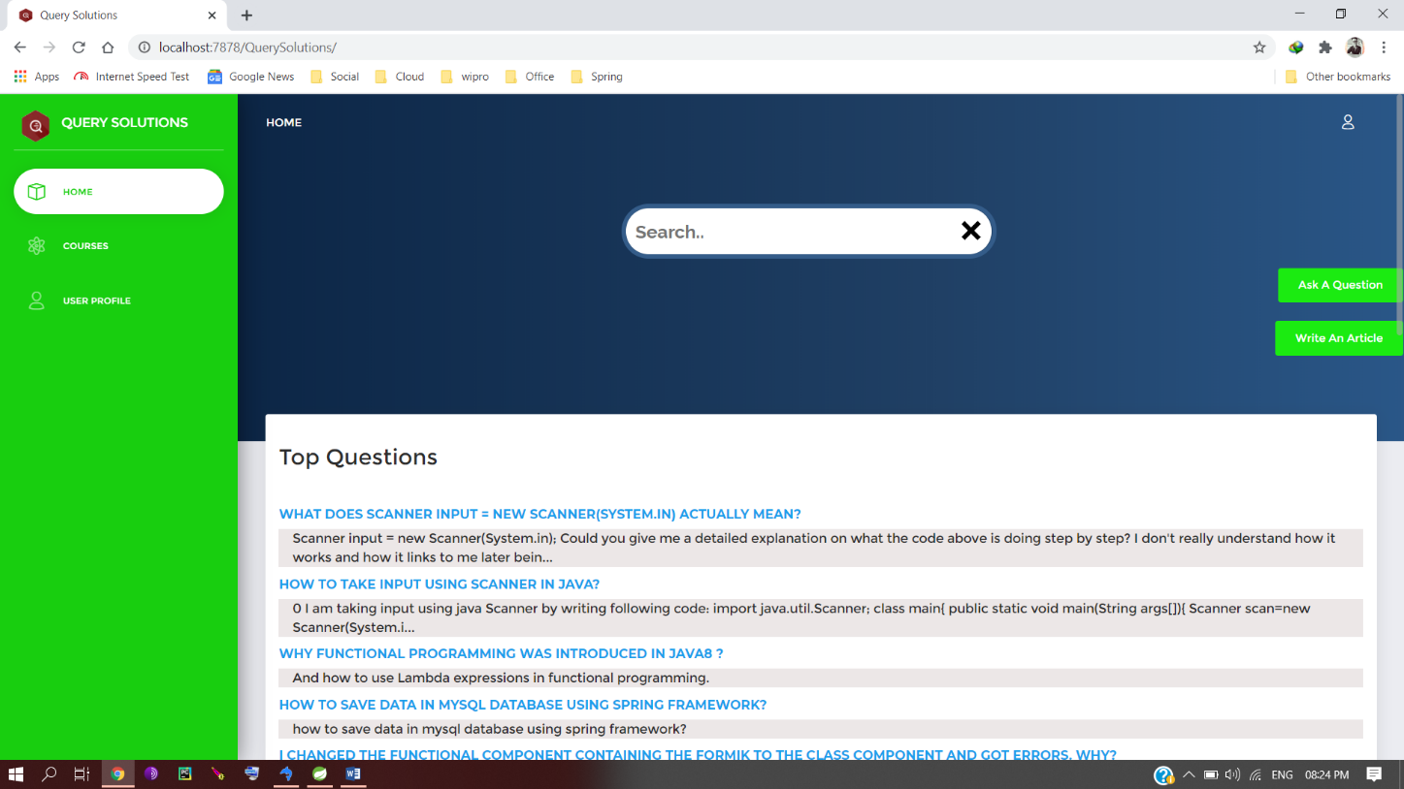

Part 2

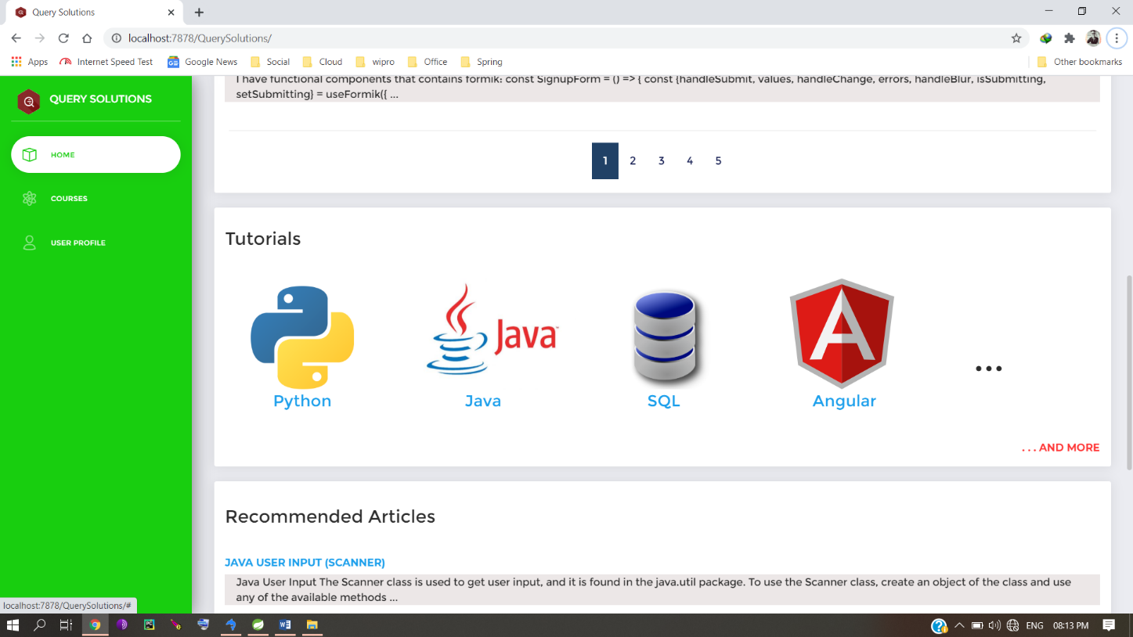

Part 3

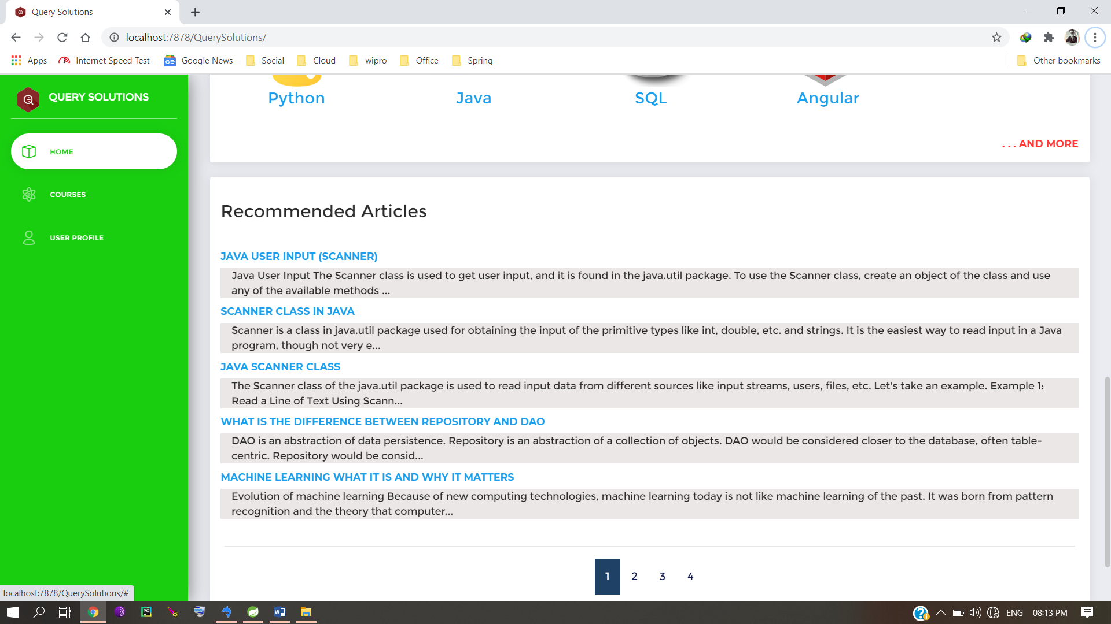

Courses / Tutorials part 1

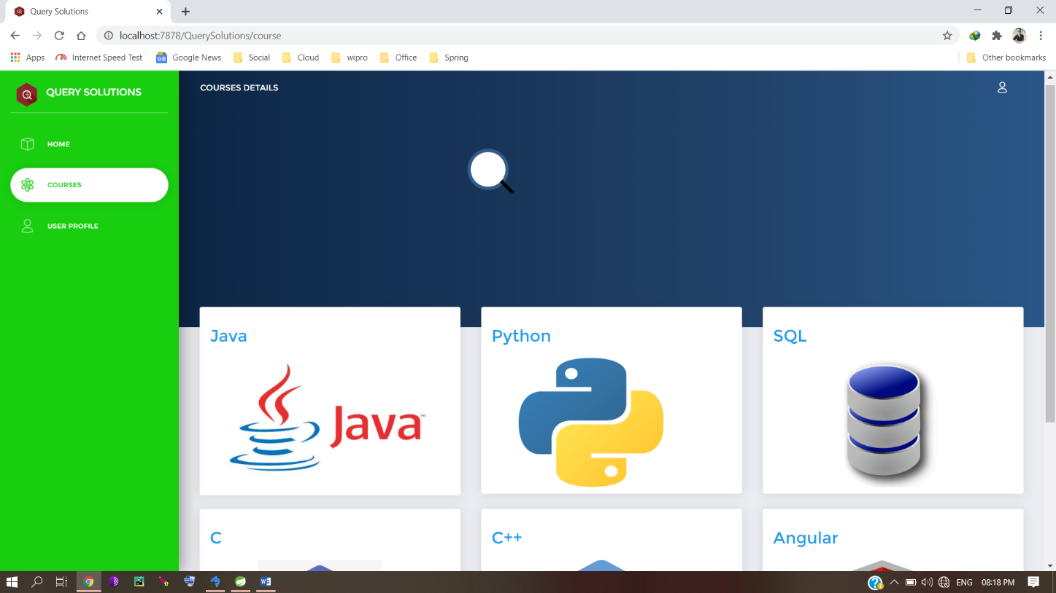

Part 2

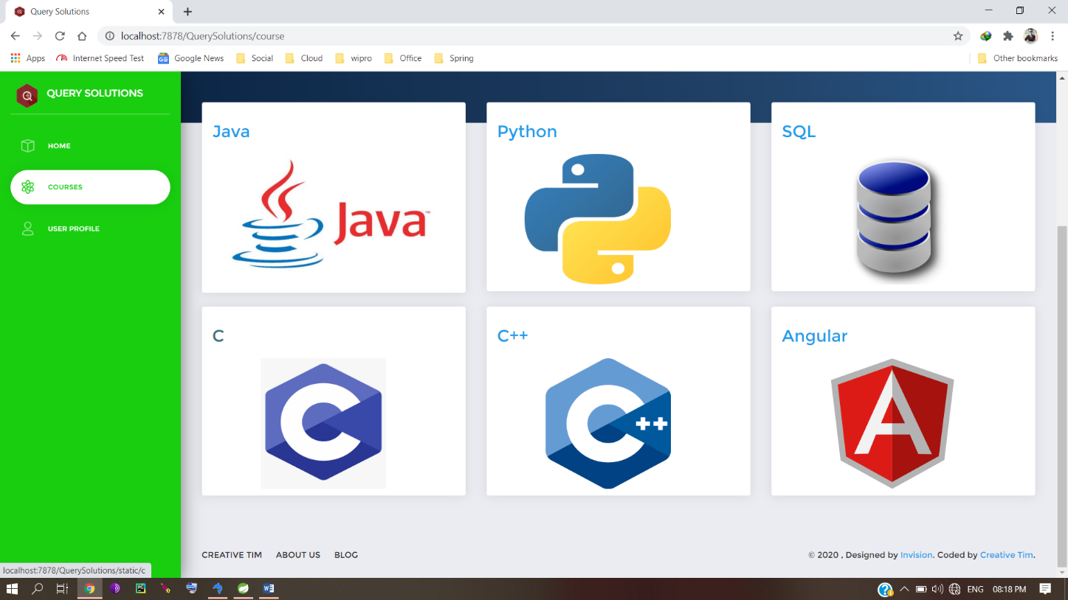

Java Tutorial part 1

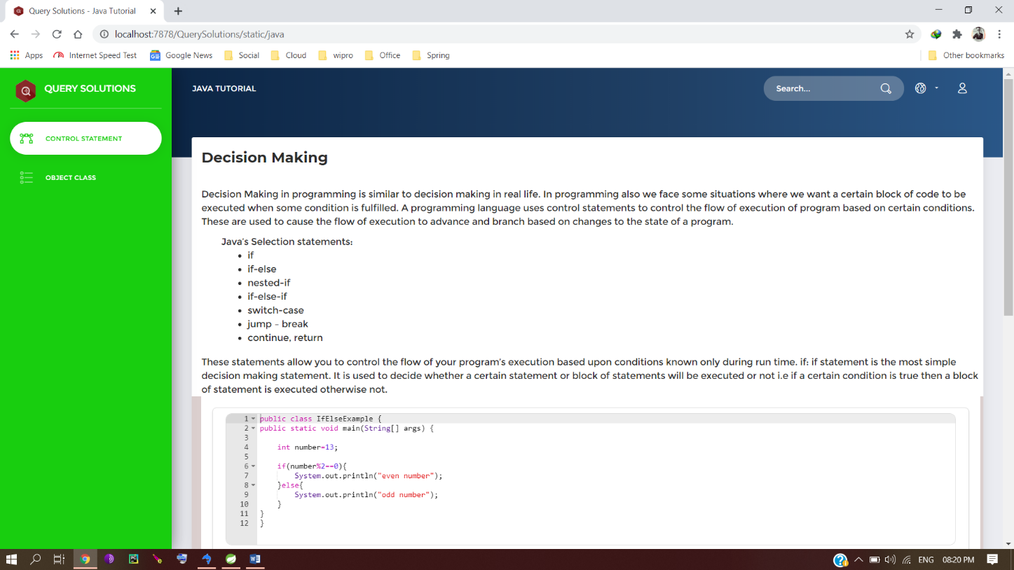

Part 2

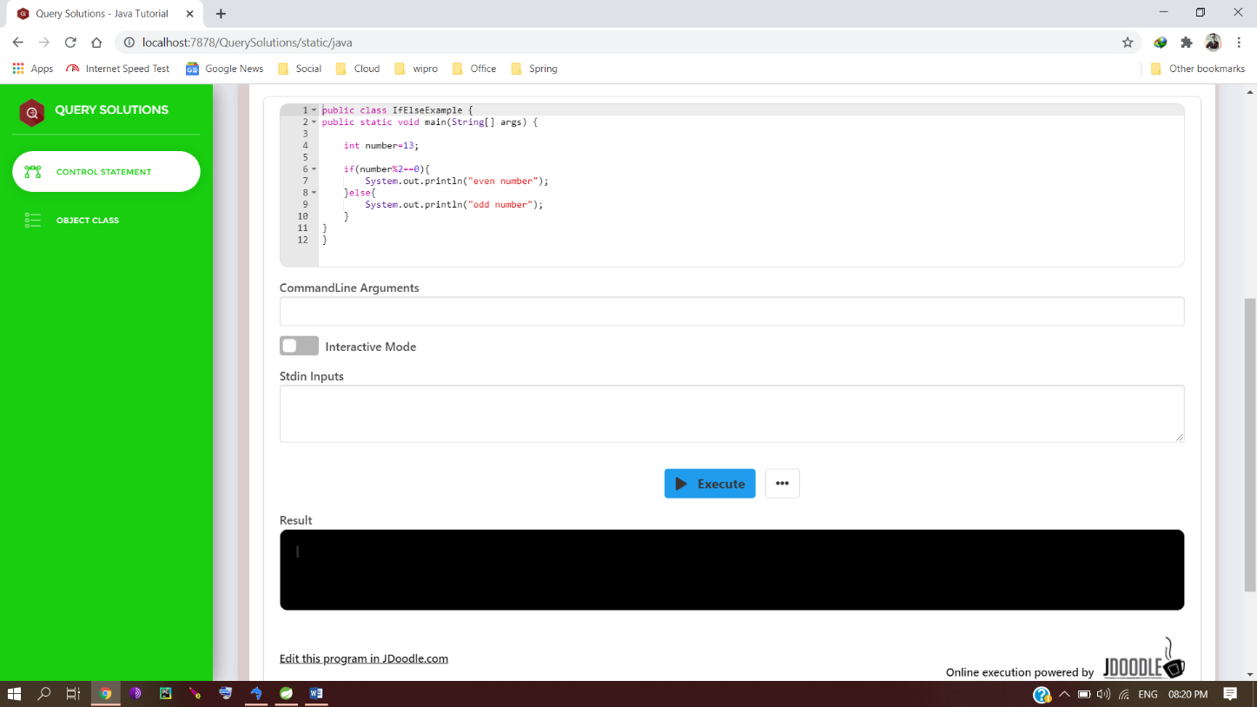

Online compiler

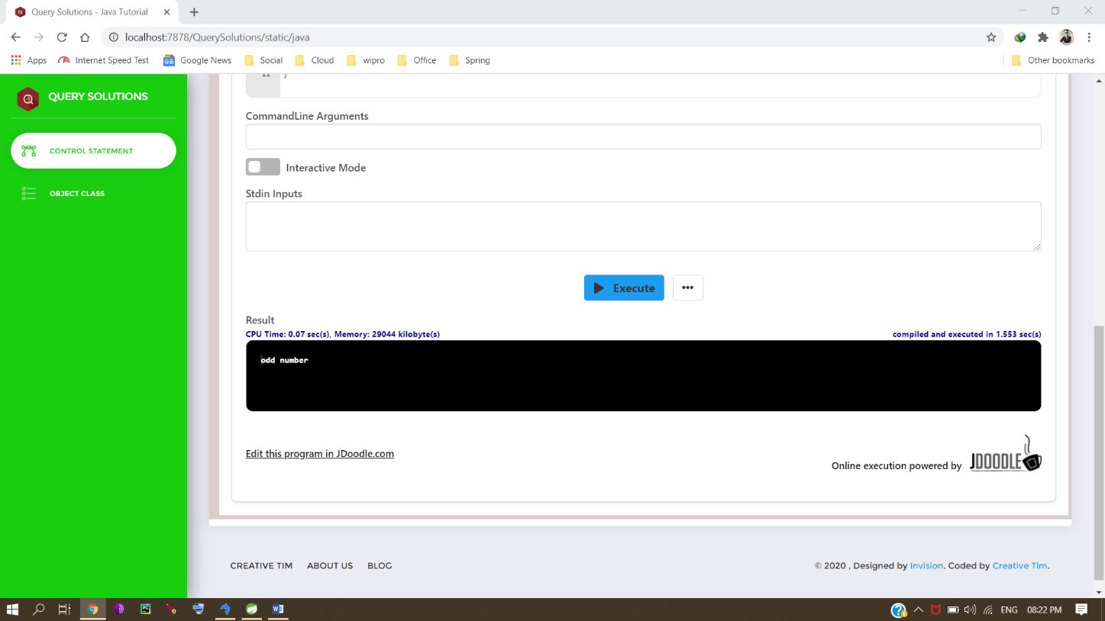

Ask a Question

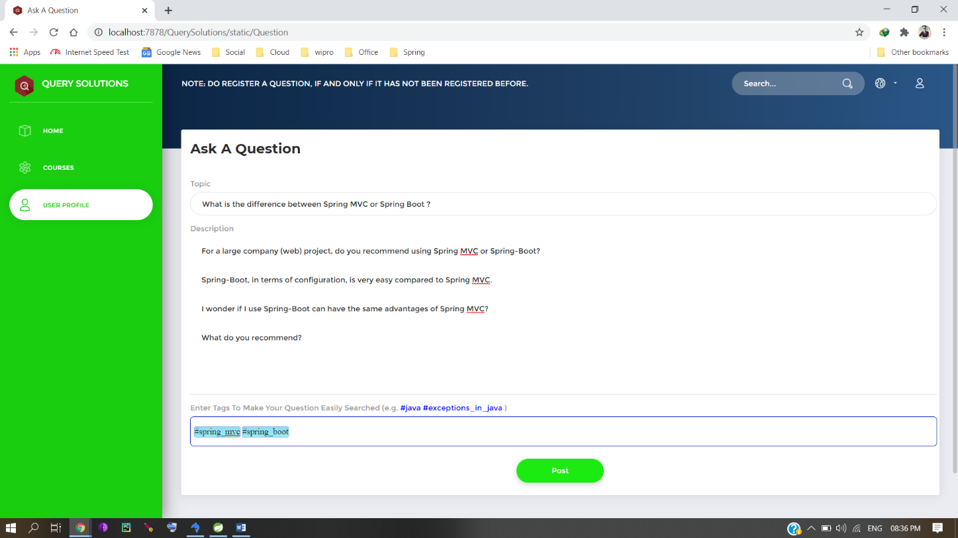

Derogatory words scrutinized

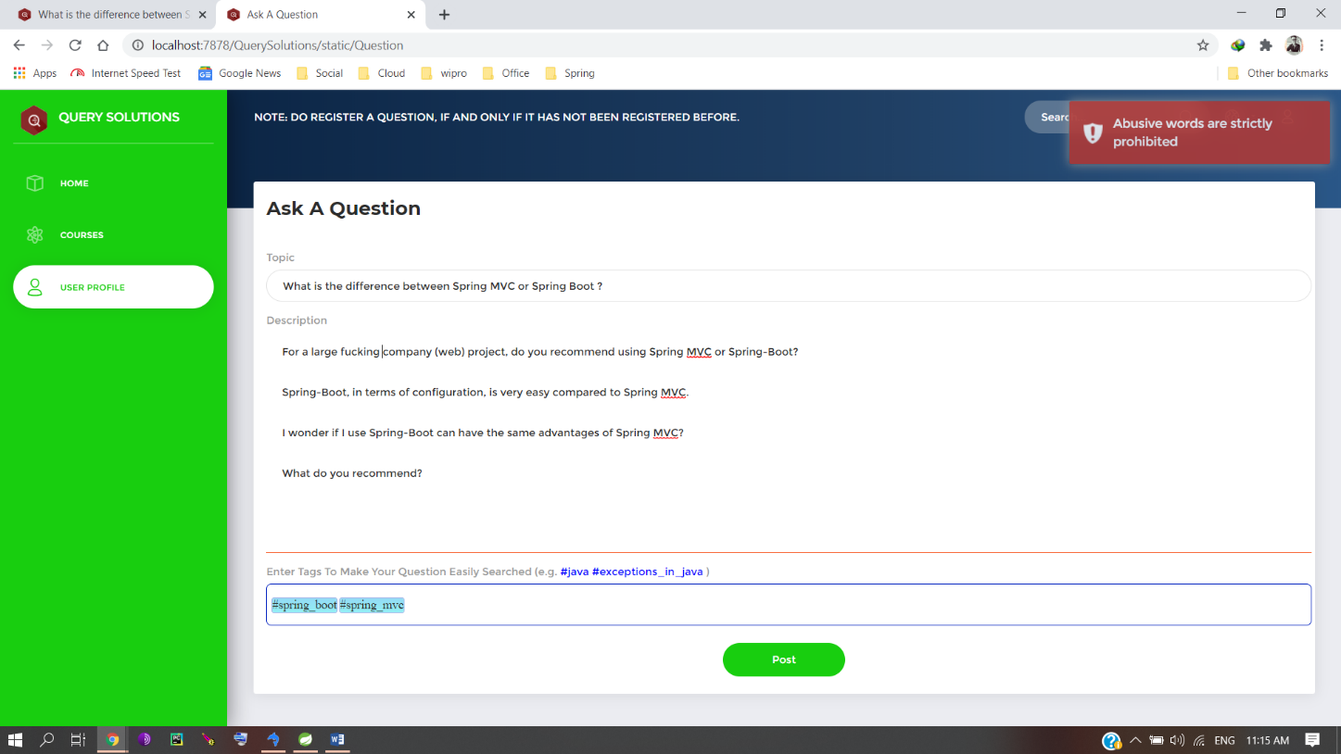

Login Page part 1

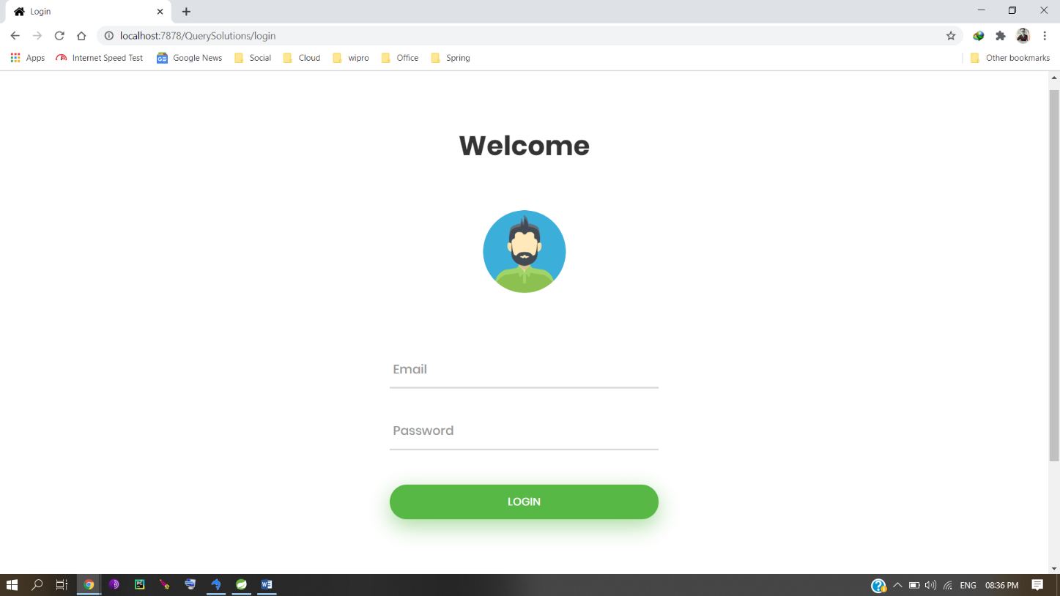

Part 2

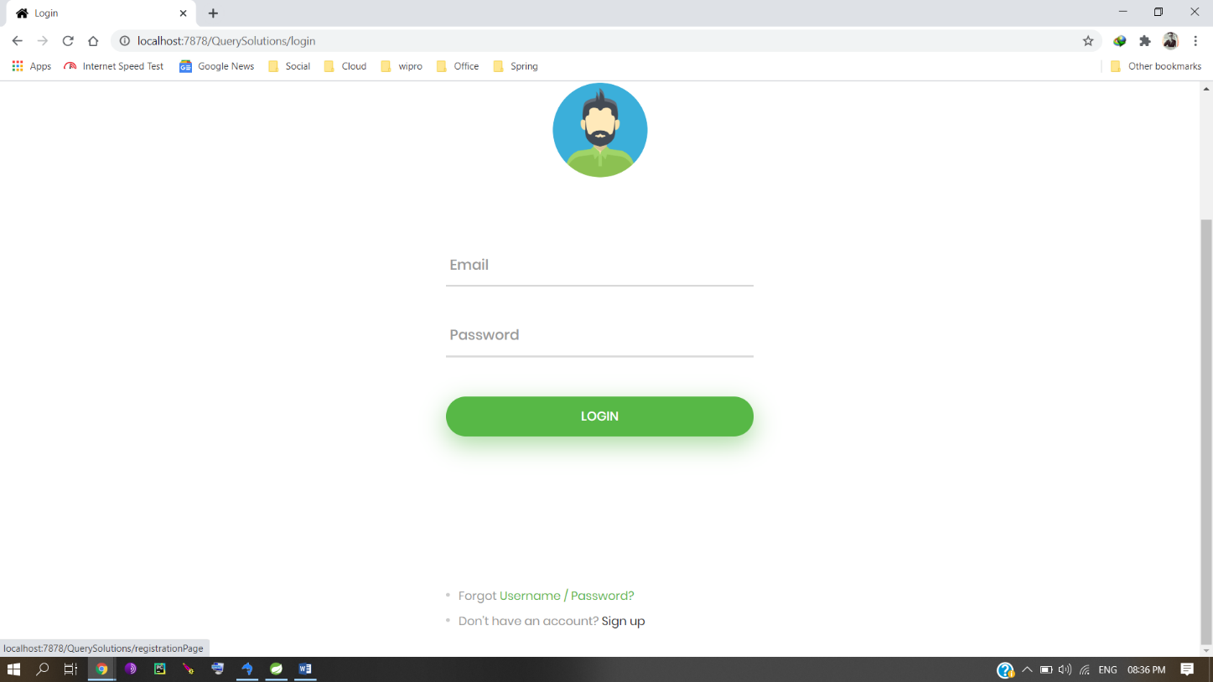

Registration Page part 1

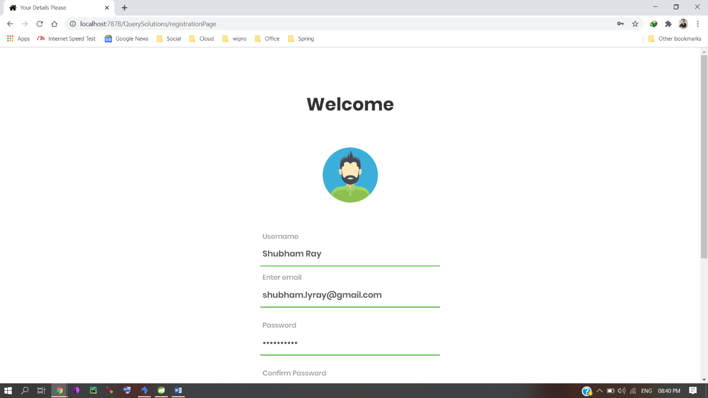

part 2

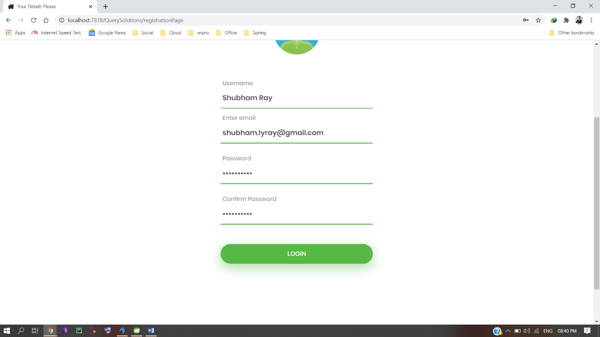

2-Step Verification Message

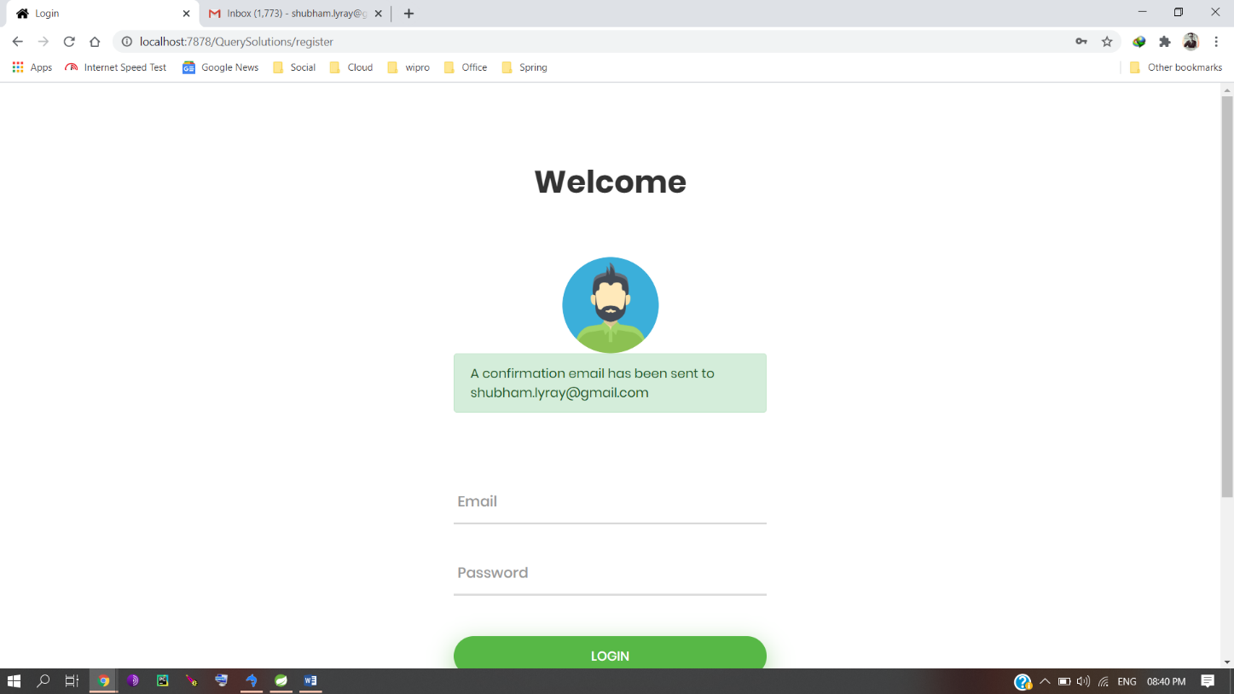

Publisher Gmail Account

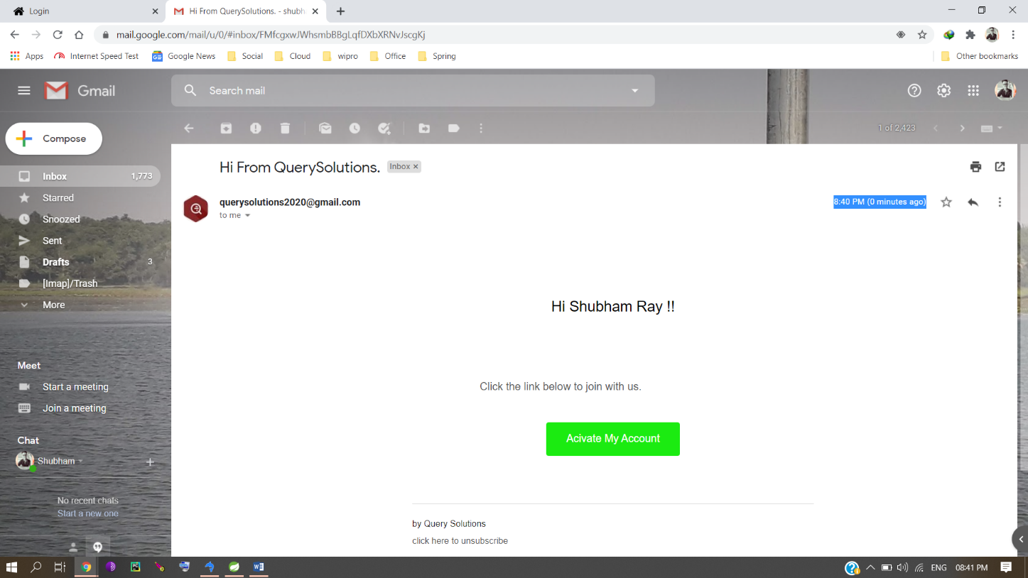

Activate Account

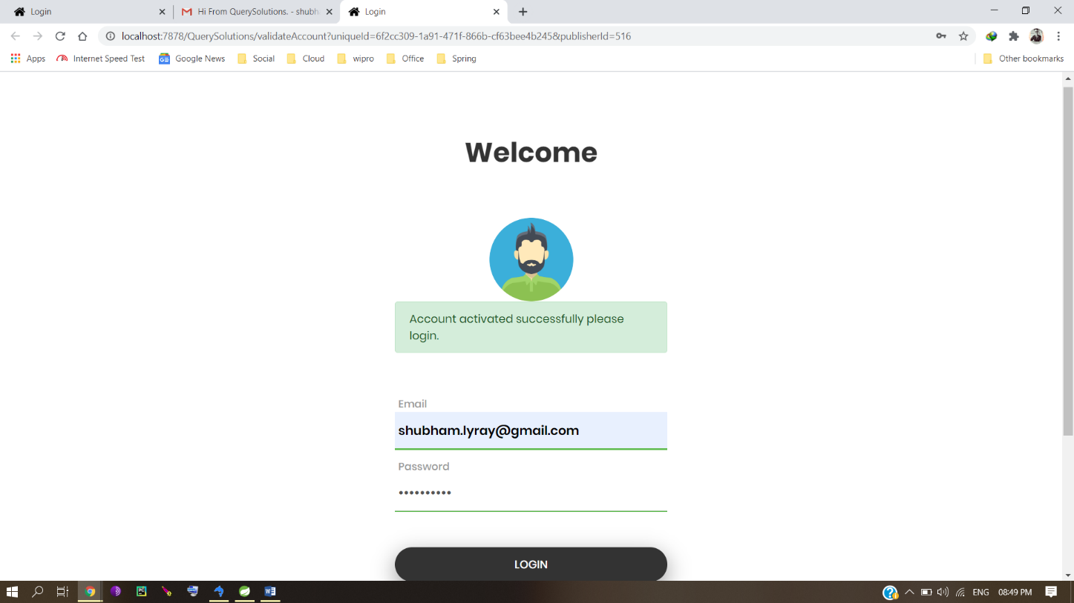

Publisher Profile Page

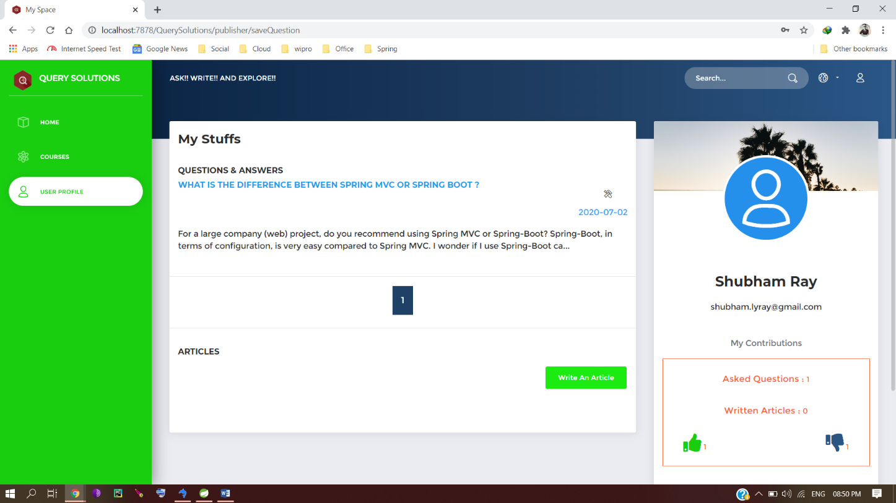

Set Profile choose a photo

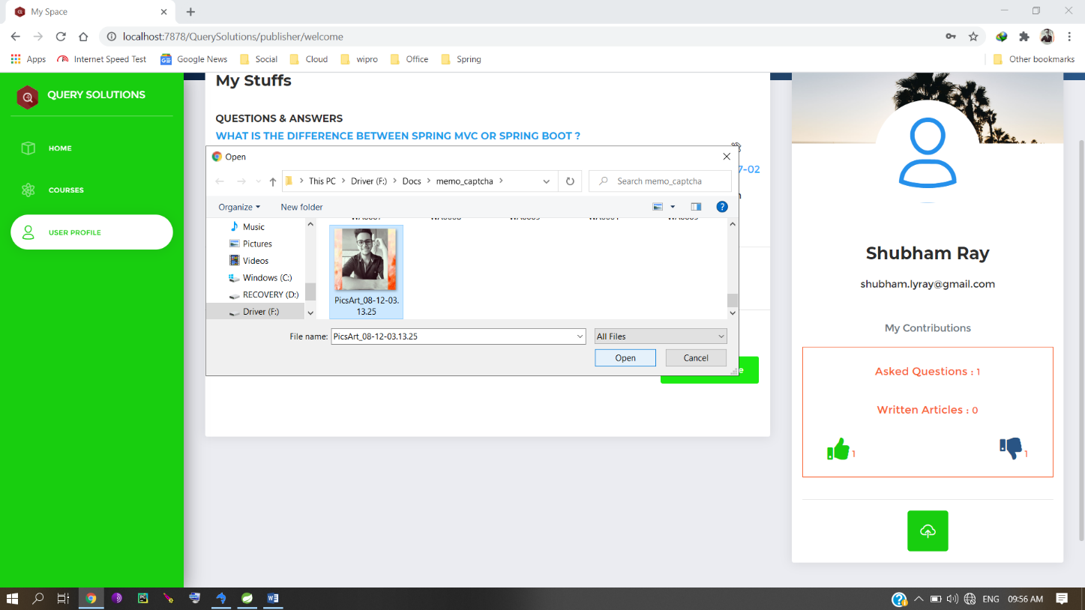

Photo saved automatically

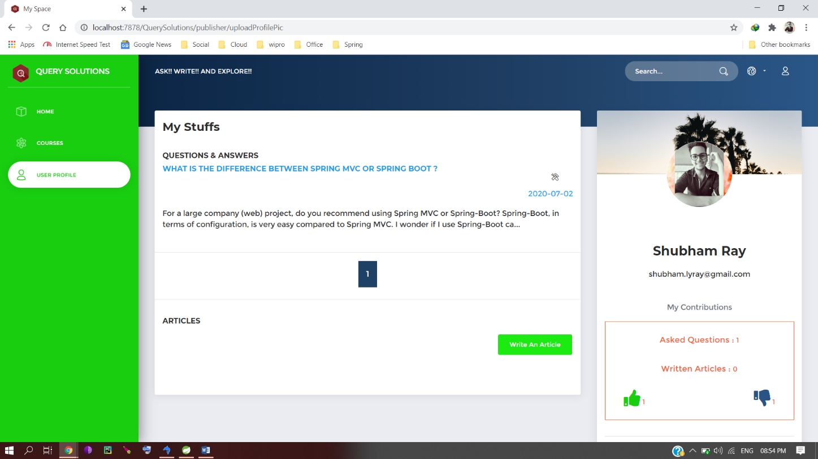

Publisher’s information on Database

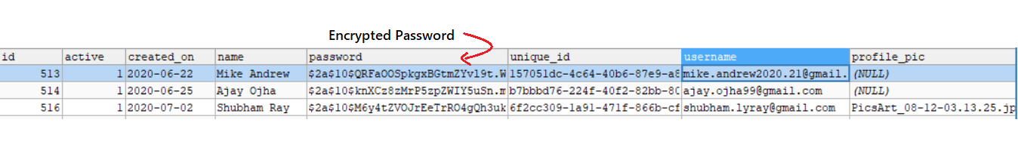

Write an article part 1

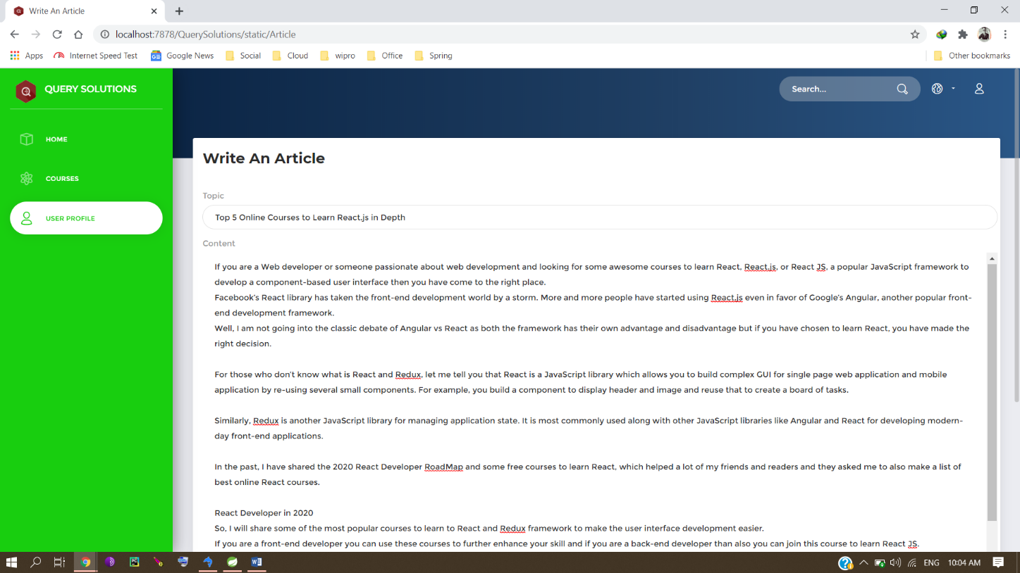

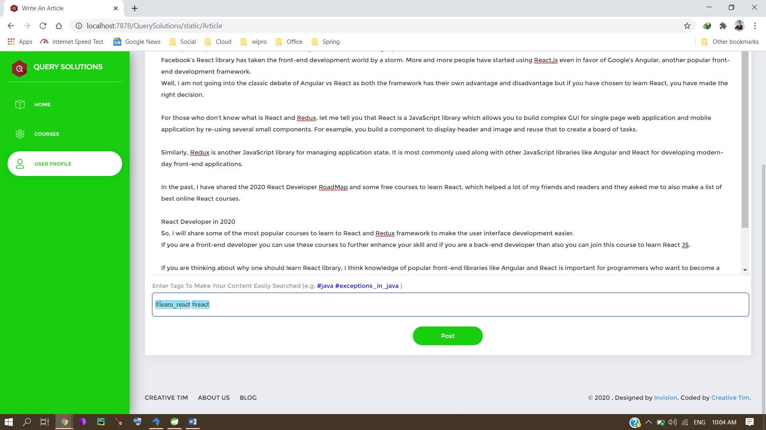Part 2

View an article

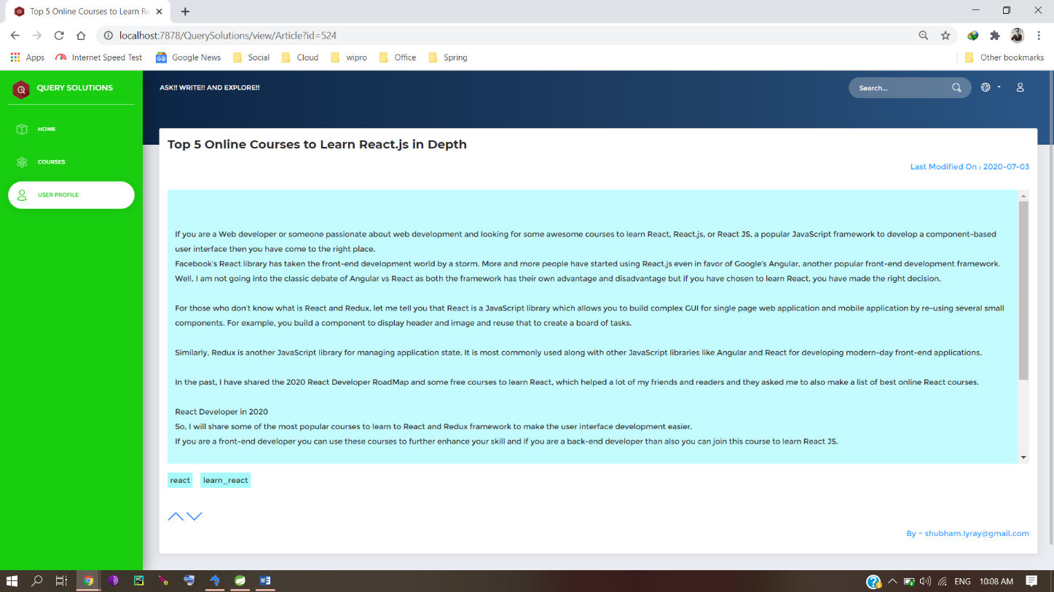

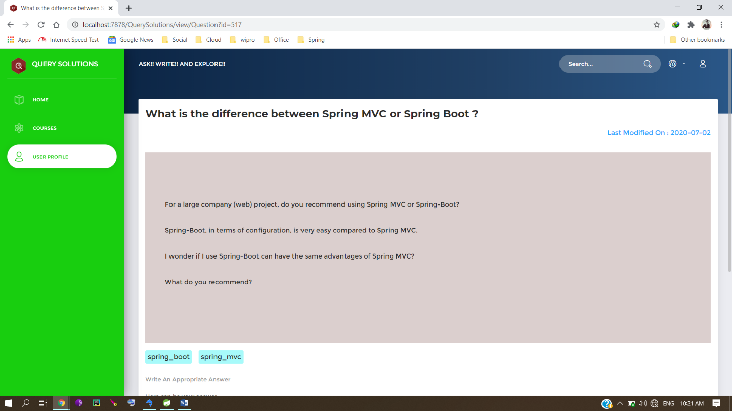View a Question

Write an answer

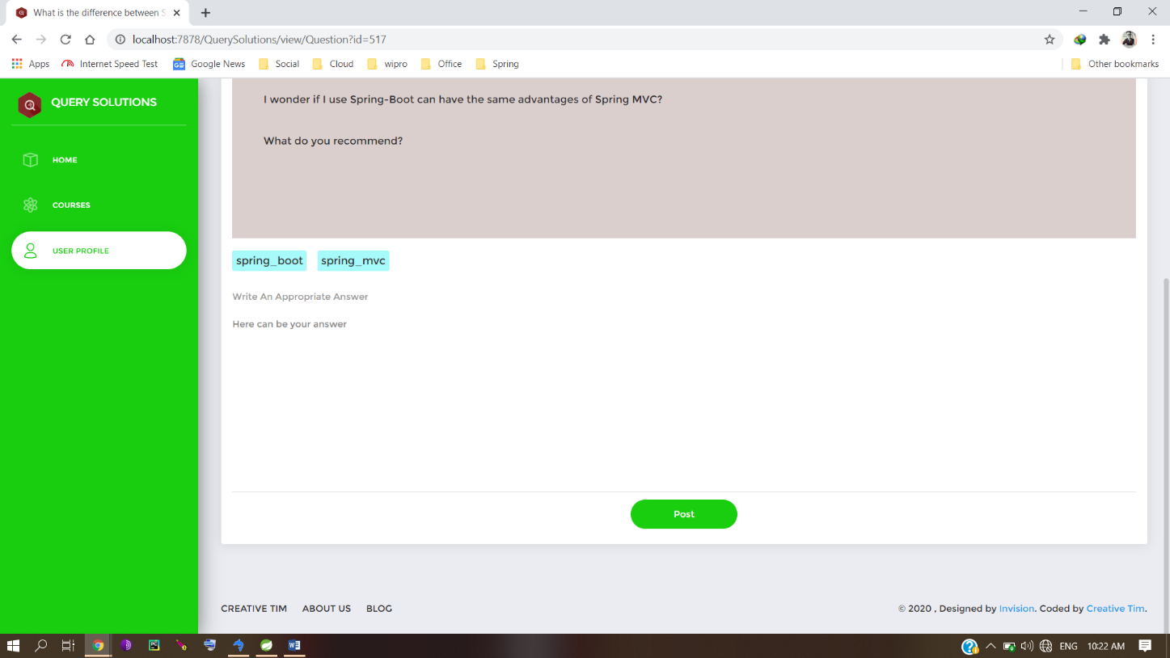

View an Answer

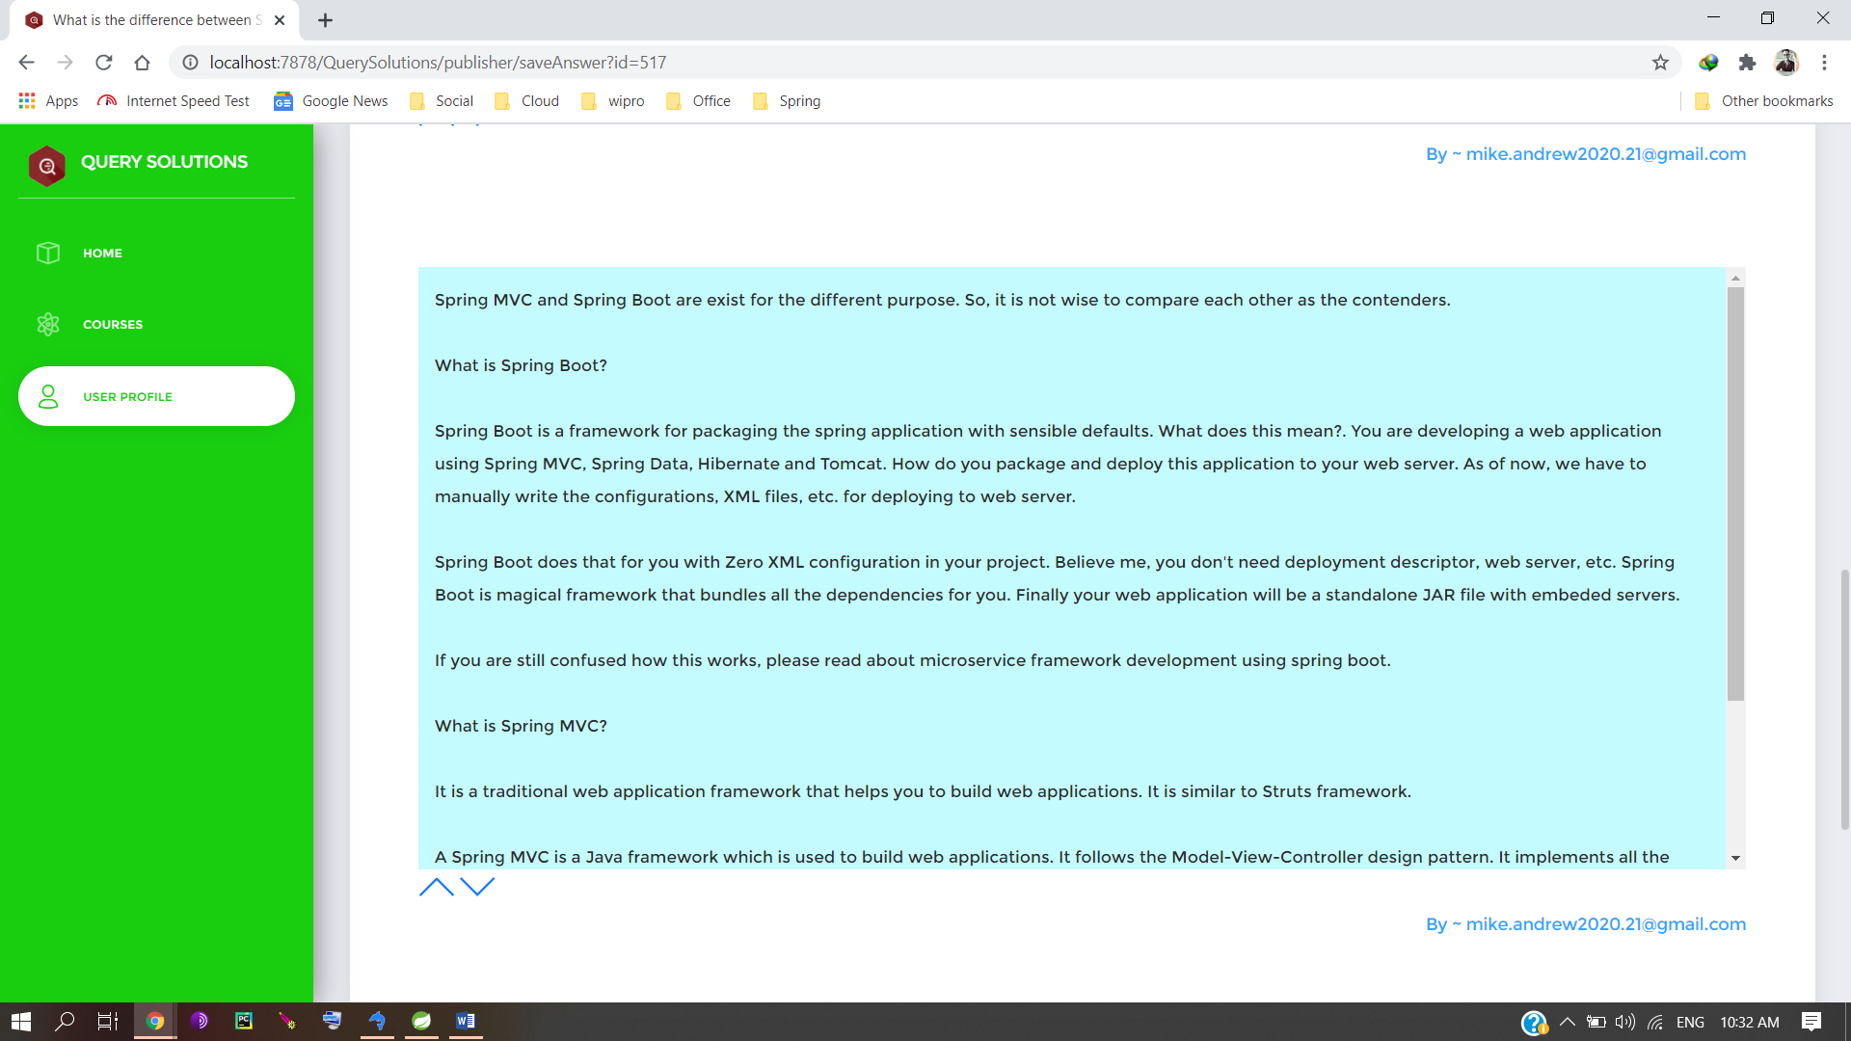

Voting an answer – condition- publisher not eligible to vote

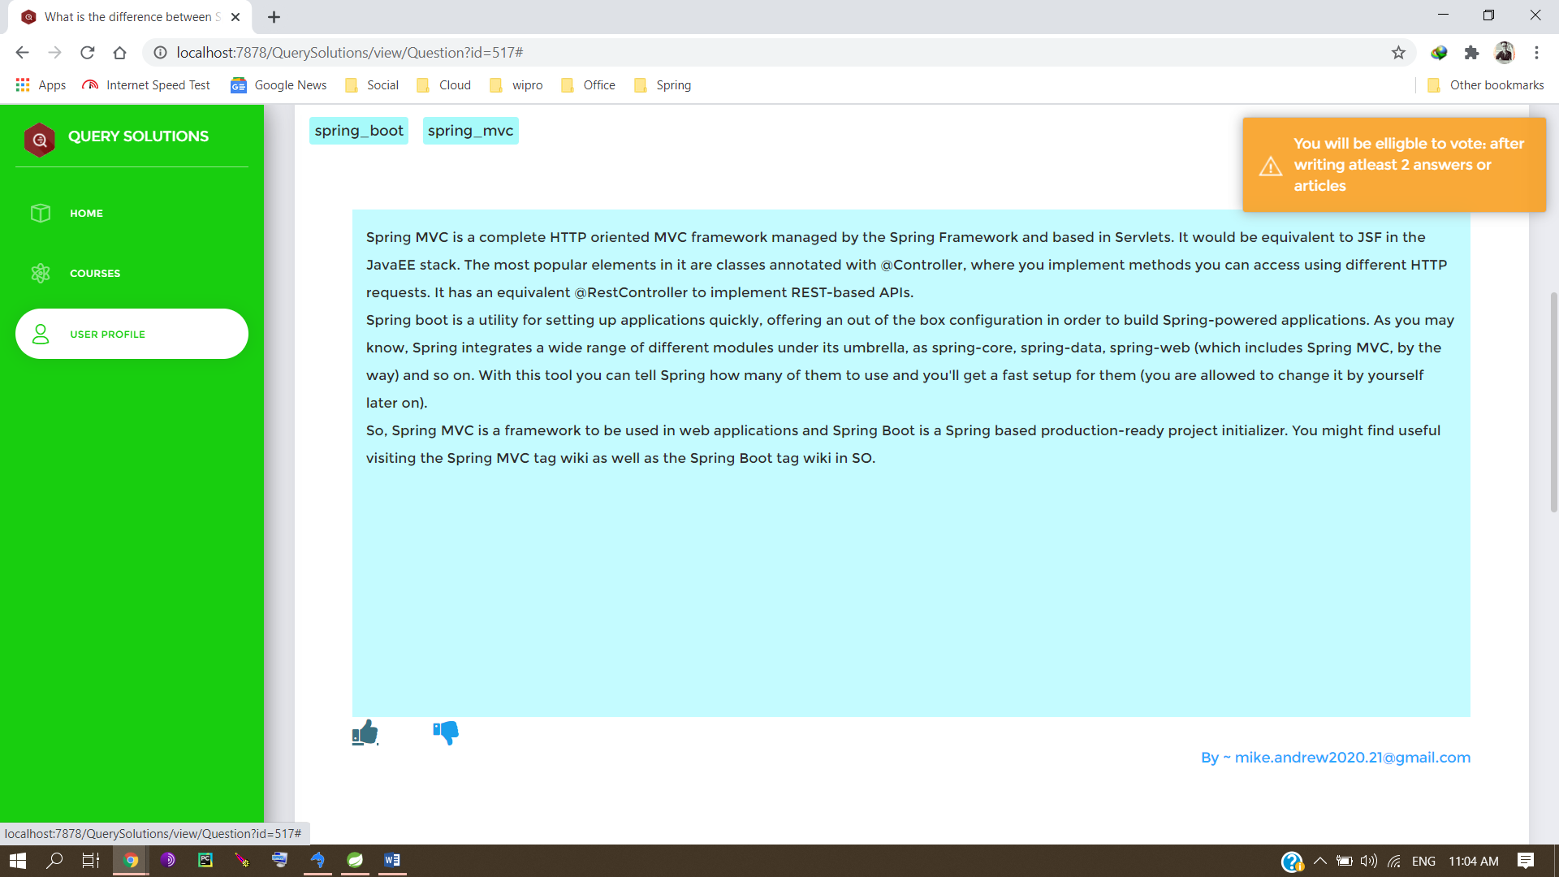

Voting an answer – condition- another publisher given like

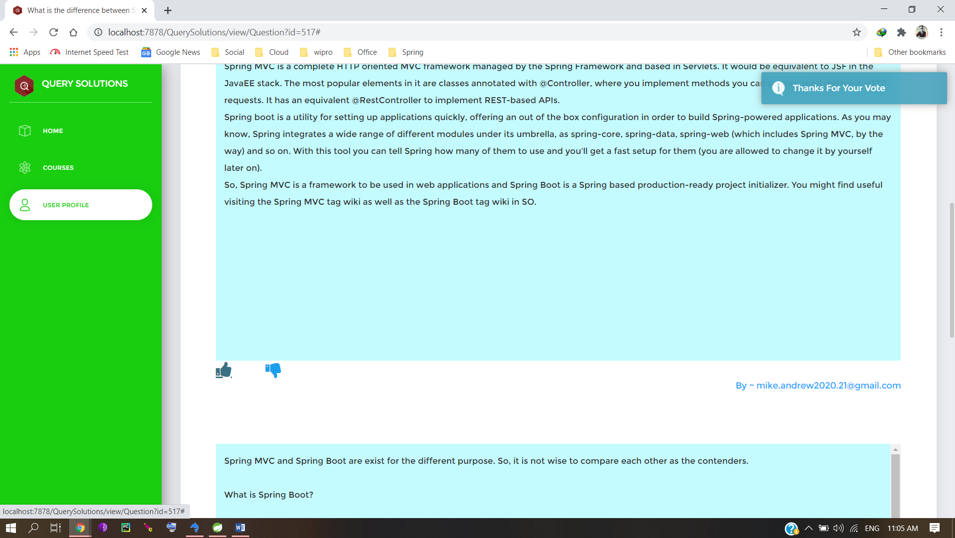

Voting an answer – condition – publisher gives dislike

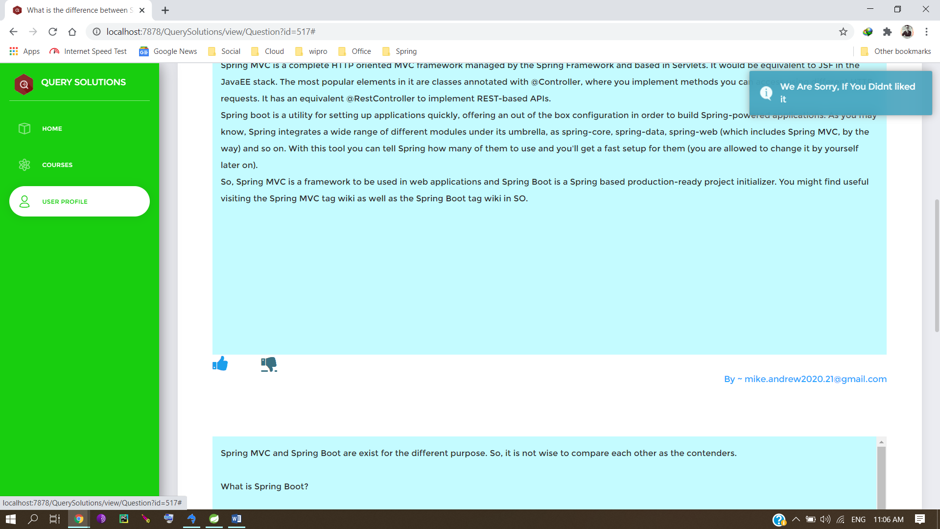

Voting an answer – condition – publisher removes his vote

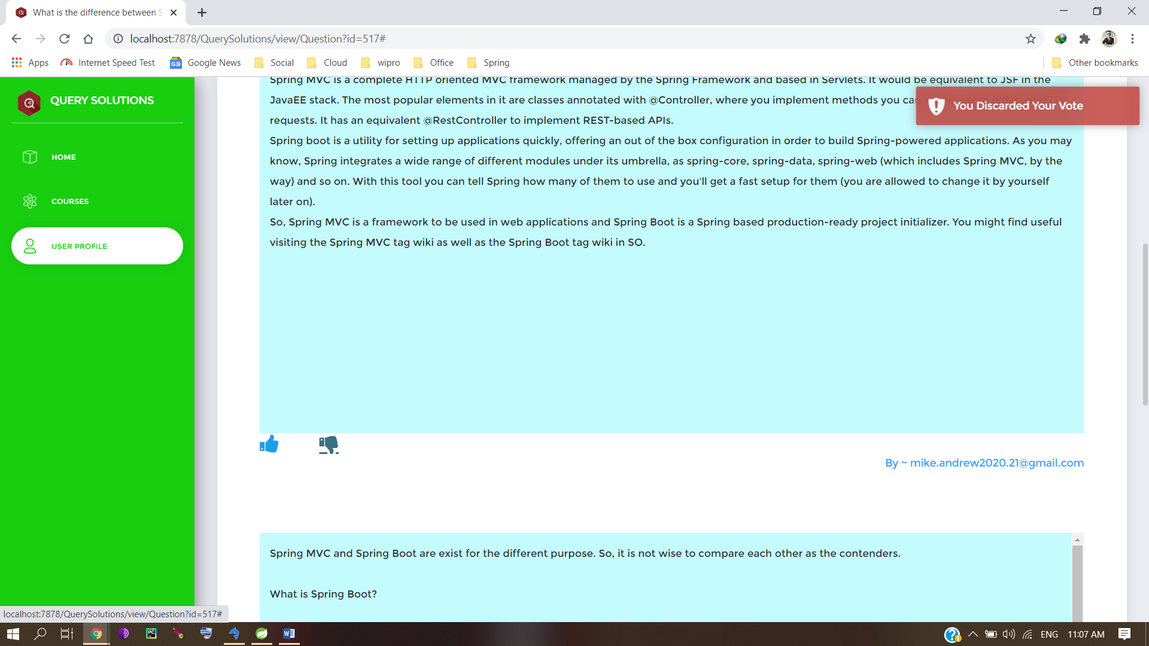

Voting an article

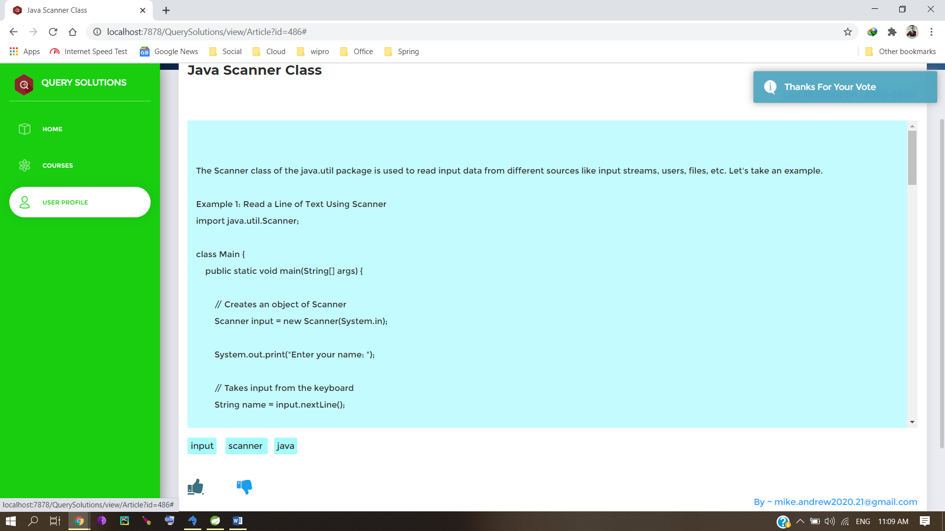

Mailing Publishers on each new answer

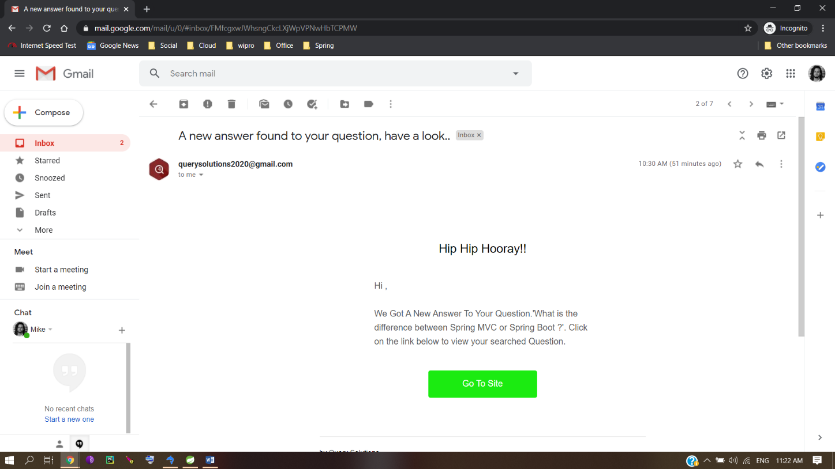

Search operation

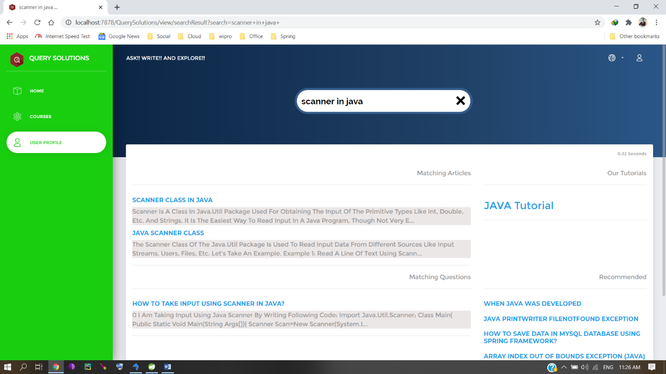

**8. Testing**

**What is Testing ?**

### Testing is a process of executing a program with the aim of finding error. To make our software perform well it should be error free. If testing is done successfully it will remove all the errors from the software.

### Principles of Testing:-

### All the test should meet the customer requirements.

### To make our software testing should be performed by third party.

### Exhaustive testing is not possible. As we need the optimal amount of testing based on the risk assessment of the application.

### All the test to be conducted should be planned before implementing it.

### It follows Pareto rule (80/20 rule) which states that 80% of errors comes from 20% of program components.

### Start testing with small parts and extend it to large parts.

### Types of Testing:-

### Unit Testing

### It focuses on smallest unit of software design. In this we test an individual unit or group of inter related units. It is often done by programmer by using sample input and observing its corresponding outputs.

### Example:

In a program we are checking if loop, method or function is working fine.

Misunderstood or incorrect, arithmetic precedence.

Incorrect initialization

Integration Testing

The objective is to take unit tested components and build a program structure that has been dictated by design. Integration testing is testing in which a group of components are combined to produce output.

Integration testing is of four types:

* Top down
* Bottom up
* Sandwich
* Big-Bang

Example:

Black Box testing:- It is used for validation.

In this we ignores internal working mechanism and

focuses on what is the output?.

White Box testing:- It is used for verification.

In this we focus on internal mechanism i.e.

how the output is achieved?

Regression Testing

Every time new module is added leads to changes in program. This type of testing make sure that who

le component works properly even after adding components to the complete program.

Example:

In school record suppose we have module staff, students

and finance combining these modules and checking if on

integration these module works fine is regression testing

Smoke Testing

This test is done to make sure that software under testing is ready or stable for further testing  
It is called smoke test as testing initial pass is done to check if it did not catch the fire or smoked in the initial switch on.

Example:

If project has 2 modules so before going to module

make sure that module 1 works properly

Alpha Testing

This is a type of validation testing. It is a type of acceptance testing which is done before the product is released to customers. It is typically done by QA people.

Example:

When software testing is performed internally within

the organization

Beta Testing

The beta test is conducted at one or more customer sites by the end-user of the software. This version is released for the limited number of users for testing in real time environment

Example:

When software testing is performed for the limited

number of people

System Testing

In this software is tested such that it works fine for different operating system.It is covered under the black box testing technique. In this we just focus on required input and output without focusing on internal working.  
In this we have security testing, recovery testing, stress testing and performance testing

Example:

This include functional as well as non functional testing

Stress Testing

In this we gives unfavorable conditions to the system and check how they perform in those condition.

Example:

Test cases that require maximum memory or other

resources are executed

Test cases that may cause thrashing in a virtual operating system

Test cases that may cause excessive disk requirement

Performance Testing

It is designed to test the run-time performance of software within the context of an integrated system. It is used to test speed and effectiveness of program.

Example:

Checking number of processor cycles.

**Why Testing Is Required ?**

# The Importance of Testing In Software Development:-

**Software testing** determines the quality of software after a programmer develops it. This process involves evaluating information that is related to a product. Businesses perform their daily activities more efficiently when they implement **software testing procedures**.

Competition is tough, so every company must operate exceptionally well; quality is needed throughout the entire day. **Software testing** helps businesses pinpoint defects in their software and make appropriate corrections. Software testing also helps businesses discover errors and bugs so that they can improve overall system capacity and accuracy.

SOFTWARE TESTING BENEFITS:-

When application quality is good, it will last longer and will perform resourcefully even if pressed to maximum capacity. Also, software can be configured so that it will operate well even when conditions are less than optimal.

Testing can also improve overall security, but testing is not a simple process. Each day, there will be difficult challenges that involve coding and decoding. The testing process is an important phase during the **software development**because each small module must be tested to ensure its accuracy and validity.

TESTING PROCEDURES:-

There are two types of testing methods:

(I)Automated testing

(II)Manual testing

**Manual software testing**is done by workers and requires they check codes and report bugs. Most Java software development companies are now implementing automated testing procedures. The main purpose of **automated testing**is to lower the amount of time it takes to test software and report bugs. Testing each unit is important because all units must perform in an efficient manner.

Software testing is now a key component of **software product development** because it improves consistency and performance. Though the main benefit of testing involves error rectification and debugging, testing also helps businesses understand an actual and expected outcome so that they can improve the quality of their products.

If software is produced without testing, it could be dangerous to buyers because software has a unique development lifecycle that has important technical components. Testing is recommended because it ensures validation and authentication. If all bugs are removed, the software will be more accurate and reliable.

**9. Conclusion and Future Work**

* As we have a voting option for every published answer by using which a user can vote for solutions with his or her choice as "Like" or "Dislike". This system encourages the publishers to provide more solutions. Further we intend to add a “comment” section to our website where other users can react to or give opinion on the solutions or answers or articles.
* A comment could include the seekers opinion of the article, suggestions, possible errors or even critical analyses of the article. This will have major implications as the publishers or the people, who have provided the answers, now know exactly about what is good and what is wrong in the article.
* We also plan to start a "Reward System" for users who frequently post questions and for persistent users who publish utmost number of articles.
* We are also thinking to put forward some sort coding contests for our users through which they can test and sharpen their knowledge and coding skills.
* After completing the courses or tutorials of any of the programming languages which we provide on our website, there shall be a Q/A session for the user to test what he/she learned throughout the course. The test shall give some points in the users account, after the completion of the session. This will help the users to recapitulate and remember the lessons effortlessly.
* “Query Solutions” is a technological assistance based website that essentially gives priority to not only popular computer languages but also to other not so popular ones. Subsequently we also plan to include languages that are in the developing stage or are yet to come, as and when they are released.
* By this, we can assure you that our website will be one of the most regularly updated websites in the market with a promise to continue this in the future.
* The users will also be provided with a completion certificate as a soft-copy which they can retain as a computer printout also. This shall be issued by our website mentioning the details of the course as well as the user’s portfolio. The users may show this as an achievement during career or job interviews.
* We also help in the creation of a community of developers which will include various stages from beginners to professionals. We also create a communication platform for our users through which they can interact and post comments about their views and also regarding latest technologies, contrivances, pioneering and innovations.

**10. Bibliography**

1. Wikipedia - https://www.wikipedia.org/
2. Stack Overflow - https://stackoverflow.com/
3. W3Schools - https://www.w3schools.com/
4. **Spring Tutorial & Hibernate for Beginners 2019 (Udemy)** - https://www.udemy.com/course/spring-hibernate-tutorial/
5. Spring Framework 5 Course : Beginner to Guru (Udemy) **-** https://www.udemy.com/course/spring-framework-5-beginner-to-guru/
6. Spring: Framework In Depth (LinkedIn Learning) - https://www.linkedin.com/learning/spring-framework-in-depth
7. Learning Spring with Spring Boot (LinkedIn Learning) - https://www.linkedin.com/learning/learning-spring-with-spring-boot/
8. Spring Framework Training Masterclass: Beginner to Professional - https://www.udemy.com/course/java-spring-framework-masterclass/
9. Spring Framework Master Class – Beginner to Expert - https://www.udemy.com/course/spring-tutorial-for-beginners/
10. The Java Spring Tutorial: Learn Java’s Popular Web Framework - https://www.udemy.com/course/javaspring/
11. HowToDoInJava : Java Tutorials : Spring Framework - https://howtodoinjava.com/
12. In28Minutes - https://courses.in28minutes.com/
13. Learn Spring Boot : Baeldung - <https://www.baeldung.com/>
14. Documentation : Thymleaf - https://www.thymeleaf.org/index.html